# Scenario 1

**Description:**

This scenario demonstrates the successful insertion of a new employee into the tblEmployees table. The insert statement includes all required values and populates the CreatedDate and CreatedBy audit fields using system functions. Upon successful insertion, the script retrieves and returns the auto-generated EmployeeID (IDENTITY value) to confirm the operation was completed.

**Output Screenshots:**

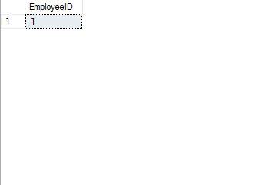



# Scenario 2

**Description:**

This scenario intentionally attempts to insert a new employee with values that violate defined business rules. It includes errors in the middle initial length, date of birth (underage), gender (invalid character), employee number format, and social security number (non-numeric and incorrect length). Each of these invalid inputs is designed to trigger the validation logic within the usp_InsertEmployees procedure and log corresponding error messages in tblLogErrors.

**Output Screenshots:**

# Scenario 3

**Description:**

This scenario showcases how the usp_UpdateEmployee procedure handles updates that violate business rules. Each test case targets a different field with invalid data:

* Middle initial with more than one character
* Date of birth outside the allowed age range
* Invalid gender
* Employee number format that doesn't match the naming convention
* Social security number that includes characters or exceeds 9 digits  
  Each violation is captured and logged into the tblLogErrors table for tracking and debugging.

**Output Screenshots:**



# Scenario 4

**Description:**

This scenario tests the deletion functionality through the usp_DeleteEmployees procedure. It includes one successful deletion using a valid EmployeeID, followed by an attempted deletion with a non-existent EmployeeID (0). The success is logged with a neutral status, and the failed attempt triggers an error message, which is logged for audit purposes in the tblLogErrors table.

**Output Screenshots:**

# Scenario 5

**Description:**

This optional scenario queries the tblLogErrors table to display a list of logged error messages related to insert, update, and delete operations. It demonstrates how the system maintains a central log of issues, which can be used for troubleshooting and validation of business rule enforcement.

**Output Screenshots:**