# Scenario 1

**Description:**

In this scenario, I tested multiple insert cases that each violated a different business rule, such as missing gender, invalid gender values, missing or invalid date of birth, incorrect employee number formatting, and missing required fields like first name, last name, and SSN. Each violation was correctly caught and logged by the business rule function and the **usp_InsertEmployee** procedure.

**Screenshots:**

# Scenario 2

**Description:**

In this scenario, I tested the **usp_InsertEmployee** procedure by submitting new employees with increasing levels of business rule violations. I started with single violations like an invalid gender and a bad date of birth, and gradually moved to more complex cases with two, three, and finally four violations. Each time, the procedure correctly identified the violations, returned the expected error message, and logged a single entry in the error log with all issues clearly listed.

**Screenshots:**

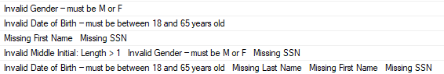

# Scenario 3

**Description:**

In this scenario, I tested the **usp_UpdateEmployee** procedure by updating existing employee records with values that violate one or more business rules. I began by triggering isolated violations such as an invalid gender and a bad date of birth, and then tested combinations of two, three, and four violations, including bad middle initials, missing fields, and mismatched employee numbers. The procedure correctly returned detailed error messages and logged each violation group as a single entry in the error log.

**Screenshots:**

