True Messiah - Properly Anointed;
False Messiah - Smeared with Ointment

by

Messiah truth

I. Introduction

The ninth chapter in the Book of Daniel has been a popular component in the portfolio of Christian apologists and missionaries. The passage that is commonly extracted from this chapter as an example of a definitive "messianic prophecy" is Daniel 9:24-27 because, according to most Christian translations, it contains two direct references to the Messiah (Dan 9:25-26), which are claimed to be references to Jesus. With the help of mistranslations and some mathematical hocus-pocus, they transform this passage into a prophecy that allegedly foretells the coming of Jesus and his crucifixion.

The analysis presented in this essay demonstrates that these claims concerning Daniel 9:25-26 are inconsistent with the teachings of the Hebrew Bible. Moreover, since these claims also include references to being anointed, the anointing process, as defined and applied in the Hebrew Bible, is cast into a template against which the "anointing" of Jesus, as described in the New Testament, is compared in order to test its validity.

- II. Christian and Jewish Translations of Daniel 9:25-26

Table II-1 shows side-by-side English renditions and the Hebrew text of the passage Daniel 9:25-26. The Hebrew term 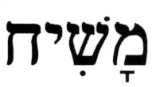 (mashia'h) and its respective renditions in the two translations are shown in highlighted form.

Table II-1 – Daniel 9:25-26

King James Version Translation |  | Jewish Translation from the Hebrew |  | Hebrew Text
Daniel 9 |  |  |  | 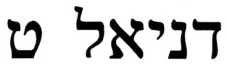
25 | Know therefore and understand, that from the going forth of the commandment to restore and to build Jerusalem unto the Messiah the Prince shall be seven weeks, and threescore and two weeks: the street shall be built again, and the wall, even in troublous times. |  | And you should know and understand that, from the emergence of the word to restore and build Jerusalem until an anointed ruler, [shall be] seven weeks; and [in] sixty-two weeks it will be restored and be built, street and moat, but in troubled times. | 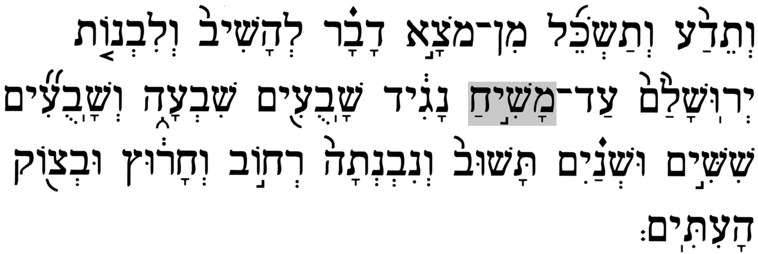 | 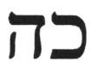
26 | And after threescore and two weeks shall Messiah be cut off, but not for himself: and the people of the prince that shall come shall destroy the city and the sanctuary; and the end thereof shall be with a flood, and unto the end of the war desolations are determined. |  | And after the sixty-two weeks, an anointed one will be cut off, and [he] will be no more; and the city and the Sanctuary will be destroyed by people of the coming ruler, and his end will come about like a flood; and by end of the war, there will be desolation. | 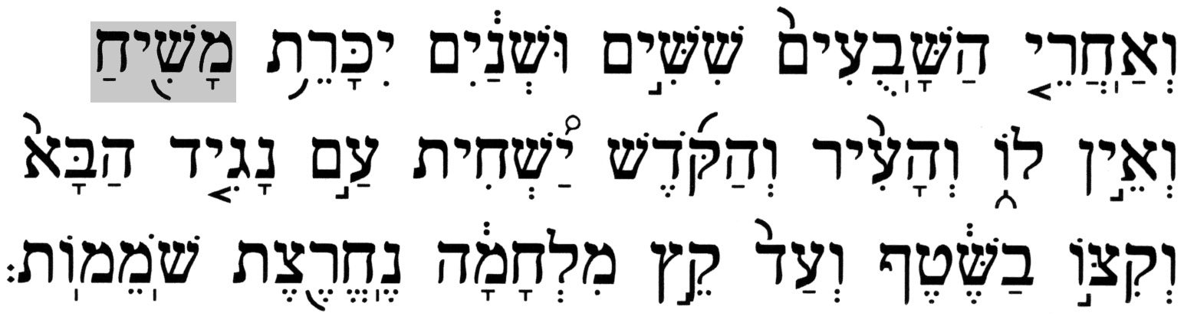 | 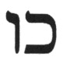

A significant disagreement exists between the two translations in their respective renditions of the noun . A study of the applications of this term in the Hebrew Bible helps resolve this issue.

- III. Review of Hebrew Terminology
According to the Hebrew Bible, the men who were selected to fill the positions of the high priest [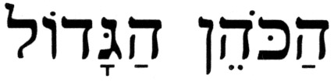(ha'kohen ha'gadol)] and king [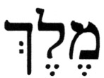(melech)] had to go through a ritual anointing ceremony. The Hebrew root verb 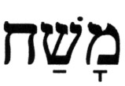 (mashah), [to] anoint, appears in the Hebrew Bible 70 times in various conjugations. This verb is used on 63 occasions to describe an act of anointing, i.e., applying a specially prepared oil or compound to someone or something for the purpose of sanctification or consecration; and on the seven remaining occasions, it is used in the context of covering something with paint or oil for various other purposes.

Someone who went through the process of anointing was referred to as (mashi'ah), an anointed one, in the Hebrew Bible. The noun derives from the root verb , [to] anoint, and it appears in various conjugations and forms in the Hebrew Bible on 39 occasions. The salient fact about the noun is that not one of these 39 instances refers to the Messiah. The reason is that the usage of the noun as the present Hebrew term for Messiah is a product of the first century B.C.E., which is interesting information that emerged from research done on the Dead Sea Scrolls. Around that time, the Jewish messianic vision experienced a significant paradigm shift from the expectation of an era (i.e., “End of Days”) to an expectation of a Jewish leader who will deliver Israel ("Redeemer"). This fact alone defeats the claim by Christian apologists and missionaries concerning references to the Messiah in Daniel 9:25-26.

- IV. Application of the Noun in the Hebrew Bible

An analysis of the 39 applications of the noun in the Hebrew Bible, and how these are rendered in most Christian Bibles, provides the Biblical evidence that refutes the claims concerning its occurrences in Daniel 9:25-26. Table IV-1 shows the 39 applications of the noun in the Hebrew Bible. Each form of the noun is shown separately along with the frequency of occurrence, a pronunciation guide (CAPS identify the accented syllable), the respective Scriptural citations, the correct English translation, and the respective KJV rendition. References indicate chapter and verse numbers in the Hebrew Bible; verse numbers in Christian Bibles, if different from the Hebrew Bible, are shown in brackets.

Table IV-1 – The term in the Hebrew Bible and its KJV renditions

Hebrew Term | # | Pronunciation | References | Correct Translation | KJV Rendition
 | 3 | mah-SHEE-ah | 2 Sam 1:21 | an anointed | anointed
 | 3 | mah-SHEE-ah | Dan 9:25 | an anointed | The Messiah
 | 3 | mah-SHEE-ah | Dan 9:26 | an anointed | Messiah
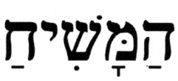 | 4 | ha'mah-SHEE-ah | Lev 4:3,5,16,6:15[22] | the anointed | [the priest] that is anointed
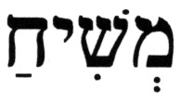 | 8 | m^{e}-SHEE-ah | 1 Sam 24:6,10, 26:16; 2 Sam 1:14,16, 19:22[21], 23:1;  Lam 4:20 | anointed [of] | anointed [of]
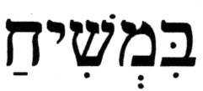 | 3 | bim-SHEE-ah | 1 Sam 26:9,11,23 | against the anointed of - | against [the LORD's] anointed
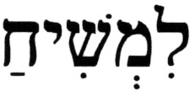 | 1 | lim-SHEE-ah | 1 Sam 24:7 | to the anointed of - | to [the LORD's] anointed
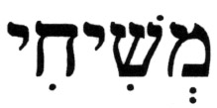 | 1 | m^{e}-shee-HEE | 1 Sam 2:35 | my anointed | mine anointed
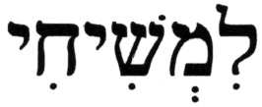 | 1 | lim-shee-HEE | Ps 132:17 | for/to my anointed | for mine anointed
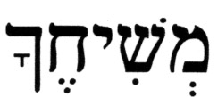 | 6 | me-shee-HEH-cha | Hab 3:13; Ps 84:10[9], 89:39[38],52[51], 132:10; 2 Chron 6:42 | your anointed | thine anointed
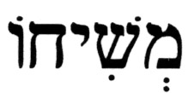 | 7 | me-shee-HO | 1 Sam 2:10, 12:3,5, 16:6; Ps 2:2, 20:7[6], 28:8 | his anointed | his anointed, *[the LORD's] anointed
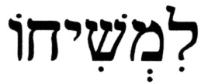 | 3 | lim-shee-HO | 2 Sam 22:51; Is 45:1; Ps 18:51[50] | to his anointed | to his anointed
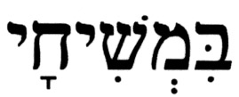 | 2 | bim-shee-HAI | Ps 105:15;  1 Chron 16:22 | at/upon my anointed | [touch not] mine anointed

The KJV rendition of the term differs from the generic an anointed one in only two cases out of the 39 applications, with both instances occurring in Daniel 9:25-26. The question is: "What motivated the KJV translators to cast the term as a reference to the Messiah in Daniel 9:25-26, particularly in view of the historical fact that this association of the two terms came much later than the Book of Daniel?"

A related issue arises from the way some other Christian Bibles render the noun in Daniel 9:25-26, as shown in Table IV-2.

Table IV-2 – The term as rendered in other Christian Bibles

Source | Verse | Source Translation | Correct Translation
Amplified Bible (AMP) | Daniel 9:25 | the Anointed One | an anointed one
Amplified Bible (AMP) | Daniel 9:26 | the Anointed One | an anointed one
New International Version (NIV) | Daniel 9:25 | the Anointed One | an anointed one
New International Version (NIV) | Daniel 9:26 | the Anointed One | an anointed one
New Living Translation (NLT) | Daniel 9:25 | the Anointed One | an anointed one
New Living Translation (NLT) | Daniel 9:26 | the Anointed One | an anointed one
World English Bible (WEB) | Daniel 9:25 | the Anointed One | an anointed one
World English Bible (WEB) | Daniel 9:26 | the Anointed One | an anointed one

The translation of as the Anointed One, although closer to the correct an anointed one, still contains Christological bias, though it is more subtle. The use of the definite article, the, and the capitalization of the terms in the expression, Anointed One, is a design that implicitly points to Jesus.

For the sake of fairness, it should be noted, however, that not all Christian Bibles have mistranslated in Daniel 9:25-26. Among the Christian Bibles that translate the term correctly are: Basic Bible in English (BBE), Revised Standard Version (RSV), and New Revised Standard Version (NRSV).

- V. Anointing According to the Hebrew Bible

- The process of anointing

According to the Hebrew Bible, the substance used and the ritual performed are the two significant components of the anointing process.

- 1. The substance

In order to be considered properly anointed, a king (or high priest) had to be sprinkled with a special substance that was stored in a special container, and which was prepared from pure olive oil, according to the following formula:

Exodus 30:22-25 – (22) And the L-rd spoke to Moses, saying, (23) "And you, take for yourself spices of the finest sort - of pure myrrh five hundred [shekel weights]; of fragrant cinnamon half of it, two hundred and fifty [shekel weights]; of fragrant cane two hundred and fifty [shekel weights], (24) and of cassia five hundred [shekel weights] according to the sacred shekel, and one hin of olive oil. (25) And you shall make it onto an oil of sacred anointment [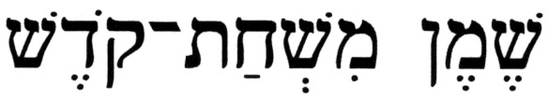(shemen mish'hat-qodesh)] a perfumed compound according to the art of the perfumer; it shall be an oil of sacred anointment [(shemen mish'hat-qodesh)]."

No other substance is acceptable for anointing and, being a holy substance, this anointing oil had to be stored in the (portable) Tabernacle while the Israelites were in the wilderness, and in the Temple in Jerusalem later on.

- 2. The ritual

Moses was commanded to anoint his brother Aaron as the first high priest:

Exodus 29:7 – And then you shall take the anointing oil, and pour [it] upon his head, and anoint him.

The Hebrew Bible contains several accounts of the anointing of royalty in Israel.

- a. King Saul
Saul was anointed as King of Israel when the prophet Samuel poured the special oil on his head:
1 Samuel 10:1 - And Samuel took the vial of oil, and poured it on his [Saul's] head, and kissed him. And he [Samuel] said, "Indeed, the L-rd has anointed you to be a ruler over His inheritance."

- b. King David
David, the son of Jesse, was anointed as King of Israel when the prophet Samuel poured the special oil on his head:
1 Samuel 16:13 - And Samuel took the horn of oil, and anointed him [David] in the midst of his brothers. And a spirit of the L-rd passed over David from that day forth, and Samuel arose and went to Ramah.

- c. King Solomon
This is who anointed Solomon to be King of Israel, and how it was done:
1 Kings 1:34,39,45 - (34) And Zadok the [high] priest and Nathan the prophet shall anoint him [Solomon] there as king over Israel, and blow the horn and say, "[Long] live King Solomon."
(39) And Zadok the [High] Priest took the horn of oil from the Tabernacle [the Sanctuary] and anointed Solomon, and they blew the shofar [ram's horn], and all the people said, "Long live king Solomon."
(45) And Zadok the [high] priest and Nathan the prophet anointed him [Solomon] king in Gihon, and they came up from there rejoicing, and (therefore) the city was in an uproar; that is the noise you were hearing.

- A template for the anointing of kings

The Biblical accounts of the anointing of the first three kings of Israel, Saul, David, and Solomon, contain the necessary elements for the construction of a template for the process of anointing royalty of Israel, one of which will be the promised Jewish Messiah. According to the Hebrew Bible, these elements are:

    - [1] A special preparation from pure olive oil was used as the oil of anointing.

    - [2] Being sacred, the anointing oil was stored in the Temple.

    - [3] A universally recognized prophet performed the ritual of anointing a king.

    - [4] The prophets used the vial of oil, or the horn of oil, to anoint the new king, not merely a vial of oil or a horn of oil.[1]

    - [5] The oil of anointing was poured only on the head.

    - [6] Anointing was tantamount to crowning a king (or appointing a high priest).[2]

- I. Anointing According to the New Testament

This template for the anointing process can now be used to test the validity of the anointing of Jesus, as deduced from the accounts in the New Testament.

- The process of anointing

  - 1. The substance

The four Gospel authors describe the substance used on Jesus as follows:

Matthew 26:7-9(KJV) – (7) There came unto him a woman having an alabaster box of very precious ointment, and poured it on his head, as he sat at meat. (8) But when his disciples saw it, they had indignation, saying, To what purpose is this waste? (9) For this ointment might have been sold for much, and given to the poor.

Mark 14:3-5(KJV) – (3) And being in Bethany in the house of Simon the leper, as he sat at meat, there came a woman having an alabaster box of ointment of spikenard very precious; and she brake the box, and poured it on his head. (4) And there were some that had indignation within themselves, and said, Why was this waste of the ointment made? (5) For it might have been sold for more than three hundred pence, and have been given to the poor. And they murmured against her.

Luke 7:37(KJV) - And, behold, a woman in the city, which was a sinner, when she knew that Jesus sat at meat in the Pharisee's house, brought an alabaster box of ointment,

John 12:3-5(KJV) – (3) Then took Mary a pound of ointment of spikenard, very costly, and anointed the feet of Jesus, and wiped his feet with her hair: and the house was filled with the odour of the ointment. (4) Then saith one of his disciples, Judas Iscariot, Simon's son, which should betray him, (5) Why was not this ointment sold for three hundred pence, and given to the poor?

- 1. The ritual

All four Gospel authors describe the manner in which Jesus was anointed:

Matthew 26:7(KJV) - There came unto him a woman having an alabaster box of very precious ointment, and poured it on his head, as he sat at meat.

Mark 14:3(KJV) - And being in Bethany in the house of Simon the leper, as he sat at meat, there came a woman having an alabaster box of ointment of spikenard very precious; and she brake the box, and poured it on his head.

Luke 7:37-38,46(KJV) – (37) And, behold, a woman in the city, which was a sinner, when she knew that Jesus sat at meat in the Pharisee's house, brought an alabaster box of ointment, (38) And stood at his feet behind him weeping, and began to wash his feet with tears, and did wipe them with the hairs of her head, and kissed his feet, and anointed them with the ointment.
(46) My head with oil thou didst not anoint: but this woman hath anointed my feet with ointment.

John 11:2(KJV) - (It was that Mary which anointed the Lord with ointment, and wiped his feet with her hair, whose brother Lazarus was sick.)

John 12:3(KJV) - Then took Mary a pound of ointment of spikenard, very costly, and anointed the feet of Jesus, and wiped his feet with her hair: and the house was filled with the odour of the ointment.

Moreover, Jesus himself allegedly states the purpose of his anointing:

Matthew 26:12(KJV) - For in that she hath poured this ointment on my body, she did it for my burial.

Mark 14:8(KJV) - She hath done what she could: she is come aforehand to anoint my body to the burying.

- Elements of the ritual of anointing Jesus

The accounts quoted from the Gospels contain the elements of the process that was described as the anointing of Jesus, and these are listed in the order of the elements in the template for the anointing process developed above:

- [1] The substance used to anoint Jesus was an ointment of spikenard.[3]

- [1] It is unknown from where the costly ointment of spikenard came. It clearly was not a sacred substance, since people complained about having wasted it by pouring it on Jesus rather than selling it and giving the money to the poor.

- [2] Jesus was anointed by a woman (Mary of Bethany, described as a sinner).

- [3] The ointment used on Jesus was contained in an alabaster box.[4]

- [4] There are conflicting accounts in the New Testament about where on his body the anointing substance was applied to Jesus. The accounts in the Gospels of Matthew and Mark say it was applied to his head; while the accounts in the Gospels of Luke and John state it was applied to his feet only.

- [5] Jesus declared that his anointing was a preparation for burial, i.e., for death, and not for kingship.[5]

- II. The Anointing of Jesus Contrasted with the Requirements in the Hebrew Bible

Table VII-1 contains an element-by-element comparison of the components of the anointing process in the template against the accounts described in the Gospels. For each element, a yes/no score indicates whether the respective component from the Gospel accounts meets the specification set forth in the Hebrew Bible.

Table VII-1 – Hebrew Bible specifications versus New Testament accounts of anointing

Item | Hebrew Bible Specifications | According to the  New Testament | Comments | Valid?
[1] | The oil of anointing was a special mixture of spices and pure olive oil. | The substance used to anoint Jesus was an ointment of spikenard. | Ointment of spikenard, no matter how costly, cannot substitute for the sacred special oil. | NO
[2] | Being sacred, the oil of anointing had to be stored in the Temple. | The spikenard was not sacred, and its source is unknown. | Sacred items were kept in the Temple, and were not offered for sale. | NO
[3] | A recognized prophet had to anoint a king. | A woman named Mary anointed Jesus. | Did a recognized prophet anoint Jesus? | NO
[4] | A special vial, or special horn, of the special anointing oil had to be used in anointing a king. | The spikenard ointment used on Jesus came from an alabaster box. | The Hebrew Bible never speaks of alabaster containers used for holding the oil of anointing. | NO
[5] | The oil of anointing was poured on the head only. | 2 accounts - head only;  2 accounts - feet only. | Which version of the account is the true one? | NO
[6] | The anointing was a preparation for kingship (or high priesthood). | Jesus declared his anointing was to prepare him for burial. | Jesus never reigned as the monarch over any kingdom. | NO

This comparison demonstrates that the anointing of Jesus, as described in the New Testament, violates all the specifications for a valid anointing of royalty in Israel as provided in the Hebrew Bible.

Conclusion: Jesus was smeared with ointment and not properly anointed and,
for that reason alone, he was a false Messiah.

- III. Summary

Two important and interconnected issues were addressed. The first question concerned the Hebrew noun as it appears in Daniel 9:25-26:

- ¤ What is the correct translation of the Hebrew noun , which appears twice in the passage Daniel 9:25-26?

According to most Christian translations, the term points to Jesus either by being translated as [the] Messiah or the Anointed One. A word study on all 39 occurrences in the Hebrew Bible of the noun in its various forms demonstrated that the correct translation is an anointed one, a "generic" reference to two different individuals who were to appear on the scene at some future time, neither of whom had any connection to the Jewish Messiah.

The question concerned the validity of the "anointing" of Jesus, which arose from the translation of the term in some Christian Bibles as the Anointed One:

- ¤ Did the "anointing" of Jesus, as described in the New Testament, conform to the specifications given in the Hebrew Bible?

To help determine the validity of the "anointing" process which the accounts in the New Testament describe, a template for the anointing process of kings and high priests of Israel was constructed from the specifications detailed in the Hebrew Bible. The relevant elements of information were then extracted from the accounts in the New Testament which describe the "anointing" of Jesus, and these were compared, on an element-by-element basis against the template. The analysis demonstrated that Jesus was not anointed according to the specifications described in the Hebrew Bible.

Therefore, since Jesus was never properly anointed according to the specifications contained in the Hebrew Bible, the Scripture in force during his lifetime, neither of the two applications of the term in Daniel 9:25-26 can possibly point to him.

Source: www.messiahtruth.com/anointed.html

Feel free to contact me at b_zawadi@hotmail.com

Return to Refuting Alleged Old Testament Prophecies Pointing to Jesus

Return to Homepage

[1] King David and his royal descendants were anointed with the sacred oil poured from the horn. According to the Jewish Sages, this indicated the superiority of the Davidic kings over the non-Davidic kings of Israel (e.g., Saul), who were anointed using the vial.
[2] Saul, David, and Solomon all sat on the throne as kings soon after being anointed. They successfully fought those nations that were enemies of Israel. They commanded entire governments, complete with soldiers, spies, tax collectors, foreign ambassadors, treasuries, palace servants and courts.
[3] The American Heritage Dictionary (Second College Edition, Houghton Mifflin Company, Publishers [1991]), describes spikenard as: "1. An aromatic plant, Nardostachys jatamansi, of India, having rose-purple flowers. 2. A costly ointment of antiquity, probably prepared from the spikenard."
[4] The authors of the New Testament refer to Jesus as the "son of David", implying that he is from the royal line of King David: Matthew 1:1(KJV) - The book of the generation of Jesus Christ, the son of David, the son of Abraham. If, as claimed in the New Testament, Jesus were a bona fide king of the Davidic dynasty, why was the anointing substance taken from an alabaster box and not from that special vessel called the horn?
[5] The New Testament is silent on whether Jesus sat on the throne of David during his lifetime, and whether he led a Jewish army in any battles against Israel's enemies and defeated them. Likewise, there is no mention in the New Testament of Jesus being in command of an entire political government.

