Isaiah 9:5-6 – Historic Events or Messianic Prophecy?

by

Messiah truth

I. Introduction

The passage Isaiah 9:5-6[1] is an important "proof-text" in the portfolio of Christian apologists and missionaries, one that is claimed to foretell the advent of the Christian Messiah, Jesus.

A detailed study and analysis of the Hebrew text of Isaiah 9:5-6 within its proper context, and using other relevant passages found elsewhere in the Hebrew Bible, demonstrates how this passage describes historic events that occurred during the era in which these words were spoken by Isaiah, and is not messianic prophecy.

II. Review and Comparison of English Translations of Is 9:5-6[6-7]

Table II-1 shows the Hebrew text and side-by-side English renditions of the passage Isaiah 9:5-6[6-7]; the King James Version (KJV) translation in the left column and a Jewish translation in the middle column next to the Hebrew text. The KJV rendition also points to cross-referenced passages in the New Testament, references that were taken from the New American Standard Bible (NASB).

Table II-1 – Isaiah 9:5-6[6-7]

King James Version Translation |  | Jewish Translation from  the Hebrew |  | Hebrew Text
Isaiah 9 |  |  |  | 
6 | For unto us a child is born,⁽¹⁾ unto us a son is given:⁽²⁾ and the government shall be upon his shoulder:⁽³⁾ and his name shall be called Wonderful, Counsellor, The mighty God, The everlasting Father, The Prince of Peace. | 5 | For a child has been born to us, a son has been given to us, and the authority was placed upon his shoulder, and [he] called his name: Wondrous Adviser, Mighty G-d [or, Mighty Hero], Eternal Patron, Ruler of Peace; | 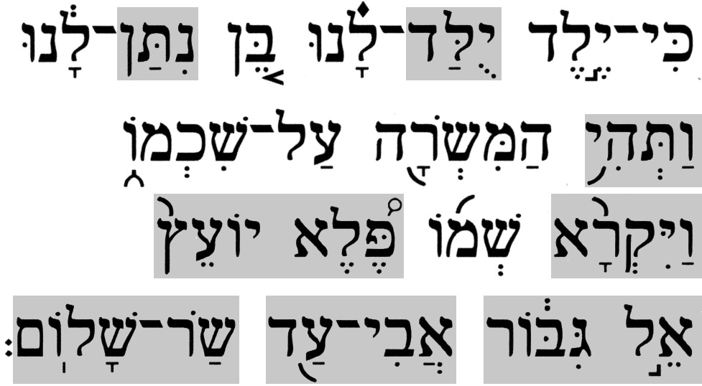 | 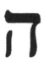
7 | Of the increase of [his] government and peace there shall be no end,⁽⁴⁾ upon the throne of David, and upon his kingdom, to order it, and to establish it with judgment and with justice from henceforth even for ever. The zeal of the LORD of hosts will perform this. | 6 | for the increase of the authority and for peace without end, on David's throne and on his kingdom, to establish it and to support it with justice and with righteousness; from now and to eternity, the zeal of the L-rd of Hosts shall accomplish this. | 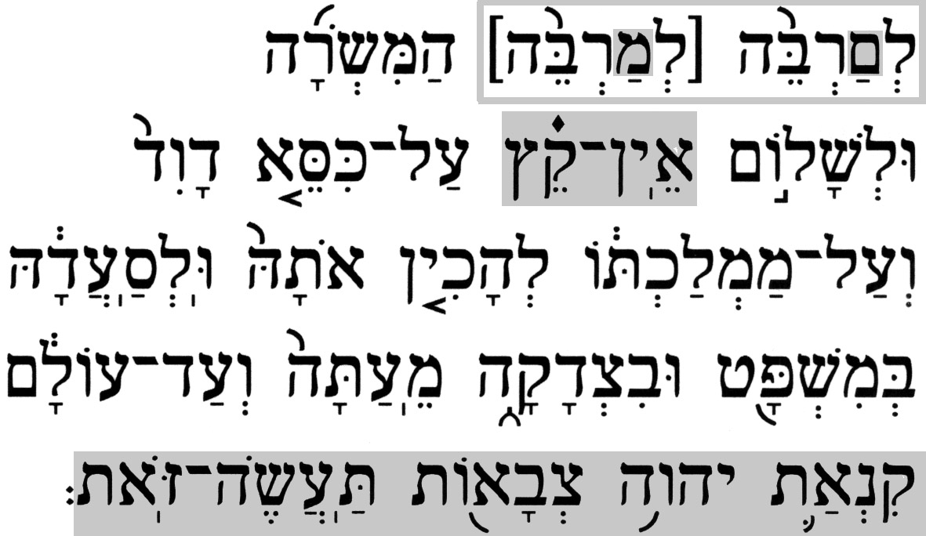 | 
(1) Luke 2:11(KJV) – For unto you is born this day in the city of David a Saviour, which is
Christ the Lord.
(2) John 3:16(KJV) - For God so loved the world, that he gave his only begotten Son, that
whosoever believeth in him should not perish, but have everlasting life.
(3) Matthew 28:18(KJV) – And Jesus came and spake unto them, saying, All power is given
unto me in heaven and in earth.
1 Corinthians 15:25(KJV) - For he must reign, till he hath put all enemies under his feet.
(4) Luke 1:32-33(KJV) – (32) He shall be great, and shall be called the Son of the Highest:
and the Lord God shall give unto him the throne of his father David:
(33) And he shall reign over the house of Jacob for ever; and of his
kingdom there shall be no end.

The most significant differences in the two translations are found in the first verse, Isaiah 9:5[6]. One such difference is that the Hebrew text, as reflected in the Jewish translation, uses verbs that are conjugated in the past tense, and which describe a sequence of events that has already occurred, while the KJV translation uses the present and future tenses, thereby describing events that are contemporary and also still to come. The other important difference between the two renditions of the first verse is in the various names/titles ascribed to this child. The Jewish translation lists four, none of which is modified with a definite article the (as in the Hebrew text). The Christian translation lists five, the first two of which are split out of the first Hebrew one and are without a definite article, and each of the last three has a definite article attached, and it is capitalized in all three cases.

With the exception of a subtle difference in the respective renditions of the second verse, Isaiah 9:6[7], other differences are, in general, insignificant with respect to the context of the passage; they are reasonable variations in translation due to the fact that Hebrew and English/Greek belong to different language families. Both the Hebrew text and the Jewish translation of this verse capture the message – the explanation of the series of names/titles from the previous verse – in one sentence. Yet, the KJV translators start a new sentence with Isaiah 9:6[7], which removes the continuity from the previous verse, and then break this verse into two separate sentences, which results in an abstruse redirection of the focus in order to support their translation of the previous verse, as will be demonstrated later.

III. Overview of Christian and Jewish Interpretations of Is 9:5-6[6-7]

  - A. The Christian Interpretation

Only a summary of the Christian interpretation is provided here. More complete and detailed descriptions by well-known Christian commentators, such as Matthew Henry and Jamieson, Fausset & Brown, are outside the scope of this essay and may be found in other sources.

In the common Christian perspective, this passage is a messianic prophecy that foretells the birth of Jesus, his divinity, and his destined mission as the promised King/Messiah. Though the authors of the New Testament never explicitly cite any portion of these two verses, Christians will often point to the passages shown under Table II-1, which are hindsight references inserted by the translators, not by the authors, as evidence that the prophecy in Isaiah 9:5-6[6-7] was fulfilled.

B. The Jewish Interpretation

This, too, is only a summary of the Jewish interpretation. A detailed analysis and commentary will follow.

According to the Jewish perspective, Isaiah 9:5-6 is not a messianic prophecy. The correct context of this passage is that it describes events that had already taken place in Jewish history, namely, events concerning the birth of this child (believed to be Hezekiah, the son of King Ahaz), and a prophecy concerning his future as King of Judah. Hezekiah's role was to lift Judah from the degenerate conditions into which it had sunk, and he would lead the indestructible faithful "Remnant of Israel". This passage speaks of the wonders performed by G-d for Hezekiah as King of Judah, and in it, the Prophet expresses his praise of G-d for sparing Hezekiah and his kingdom from demise at the hands of Sannheriv, who besieged Jerusalem.

IV. Historic Events or Messianic Prophecy?

A comparison of the Christian and Jewish perspectives on Isaiah 9:5-6[6-7] shows that both cannot be valid simultaneously. The question is: “Which of the two interpretations is consistent with the Hebrew Bible (and the historical record)?”

A. Hebrew Linguistic Analysis

Significant differences exist between the Hebrew text of the passage and its rendition by the KJV.

- 1. Tenses

As was noted above, the Hebrew text of the opening phrases of Isaiah 9:5 utilizes verbs which are conjugated in the past tense, while the KJV translation of this verse, which is Isaiah 9:6 in Christian Bibles, utilizes a combination of present and future tenses in the corresponding phrases.

The first verb that appears in the verse is 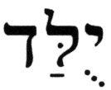 (yulad). This is a conjugation of the root verb 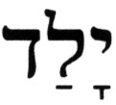 (yalad), [to] bear, in the 3rd-person, singular, masculine, past tense, in the pu'al stem, a passive verb construct, that gives it the meaning has been born or was born, depending on the context of the passage in which it appears. The KJV renders (yulad) at Isaiah 9:6 as is born, in the present tense, which conflicts with the Jewish translation. A simple word study, using other applications of this identical term in the Hebrew Bible, helps resolve this issue. Although it is, in general, preferable to study identical terminology as applied within a specific Book of the Hebrew Bible, this is not always possible. There are 15 identical instances (in terms of both spelling and vowel markings) of the term (yulad) in the Hebrew Bible, only one of which appears in the Book of Isaiah - at Isaiah 9:5. Of the remaining 14 instances, on seven occasions (Gen 10:21,25, 35:26, 46:22,27, 51:50; 1 Chron 1:19), the KJV correctly renders the term as were born, where the references are to more than one son (Biblical Hebrew does, at times, interchange singular with plural nouns and conjugated verbs). These cases will be excluded from the analysis since they concern a plurality and not a single subject, which leaves a sample of eight cases to be included in the analysis, which is shown in Table IV.A.1-1.

Table IV.A.1-1 – Analysis of the term (yulad)

Term | # | Pronunciation | Root | Reference | Jewish  Translation | KJV Rendition
 | 15 | yoo-LAD |  | Isaiah 9:5[6] | has been born | is born
 |  |  |  | Genesis 4:26 | was born | was born
 |  |  |  | 2 Samuel 21:20 | was born | was born
 |  |  |  | Jeremiah 20:15 | has been born | is born
 |  |  |  | Psalms 87:4 | was born | was born
 |  |  |  | Psalms 87:5 | was born | was born
 |  |  |  | Psalms 87:6 | was born | was born
 |  |  |  | Ruth 4:17 | has been born | is born

While the Jewish renditions cast all eight occurrences in some form of the past tense, the KJV renditions are inconsistent – in the past tense on five occasions, and in the present tense on three occasions (including Isaiah 9:6).

The next verb that appears in the verse is 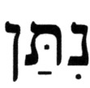 (nitan). This is a conjugation of the root verb 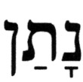 (natan), [to] give, in the 3rd-person, singular, masculine, past tense, in the niph'al stem, a passive verb construct, that gives it the meaning has been given or was given, depending on the context of the passage in which it appears. The KJV renders (nitan) at Isaiah 9:6 as is given, in the present tense, which conflicts with the Jewish translation. A simple word study, using other applications of this identical term in the Hebrew Bible, will help resolve this issue. As was noted above, it is best to remain within a given Book when doing a word study, though it is not always possible to do so. There are 14 identical instances of the term (nitan) in the Hebrew Bible, two of which appear in the Book of Isaiah - at Isaiah 9:5 and at Isaiah 35:2. Since a sample of two is inadequate, all 14 cases are included in the analysis, which is shown in Table IV.A.1-2.

Table IV.A.1-2 – Analysis of the term (nitan)

Term | # | Pronunciation | Root | Reference | Jewish  Translation | KJV Translation
 | 14 | nee-TAN |  | Isaiah 9:5[6] | has been given | is given
 |  |  |  | Isaiah 35:2 | has been given | shall be given
 |  |  |  | Leviticus 19:20 | had … been given | [was … ] given
 |  |  |  | Numbers 26:62 | was given | was given
 |  |  |  | Joshua 24:33 | was given | was given
 |  |  |  | Jeremiah 13:20 | was given | was given
 |  |  |  | Jeremiah 51:55 | was uttered | is uttered
 |  |  |  | Ezekiel 15:4 | were given | is cast
 |  |  |  | Ezekiel 16:34 | was … given | is … given
 |  |  |  | Ezekiel 32:25 | was given | is put
 |  |  |  | Ecclesiastes 10:6 | was set | is set
 |  |  |  | Esther 4:8 | was given | was given
 |  |  |  | Esther 6:8 | [was] placed | is set
 |  |  |  | 2 Chronicles 34:16 | was given | was committed

While the Jewish renditions cast all occurrences in some form of the past tense, the KJV renditions are inconsistent – in the past tense on six occasions, in the present tense on seven occasions (including Isaiah 9:6), and once in the future tense.

The next verb that appears in the verse is 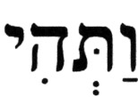 (va't^{e}hi). This term is a combination of the conjugated verb, 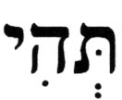 (t^{e}hi) and a special form,  (va-), of the preposition  (v^{e}-) [called 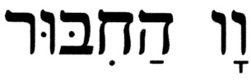 (vav-ha'khibur), the conjunctive-vav, which is the preposition and]. The verb (t^{e}hi) is a poetic form of the conjugation of the root verb 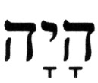 (haya), [to] be, in the 3rd-person, singular, feminine, future tense, in the pa'al/qal stem, an active verb construct, which translates as [it {fem.}] shall be. [Note: Since the Hebrew language has no neuter gender, all nouns are either masculine or feminine, and the neuter gender must be inferred from the context when translating]. Together with the preposition (v^{e}-), and, this would then be and [it {fem.}] shall be. However, as noted above, the preposition appears in a special form called in Hebrew 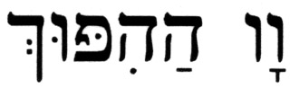 (vav-ha'hipuch), the conversive-vav, which, in addition to functioning as the preposition and, also reverses the tense of the verb it modifies. In other words, if the verb is in the past tense, it is changed to the future tense, and vice versa. Putting all this together, the verb (va't^{e}hi) translates as and [it {fem.}] was [placed], i.e., a verb conjugated in the 3rd-person, singular, feminine, past tense. The KJV renders (va't^{e}hi) in Isaiah 9:6 as [it] shall be [placed], in the future tense, which conflicts with the Jewish translation. There are 85 identical instances of (va't^{e}hi) in the Hebrew Bible, five of which appear in the Book of Isaiah - at Isaiah 5:25, 9:5, 23:3, 29:11,13. This sample of five cases is included in the analysis, which is shown in Table IV.A.1-3.

Table IV.A.1-3 – Analysis of the term (va't^{e}hi)

Term | # | Pronunciation | Root | Reference | Jewish  Translation | KJV  Translation
 | 5 | vah-t^{e}-HEE |  | Isaiah 9:5[6] | and … was [placed] | and … shall be [placed]
 |  |  |  | Isaiah 5:25 | and … were* | and … were
 |  |  |  | Isaiah 23:3 | and she became | and she is
 |  |  |  | Isaiah 29:11 | and … has been | and … is become**
 |  |  |  | Isaiah 29:13 | and … has been | and … is
* - The Hebrew is actually in the singular, which would literally translate as and [it] was…
** - The context here is clearly has become, i.e., it is something that has taken place.

While the Jewish renditions cast all of the occurrences in some form of the past tense, the KJV renditions are inconsistent – twice in the past tense, twice in the present tense, and once in the future tense, at Isaiah 9:6.

The last verb that appears in the verse is 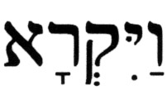 (va'yiqra). As in the previous case, this term, too, is a combination of the conjugated verb 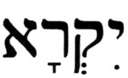 (yiqra) and the special preposition (va-), the conversive-vav [(vav-ha'hipuch)], the net effect of which is the addition of the preposition and to the verb of the same conjugation but with a reversed tense. The verb (yiqra) is the conjugation of the root verb 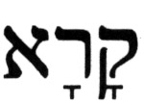 (qara), [to] call, in the 3rd-person, singular, masculine, future tense, in the pa'al/qal stem, an active verb construct, which translates as [he] shall call. Thus, the combination (va'yiqra) translates as and [he] called, where the future tense has been reversed to the past tense. The KJV renders (va'yiqra) in Isaiah 9:6 as shall be called, in the future tense, and in a passive form, which conflicts with the Jewish translation. There are 205 identical instances of (va'yiqra) in the Hebrew Bible, four of which appear in the Book of Isaiah – at Isaiah 9:5, 21:8, 22:12, 36:13. This sample of four cases is included in the analysis, which is shown in Table IV.A.1-4.

Table IV.A.1-4 – Analysis of the term (va'yiqra)

Term | # | Pronunciation | Root | Reference | Jewish  Translation | KJV  Translation
 | 4 | vah-yiq-RAH |  | Isaiah 9:5[6] | and [he] called | and … shall be called
 |  |  |  | Isaiah 21:8 | and … called | and he cried
 |  |  |  | Isaiah 22:12 | and … called | and … did call
 |  |  |  | Isaiah 36:13 | and [he] called | and cried

While the Jewish renditions cast all of the occurrences in some form of the past tense, the KJV renditions are inconsistent – in the past tense on three occasions, and once in the future tense. at Isaiah 9:6.

In summary, the results of the above group of analyses on the tenses in Isaiah 9:5[6] demonstrate the consistency of the Jewish translations and the inconsistency of the KJV renditions. This passage, Isaiah 9:5-6[6-7], appears to have appealed to the Church as a good candidate for imputing Christological significance, since all that was required to accomplish this was some adjustments to the tenses. This action changed the historical context (past tense) into a current and prophetic context (present and future tenses).

Sidebar Note: Some Christian apologists and missionaries attempt to justify the present tense translations commonly found in Christian Bibles by pointing to a respected Jewish translation, the Soncino Press translation of the Hebrew Bible, in which Isaiah 9:5 is translated as:

Isaiah 9:5(Soncino) – For a child is born unto us, A son is given unto us; And the government is upon his shoulder; And his name is called Pele-joez-el-gibbor-Abi-ad-sar-shalom;

They use this particular translation as evidence that refutes the consensus about the verbs being conjugated in the past tense. What these Christian apologists and missionaries leave out of their so-called evidence are the notes on this verse by the Soncino translators. Here is the relevant portion of these notes, as quoted from the Soncino Press translation of Isaiah[2]:

5. a child. The verse has been given a Christological interpretation by the Church, but modern non-Jewish exegetes agree that a contemporary person is intended. The Talmud and later Jewish commentators understood the allusion to be the son of Ahaz, viz. Hezekiah.

is born . . . is given. Better, in agreement with the Hebrew, 'has been born . . . has been given.'

The Soncino translators, being well aware of what Christian translators have done to this passage, specifically address this in the notes by pointing out that the past tense conjugation, not the present tense conjugation, was in better agreement with the Hebrew. Clearly, this missionary claim is without merit.

- 2. Names/Titles

The last verb in Isaiah 9:5[6] is followed by a series of names/titles. These names/titles are actually components of an expression which, in its totality, may be viewed as a long name/title that refers to someone. Apparently, this set of names/titles appealed to the KJV translators as an easy target for editing to support the Christological message that was being developed for this passage.

The first name/title is 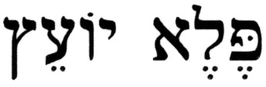 (pele yo'etz), Wondrous Adviser, and it appears in the Hebrew Bible only once, here in Isaiah 9:5, which preempts the ability to do a comparative analysis as was done for the verbs. In the KJV rendition, this name/title is separated into two entities – Wonderful and Counsellor. Although a comparative analysis here is precluded, as explained, the rules of Hebrew grammar still apply. According to the rules of Hebrew grammar, this split may not be done. While the two terms can stand on their own as nouns, they take on different meanings as such. The term 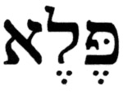 (pele) means a wonder or a marvel, as may be seen in its only two occurrences, in singular form, in the Book of Isaiah – at Isaiah 25:1 as (pele), a wonder, and at Isaiah 29:14 as 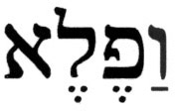 (va'phele), and a wonder. The noun 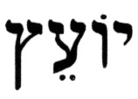 (yo'etz) means an adviser or a counselor, as may be seen from its two occurrences, in singular form, in the Book of Isaiah – at Isaiah 3:3 as 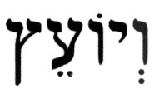 (v^{e}yo'etz), and an adviser or and a counselor, and at Isaiah 41:28 as (yo'etz), a counselor. This information and the respective renditions in the KJV are shown in Table IV.A.2-1 .

Table IV.A.2-1 – The name/title (pele yo'etz) and its components and

Term | # | Pronunciation | Reference | Jewish  Translation | KJV  Translation
 | 1 | PEH-leh yo-ETZ | Isaiah 9:5[6] | Wondrous Adviser | Wonderful, Counsellor
 | 1 | PEH-leh | Isaiah 25:1 | wonders* | wonderful things
 | 1 | va-FEH-leh | Isaiah 29:14 | and a wonder | and a wonder
 | 1 | yo-ETZ | Isaiah 41:28 | … counselor | … counsellor
 | 1 | v^{e}-yo-ETZ | Isaiah 3:3 | and counselor | and the counsellor
* - The Hebrew is actually in the singular, which literally translates as a wonder, but the
plural is clearly implied here – a rather common occurrence in the Hebrew Bible.

Considering the factual evidence from Hebrew grammar, the rendition by the KJV of (pele yo'etz) as two separate names/titles cannot be correct.

The next name/title is 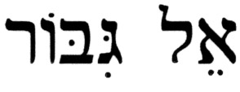 (el gibbor). This expression appears three times in the Hebrew Bible. Two of these cases are in the singular form, and are found in the Book of Isaiah – at Isaiah 9:5, 10:21. The third instance is found at Ezekiel 32:21, where it appears in the plural form, 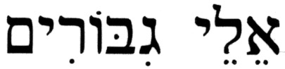 (elei gibborim).

The components of this name/title are  (el) and 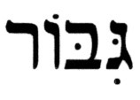 (gibbor). The term (el) is common in the Hebrew Bible, and it has three applications. The most frequent use of this term is in reference to G-d (e.g. Exod 34:6). Another application is in reference to other gods, i.e., idols (e.g., Exod 34:14). The third use of this term is to identify someone strong or mighty (e.g., Ezek 17:13; Ps 29:1), or even something powerful (e.g., Ps 90:11). The term (gibbor) is commonly used in the Hebrew Bible to identify someone who is mighty, brave, a hero (e.g., Gen 10:9; Zech 9:13).

The combined expression, (el gibbor), can have different meanings, depending on the context of the surrounding passage. (el gibbor) can mean mighty hero, when the context speaks of a person, or it can mean Mighty G-d, when the context refers to G-d. The KJV renders (el gibbor) as The mighty God at Isaiah 9:6, and as the mighty God at Isaiah 10:21. Most Jewish translations render these as Mighty G-d and the mighty G-d, respectively. The comparison shown in Table IV.A.2-2, which also includes a valid alternate translation.

Table IV.A.2-2 – The name/title (el gibbor)

Term | # | Pronunciation | Reference | Common Jewish Translation | KJV  Translation | Alternate Jewish  Translation
 | 2 | EL gih-BOR | Isaiah 9:5[6] | Mighty G-d | The mighty God | Mighty Hero
 |  |  | Isaiah 10:21 | [to the] Mighty G-d | the mighty God | [to the] mighty hero
 | 1 | e-LEI gih-bo-RIM | Ezekiel 32:21 | The strongest of the mighty men | The strong among the mighty | The mightiest of heroes

Though the KJV renditions appear to be consistent with the common Jewish translations, they differ in terms of the definite article the, which is capitalized at Isaiah 9:6 and in lower case at Isaiah 10:21. Also, the definite article  (ha), the, is not present in the Hebrew name//title (el gibbor) at Isaiah 9:5. The same is true for Isaiah 10:21, except that, in this case, due to the presence of the preposition  (el-), to, and the context of the passage, the definite article (ha), the, is implicit; both translations agree on this. The alternate translation has been added to Table IV.A.2-2 because it is both valid within the context of each passage and helpful in identifying of whom Isaiah might be speaking here. This will be further explored later on.

The next name/title is 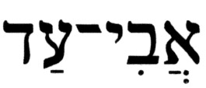 (avi-ad), and it appears in the Hebrew Bible only once, here in Isaiah 9:5. Consequently, no comparisons are possible, though some analysis will shed light on how to correctly understand it. This name/title is a compound term, in the possessive form, which is made up of two components. The first component, 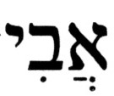 (avi), is the possessive form of the noun  (av). The Hebrew noun (av) appears in the Hebrew Bible 723 times, and in several different contexts. The predominant application of this term is a father. However, the (singular) noun is also applied as: (a) a grandfather (e.g., Gen 31:42, 32:10); (b) a progenitor of a line of descendants (e.g., Gen 17:4, Is 51:2); (c) one who is the first of a kind or an inventor (e.g., Gen 4:20,21); (d) an advisor, a counselor, a patron (e.g., Gen 45:8, Job 29:16); (e) a founder (e.g., Josh 17:1, 1 Chron 2:50). In addition, the term is used as a form of address to a prophet, a king, etc. (e.g., 1 Sam 24:12, 2 Kgs 5:13), and in the plural it has additional applications in the Hebrew Bible; however, neither of these applications are significant to Isaiah 9:5[6]. Consequently, according to the various applications given above, the first component of this name/title, (avi) can have meanings such as, father of…, or grandfather of…, or progenitor of…, etc.

The second component of this name/title is  (ad), and it is used in Hebrew as either a preposition, such as by (a certain time); to, up-to; till, until, and as a noun, eternity, when in combinations with other terms.

What is the correct application in Isaiah 9:5[6]? The Hebrew concordance[3] lists (avi-ad) as one of the 22 cases in which the application of the noun (av) falls under category (d) above, an advisor, a counselor, a patron. Therefore, the literal translation of (avi-ad) would be advisor of eternity, or counselor of eternity, or patron of eternity. In terms of the passage and its context, perhaps the most appropriate translation of this name/title (avi-ad) is Eternal Patron. Most Jewish translations render it Everlasting Father, and the KJV renders it The everlasting Father. This is shown in Table IV.A.2-3

Table IV.A.2-3 – The name/title (avi-ad)

Term | # | Pronunciation | Reference | Jewish  Translation | KJV  Translation
 | 1 | ah-VEE AD | Isaiah 9:5[6] | Eternal Patron | The everlasting Father

The definite article, The, and the noun, Father, are capitalized in the KJV in order to enhance the Christological message, yet, the definite article (ha), the, is absent from the Hebrew name//title (avi-ad).

The last name/title is 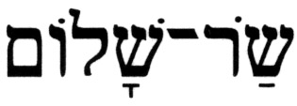 (sar shalom), and it appears in the Hebrew Bible only once, here in Isaiah 9:5. Consequently, as was the case with the previous name/title, no comparisons are possible. Once again, linguistic analysis will help shed light on how to correctly understand it. This name/title is a compound term, in a possessive form, that consists of two components. The first component,  (sar), though part of a possessive construct, is identical to the noun that is applied in the Hebrew Bible 421 times, in various conjugations, and which means a government official (e.g., a ruler, or a minister, or a nobleman, etc.). Although (sar) is often rendered a prince even in Jewish translations, it should be noted that there is no application of this term in the Hebrew Bible to describe someone who is a real prince. In the possessive form, then, (sar) would mean commander of…, or ruler of…, or minister of…, etc.

The second component of this name/title is 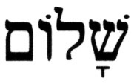 (shalom), which has 237 applications in the Hebrew Bible. The predominant usage of this word is in the meaning of peace, as in serenity, or tranquility, or security (from danger, etc.), and also as in good relations among people and between nations, the opposite of conflict or war (e.g., Is 39:8, Eccl 3:8). Two additional rather infrequent applications are: status, or condition (e.g., Gen 37:14, Is 54:13), and how is…? (a form of inquiry about the welfare of someone; e.g., Gen 29:6, 2 Sam 18:32). Clearly, the application of (shalom) in Isaiah 9:5 is peace. Therefore, the proper translation of the name/title (sar shalom) is Ruler of Peace. The KJV renders it as The Prince of Peace. This is shown in Table IV.A.2-4.

Table IV.A.2-4 – The name/title (sar-shalom)

Term | # | Pronunciation | Reference | Jewish  Translation | KJV  Translation
 | 1 | SAR sha-LOM | Isaiah 9:5[6] | Ruler of Peace | The Prince of Peace

As was the case with the previous two names/titles, the definite article, The, and the expression, Prince of Peace, are capitalized in the KJV in order to enhance the Christological message, yet the definite article (ha), the, is not present in the Hebrew name//title (sar shalom).

In summary, the KJV renditions of these names/titles in Isaiah 9:5[6] appear to contain a bias, one that reinforces the motivation for the editing of the tenses. Namely, it points at a certain personality of particular importance to Christianity, Jesus, who is allegedly foretold to be coming at a future time. There is also an interesting point to ponder about attributing the name/title (avi-ad), which the KJV renders as The everlasting Father, to Jesus. According to the New Testament and, therefore, in Christianity, Jesus is the only begotten Son of G-d, which naturally means that G-d is The Father. How, then, can The everlasting Father also be a reference to The Son?

- 3. Other

As noted above, there is a somewhat more subtle difference in the respective renditions of Isaiah 9:6[7]. This subtlety goes hand-in-hand with the changes made in the previous verse, aimed at shifting the focus of this verse. Namely, attention is diverted from an individual the Prophet had in mind in Isaiah 9:5[6], the one who will eventually become a righteous and successful King of Judah sitting on the throne of David, to the lord and savior of Christianity, the one who is considered to be a deity.

As a direct continuation from the previous verse, the Hebrew text of Isaiah 9:6 and its Jewish rendition in English start out with the explanation of that rather lengthy and complex name/title given to the child. The text indicates that G-d will help create these conditions for the child being spoken of in Isaiah 9:5[6] – the future king in the line of King David.

If Isaiah 9:5[6] were about G-d, then the statement, "for the increase of the authority and for peace without end, on David's throne and on his kingdom", in Isaiah 9:6[7] would be tantamount to placing G-d "in a box", i.e., this would be equivalent to severely restricting G-d. This phrase describes the reign of a successful king, such as King Solomon whose reign was described in similar terms:

1 Kings 2:12 - And Solomon sat on the throne of David his father; and his kingdom was firmly established.

Isaiah's vision of G-d, found just three chapters before the passage Isaiah 9:5-6[6-7], is in sharp contrast to that of a mortal monarch:

Isaiah 6:1 - In the year of the death of King Uzziah, I also saw the L-rd sitting upon a high and exalted throne; and His lower extremities filled the Temple.

If, as is written, that child in Isaiah 9:5[6] eventually became the ruler only of David's kingdom and nothing more, would it not be presumptuous to attribute divinity to someone whose rule did not exceed that of flesh and blood?

Finally, there is the term 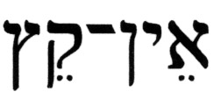 (ein-qeitz). This expression can function both as an adjective that means without end, or endless, and as a descriptive phrase such as there is no end, or is without end, depending on the context. This same term appears three times in the Hebrew Bible – at Isaiah 9:5, Ecclesiastes 4:16, 12:12, and twice in combined form with the preposition (v^{e}-), and, as 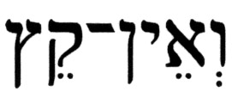 (v^{e}ein qeitz), and without end – at Job 22:5, Ecclesiastes 4:8. These cases are shown in Table IV.A.3-1.

Table IV.A.3-1 – The terms (ein-qetz) and (v^{e}ein qetz)

Term | # | Pronunciation | Reference | Correct Translation | KJV Rendition
 | 3 | AYN QEITZ | Isaiah 9:5[6] | without end | there shall be no end
 |  |  | Ecclesiastes 4:16 | there is no end | there is no end
 |  |  | Ecclesiastes 12:12 | is without end | there is no end
 | 2 | v^{e}-AYN QEITZ | Job 22:5 | and are not … without end | and are not … infinite
 |  |  | Ecclesiastes 4:8 | and there is no end | is there no end

It is interesting to note that the KJV renders the expression in Isaiah 9:6[7] as a phrase in the future tense, while in all other instances the phrase is cast in the present tense. This, too, appears to be part of the effort to continue the message being conveyed by the KJV translation of the previous verse.

- What's In A Name?

When reading the KJV rendition, which typifies most other Christian translations of this passage, it appears that the name is being emphasized and misapplied. The way the accolades in the first of the two verses are rendered, "… Wonderful, Counsellor, The mighty God, The everlasting Father, The Prince of Peace …", leaves one with the impression that the subject here is G-d, His substance, and who He is. This is quite impossible in the Jewish perspective, since no true prophet of Israel or any true Israelite would ascribe terms such as The mighty God or The Everlasting Father to a person. Moreover, it is documented in the Hebrew Bible that significant names of children of prophets never describe the child. Rather, such names carried with them messages for the people, as is the case with Isaiah's sons, 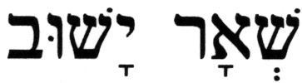 (she'ar Yashuv), a remnant shall return, 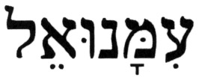 (immanu'el) is G-d is with us, and 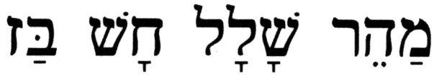 (maher-shalal-khash-baz), quicken-booty hasten-plunder, and with Hosea's children, 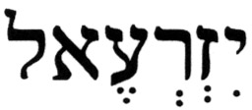 (yizr^{e}'el), G-d will sow, 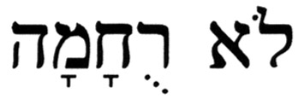 (lo-rukhammah), [She Was] Not Pitied, and 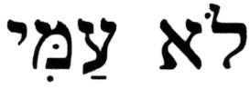 (lo-ammi), [You Are] Not My People.

The predominant view among Jewish Sages is that (pele yo'etz), Wondrous Adviser, (el gibbor), Mighty G-d/Mighty Hero, (avi-ad), Eternal Patron/Father, all refer to G-d, and that (sar shalom), Ruler of Peace is the symbolic name/title of the child. A notable exception is Abraham Ibn Ezra, the well-known 12th century C.E. Jewish-Spanish exegete, grammarian, and philosopher, who relates these attributes to events and situations that took place during Hezekiah's life (see below). However, there is unanimous agreement among the Jewish Sages that, in the original Hebrew text, Isaiah 9:5[6] is saying that some individual, a certain special person, would embody all these attributes, perhaps as a sign or symbolic reminder to Israel of the message the nation embodies.

This is how the passage can be associated with King Hezekiah, the righteous King of Judah, who was born nine years prior to the ascension of his wicked father, King Ahaz, to the throne of David. Hezekiah indeed assumed the authority or dominion of G-d, and he bent his shoulder to bear the yoke of Torah, the burden of the Holy One of Israel. The attributes listed in this passage as components of the long name this child was given, characterize some of G-d’s actions relating to Hezekiah, King of Judah: Wondrous refers to wonders G-d performed in his day, such as the wonder of the sun going backwards when Hezekiah was miraculously cured of his illness (Is 38:8). in fact, Hezekiah's recovery, in itself, was considered a wonder. The root verb from which the noun (yo'etz), an adviser, derives, 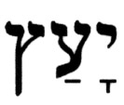 (ya'atz), [to] counsel, is used when Hezekiah decided to celebrate the Passover in Jerusalem and invite the people of the Northern Kingdom to join in the celebration:

2 Chronicles 30:2 - And the king took counsel [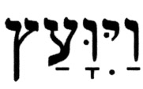(va'yiva'etz)] with his officers and the entire congregation in Jerusalem, to celebrate the Passover in the second month.

As the siege of Jerusalem by Sannheriv drew near, the text describes how Hezekiah and his staff came up with a plan of defense:

2 Chronicles 32:3 - And he [Hezekiah] took counsel (va'yiva'etz) with his officers and his mighty men to stop up the waters of the fountains that were outside the city, and they assisted him.

And Hezekiah gave the following counsel of assurance to his people:

2 Chronicles 30:8 – "With him [Sannheriv] is an arm of flesh; and with us is the L-rd our G-d to help us and to fight our wars." And the people relied on the words of Hezekiah, king of Judah.

Does the expression, "… and with us is the L-rd …", used in the above passage sound familiar? The Hebrew text of this expression is 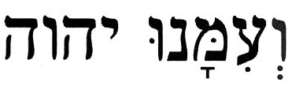 (v^{e}immanu YHVH). When the Tetragrammaton YHVH is replaced by another common title of G-d's, (El), the Hebrew expression would read 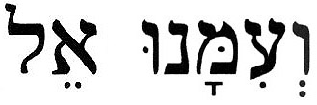 (v^{e}immanu El), an expression similar to that found in Isaiah 7:14, 8:8,10, during the siege of Jerusalem by the armies of the Northern Kingdom of Israel and Syria, from which the Kingdom of Judah was miraculously saved. G-d’s plan for Hezekiah against Sannheriv was successful.

(el gibbor), Mighty Hero, because even though Sannheriv approached Hezekiah with a large army, Hezekiah did not surrender in defeat. Instead, he defied Sannheriv's threats and blasphemy, and he (and Isaiah) prayed for G-d's intervention and help, and G-d’s mighty hand destroyed the threat:

2 Chronicles 32:20-22 – (20) And King Hezekiah and the Prophet, Isaiah the son of Amoz, prayed concerning this, and they cried out to Heaven. (21) And the L-rd sent an angel, and he destroyed every mighty warrior and commander and officer in the camp of the king of Assyria, and he [Sannheriv] returned in shame to his land, and he entered the temple of his god, and some of his own offspring felled him there with the sword. (22) And the L-rd saved Hezekiah and the inhabitants of Jerusalem from the hand of Sannheriv, the king of Assyria, and from the hand of all others, and guided them on every side.

(avi-ad), Eternal Patron, because of Hezekiah’s merit the Davidic dynasty was prolonged, and has been preserved for the future. King Hezekiah was one of the most extraordinary personalities among the Jewish kings, about whom the Sages said that he was worthy to be the Messiah.

- A Historical Perspective

The ninth chapter in the Book of Isaiah deals with the crisis that existed in the Kingdom of Judah during a time when the Assyrian king Sannheriv wanted to destroy it. Isaiah responds to the messenger sent by Hezekiah with a message in which he reaffirms the promise that G-d made to David, namely, that the kingdom would be preserved (see 2 Sam 7:12-16). The army of Sannheriv, the king who previously exiled the tribes of the Northern Kingdom of Israel, lays siege to Jerusalem seeking to capture and exile the people of the Kingdom of Judah. The nation turned to G-d and obeyed Hezekiah's order not to respond and, as noted (see 2 Chron 32:21, above), a miracle occurred. An angel came and slaughtered the Assyrian army, and the king, Sannheriv, was assassinated by members of his own family upon his return in defeat. Thus, the Jewish nation that was on the brink of destruction, standing in the shadow of death, suddenly and miraculously was redeemed, and it stood in a great light.

The tenth chapter in the Book of Isaiah provides the epilogue to the events described in Chapter 9. In these two chapters, the Prophet recounts how G-d saved King Hezekiah and his Kingdom of Judah from Sannheriv’s massive military attack. Prior to the siege on Jerusalem, the Assyrian army successfully captured and exiled most of the population of the Northern Kingdom of Israel. Now Assyria was poised to exile the people of the Kingdom of Judah, the helpless remnant of the Jewish people who so desperately needed divine intervention. By way of leading into a description of the events that lifted a nation from a state of despair to the ecstasy of a miraculous redemption; Isaiah opens up his ninth chapter with the following declaration:

Isaiah 9:1 - The people who walked in darkness, have seen a great light; those who dwell in the land of the shadow of death, light shone upon them.

When certain passages in Chapter 10 are superimposed on some passages in Chapter 9, it becomes even more evident that the passage Isaiah 9 5-6/[6-7] relates directly to G-d saving Hezekiah and his people from Sannheriv in the eighth century B.C.E. This correlation is illustrated in Table IV.C-1 (adapted from material by Rabbi Tovia Singer).

Table IV.C-1 – "Overlay" of passages from Isaiah 9 with passages from Isaiah 10

Isaiah 9 |  | Isaiah 10
3[4] | For the yoke of his burden … | 27 | And it shall come to pass on that day, that his burden shall be removed from upon your shoulder, and his yoke from upon your neck, and the yoke shall be destroyed because of oil.
3[4] | … and the staff of his shoulder, the rod of the one who oppressed him have You broken … | 5 | Woe to Assyria, the rod of My wrath and the staff in whose hands is My anger.
3[4] |  | 24 | Therefore, so said the L-rd, G-d of Hosts: "My people who dwell in Zion, do not fear Assyria; with a rod may he smite you, and his staff may he bear over you as he did in Egypt."
3[4] | … as on the day of Midian. | 26 | And the L-rd of Hosts shall stir up a scourge against him, like the smiting of Midian at the Rock of Oreb, and his staff on the sea, and He shall carry him off after the manner of Egypt.
5[6] | … and [he] called his name Wondrous Adviser, Mighty G-d [or, Might Hero], Everlasting Patron, Ruler of Peace; | 21 | The remnant shall return, the remnant of Jacob, to the Mighty G-d [or, mighty hero]

Several additional explicit connections between Hezekiah and Isaiah 9:5-6[6-7] are found in the Hebrew Bible. The following passage connects Hezekiah with peace:

2 Kings 20:19 - Then said Hezekiah to Isaiah, "Good is the Word of the L-rd which you have spoken." And he said [to himself], "Is it not so, if there will be peace and truth in my days?"

Then, there is the passage, part of which was already used in Table IV.C-1, where Isaiah foretells what will occur sometime in the near future:

Isaiah 10:21-22 – (21) The remnant shall return, the remnant of Jacob [Israel], to the Mighty G-d [or, mighty hero] [(el gibbor)]. (22) For if your people Israel shall be as the sand of the sea, a remnant [of them] shall return; the decreed destruction shall wash away with righteousness.

With Isaiah 10:21-22 in mind, 2nd Chronicles, Chapter 30, describes how a remnant from that which was the Northern Kingdom of Israel had returned to Jerusalem during the reign of King Hezekiah to celebrate the Passover. The Northern Kingdom of Israel, which was devastated by the Assyrians in the days of King Ahaz, fell into the hands of Hezekiah as Assyria weakened. For the first time since the days of King Solomon, the national unity was reestablished, and Hezekiah was the first monarch on the throne of David who ruled over a "united" people, at least for the duration of his kingdom (hence Isaiah's explanation of the long name, "for the increase of the authority").

Finally, as another connection between Hezekiah and Isaiah 9:5-6[6-7], there is the expression, "the zeal of the L-rd of Hosts shall accomplish this.", which occurs in only two other places in the Hebrew Bible – at 2 Kings 19:31 and Isaiah 37:32. These two passages, which are almost identical, describe the downfall of the Assyrian king Sannheriv and the miraculous victory of Hezekiah.

Is the passage Isaiah 9:5-6[6-7] a historic one about King Hezekiah, or is it a messianic passage about Jesus? Even if Christian apologists and missionaries were convinced by the analysis presented above that this passage is consistent with the historic events during Hezekiah's reign, they may still try to play their "trump card" and proclaim that, by virtue of the idea of dual prophetic fulfillment, this passage also describes Jesus, the messiah of Christianity. This claim by Christian apologists and missionaries, even without the evidence of changed tenses, suffers from two major problems:

  - ▪ The notion of dual prophetic fulfillment is unbiblical, and it appears to have been fashioned in order to explain away serious theological deficiencies.

  - ▪ The historical record, including even the accounts in the New Testament, verify the fact that none of the names/titles listed in Isaiah 9:5-6[6-7] describes any attribute of Jesus during his lifetime, except by definition.

- Isaiah 9:5-6[6-7] and the New Testament

In addition to all the evidence from the Hebrew Bible presented in the analysis above, there are some additional issues, relevant specifically to the New Testament, which need to be considered by those who insist on interpreting Isaiah 9:5-6[6-7] as describing the messiah of Christianity:

- ▪ The authors of the New Testament do not cite either of these verses, which would indicate that even they did not consider them as references to Jesus. Nowhere do the authors of the New Testament ever refer to Jesus by any of the names/titles listed in Isaiah 9:5[6].

- ▪ These names/titles actually are inconsistent with common references to Jesus. How can The Everlasing Father also be The Son?

- ▪ Regarding Jesus being The Prince of Peace, as in the KJV rendition of Isaiah 9:6, he appears to proclaim just the contrary about himself:

Matthew 10:34(KJV) - Think not that I am come to send peace on earth: I came not to send peace, but a sword.

Surely, this does not portray someone who is called The Prince of Peace.

- V. Summary

The analysis presented of the Hebrew text of Isaiah 9:5-6 demonstrates how this passage describes events that had already taken place during the era in which it was spoken by the Prophet, i.e., it is a historic, not messianic, passage. With the help of other relevant passages from the Hebrew Bible, it was further demonstrated that King Hezekiah is most likely the one of whom Isaiah spoke here.

What would motivate the KJV translators to make these changes from the Hebrew text in this passage relative to other instances where the same terms were correctly translated? Apparently, this passage presented an opportunity for Church translators to infuse into the words of the Prophet Isaiah some Christological "spin" that would turn it into a messianic prophecy about Jesus. However, it still is puzzling why this passage would be targeted for revision in view of the fact that even the authors of the New Testament did not believe that it applied to Jesus, as is evident from their silence about it.

Source: http://www.messiahtruth.com/isa9.html

Feel free to contact me at b_zawadi@hotmail.com

Return to Refuting Alleged Old Testament Prophecies Pointing to Jesus

Return to Homepage

