Will the Real "New Covenant" Please Stand Up!

by

messiah truth

I. Introduction

The passage Jeremiah 31:30-36 [31-37] [1] is an important so-called proof-text in the portfolio of Christian apologists and missionaries. One of the unique attributes of this passage in the Hebrew Bible is the occurrence of the phrase 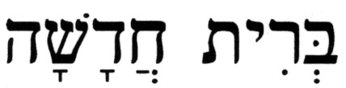 (brit hadashah), a new covenant, the only such instance in the entire Hebrew Bible. Consequently, Christian apologists and missionaries point at this passage as one that foretells the replacement of what they call the Old Covenant, which is Judaism's Torah, with their New Covenant, more commonly known as the New Testament.

Jeremiah 31:30-36[31-37] is a messianic passage to both Christians and Jews, albeit for different reasons. A careful analysis of the Hebrew text of this passage within its proper context, along with other relevant passages from the Hebrew Bible, demonstrates how this messianic passage is irrelevant to the Christian New Testament and to the Christian messiah.

II. Christian and Jewish Translations of Jeremiah 31:30-36[31-37]

Table II-1 shows the Hebrew text and side-by-side English renditions of the passage Jeremiah 31:30-36[31-37]; the King James Version (KJV) translation in the left column and a Jewish translation in the middle column next to the Hebrew text. [Note: In some Jewish editions the passage is numbered as Jeremiah 31:31-37, as it appears in all Christian Bibles, where Chapter 31 starts with the verse that is normally the last verse in Chapter 30 - Jeremiah 30:25]. The KJV rendition also points to cross-referenced passages in the New Testament, references that were taken from the New American Standard Bible (NASB).

Table II-1 – Jeremiah 31:30-36[31-37]

King James Version Translation |  | Jewish Translation from the Hebrew |  | The Hebrew Text
Jeremiah 31 |  |  |  | 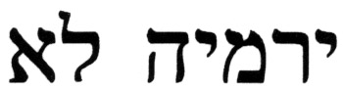
31 | Behold, the days come, saith the LORD, that I will make a new covenant with the house of Israel, and with the house of Judah:⁽¹⁾ ⁽²⁾ | 30 | "Behold, days are coming," says the L-rd, "when I will form with the House of Israel and with the House of Judah a new covenant. | 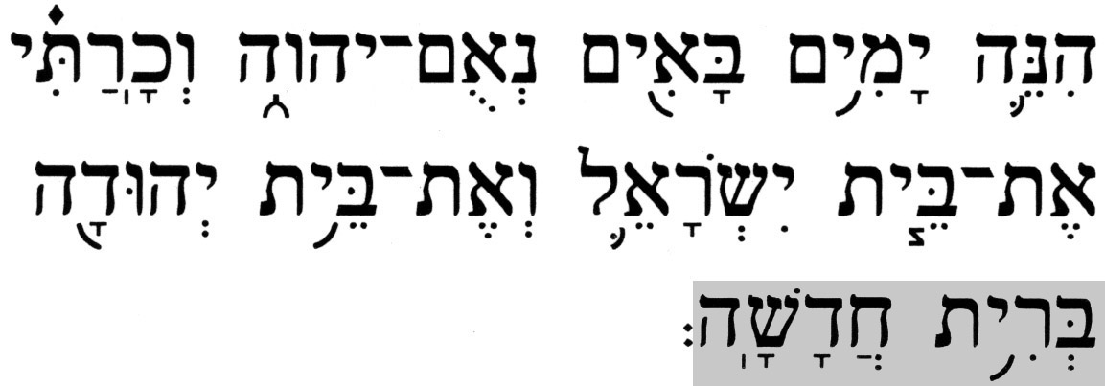 | 
32 | Not according to the covenant that I made with their fathers in the day that I took them by the hand to bring them out of the land of Egypt; which my covenant they brake, although I was an husband unto them, saith the LORD:⁽¹⁾ | 31 | Not like the covenant that I formed with their forefathers on the day I held them by the hand to take them out of the land of Egypt, for they broke My covenant, although I was a husband unto them," says the L-rd. | 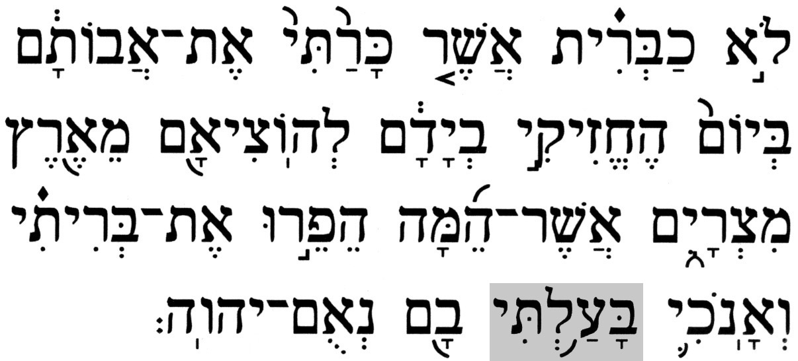 | 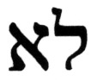
33 | But this shall be the covenant that I will make with the house of Israel; After those days, saith the LORD, I will put my law in their inward parts, and write it in their hearts; and will be their God, and they shall be my people.⁽¹⁾ ⁽³⁾ | 32 | "For this is the covenant that I shall form with the House of Israel after those days," says the L-rd; "I will place My Torah within them, and I will inscribe it upon their heart; and I will be their G-d and they shall be a people for Me. | 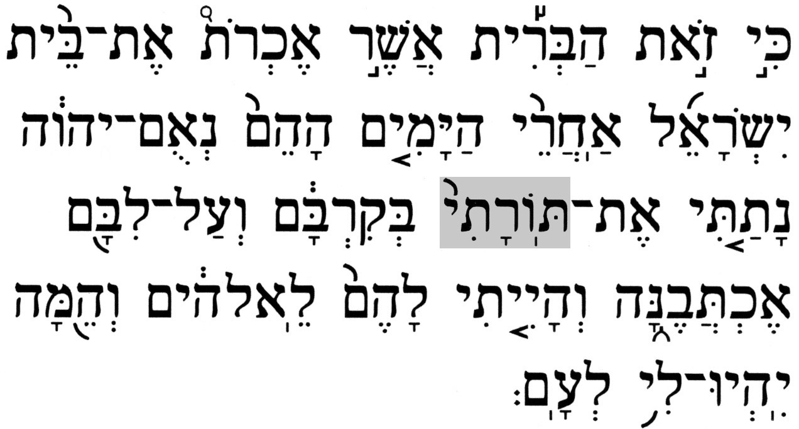 | 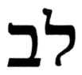
34 | And they shall teach no more every man his neighbour, and every man his brother, saying, Know the LORD: for they shall all know me, from the least of them unto the greatest of them, saith the LORD: for I will forgive their iniquity, and I will remember their sin no more.⁽⁴⁾ | 33 | And no longer they shall teach, a man his neighbor, and a man his brother, saying, 'know the L-rd,' for they shall all know Me, from their smallest to their greatest," says the L-rd, "for I will forgive their iniquity, and their sin I will no longer remember." | 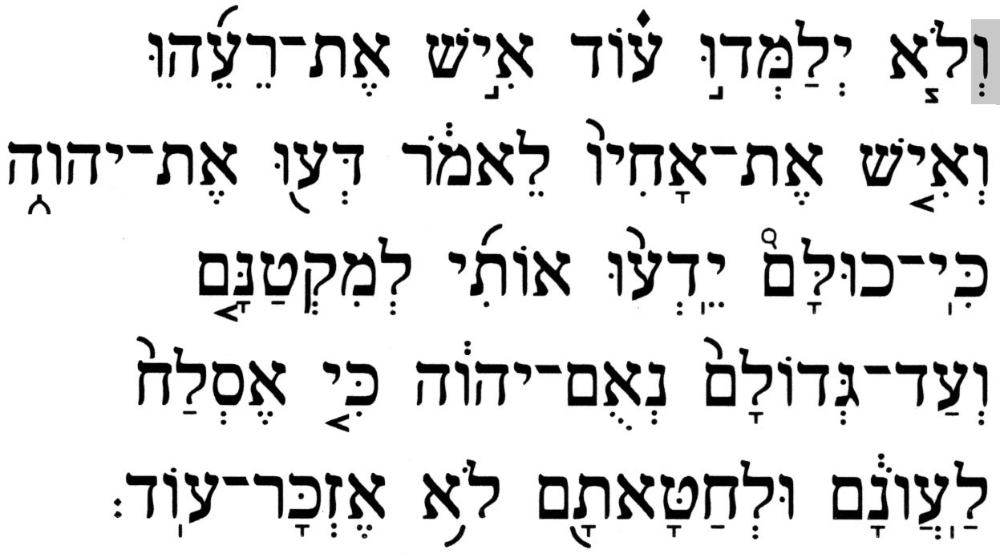 | 
35 | Thus saith the LORD, which giveth the sun for a light by day, and the ordinances of the moon and of the stars for a light by night, which divideth the sea when the waves thereof roar; The LORD of hosts is his name: | 34 | So said the L-rd, Who gives the sun to illuminate by day, the laws of the moon and the stars to illuminate at night, Who stirs up the sea to make its waves roar, the L-rd of Hosts is His name: | 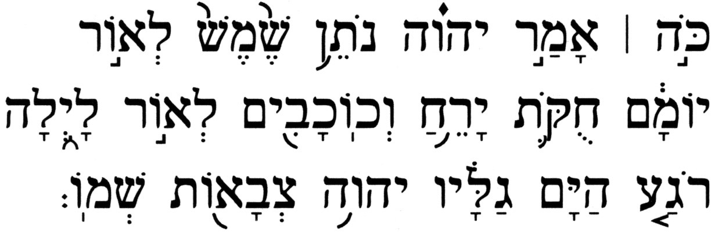 | 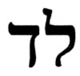
36 | If those ordinances depart from before me, saith the LORD, then the seed of Israel also shall cease from being a nation before me for ever. | 35 | "If these laws could depart from before Me," says the L-rd, "so will the seed of Israel cease being a nation before Me for all time." | 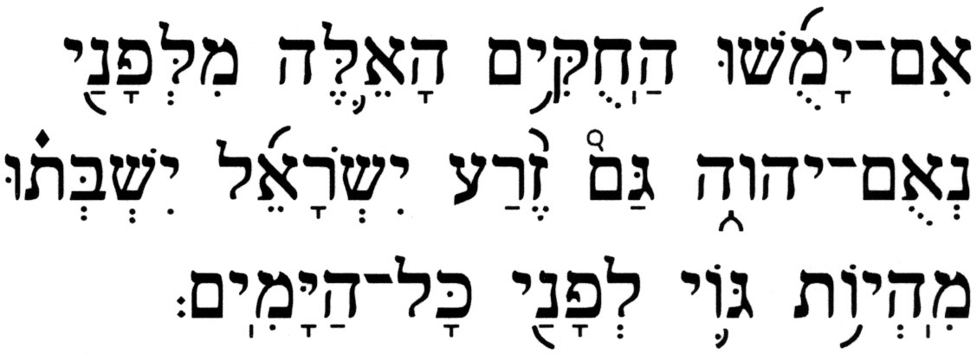 | 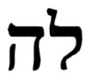
37 | Thus saith the LORD; If heaven above can be measured, and the foundations of the earth searched out beneath, I will also cast off all the seed of Israel for all that they have done, saith the LORD. | 36 | So said the L-rd, "if the heavens above will be measured and the foundations of the earth below will be fathomed, so too will I reject all the seed of Israel because of all they did," says the L-rd. | 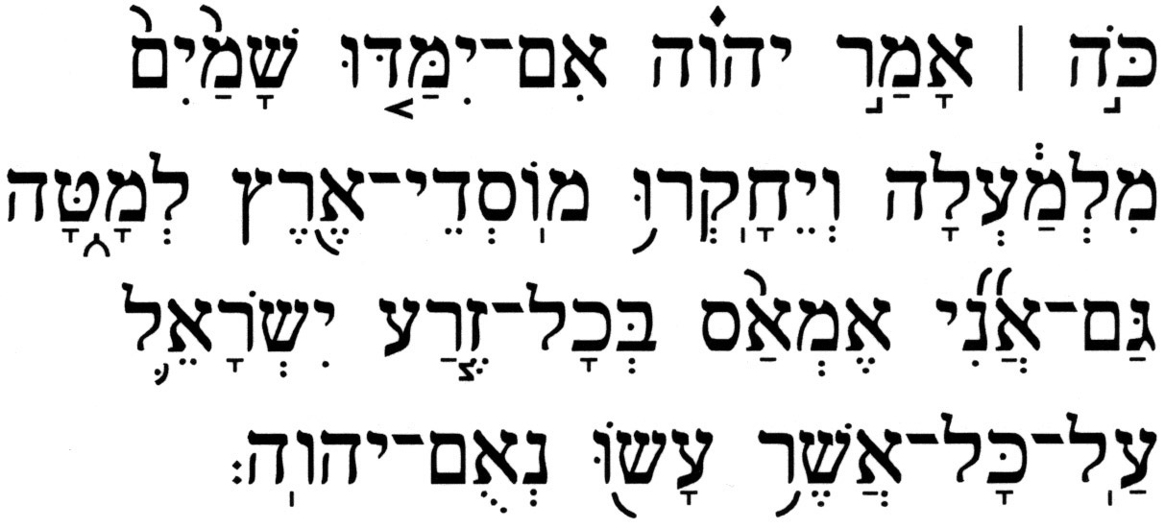 | 
(1) Hebrews 8:8-12(KJV) – See Section III.A
(2) Luke 22:20(KJV) - Likewise also the cup after supper, saying, This cup is the new
testament in my blood, which is shed for you.
2 Corinthians 3:6(KJV) - Who also hath made us able ministers of the new testament;
not of the letter, but of the spirit: for the letter killeth, but the spirit
giveth life.
(3) Hebrews 10:16(KJV) - This is the covenant that I will make with them after those days,
saith the Lord, I will put my laws into their hearts, and in their
minds will I write them;
2 Corinthians 3:3(KJV) - Forasmuch as ye are manifestly declared to be the epistle of
Christ ministered by us, written not with ink, but with the Spirit of
the living God; not in tables of stone, but in fleshy tables of the
heart.
(4) 1 Thessalonians 4:9(KJV) - But as touching brotherly love ye need not that I write unto
you: for ye yourselves are taught of God to love one
another.
John 6:45(KJV) - It is written in the prophets, And they shall be all taught of God. Every
man therefore that hath heard, and hath learned of the Father, cometh
unto me.
Romans 11:27(KJV) - For this is my covenant unto them, when I shall take away their
sins.
Hebrews 10:17(KJV) - And their sins and iniquities will I remember no more.

Overall, the two translations are remarkably similar; there are no major issues of mistranslation to be resolved.

As noted, this passage is referenced in the New Testament on a number of occasions and, when "quoted" in Chapter 8 of the Letter to the Hebrews, it is subjected to some rather serious manipulation, as will be demonstrated.

III. Overview of Christian and Jewish Interpretations

  - A. The Christian Perspective

The Christian position concerning Jeremiah's new covenant is contained in the eighth chapter of the Letter to the Hebrews in the New Testament. The author first states the rationale:

Hebrews 8:6-8(KJV) – (6) But now hath he obtained a more excellent ministry, by how much also he is the mediator of a better covenant, which was established upon better promises. (7) For if that first covenant had been faultless, then should no place have been sought for the second. (8) For finding fault with them, he saith, …

Following the opening phrase of Hebrews 8:8, the author proceeds to cite a carefully edited version of the first four verses from the passage in Jeremiah, Jeremiah 31:30-33[31-34]:

Hebrews 8:8-12(KJV) (8)… Behold, the days come, saith the Lord, when I will make a new covenant with the house of Israel and with the house of Judah: (9) Not according to the covenant that I made with their fathers in the day when I took them by the hand to lead them out of the land of Egypt; because they continued not in my covenant, and I regarded them not, saith the Lord. (10) For this is the covenant that I will make with the house of Israel after those days, saith the Lord; I will put my laws into their mind, and write them in their hearts: and I will be to them a God, and they shall be to me a people: (11) And they shall not teach every man his neighbour, and every man his brother, saying, Know the Lord: for all shall know me, from the least to the greatest. (12) For I will be merciful to their unrighteousness, and their sins and their iniquities will I remember no more.

Sidebar Note: It interesting to compare the phrase "… and I regarded them not …" in Hebrews 8:9 above with the (corresponding) phrases in Jeremiah 31:31[32] found in both the Jewish and KJV renditions shown in Table II-1, "… although I was a husband unto them …", and, "… although I was an husband unto them …", respectively. How does being a husband transform into not regarding? This will be addressed later in the analysis.

The author of the Letter to the Hebrews then concludes his discussion by explaining the status of the New Covenant as compared with the Old Covenant:

Hebrews 8:13(KJV) - In that he saith, A new covenant, he hath made the first old. Now that which decayeth and waxeth old is ready to vanish away.

Thus, the overall message here is that Jeremiah's (brit hadashah), a new covenant, is the covenant of the cross, fulfilled some 2,000 years ago when, according to Christian theology, the blood of Jesus was shed for the sins of mankind. In other words, the author of the Letter to the Hebrews proclaims that the covenant G-d made with Israel at Mount Sinai had expired. And, therefore, the Jewish people need no longer keep the commandments of the Torah since salvation now comes with the belief in Jesus as high priest, sacrifice, lord, and messiah:

Matthew 26:28(KJV) - For this is my blood of the new testament, which is shed for many for the remission of sins.

Christian theology holds that the New Covenant has replaced the existing covenant, the Torah, which was deemed old and flawed. Thus, it is claimed that Jeremiah's (brit hadashah), a new covenant, is a prophecy fulfilled with the death of Jesus on the cross, an event that led to the writing of the New Testament of Christianity (the Greek noun διαθήκη (diatheke) means a covenant or a testament), the one that replaced the (Mosaic) Law, i.e., the Torah.

  - B. The Jewish Perspective

A correct reading and understanding of the Hebrew text shows unequivocally that Jeremiah 31:30-36 is not a prophecy that was fulfilled during the first century C.E., or at any other time in the past. Rather, it is a prophecy that is yet to be fulfilled, one that will be fulfilled in the messianic era. This passage contains two significant messianic agenda items, i.e., messianic prophecies, which are yet to be fulfilled: the ingathering and restoration of the Jewish People to the Land of Israel, and the existence of a state of the universal knowledge of G-d. Here is a closer look at these:

- 1. Ingathering and Restoration of the Jewish People

The passage begins with the prophet addressing both the House of Israel and the House of Judah, which clearly indicates that Jeremiah is addressing an ingathered Jewish people. This was not the existing situation at the time those words were written, and it certainly was not the case when Jesus was allegedly crucified. To the contrary, during the first century C.E. the House of Israel no longer existed as a people because Assyria had exiled the Northern Kingdom of Israel well over 700 years earlier, during the days of Ahaz King of Judah. Moreover, in the first century C.E. the Jewish people were dispersed throughout the Roman Empire and beyond. Thus, not even the House of Judah was all present in the Holy Land at that time - the Jews were exiled into the Diaspora and were spread around much more than during their previous exile in Babylon following the destruction of the First (Solomon's) Temple.

The fact that the era of which Jeremiah is speaking has not yet arrived - a future messianic age when all the Jewish people, both House of Judah and House of Israel, will be restored together in their rightful place, the land of Israel - is addressed elsewhere by the Prophet:

Jeremiah 16:15 - But, As the L-rd lives, Who brought the people of Israel from the land of the north, and from all the lands where He had driven them; and I will bring them back to their land that I gave to their forefathers.

This is also confirmed by some of Jeremiah's fellow prophets:

Isaiah 11:12 - And He shall carry a banner for the nations, and He shall collect the lost of Israel, and the dispersed one of Judah He shall gather from the four corners of the earth.

Ezekiel 37:21-22 – (21) And say to them, Thus says the L-rd G-d: "Behold, I will take the Children of Israel from among the nations where they have gone, and I will gather them on every side, and I will bring them into their land; (22) And I will make them into one nation in the land upon the mountains of Israel, and one king shall be king to them all; and they shall no longer be two nations, and neither shall they be divided into two kingdoms any more.

Zechariah 10:6 - And I will strengthen the House of Judah, and the House of Joseph I will save, and I will get them settled for I have mercy on them, and they shall be as though I had not neglected them; for I am the L-rd their G-d, and will respond to them.

Note how, in Jeremiah 31:30[31], the Prophet starts out by speaking of "… days are coming …" where he speaks of both Houses, the House of Israel and the House of Judah. Then, in Jeremiah 31:32[33], he mentions only the House of Israel when he talks about an era "… after those days …", i.e., the days after the scattered Jewish people are repatriated to the Land of Israel and are united under a single kingdom called Israel.

The message in these Scriptures is unambiguous – the dispersed Jewish people will be returned to the Land of Israel and will be united once again as one nation lead by the promised Jewish Messiah/King.

- 2. Universal Knowledge of G-d

A verse in this passage that is often overlooked or ignored by Christian apologists and missionaries is Jeremiah 31:33[34]. This verse has two interesting attributes. First, in the Hebrew text, the verse starts with the preposition  (v^{e}), and, which means that Jeremiah 31:30-36[31-37] is not a two-prophecy passage. Rather, the presence of the preposition, (v^{e}), and, at the beginning of Jeremiah 31:33[34] connects it with the previous verse, Jeremiah 31:32[33], which makes it a continuation of the earlier prophecy and not the start of another, separate prophecy.

Jeremiah 31:33[34] – "And no longer shall they teach, a man his neighbor, and a man his brother, saying, 'Know the L-rd', for they shall all know Me, from their smallest to their greatest," says the L-rd, "for I will forgive their iniquity, and their sin I will no longer remember."

This verse speaks of a time when the knowledge of G-d will be universal. Ask yourself: "Is there a universal knowledge of G-d in the world today?" If that were the case, then why are Christian missionaries still spread all over the globe, spending many millions of dollars annually, trying to teach everyone to "know the (Christian) lord"? Is this not in complete contradiction to the words of the Prophet in Jeremiah 31:33[34]? The existence of Christian missionaries is a de-facto admission by evangelical Christians that this prophecy has not yet been fulfilled! What does that do to the Christian "New Covenant"?

The message found in Jeremiah 31:33[34], of a universal knowledge of G-d in the messianic era, is also echoed by other prophets:

Isaiah 11:9 - They shall neither harm nor destroy on My entire Holy Mountain; for the earth shall be full of knowledge of the L-rd, as the waters of the sea cover up [the sea floor].

Zechariah 14:9 - And the L-rd shall be King over all the earth; on that day shall the L-rd be One, and His Name One.

As the Jewish perspective correctly demonstrates, the prophecy of Jeremiah's (brit hadashah), a new covenant, has not yet come to pass; its fulfillment is coupled with Israel being united again in the Promised Land and with a universal knowledge of G-d prevailing.

- IV. Does This Passage Foretell the (Christian) New Testament?

A comparison of the Christian and Jewish perspectives indicates that they cannot both be valid. Though the Jewish perspective clearly demonstrates how this messianic passage has not yet been realized, there still remains the issue of the nature of Jeremiah's (brit hadashah), a new covenant, first mentioned in Jeremiah 31:30[31], and then alluded to throughout the rest of the passage. A detailed look at the passage will help resolve this issue.

- An Attempt to Reverse the Prophetic Message

In his deliberate revision of the original text of Jeremiah 31:31[32], the author of the Letter to the Hebrews had intended to solve a serious theological problem for Christianity – the prophesied eternity of the Jewish people and the Torah – he tried to reverse the Prophet's original message.

Hebrews 8:9 appears to be "quoting" Jeremiah 31:31[32]. However, checking the Hebrew text and translations of Jeremiah 31:31[32], one discovers that the phrase, , is translated in both Jewish and KJV renditions as, "for they broke my covenant, although I was a(n) husband unto them", but is rendered in Hebrews 8:9 as, "because they continued not in my covenant, and I regarded them not". The highlighted phrases are obviously not congruent in their context.

The Hebrew term for the English phrase I was a husband is 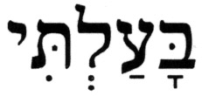 (ba’alti). The same conjugated verb appears once again in the Book of Jeremiah, and in the same context, at Jeremiah 3:14. The Hebrew root verb 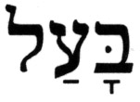 (ba'al) is most commonly applied throughout the Hebrew Bible in the context of being espoused. Of its 16 occurrences, in 11 cases (ba'al) refers to espousal, in one case it is used in a metaphorical sense, and in the remaining four cases it is used in the context of being a master over someone or something. A Hebrew noun derived from this verb is 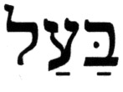 (ba'al), which can mean a husband (either married or betrothed) or a master and, in various combinations with other terms, it is used to describe someone who possesses certain attributes, qualities, or skills. As it concerns the verb (ba'al) in the context of espousal or mastership, it should be rather obvious that disregarding someone, as Hebrews 8:9 has it, is the antithesis of being a husband or master of someone, as Jeremiah 31:31[32] has it.

Another interesting aspect of the attempt at Hebrew Bible revisionism by the author of the Letter to the Hebrews is that he actually ends up contradicting one of the main messages conveyed in the Gospels – that Jesus did not come to change The Law but to fulfill it:

Matthew 5:17-19(KJV) – (17) Think not that I am come to destroy the law, or the prophets: I am not come to destroy, but to fulfil. (18) For verily I say unto you, Till heaven and earth pass, one jot or one tittle shall in no wise pass from the law, till all be fulfilled. (19) Whosoever therefore shall break one of these least commandments, and shall teach men so, he shall be called the least in the kingdom of heaven: but whosoever shall do and teach them, the same shall be called great in the kingdom of heaven.

Perhaps the editing by the author of the Letter to the Hebrews was not done as carefully as initially stated.

- Is the New Covenant A New Torah/Law?

What is a covenant anyway? The American Heritage Dictionary, p. 334, Second College Edition, Houghton Mifflin Company (1991), defines covenant (the noun) as follows:

covenant n. 1. A binding agreement made between two or more persons or parties; compact. 2. Law. a. A formal sealed agreement or contract. b. A suit to recover damages for violation of such a contract.

In other words, a covenant is a contractual agreement between two parties. Concerning the case in point here, the covenant is merely the agreement made by the Children of Israel to accept and obey the Torah in return for the promises made by G-d.

The opening promise to Israel is made just before the revelation at Mount Sinai:

Exodus 19:5 - And now, if you will obey Me and keep My covenant, you shall be to Me a treasure out of all peoples, for Mine is the entire earth.

The terms of the contract consist of blessings (rewards) that would accrue by obedience and warnings and curses (consequences) that would result from disobedience. Detailed blessings in the wake of obedience are found in Leviticus 26:3-13, in Deuteronomy 11:13-25, and in Deuteronomy 28:1-14. The wages of disobedience are detailed in Leviticus 26:14-39, and again in Deuteronomy 28:15-68.

Exodus 24:3-4,7 – (3) And Moses came and told the people all the words of the L-rd and all the ordinances, and all the people answered in unison and said, "All the words that the L-rd has spoken we will do." (4) And Moses wrote all the words of the L-rd, and he arose early in the morning and built an altar at the foot of the mountain and twelve monuments for the twelve tribes of Israel.
(7) And he [Moses] took the Book of the Covenant [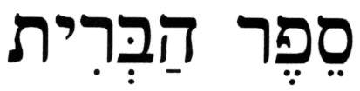(sefer ha'brit)] and read it for the people to hear, and they said, "All that the L-rd spoke we will do and we will hear."

It is important to recognize that the covenant is the contractual agreement to obey the Torah and is not the Torah itself. The Torah contains the commandments that are to be obeyed, and that is why it is referred to as (sefer ha'brit), Book of the Covenant. Thus, breaking the agreement by Israel does not change or invalidate the Torah! This is an important point to remember.

The fact that this (brit hadashah), a new covenant, will not replace the Torah is emphasized by Jeremiah himself:

Jeremiah 31:32 – "For this is the covenant that I shall form with the House of Israel after those days," says the L-rd, "I will place My Torah [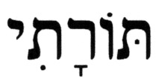(torati)] within them, and I will inscribe it upon their heart; and I will be their G-d and they shall be a people for Me."

The Hebrew term 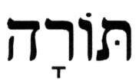 (torah) is used in the Hebrew Bible in two general contexts. First, it could refer to rules, doctrines, or other instructions for behavior, i.e., laws, statutes, and ordinances. Second, it could refer to the Mosaic Law, which is commonly referred to as the Torah.

The context of the Hebrew term (torati), My Torah, is unambiguous – it refers to the Torah. This is supported by the way Jeremiah uses the root noun (torah) throughout his Book, in which the noun appears on 11 occasions in various forms. The remaining ten instances of (torah) in the Book of Jeremiah are at Jeremiah 2:8, 6:19, 8:8, 9:12/[13], 16:11, 18:18, 26:4, 32:23, 44:10,23. In all ten cases the application is in the context of the Torah, as is the case in point, at Jeremiah 31:32[33]. It is interesting to note that even the KJV translators render all 11 instances as the/my/his law, as appropriate in the individual passages, clearly indicating this is The Law, a term commonly applied by New Testament authors as a reference to the Mosaic Law, i.e., the Torah.

Sidebar note: Jeremiah 31:32[33] would have been the ideal place for G-d to let us know, through the Prophet, that this new covenant will be a new Torah. All that would have had to be said is 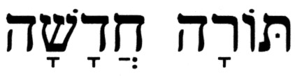 (torah hadashah), a new Torah, or 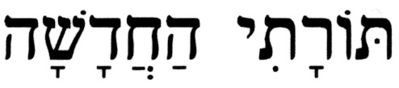 (torati ha'hadashah), My new Torah, instead of (torati), My Torah, and the deed would have been accomplished.

- The New Covenant vs. the Original Sinai Covenant

In Jeremiah 31:31[32], the Prophet declares the new covenant to be:

Not like the covenant that I formed with their forefathers on the day I took them by the hand to take them out of the land of Egypt, for they broke My covenant,…

How will this new covenant differ from the original Sinai covenant? The only difference between the two covenants is in where (sefer ha'brit), the Book of the Covenant resides. In the original Sinai covenant, it was placed in the mouths of the Israelites:

Exodus 13:9 - And it shall be to you for a sign upon your hand, and for a memorial between your eyes, in order that the Torah of the L-rd shall be in your mouth; for with a mighty hand has the L-rd brought you out of Egypt.

And the contract was verbally agreed to, as was seen from Exodus 24:3,7. On the other hand, according to Jeremiah 31:32[33], G-d says, "… I will place My Torah within them and I will inscribe it upon their heart …"; the new covenant will be placed within the people. In other words, this new covenant will simply be an integral part of the people of Israel and, thus, will become just part of the Jewish way of life.

- The Everlasting Sinai Covenant

Christian apologists and missionaries often use the phrase, "… for they broke My covenant ...", found in Jeremiah 31:32[33], to support their claim that the original Sinai covenant is no longer in force. After all, they claim, it is stated very clearly here that Israel broke the contract, and thus, the New Testament is the new covenant prophesied by Jeremiah, and it replaces the "Old Covenant/Testament". Is this claim valid?

Evidently, those who make that claim do not understand the difference between the covenant and the Book of the Covenant, as was explained in Sec. IV.B&C above. The Hebrew Bible teaches that, although the people of Israel often fell short of fulfilling their end of the agreement made at Mount Sinai and, in effect, broke the covenant, G-d has stated on many occasions that He will not break His covenant with Israel:

Leviticus 26:44-45 – (44) And despite all this, when they are in the land of their enemies, I will not despise them nor will I reject them to annihilate them, thereby breaking My covenant with them; for I am the L-rd their G-d. (45) And I will for their sakes remember the covenant of their ancestors, whom I brought out of the land of Egypt before the eyes of the nations, to be a G-d to them; I am the L-rd.

Judges 2:1 - And an angel of the L-rd came up from Gilgal to Bochim, and said [in G-d's name], "I will bring you up from Egypt, and I have brought you to the land which I swore to your forefathers, and I said, 'I will never break My covenant with you.'"

Ezekiel 16:59-60 – (59) For thus said the L-rd G-d [to Jerusalem]: "I have done with you in accordance to that which you have done, that you have despised an oath in breaking a covenant. (60) Nevertheless I will remember My covenant with you in the days of your youth, and I will establish with you an everlasting covenant.

Psalms 105:8-10 – (8) He has remembered His covenant forever, the word which He commanded to a thousand generations. (9) That which He had made with Abraham, and His oath to Isaac; (10) And He established it for Jacob as a law, and for Israel as an everlasting covenant;

There is no argument about the fact that Israel has strayed from the path many times since the promise was made at Mount Sinai, and for which Israel has suffered the consequences. Yet, the Hebrew Bible clearly shows that G-d will neither break that covenant nor replace the Torah - The Torah is eternal.

Given the evidence presented from the Hebrew Bible, the response to the question asked in the title of this section, "Does This Passage Foretell the (Christian) New Testament?", is that the claim made by Christian apologists and missionaries cannot be supported with any other Scriptures from within the Hebrew Bible. Quite to the contrary, the Hebrew Bible establishes the eternity of both the covenant and the Torah.

- V. Summary

The analysis presented in this essay demonstrates how to correctly read and interpret the passage Jeremiah 31:30-36[31-37]. The effort by an author of the New Testament to revise the prophetic message of Jeremiah about the eternity of the Jewish people and the Torah and turn it into a prophecy about the coming of the Christian New Testament has been exposed.

The Jewish prophets foretell that, in the messianic era, the Jewish people will observe the commandments of the Torah:

Isaiah 2:3 - And many people shall go and say, "Come, and let us go up to the mountain of the L-rd, to the House of the G-d of Jacob, and He will teach us of His ways, and we will walk in His paths;" for out of Zion shall Torah emerge, and the word of the L-rd from Jerusalem.

Ezekiel 37:24 - And My servant David shall be king over them, and one shepherd shall shall be for them all; and they shall follow My ordinances, and observe My statutes, and perform them.

Malachi 3:22/[4:4] - Remember the Torah of Moses My servant; that which I commanded him in Horeb for all Israel, statutes and ordinances.

It is evident that Jeremiah's use of the term (brit hadashah), a new covenant, does not involve the replacement of the Torah, which is eternal. Rather, it signals a renewal of the original Sinai covenant, which was declared to be everlasting, through its placement within us along with the (sefer ha'brit), the Book of the Covenant, to make them an inseparable part of the Jewish way of life. The term (brit hadashah), a new covenant, would be meaningless in any context other than one that describes the revitalized original Sinai covenant, along with the Torah, which cannot be replaced, superseded, or rescinded.

Source: http://www.messiahtruth.com/jer31.html

Has God Divorced Israel? What is the Meaning of the 'New Covenant' Promised in Jeremiah?

By

Out Reach Judaism

Question:
Rabbi,
How do you explain the divorce in Jeremiah? How do you explain that the Jewish people are divorced from God by His own word? How do we as Jews get back to God under the Law which prohibits us from coming back? I am not saying that we are no longer God's Chosen -- I am saying that for us to be reconciled to God, it cannot happen under the Law. Would God have to bring a "new covenant" in to bring us back to Him? You may post this question.
Thank you.
Answer:
When you ask about the "divorce in Jeremiah," I am sure that you are referring to the parable in the opening verse of the third chapter of Jeremiah, where the prophet uses a harsh allegory to illustrate God's displeasure with His wayward nation. For the readers of our website who are unfamiliar with this subject, I will briefly explain your series of questions.
Using a jarring metaphor, Jeremiah compares Israel's spiritual disloyalty to an adulterous woman who has been put away by her husband whom she betrayed. The prophet then asks a biting question, "After she leaves him and marries another man, may he return to her again?" (Jeremiah 3:1) The unspoken answer is that he cannot. Deuteronomy 24:1-4 states that the original husband may never come back to his twice-divorced wife.
Your question therefore is how can Israel ever return to its rightful place as God's priestly nation? The prophet seems to indicate that she (Israel) has married another, namely, the gods of the heathen nations, and she is therefore unable to return as God's "firstborn son" (Exodus 4:22). How can Israel ever hope to restore herself with the Almighty when the Law of Moses seems to indicate that she cannot? How can the nation of Israel look to the commandments of the Torah for her salvation when, according to Jeremiah's metaphor, it is those very commandments that prevent her from returning?
The reason you have had difficulty understanding Jeremiah 3:1 is that you made two mistakes while reading the parable of Israel as the divorced wife. Your first error is you attempted to interpret a parable in a hyper-literal fashion. I find it puzzling that Christians, who should be quite familiar with the use of parables, have such difficulty understanding how Jeremiah is using the parable of the "divorced wife." Your second mistake is you read only half the parable. In fact, the answer to your question is embedded in the final clause of the very same verse. Let's first examine this parable more closely.
Jeremiah's purpose in using this parable is two-fold. First, the prophet wishes to vividly illustrate Israel's spiritual disloyalty to its Creator. Second, and most importantly, unlike the twice-estranged wife whose original husband cannot return to her, the prophet appeals to the Jewish people to repent and proclaims that it is their covenantal purpose to be restored as God's chosen people. What is impossible with the forsaken woman is the destiny for the children of Israel. Let's look at the entire verse in context.
They say, "If a man divorces his wife, and she goes from him and becomes another man's, may he return to her again?" Would not that land be greatly polluted? But you have played the harlot with many lovers; "Yet return to Me," says the Lord. (Jeremiah 3:1)
The central feature of the prophet's exhortation that you overlooked appears at the very end of the verse, " 'Yet return to Me', says the Lord." Jeremiah makes this plea five times throughout the chapter. The message of the prophet is clear: The mercy and compassion of the Almighty is far beyond the scope of man's comprehension. Whereas normally the betrayed husband would never take back his adulterous wife, our merciful God will forgive His wayward nation. While the transgressed husband would never part with his burning wrath against his estranged wife, Jeremiah points the way to forgiveness, reconciliation, and salvation with the Almighty. In contrast to the enraged husband who would never take back his unfaithful wife, God will, upon repentance, compassionately receive his disobedient people. What must Israel do to win the affection of its Maker?
Just cry out to Me, "My Father, you are the Master of my youth!" (Jeremiah 3:4)
Yet how can this be? Will God's wrath not be kindled forever against His nation? Jeremiah responds with a rhetorical question.
Will He remain angry forever? Will He keep it to eternity? (Jeremiah 3:5)
The Almighty's answer follows with a comforting oath promising Israel an eternal destiny and permanent union with the Almighty.
"Return, O backsliding children," says the Lord, "for I am married to you. I will take you, one from a city and two from a family, and I will bring you to Zion." (Jeremiah 3:14)
The central message of the third chapter remains: The fate of disloyal Israel stands in stark contrast to an unfaithful wife. Whereas the adulterous woman may never return to her former husband, Jeremiah beckons the Jewish people back to the Almighty, and assures them of their eternal destiny to be forever married to their Maker.
Yet, by what means can the Jewish people return to God? A few chapters later, Jeremiah answers this question as he outlines for his disobedient nation how they are to end their persistent backsliding. In his seventh chapter, the prophet warns his people not to place their hopes on blood sacrifices or look to The Temple of the Lord to save them. Jeremiah proclaims that these institutions cannot deliver them from their brazen sins. Rather, they must turn away from idolatry and return to God by keeping the commandments. Please take a moment and study Jeremiah's remarkable message on atonement.
So said the Lord of Hosts, the God of Israel, "Improve your ways and your deeds, I then will allow you to dwell in this place. Do not rely on false words, saying, 'The Temple of the Lord, The Temple of the Lord, The Temple of the Lord are they.' If you improve your ways and your deeds, if you perform judgment between one man and his fellow man, you do not oppress the stranger, an orphan, or a widow, and you do not shed innocent blood in this place, and you do not follow other gods for your detriment. I will then allow you to dwell in this place, in the land that I gave your forefathers from days of yore to eternity . . . . So says the Lord of Hosts, the God of Israel, "Add your burnt offerings upon your sacrifices and eat flesh; for neither did I speak with your forefathers nor did I command them on the day I brought them out of the land of Egypt concerning a burnt offering or a sacrifice. This thing did I command them saying, 'Listen to Me so that I am your God and you are My people, you walk in all the ways that I command you . . . .' " (Jeremiah 7:3-7, 21-23)
The above chapter stands as a reverberating indictment against the church's most fundamental creeds. For example, according to Christian doctrine, man cannot merit salvation through his own repentance. Atonement comes only through the shedding of innocent blood. Throughout the seventh chapter of Jeremiah, however, the prophet proclaims the very opposite message on atonement. Over and over again, Jeremiah loudly declares that God does not want blood sacrifices but rather repentance alone for man's grievous sins.
Finally, as we study the words of Jeremiah, attention also must be paid to what the prophet does not say. Because Jeremiah's silence on missionary teachings is deafening, this chapter presents a serious theological problem for evangelical Christians. Why isn't there one word throughout the prophet's admonishment about believing in Jesus for salvation? Bear in mind that the purpose of this prophecy is to guide Jewish people who have lost their way into a sanctified relationship with the Almighty. Why didn't Jeremiah, as he points his wayward nation in the direction of Godliness, direct the Jewish people to Jesus' atoning death on the cross? Why did Jeremiah instead prophesy that the day will come when the Jewish people will be restored to their land as a result of their heartfelt repentance? (Jeremiah 3:14-18) According to Christian doctrine, repentance alone cannot save man from damnation. He can weep and wax forth with humble words of remorse from dawn until dusk, but without the blood of the cross, missionaries argue, there can be no forgiveness of sin. Why didn't the prophet ever mention this foundational creed in his sermon on forgiveness or declare that the Jewish people will eventually be restored because they believed in Jesus as their Lord and Savior?
Moreover, why would Jeremiah prophesy that in this act of penitence, you will one day "call Me 'My Father,' and not turn away from Me"? (3:4) Why is there no mention in Jeremiah's prophecy of the Jewish people calling out to the Son or the Holy Spirit in repentance? In short, why is there not a word mentioned throughout Jeremiah's prophetic sermon on atonement regarding the foundational claims of Christendom? It is not only what the prophet does say, but also what he doesn't say that draws our attention.
Your next question insists that Jews can only find salvation through a "new covenant" or New Testament (the Greek word diatheke means both a "covenant" and a "testament"). This "new covenant," missionaries argue, is the covenant of the cross that was fulfilled nearly 2,000 years ago when the blood of Jesus was shed for the sins of mankind. Moreover, Christians insist, this new covenant was prophesied in Jeremiah 31:31-34, which states,
"Behold, days are coming," declares the Lord, "when I will make a new covenant (bris) with the House of Israel and with the House of Judah. Not like the covenant (bris) which I made with their fathers in the day I took them by the hand to bring them out of the land of Egypt, My covenant which they broke, although I was a husband to them," declares the Lord. "But this is the covenant which I will make with the house of Israel after those days," declares the Lord, "I will put My law within them, and on their hearts I will write it; and I will be their God, and they shall be My people. No more shall every man teach his neighbor, and every man his brother, saying, 'Know the Lord,' for they all shall know Me, from the least of them to the greatest of them," says the Lord, "for I will forgive their iniquity, and their sin I will remember no more."
This "new covenant," missionaries maintain, is the New Testament which speaks of salvation by believing in the atoning death of Jesus as proclaimed in Matthew 26:28,
. . . for this is my blood of the new testament, which is shed for many for the remission of sins.
What of the Sinaitic covenant founded on the keeping of the Torah's commandments? Commenting on Jeremiah 31:31, the author of the Book of Hebrews relegates the Torah's life-giving commandments to obsolescence and concludes that,
In that He says, "A new covenant," He has made the first obsolete. Now what is becoming obsolete and growing old is ready to vanish away. (Hebrews 8:13)
In short, the New Testament writer pronounces that the covenant God made with the Jewish people has expired. The Jewish people no longer have to keep the commandments of the Torah. Salvation comes by believing in Jesus as high priest, sacrifice, and messiah. It is therefore not difficult to understand how the Calvinist author Arthur W. Pink in his An Exposition of Hebrews writes,
It is exceedingly difficult, if not quite impossible, for us to form any adequate conception of the serious obstacles presented to the mind of a pious Jew, when any one sought to persuade him that Judaism had been set aside by God and that he must turn his own back upon it. 1
Some of our readers will undoubtedly be offended by Pink's conclusion, but, in fact, this Reformed author is a rationalist. He is simply drawing the conclusion that the Book of Hebrews is conveying. Essentially, the Book of Hebrews is a multifaceted polemic against the church's older rival: Judaism.
In order to answer your question regarding Jeremiah's prophecy of a "new covenant," you must first understand how the New Testament has misapplied and altered Jeremiah 31:31-34, and then grasp the prophet's message in these four well-known verses.
As mentioned above, missionaries argue that Jeremiah 31:31-34 is a prophecy of an event that occurred nearly 2,000 years ago with Jesus' death on the cross. They insist that this is the new covenant that replaced the old and decaying Mosaic covenant made with Israel.
This Christian rendering of Jeremiah's prophecy of a "new covenant," however, is an extraordinary reconstruction of the prophet's own words. Jeremiah 31:31-34 is not a prophecy that occurred 2,000 years ago, or any time in the past. Rather, it is a prophecy that will be fulfilled in the future messianic age.
The fact that Jeremiah 31:31-34 begins with the prophet addressing both the "House of Israel and the House of Judah" clearly indicates that Jeremiah is speaking to a restored and fully ingathered Jewish people. This, however, was not at all the case at the time when Christians claim the new covenant was fulfilled in Jesus' death . . . quite the contrary. During the Christian century there was no House of Israel in existence because Assyria had exiled the Kingdom of Israel more than 700 years earlier (approx. 732 B.C.E.). Moreover, in the first century the Jewish people were spread throughout the Roman Empire and beyond. Thus, even the "House of Judah" was not all in the Promised Land during the Christian century.
In short, the era of the new covenant has not yet arrived. Rather, Jeremiah's prophecy addresses a future messianic age when the entire Jewish people -- both Judah and Israel -- will be restored together in their rightful place, the land of Israel (Ezekiel 37:15-22). In contrast, there had been no time in history when the Jewish people were more fractured and dispersed than during the Christian century when, according to the author of Hebrews, Jeremiah's prophecy of a new covenant was supposedly fulfilled.
Moreover, a cursory reading of verse 31:34 further confirms that Jeremiah's prophecy is not speaking of a Christian cross 2,000 years ago but rather a restored Jewish people in the future messianic era. Missionaries often overlook verse 34 and emphasize only 31:31-33 when quoting Jeremiah's declaration of a new covenant. This oversight has proved to be devastating to their understanding of this prophecy because verse 31:34 sheds much light on this new covenant era. Jeremiah 31:34 reads,
No more shall every man teach his neighbor, and every man his brother, saying, "Know the Lord," for they all shall know Me, from the least of them to the greatest of them, says the Lord; for I will forgive their iniquity, and their sin I will remember no more.
The above verse reveals that the age of the new covenant will be realized during an epoch of the universal knowledge of God. It will occur when no one will have to teach his neighbor about God, "for they all shall know Me, from the least of them to the greatest of them . . . ." Did this occur at the time of the Christian century nearly 2,000 years ago, or at any time since? Does every human being "know the Lord"? This is hardly the case. The church is spending many hundreds of millions of dollars annually in order to convert masses worldwide to Christianity. There are roughly one billion Moslems and Hindus in the world today who, according to Christian teachings, do not know the Lord; and there are an untold number of atheists throughout the globe who certainly do not know the Lord. Has Jeremiah's prophecy of a "new covenant" yet been fulfilled by anyone's standards? Are we living in a time when each and every person "knows the Lord"? Certainly not.
The Hebrew word bris (covenant) in Jeremiah 31:31 does not mean a Bible or refer to a new salvation program or Torah. The word bris always refers to a promise or a contract. This covenant was made with the Jewish people while they were still in the desert before they were brought into the Promised Land.
In the 28th and 29th chapters of Deuteronomy, Moses told the children of Israel that if they remained faithful to God in the land they were about to enter then the Almighty would bestow upon them manifold blessings and they would flourish in the Holy Land. On the other hand, if they backslid and turned away from the Lord, they would be driven out of Israel into a bitter exile in the land of their enemies. We are all familiar with the events that followed when the Jewish people broke their side of the covenant and they were sent into diaspora.
These four verses in Jeremiah 31:31-34 are part of an ongoing theme repeated throughout the Book of Jeremiah. Jeremiah's unique literary motif is to contrast the redemption of the children of Israel from Egypt with their final redemption in the messianic age -- always vividly illustrating how the latter will far outshine the former. In Jeremiah 23:7-8, the prophet makes this clear when he proclaims,
Therefore, behold, the days are coming, says the Lord, when men shall no longer say, "As the Lord lives who brought up the people of Israel out of the land of Egypt," but, "as the Lord lives who brought up and led the descendants of the house of Israel out of the north country and out of all the countries where He had driven them." Then they shall dwell in their own land.
In the 31st chapter of the Book of Jeremiah, the prophet continues to contrast the exodus from Egypt with the messianic age. He therefore foretells that unlike the exodus from Egypt when the Jewish people were brought into the land of Israel only to be exiled centuries later because they broke their original covenant as a result of their faithlessness, in the messianic age, the Jewish people will enter into a "new covenant" when they will be permanently restored to their land, never to be exiled again.
As was declared by every prophet, the covenant that God has with the Jewish people is eternal. No words in the Christian Bible or interpolation of the Jewish scriptures can ever change this eternal oath. The prophet Isaiah proclaimed this vow more than 2,700 years ago,
"With a little wrath I hid My face from you for a moment; but with everlasting kindness I will have mercy on you," says the Lord, your Redeemer. "This is like the waters of Noah to Me; for as I have sworn that the waters of Noah would no longer cover the earth, so have I sworn that I would not be angry with you, nor rebuke you. The mountains shall depart and the hills be removed, but My kindness shall not depart from you, nor shall My covenant of peace be removed," says the Lord, Who has mercy on you. (Isaiah 54:8-10)
Remarkably, the contorted manner in which Hebrews rendered Jeremiah's prophecy promulgates the precise opposite message of the prophet's original intent. Hebrews misconstrued Jeremiah's prophecy to be understood that God had somehow disregarded His covenant with Israel, when, in fact, the prophet's message is that God's unique covenantal relationship with the Jewish people will never be destroyed.
Moreover, in the next two verses the prophet determinedly proclaims this, pointing to the natural phenomena of the world as a witness to His eternal relationship with the children of Israel. Jeremiah 31:35-36 reads,
Thus says the Lord, Who gives the sun for light by day and the fixed order of the moon and the stars for light by night, Who stirs up the sea so that its waves roar-- the Lord of hosts is His name: If this fixed order were ever to cease from My presence, says the Lord, then also the offspring of Israel would cease to be a nation before Me forever. Thus says the Lord: If the heavens above can be measured, and the foundations of the earth below can be explored, then I will reject all the offspring of Israel because of all they have done.
Because Jeremiah's prophecy of an eternal Jewish people presents the church with a serious theological problem, the New Testament went to great lengths to undermine it. In fact, the author of Hebrews deliberately changed the words of Jeremiah in order to reverse the prophet's original message.
In Hebrews 8:9, while quoting Jeremiah 31:32, the author changed a most crucial word in the verse. The last clause of Jeremiah 31:32 reads,
. . . My covenant which they broke, although I was a husband to them.
Hebrews misquoted Jeremiah's words and instead wrote,
. . . because they did not continue in My covenant, and I disregarded them, says the Lord."
The Hebrew word "ba'altee," means a "husband," not "to disregard." This is a stunning alteration of the words of Jeremiah; to be a "husband" is the precise opposite of "disregarding" someone. How can the author of Hebrews change the word of God in order to demonstrate the superiority of Christianity over its older rival Judaism? When New Testament authors wantonly tamper with the Jewish scriptures, do they not convey the very opposite message?
Furthermore, in contrast to the message of Hebrews 8:13, the life-giving commandments of the Torah have no expiration date. Moses declared that these commandments are forever and ever.
The secret things belong unto the Lord our God; but the things that are revealed belong unto us and to our children forever, that we may do all the words of this law. (Deuteronomy 29:28 [29:29])
The works of his hands are verity and judgment; all his commandments are sure. They stand fast forever and ever, and are done in truth and uprightness. (Psalm 111:7-8)
Moreover, the prophets foretold that the Jewish people will observe the commandments of the Torah after the messiah arrives. In fact, the Jewish scriptures prominently testify that the faithful observance of the Torah will be the emblematic feature of the messianic era.
And I shall give them one heart, and shall put a new spirit within them. And I shall take the heart of stone out of their flesh and give them a heart of flesh, that they may walk in My statutes and keep My ordinances, and do them. Then they will be My people, and I shall be their God. (Ezekiel 11:19-20)
My servant David will be king over them, and they will all have one shepherd. They will follow my laws and be careful to keep my decrees. (Ezekiel 37:24)
And many peoples shall come, and say: "Come, let us go up to the mountain of the Lord, to the house of the God of Jacob; that he may teach us his ways and that we may walk in his paths," for out of Zion shall go forth the law, and the word of the Lord from Jerusalem. (Isaiah 2:3)
So let's ask ourselves this question: Do Hebrew-Christians who insist that the messiah has already come keep the commandments of God? Do members of Messianic congregations actually keep the mitzvoth of Shabbat and Kashruth clearly outlined in the Jewish scriptures? For example, do those Jews who have converted to Christianity make sure never to kindle a fire and refrain from carrying any object on the Sabbath day as the Bible decrees? (Exodus 35:3; Jeremiah 17:19-20) The answer is that they do not. Yet, why don't they if they believe the messiah has already come? Who are those people who diligently and joyfully adhere to these life-giving commandments? The faithful remnant of the Jewish people who loudly reject the teachings of Christianity.
Paradoxically, Hebrew-Christians misguidedly point to Jeremiah's new covenant to explain away their continued indifference to the commandments of the Torah, when in fact the central messianic prophecy in the Bible declares that the Children of Israel will diligently keep the commandments as a result of the coming of the messiah.
Finally, let's consider which grievous sin the Jewish people committed that brought down the wrath of God upon them in the first place. In which iniquity did Israel indulge that brought about Jeremiah's bitter reproach? The appalling sin of idolatry; they had violated the first of the Ten Commandments. The Jewish people worshiped gods that their fathers had not known. They indulged in idol worship and heathen practices of the surrounding gentile nations. Let us consider whether a pious Jew ever read the third chapter of Jeremiah and as a result was somehow moved to convert to Christianity.
More than 3,300 years ago the Torah warned the Jewish people that they would one day serve gods that their fathers didn't know (Deuteronomy 28:36). When a Jew becomes a Hebrew-Christian, whether he then calls himself Messianic or Baptist, did this occur as a result of the teachings of his grandfather or great grandfather? Did he come to this theological conclusion by fervently studying the Torah in a yeshiva? Did he find the doctrine of the Trinity in the Book of Jeremiah, or by any other prophet in Tanach? This is certainly never the case. Hebrew-Christians learn and adopt their spiritual craft from the gentiles who evangelized them. Just as in the Bible.
Sincerely yours,
Rabbi Tovia Singer
As a postscript, our readers should be excited to know that the author of this letter, who has spent many years of his life as a Hebrew-Christian, has returned to the truth and beauty of the Jewish faith.
Give thanks to the Lord, for He is good! His mercy endures forever. Psalm 136:1
Footnote:
Click on the footnote to return to the article
1: Pink, Arthur W., An Exposition of Hebrews, Baker Book House, Grand Rapids, MI; 1984: pp. 1065.

Source: http://www.outreachjudaism.org/jeremiah31.html

Feel free to contact me at b_zawadi@hotmail.com

Return to Refuting Alleged Old Testament Prophecies Pointing to Jesus

Return to Homepage

