Bethlehem: The Messiah's Birthplace?

by

Messiah truth

I. Introduction

The Christian apologetic and missionary claim that Bethlehem is the birthplace of the Messiah was briefly considered in another essay[1]. A more detailed analysis of the claim will be the focus of the present essay.

In the opening verse of the second chapter in the Gospel of Matthew, the author declares that Bethlehem was the birthplace of Jesus:

Matthew 2:1(KJV) – Now when Jesus was born in Bethlehem of Judaea in the days of Herod the king, behold, there came wise men from the east to Jerusalem, …

The author then claims this event to be a "fulfillment" of a prophecy found in the Hebrew Bible, which he states as follows:

Matthew 2:5-6(KJV) – (5) And they said unto him, In Bethlehem of Judaea: for thus it is written by the prophet, (6) And thou Bethlehem, in the land of Juda, art not the least among the princes of Juda: for out of thee shall come a Governor, that shall rule my people Israel.

According to Christian apologists and missionaries, Matthew 2:6 points to Micah 5:2 in their Old Testament; in the Hebrew Bible this is Micah 5:1. Micah 5:1[2][2] has thus become a popular Christian "proof-text" in the apologist and missionary's portfolio.

A careful analysis of the Hebrew text in Micah 5:1 demonstrates that the false application by the Greek rendition of this verse in the New Testament, and its subsequent mistranslation in the King James Version (KJV) Old Testament (and in other Christian Bibles), are inconsistent with the teachings of the Hebrew Bible. Moreover, the KJV Old Testament's rendition of a key phrase in the verse is also inconsistent with other instances of the same phrase elsewhere in the King James Version Bible.

- II. Comparison of Jewish and Christian Translations, and the New Testament Application

Table II-1 provides a side-by-side comparison between the verse from the KJV New Testament, the KJV Old Testament rendition of the verse, and a Jewish translation of the original verse. For reference, the corresponding verse from the Hebrew Bible is also displayed in the table. As was already pointed out above, note that the KJV Old Testament verse number is different from the verse number as it appears in the Hebrew Bible. The highlighted phrase in both the Jewish and KJV translations corresponds to the highlighted phrase shown in the Hebrew text.

Table II-1 – Comparing Matthew 2:6 with Micah 5:1[2]

Hebrew Text
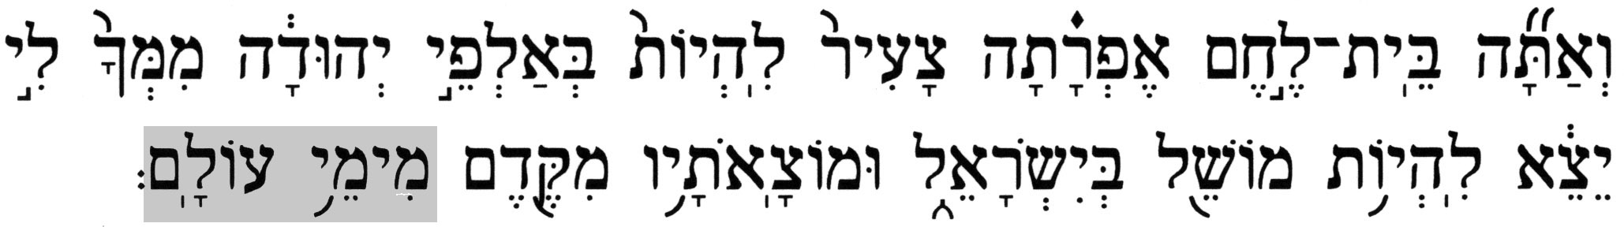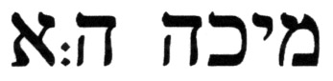
King James Version  New Testament | King James Version  "Old Testament" |  | Jewish Translation from the Hebrew
Matthew 2:6 | Micah 5
And thou Bethlehem, in the land of Juda, art not the least among the princes of Juda: for out of thee shall come a Governor, that shall rule my people Israel. | v.2 | But thou, Bethlehem Ephratah, though thou be little among the thousands of Judah, yet out of thee shall he come forth unto me that is to be ruler in Israel; whose goings forth have been from of old, from everlasting. | v.1 | And you, Bethlehem Ephratah - you should have been the lowest amongst the clans of Judah – from you [he] shall emerge for Me, to be a ruler over Israel; and his origin is from old, from ancient days.

Aside from the fact that Matthew 2:6 leaves out the last phrase of the source verse and is, at best, a paraphrase of the quoted portion, there are a number of problems with the Micah 5:2 rendition in the KJV. These problems, as well as the truncated rendition of the verse in the New Testament, will be explained in the analysis.

- III. Analysis of the Passage

To help facilitate the analysis, the correct translation of Micah 5:1 is separated into two segments:

Segment A

Micah 5:1A – And you, Bethlehem Ephratah - you should have been the lowest amongst the clans of Judah – from you [he] shall emerge for Me, to be a ruler over Israel;

Segment B

Micah 5:1B – and his origin is from old, from ancient days.

Segment A and Segment B will now be separately analyzed.

- Analysis of Segment A

Micah 5:1A – And you, Bethlehem Ephratah - you should have been the lowest amongst the clans of Judah – from you [he] shall emerge for Me, to be a ruler over Israel;

The name Bethlehem, in the original Hebrew is 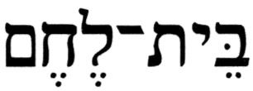 (beit-lehem), which literally means House of Lehem [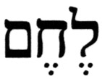(lehem) means bread, or (generic) food]. Therefore, the title (beit-lehem) may refer either to the town or to a clan with the name (lehem). In the case of Micah 5:1, the reference is to a clan. How can one determine this?

The first clue is found in the opening phrase of the verse, where the Hebrew is 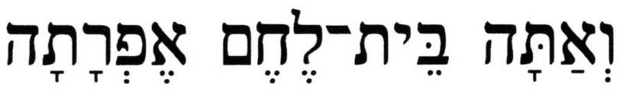 (v^{e}atah beit-lehem ephratah). The term 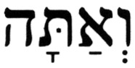 (v^{e}atah) has the components  (v^{e}), the preposition and, and 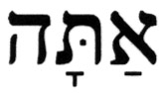 (atah), the pronoun you for the 2nd-person, singular, masculine gender. Thus, (v^{e}atah) translates as and you, using the 2nd-person, singular, masculine gender pronoun (the KJV has but you in Micah 5:2; note, however, how the KJV translators correctly render this phrase as And thou in Mt 2:6!). The rest of the phrase in Segment A is also cast in a 2nd-person, singular, masculine gender conjugation. Following this term (v^{e}atah) is the phrase 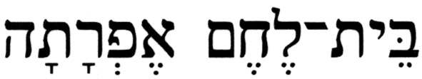 (beit-lehem ephratah), where 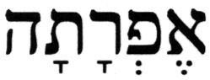 (ephratah) or, alternatively, 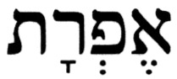 (ephrat), is an alternate name for the town of Bethlehem in Judah in the Hebrew Bible, as seen from the following example:

Genesis 35:19(KJV) - And Rachel died, and was buried in the way to Ephrat (ephrat), which is Bethlehem (beit-lehem).

In the Hebrew Bible, singular pronouns, such as (atah), you, are often used interchangeably in both the singular and plural context. In the case of Micah 5:1, (atah) is a singular compound entity, a specific clan, so that the context is the [plural, masculine] you. Though the singular usage is the most common one, the plural application occurs as well (e.g., Exod 33:3, Deut 9:6). Therefore, the one being addressed here in Micah 5:1 is (beit-lehem), which is the name of a family, or clan, residing in the town of (ephratah), Ephratah, i.e., in the town of Bethlehem. According to this analysis, perhaps a more accurate version of Segment A (and, thus, Micah 5:1) would be:

Micah 5:1A – And you, House of Lehem [from] Ephratah - you should have been the lowest amongst the clans of Judah – from you [he] shall emerge for Me, to be a ruler over Israel;

In the expression 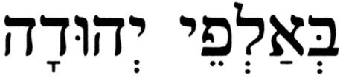 (b^{e}alphei y^{e}hudah), amongst the clans of Judah, contains a plural possessive construct of the Hebrew term 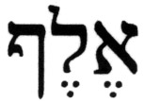 (eleph), 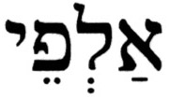 (alphei), which is used in the context of clans of …. The most common application of (eleph) in the Hebrew Bible is a thousand, which is its general meaning. However, there are instances in the Hebrew Bible where (eleph) is used in reference to a portion of a tribe, i.e., a clan or family. Micah 5:1 is one of these cases, and others are found at Numbers 31:5, Deuteronomy 33:17, Joshua 22:14, Judges 6:15, and 1 Samuel 10:19, 23:23. It is interesting to note that most translators (both Jewish and Christian) are consistent in their (mis)translation of this word in all but one of these instances, the one at Judges 6:15, where the term 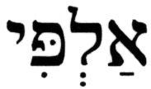 (alpi) [1st-person, singular conjugation of the noun (eleph)] is correctly translated as my family. Although, in general, it is not a serious contextual discrepancy when using a thousand in place of a clan in the above mentioned places, the correct context in Micah 5:1 is that the reference is to a [particular] clan from the town of Bethlehem. This case is further supported by the fact that members of a clan are frequently referred to by the name of the clan, often derived from the name of its progenitor, as is seen from the following example:

Numbers 3:27 - And of Kohath, the Amramite family, and the Izharite family, and the Hebronite family, and the Uzzielite family; these are the Kohathite families.

Regarding someone from the Bethlehemite clan [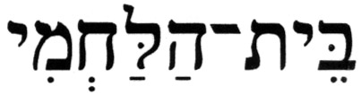(beit-ha'lahmi)], the Hebrew Bible has passages such as the following:

1 Samuel 16:1 - And the L-rd said to Samuel, "Until when will you mourn for Saul, that I have rejected him from reigning over Israel? Fill your horn with oil, and go, I will send you to Jesse the Bethlehemite [(beit-ha'lahmi)], for I have found among his sons a king for Me.

Another reference in the Hebrew Bible is even more explicit:

1 Samuel 17:12 - And David was the son of this man from Ephrat [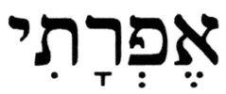(ephrati)] of the House of Lehem [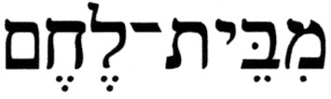(mi'beit-lehem)] in Judah, whose name was Jesse, and he had eight sons; and the man, who was elderly in Saul's time, was among the [respected] men.

In the Hebrew language, which has no neuter gender, i.e., a separate Hebrew word for it does not exist, cities and towns are assigned the feminine gender. So, if it were the town of Bethlehem being addressed in Micah 5:1, the opening term would have been 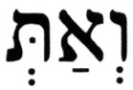 (v^{e}at), such as in Jeremiah 50:24 and elsewhere, the components of which are (v^{e}), the preposition and, and 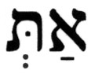 (at), the Biblical form of the pronoun you for the 2nd-person, singular, feminine gender. Consequently, (v^{e}at) translates as and you, with the 2nd-person, singular, feminine gender pronoun. Understanding this difference is essential for the correct reading of this verse!

The KJV translators, lacking the required level of proficiency of the Hebrew language, did not recognize that a certain clan, the House of Lehem, is being addressed in Micah 5:1[2]. Rather, from the sources they used, one of which was most likely the Christian LXX (that which Christians mistakenly call the Septuagint), it appeared to them that the town of Bethlehem is being addressed here. Consequently, they characterize Bethlehem as a small and insignificant town from the territory of Judah, in an introductory phrase to the prophecy. Namely, that in spite of its insignificance, the town will be the birthplace of the promised Messiah.

However, since it is the clan, the House of Lehem, and not the town, that is being addressed here by Micah, it does not matter in which town the Messiah will be born; rather, it is the clan, the family, that is significant! The phrase in Segment B, "and his origin is from old", simply means the Messiah will come from a family with a long lineage.

How can one learn more about the particular clan to which this verse refers? The ancestry of the known members of the clan is a good place from which to start the investigation, and it leads to a woman named Ruth, a Moabitess, who is among the ancestors of King David. Ruth was married to one of the two sons Elimelech and Naomi, a family that hailed from Bethlehem.

A famine in Judah forced Elimelech to take his family to a place that had food, and they wound up in the Land of Moab. Originally, Elimelech and Naomi’s plan was to go to Moab just to wait out the famine, but they then decided to remain there, a decision that eventually led to tragic consequences. Elimelech and Naomi's two sons, Killion and Mahlon (Ephrathites from House of Lehem [Ruth 1:2]), married Gentile women, Orpah and Ruth, respectively. Elimelech and his two sons died while the family was in Moab, leaving the three women, Naomi, Orpah, and Ruth, as widows. Naomi made plans to return alone to her home in the Kingdom of Judah, and she instructed her two daughters-in-law to go back to their people, the Moabites. Orpah approached her mother-in-law, kissed her goodbye and left. Ruth came over to Naomi, held on to her and did not let go. Ruth informed Naomi that she was coming with her; and even though Naomi attempted to dissuade her from returning to the famine in Judah, Ruth insisted and said to her:

Ruth 1:16-17 – (16) … Do not entreat me to leave you, or to desist from following you; for wherever you go, I will go; and where you lodge, I will lodge; your people shall be my people, and your G-d is my G-d; (17) Wherever you die, will I die, and there will I be buried; the L-rd may do so to me, and so may He continue, for [only] death will separate me from you.

From Ruth's declaration of her intentions to Naomi when she says, “…For where you go, I will go; where you lodge, I will lodge; your people are my people, and your G-d is my G-d;…”, it is understood that she converted to Judaism. But Ruth, a person of outstanding character, had a problematic ancestry – she was a Moabite woman. This is what the Torah instructs the Israelites about a Moabite:

Deuteronomy 23:4 - An Ammonite [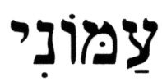(ammoni)] and a Moabite [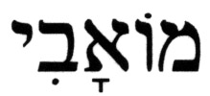(mo'avi)] shall not enter into the congregation of the L-rd; even the tenth generation shall never enter into the congregation of the L-rd.

In other words, Ammonites and Moabites were prohibited from ever converting to Judaism. Note, however, that in the Hebrew text, the terms (ammoni) and (mo'avi) are used, terms that translate as an Ammonite (male) and a Moabite (male), respectively. The corresponding terms for a female, as used in the Hebrew Bible are, 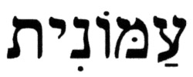 (ammonit) and 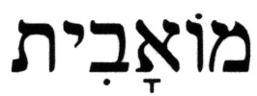 (mo'avit) [or 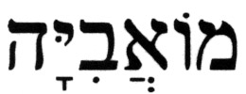 (mo'avi'yah)].

The reason for the prohibition is stated immediately following it:

Deuteronomy 23:5-6 – (5) Because they did not greet you with bread and water on the way, when you left Egypt, and because he [Moab] hired Balaam the son of Beor from Pethor in Aram Naharaim against you, to curse you. (6) But the L-rd, your G-d, did not want to listen to Balaam. So the L-rd, your G-d, transformed the curse into a blessing for you, because the L-rd, your G-d, loves you.

And this is repeated at a much later time by Nehemiah:

Nehemiah 13:1-2 – (1) On that day the Book of Moses was read to be heard by the people; and it was found written therein that an Ammonite [(ammoni)] and a Moabite [(mo'avi)] may not enter into the congregation of G-d forever; (2) Because they did not come to meet the people of Israel with bread and with water, and [instead] hired Balaam against them, to curse them; and our G-d turned the curse into a blessing.

Considering this prohibition, how was Ruth the Moabitess able to "… enter into the congregation of the L-rd…"? How could she become the ancestor of the greatest king of the Jewish people, King David? The Sages explain in the Babylonian Talmud (Tractate Yevamot, 76b; Tractate Ketubot, 7b) that this prohibition applies only to Ammonite and Moabite men, and not to women. This is because only a man was expected to leave his house and bring food and drink to the traveler; a woman was not expected to do that for obvious reasons. Thus, the interpretation of the law (Deut 23:4), which had to be rendered by ten elders, that the prohibition on becoming one of the assembly of the L-rd, i.e., to be admitted into the community of Israel, applied only to Ammonite and Moabite men and not to Ammonite and Moabite women. This clarified the law, and enabled Boaz to marry Ruth the Moabitess. So, the (beit-lehem) clan, with a history marred by Ruth's ancestry of a nation that was excluded from Judaism, is characterized by the phrase, "you SHOULD HAVE BEEN the LOWEST amongst the CLANS of Judah", in Segment A. This phrase reflects the uneasiness people may have had even with King David, whose great-grandmother was a Moabitess. Yet, the fact is that out of this clan rose the greatest king of Israel, and the promise is made that the Messiah will also come from it.

This passage is all about King David's ancestry, with the Messiah being but a "by-product" of it. This fact is even confirmed by the rendition in The New Jerusalem Bible (a Christian translation), whose translators state the following in a footnote to this verse (Micah 5:2; only the relevant portion of the footnote is being quoted here):

“Micah is thinking of the ancient origin of the dynasty of David, Rt 4:11,17,18-22; 1 S 17:12. The evangelists later interpreted this passage as a prophecy of Christ’s birthplace.”

In other words, while this passage does not rule out the town of Bethlehem as being the Messiah's birthplace, as could be any other place, the notion that it is his birthplace was introduced later, in the New Testament, as an interpretation by the Gospel writers.

B. Segment B

Micah 5:1B – and his origin is from old, from ancient days.

The fact that Segment A of Micah 5:1 voids the positive identification of Bethlehem as the Messiah's birthplace, creates a serious problem for the Church. This problem is compounded by the closing phrase in the Hebrew text in Segment B, 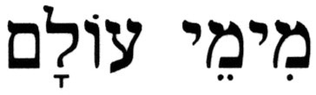 (mi'y'mei olam), from ancient days.

Micah, who was a contemporary of the prophets Amos, Hosea, and Isaiah, and of King Hezekiah (around 730 B.C.E.), states something special here, namely, that the origin of the Messiah would be from Bethlehem, from the long ago past, from ancient days. However, this statement conflicts with Christian theology, since Jesus is considered as having been around since the beginning of time, since before the Creation, and the expression from ancient days does not satisfy this condition. To "rectify" this problem, many Christian translators simply replace ancient days with days of eternity, or everlasting, or days of time indefinite (see, e.g., KJV, NAS, NWT). How can one determine who is telling the truth?

The Hebrew expression 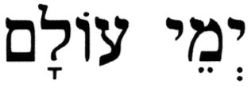 (y^{e}mei olam), ancient days, is used in Micah 5:1 with the preposition  (mi-), from, as (mi'y'mei olam), from ancient days. Table III.B-1 shows all six instances in the Hebrew Bible of the expression (y^{e}mei olam), ancient days, including its combinations with various prepositions. Also shown in the table are the respective renditions of these expressions in the KJV.

Table III.B-1 – KJV renditions of the expression (y^{e}mei olam) in the Hebrew Bible

Hebrew | Pronunciation | # | Reference | Correct Translation | KJV Rendition
 | y^{e}-ME-i o-LAM | 2 | Isaiah 63:9,11 | the days of old | the days of old
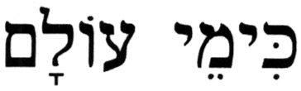 | kiy-ME-i o-LAM | 3 | Amos 9:11;  Micah 7:14;  Malachi 3:4 | as in days of old | as in the days of old
 | miy-ME-i o-LAM | 1 | Micah 5:1[2] | from ancient days | from everlasting

Note that the expression is correctly translated in the KJV in five out of the six cases as days of old, which is synonymous with ancient days, yet at Micah 5:2 it is rendered as from everlasting. What could have motivated the KJV translators to render the same expression correctly in all but one place, the one exception being at Micah 5:2, which speaks of the Messiah? Could it be that replacing from ancient days with from everlasting in this passage would "harmonize" this Old Testament prophecy with Christian theology? Did the KJV translators engage here in an act of "pious fraud"?

For the sake of completeness and fairness, it should be noted that, in contrast to the KJV (and several other Christian Bibles), some Christian translators have correctly rendered this phrase, e.g., NAB, NIV, NRSV, RSV, The New Jerusalem Bible, among others.

- Matthew 2:6

As was demonstrated above, the phrase from ancient days brings the reader back to King David and his ancestors, which created a serious theological problem for Christianity. It was also shown how the KJV translators attempted to "solve" this problem in their rendition of Micah 5:2. The author of the Gospel of Matthew apparently recognized this problem as he was attempting to construct a cohesive scenario, and his creative way of dealing with the true context of Micah 5:1[2] was to simply restates this verse:

Matthew 2:6(KJV) – And thou Bethlehem, in the land of Juda, art not the least among the princes of Juda: for out of thee shall come a Governor, that shall rule my people Israel.

Upon comparing Matthew 2:6 with even the KJV rendition of Micah 5:1[2], the following changes are evident in the part that corresponds to the passage in the KJV equivalent of Segment A:

- U The name of the place, Ephratah, is absent from the verse.

- U A subtle change in context takes place, from "though thou be little among the thousands of Judah", in the KJV Old Testament, to "thou … art not the least among the princes of Juda", in the KJV New Testament.

- U The generic title of ruler in the KJV Old Testament is replaced with the specific position of Governor In the KJV New Testament.

As was already noted earlier, the author of the Gospel of Matthew uses a truncated version of Micah 5:1[2] in Matthew 2:6. Thus, the obvious change is:

- U Segment B of the original verse was deleted

Clearly, Segment A, being a rather straight forward passage that could refer to the Messiah hailing from Bethlehem, required just a minor amount of editing to get it to "line up" with the rest of his story.

Regarding Segment B, which is disastrous to Christian theology, the author of the Gospel of Matthew does something interesting, as he also does in other places as well (e.g., Mt 2:13). He deletes the problematic part (Segment B) of Micah 5:1[2] so that it is absent from Matthew 2:6; he only applied an edited version of Segment A to what he wrote in Matthew 2:6. The problematic part would have drawn the reader to the origin of the Messiah, some 200-300 years behind Micah on the historical time scale, to King David himself.

The author of the Gospel of Matthew refused to accept the words of the Prophet Micah, because they describe Bethlehem as the least significant of the clans and communities of Judah. How can that be, if the Messiah is to be born there? The Messiah cannot be born in the insignificant place that is the lowest on the totem pole. This action demonstrates that the author of the Gospel of Matthew knew and understood very little of the Hebrew Bible, and that he did not understand that the reference here was to Ruth. So, in order to tailor this passage to fit his paradigm, he not only applied a portion of the verse out-of-context by dropping the problematic part of it, but he also changed the context of that which is written in the Hebrew Bible by reversing the you are to read you are not.

In contrast to the author of the Gospel of Matthew, the author of the Gospel of Luke was somewhat more careful. While he insists that Jesus was born in Bethlehem, he makes the correct connection, that it was the city of David (Lk 2:4,11). There are other instances where the author of the Gospel of Matthew, allegedly a Jew, made a mistake, while the author of the Gospel of Luke, allegedly a Gentile, used much more care in dealing with the same subject. One notable example is the application of Zechariah 9:9-10 in the Gospels. As dealt with in Matthew 21:1-7, the passage has Jesus coming into Jerusalem on two animals, while in Luke 19:29-35, Jesus is said to be coming on one animal.

IV. Summary

Is Micah 5:1[2] a prophecy that the (Jewish) Messiah will be born in Bethlehem? The Christian claim is that Jesus fulfilled this prophecy by being born in Bethlehem. As was demonstrated in the analysis, the town of Bethlehem was the place from which King David's family originated, and this prophecy speaks of Bethlehem as the Messiah's place of origin, though not necessarily his place of birth. The Hebrew text clearly states that the Messiah's ancestors came from Bethlehem.

Since the KJV translation of the Hebrew Bible came many centuries after the Gospel of Matthew was written, the only option available to Christian translators for "harmonizing" Micah 5:2 with Christian theology and Matthew 2:6 was to suitably alter the context of the source verse. Since Christians generally study the New Testament first, their theological ideas are well established by the time they proceed to the Old Testament to look for the "pointers". So that the discrepancies between Matthew 2:6 and Micah 5:2 are not likely to even be noticed.

Using the logic of the Christian claim, and considering the many thousands of people having come from Bethlehem during its history, how is it possible to identify which one of them was the Messiah? It is also worth noting that, relative to the important messianic attributes spelled out by the Jewish prophets in the Hebrew Bible, which Jesus did not fulfill, being born in Bethlehem is inconsequential, even if it were true.

Addressing Micah 5:2

By

Jim Lippard

A second claimed birth prophecy is that Jesus would be born in the city of Bethlehem, cited in Matthew (2:1-6), Luke (2:4-7), and John's (7:42) gospels. Of these, Matthew and John specifically refer to prophecy in the Hebrew scriptures. The passage referred to is Micah 5:2, which reads: "But as for you, Bethlehem Ephrathah, too little to be among the clans of Judah, from you one will go forth for me to be ruler in Israel. His goings forth are from long ago, from the days of eternity." "Ephrathah" is the ancient name of Bethlehem (Genesis 35:19, Ruth 4:11) but, to confuse matters, "Bethlehem Ephrathah" is also the name of a person: Bethlehem the son (or grandson) of Ephrathah (1 Chronicles 4:4, 2:50-51). This prophecy could therefore refer to either a native of the town or to a descendent of the person. If the latter, Jesus does not qualify since neither of his alleged genealogies (more on these below) list either Bethlehem or Ephrathah. If the former (more likely since Bethlehem was the birthplace of King David, from whom the Messiah is supposed to be descended), then Jesus qualifies by birthplace[4] but fails to meet the condition of being "ruler in Israel." Christians claim that this is a prophecy which will be fulfilled at the Second Coming.
There are various alleged genealogical prophecies about the ancestry of the Messiah. It is claimed that Genesis 22:18 and 12:2-3 are prophecies that the Messiah will be a descendent of Abraham, but these verses say nothing about the Messiah. They say simply that the descendents of Abraham will be blessed. Other claimed prophecies about the Messiah's ancestry are that he will be of the tribe of Judah (Genesis 49:10, Micah 5:2, of the family line of Jesse (Isaiah 11:1, 10, and of the house of David (Jeremiah 23:5, 2 Samuel 7:12-16, and Psalms 132:11). Some of these do appear to be genuine messianic prophecies, but others simply seem to refer to future kings. All of these verses refer to kings--and thus none have been fulfilled by Jesus.
But the problems for these prophecies run even deeper. Is Jesus actually of the tribe of Judah, the family line of Jesse, and the house of David? The sole evidence for this is two sets of genealogies for Jesus, in Matthew 1:1-17 and Luke 3:23-38. Both of these trace Jesus' lineage through his father, Joseph. If the virgin birth story is taken seriously, then Jesus lacks the proper ancestry. On the other hand, if the genealogy in Matthew is taken seriously, then Jesus has as an ancestor Jeconiah (Matthew 1:12), of whom the prophet Jeremiah said, "Write this man down as childless, a man who will not prosper in his days, for no man of his descendants will prosper sitting on the throne of David or ruling again in Judah." (Jeremiah 22:30) The genealogy in Luke suffers from the same problem, since it includes Shealtiel and Zerubbabel, both of whom were descendents of Jeconiah.

Source: http://www.infidels.org/library/modern/jim_lippard/fabulous-prophecies.html

Feel free to contact me at b_zawadi@hotmail.com

Return to Refuting Alleged Old Testament Prophecies Pointing to Jesus

Return to Homepage

[1] Matthew 2: Is it False, or Is it True? Copyright © 2002, Uri Yosef for http://www.MessiahTruth.com. All rights reserved.
[2] The notation Micah 5:1[2] shows the verse number from the Hebrew Bible first, followed by the corresponding verse number from the Christian Old Testament shown in brackets.

