To not Know "the L-rd" from "my master" Can End in Disaster
[Psalms 110]
by
Messiah Truth

I. Introduction

Psalms 110, an important Christian "proof text", is used by Christian apologists and missionaries as "testimony" from within the Hebrew Bible that validates theological doctrines, such as the Trinity and the divinity of the Messiah.

A rigorous analysis of the Hebrew text of this psalm demonstrates that these claims, which are based on mistranslations from the Hebrew and a lack of knowledge about Judaism, have no basis or support within the Hebrew Bible.

II. Comparison of Christian and Jewish English Translations

Side-by-side renditions of Psalms 110 are displayed in Table II-1. The King James Version (KJV) rendition also shows references to key passages in the New Testament, which cross-reference the respective portions of this psalm. [The references are found in the New American Standard Bible (NASB), but the corresponding passages, quoted below the table, are taken from the KJV.] Highlighted words and phrases will be discussed later as part of the analysis.

Table II-1 – Psalms 110

King James Version Translation |  | Jewish Translation from the Hebrew | Hebrew Text
Psalms 110 |  |  | 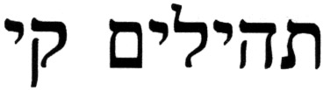
1 | The LORD said unto my Lord, Sit thou at my right hand, until I make thine enemies thy footstool.⁽¹⁾ | Of David a psalm. The word of the L-rd [Y-H-V-H] to my master [ladoni]: "Sit at/[Wait for] My right hand, until I make your enemies a footstool at your feet." | 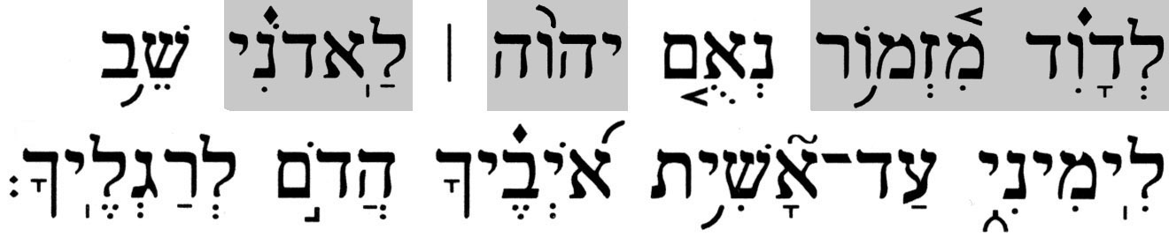 | 
2 | The LORD shall send the rod of thy strength out of Zion: rule thou in the midst of thine enemies. | The L-rd [Y-H-V-H] will send the staff of your might from Zion; rule in the midst of your enemies! | 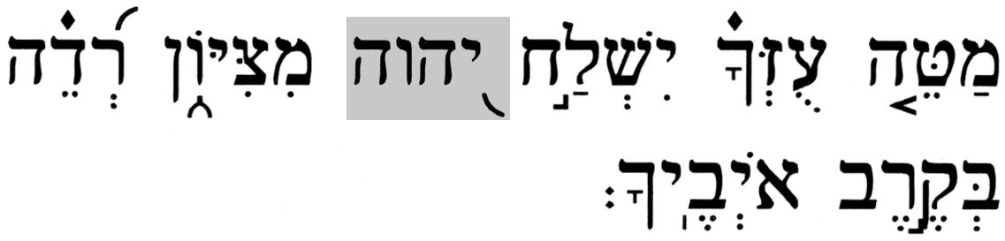 | 
3 | Thy people shall be willing in the day of thy power, in the beauties of holiness from the womb of the morning: thou hast the dew of thy youth. | Your people will volunteer in the majesty of their holiness, on the day of your battle; when still the dew of your youth was upon you, fresh from the womb of dawn. | 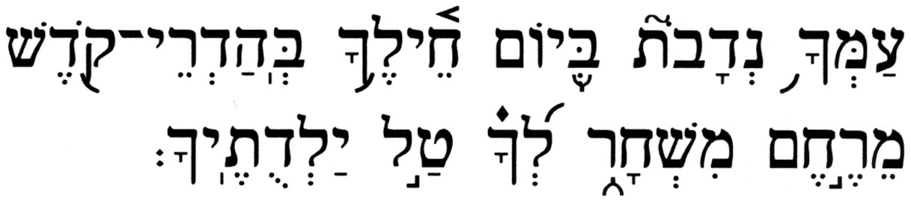 | 
4 | The LORD hath sworn, and will not repent, Thou art a priest for ever after the order of Melchizedek.⁽²⁾ | The L-rd [Y-H-V-H] has sworn, and will not change His mind, "on my word, you are to serve for ever, my righteous king." [alternatively, "you are a priest for ever, in the manner of Malki-Tzedeq."] | 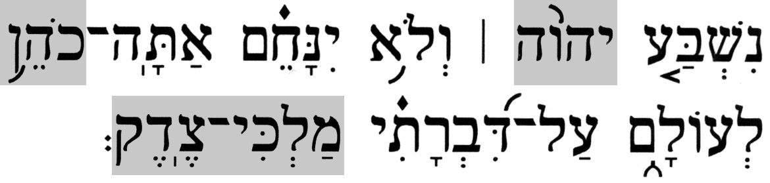 | 
5 | The Lord at thy right hand shall strike through kings in the day of his wrath.⁽³⁾ | The L-rd [A-donai] is at your right hand, He has crushed kings in the day of His wrath. |  | 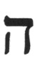
6 | He shall judge among the heathen, he shall fill the places with the dead bodies; he shall wound the heads over many countries. | He will execute justice among the nations, [their land] is filled with corpses; he has crushed the head of a great land. | 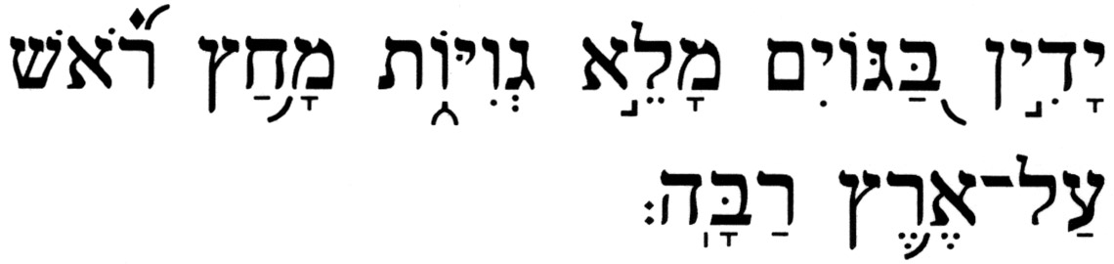 | 
7 | He shall drink of the brook in the way: therefore shall he lift up the head. | He would drink from a stream on the way; therefore, he would raise his head. | 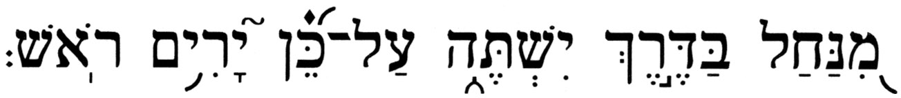 | 
1. Direct "quotes": Matthew 22:44(KJV) - The LORD said unto my Lord, Sit thou on my
right hand, till I make thine enemies thy footstool?
Mark 12:36(KJV) - For David himself said by the Holy Ghost, The LORD
said to my Lord, Sit thou on my right hand, till I make
thine enemies thy footstool.
Luke 20:42, 43(KJV) - And David himself saith in the book of Psalms, The
LORD said unto my Lord, Sit thou on my right hand,
Acts 2:34-35(KJV) – (34) For David is not ascended into the heavens: but
he saith himself, The Lord said unto my Lord, Sit thou
on my right hand, (35) Until I make thy foes thy
footstool.
Hebrew 1:13(KJV) - But to which of the angels said he at any time, Sit on
my right hand, until I make thine enemies thy
footstool?

Allusions: Matthew 26:64(KJV) - Jesus saith unto him, Thou hast said: nevertheless I say
unto you, Hereafter shall ye see the Son of man sitting on
the right hand of power, and coming in the clouds of
heaven.
Colossians 3:1(KJV) - If ye then be risen with Christ, seek those things which
are above, where Christ sitteth on the right hand of God.
Hebrews 8:1(KJV) - Now of the things which we have spoken this is the sum:
We have such an high priest, who is set on the right hand of
the throne of the Majesty in the heavens;
Hebrews 10:12(KJV) - But this man, after he had offered one sacrifice for sins
for ever, sat down on the right hand of God;
1 Corinthians 15:25(KJV) - For he must reign, till he hath put all enemies under
his feet.
2. Hebrews 5:6,10(KJV) – (6) As he saith also in another place, Thou art a priest for ever
after the order of Melchisedec.
(10) Called of God an high priest after the order of Melchisedec.
Hebrews 6:20(KJV) - Whither the forerunner is for us entered, even Jesus, made an
high priest for ever after the order of Melchisedec.
Hebrews 7:17,21(KJV) – (17) For he testifieth, Thou art a priest for ever after the order
of Melchisedec.
(21) (For those priests were made without an oath; but this
with an oath by him that said unto him, The Lord sware and
will not repent, Thou art a priest for ever after the order of
Melchisedec:)
3. Romans 2:5(KJV) - But after thy hardness and impenitent heart treasurest up unto
thyself wrath against the day of wrath and revelation of the
righteous judgment of God;

Major discrepancies exist between the Jewish and Christian translations of this psalm, particularly as it concerns the opening verse. First, unlike most Christian Bibles, the KJV completely discarded the superscription "Of David a Psalm.". In the rest of the verse, the Hebrew term 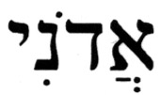 (adoni; pronounced ah-do-NEE), my lord/master, is rendered in the KJV and many other popular Christian Bibles as my Lord. This alludes to Jesus (via the capital "L"), who is G-d the Son, the second personage in the Trinity. The Tetragrammaton, 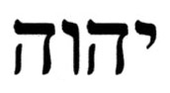, the ineffable title of the Creator that is written in the Hebrew via the four-letter sequence 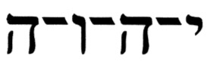 (yod-heh-vav-heh), Y-H-V-H, appears in Psalms 110:1,2,&4, and is punctuated with vowels to be pronounced ah-do-NA-i. This is rendered in the KJV as The LORD, alluding to G-d the Father, the first personage in the Trinity. The use of all capital letters aims to distinguish The LORD [G-d the Father] from The Lord [G-d the Son]. The actual word 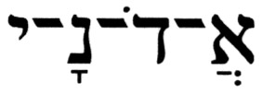 (A-donai), another one of several common titles used in the Hebrew Bible for the Creator, is the first word in Psalms 110:5. It should be noted that in the Hebrew, both (adoni), my lord/master, and (A-donai), G-d, are identically spelled, but are punctuated with different vowels. The KJV, having created the rendition my Lord for [(adoni), my lord/master] in Psalms 110:1, had no choice but to render [(A-donai), G-d] in Psalms 110:5 as "The Lord" (i.e., G-d the Son).

III. Overview of Christian and Jewish Interpretations

A. Overview of the Christian Perspective

Christians view Psalms 110 as a messianic psalm fulfilled by Jesus as both the Messiah (who, in Christian theology, is greater than his ancestor, King David) and, for Trinitarians, a divine being, the Son in the Trinity).

As can be seen from the numerous references to it, the authors of the New Testament had a great interest in this psalm. According to the Christian view, the explicit application of this psalm to Jesus is noted in several ways:

 By Jesus himself (e.g., Matt 22:41-45; Mark 12:35-37; Luke 20:41-44)

 By his apostles (e.g., Acts 2:33-35; Heb 1:13; 7:20-24)

 By frequent references to its language throughout the New Testament (e.g., 1 Cor 15:25; Eph 1:20; Col 3:1; Heb 10:12-13)

The prolific use of Psalms 110 in the New Testament leaves no doubt in the mind of a Christian believer about its purely prophetic character. In other words, the Christian view is that, when the L-rd G-d speaks of the Messiah, and when David prophetically refers to the Messiah, who is his descendant, as my Lord in Psalms 110:1, it clearly shows this cannot refer to an ordinary person. Rather, it can only refer to the one who fulfills this verse in both ways, as a divine being and Messiah, namely, Jesus of Nazareth.

Psalms 110:1,4 are the two key verses in this psalm on which the Christian interpretation rests. Psalms 110:1 allegedly refers to Jesus as being invited to sit on the right side of G-d in glory, where he will wait for G-d (the Father) to judge the earth and bring all things into subjection under him (the Son). Psalms 110:4 speaks of a priest of the Most High G-d, Melchizedek (the common Christian transliteration will be used in reference to Christian claims), who came to Abraham, and to whom Abraham tithed one-tenth of all his goods. Thus, because Abraham tithed him, the Christian view holds that Melchizedek was greater than Abraham (who was Levi's great-grandfather). So that the Melchizedek priesthood, having preceded the Aaronic priesthood, is viewed as being superior to it and, thus, supplants and replaces it.

In Judaism, and according to Torah, the royal office (which was the domain of the Tribe of Judah) and the office of the priesthood (which was the domain of the Tribe of Levi) are separate entities, so that a priest may not be a king, and vice versa. But for Christianity, this psalm celebrates the exaltation of Jesus to the throne of an eternal and increasing kingdom and a perpetual priesthood that will see the subjugation of his enemies and the multiplication of his subjects, and which is rendered a certainty by the word and oath of the Almighty.

More detailed commentary may be found in the standard Christian commentaries such as, Matthew Henry and Jamieson, Fausset, & Brown.

B. The Jewish Perspective

Regardless of who its author was, the overall theme of Psalms 110 is that it speaks of David's legendary power, which came through divine favor that was earned by his righteousness. The author of this psalm assures King David of victory over the enemies of his people, the Jewish people.

Regarding the interpretation of this psalm, as is often the case, there are several perspectives offered by the Jewish Sages. The two most common interpretations are that this psalm is about either King David or our Patriarch Abraham. Another interpretation combines these two. Lastly, since King David's name is associated with the future King/Messiah (e.g., Jer 30:9; Ezek 37:24; Hos 3:5), a messianic interpretation of this psalm is also plausible.

The interpretation of this psalm by Rabbi Ibn Ezra (and adopted also by Rabbi David Qimhi [RADAQ]) as being about King David is according to the pshat, i.e., the simple/literal reading, wherein the superscription is "A Psalm for [or, concerning] David". It entails David's ordeal with King Saul [a Benjaminite, 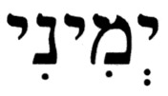 (y^{e}mini) in Hebrew, e.g., Esther 2:5, a word that is identical to the Hebrew term for the phrase my right hand]. According to this view, David is asked to wait until his enemy (Saul) is brought down.

The interpretation by RASHI (Rabbi Shlomo Yitzhaqi) uses the apparent allusion to Malki-Tzedeq as a way to relate this psalm to Abraham and his battle with Amraphel, and his subsequent victory over the four enemy kingdoms (see Genesis14).

A melding of these two interpretations is possible when one reads this psalm as a prayer by an aging King David when his soldiers went to battle without him. In his prayer, King David refers to images of G-d's dealings with Abraham during his battle with the four kings, and he asks G-d to help him as He helped Abraham to prevail over his enemies.

Finally, since King David is also counted among the 55 Jewish prophets listed in the Hebrew Bible, and there is use made in this psalm of verbs conjugated in the future tense, it becomes plausible that there is allusion here to the future King/Messiah. As such, this psalm confirms some of the basic requirements the Messiah must meet, e.g., that he will be of the seed of David, victorious over all his enemies, a Torah scholar, and a world leader.

IV. Who Is Speaking to Whom? About What Are They Speaking?

The Christian interpretation of Psalms 110 is plagued by many problems, all of which appear to be connected to the most common Christian renditions of the first verse.

- The Superscription

Christian renditions generally do not number the superscription at the head of a psalm and, in the case of Psalms 110, the KJV deleted the superscription altogether. Yet, it is noteworthy that the Christian perspective on this psalm depends on the assumption that King David is the author and speaker. On the other hand, the Jewish interpretations are not limited by such a restriction.

In the Hebrew text, the superscription reads 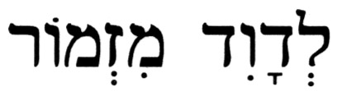 (l^{e}David mizmor), where  (l^{e}) is a preposition, 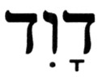 (David) is the name David, and 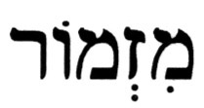 (mizmor) means a psalm. The Hebrew preposition (l^{e}) could have any of the following meanings: to or for, by, and in or into. Eliminating the last pair for obvious reasons, this particular superscription could indicate this psalm as having been either composed by David or composed for or dedicated to David. In other words, it is not possible to determine, with absolute certainty, that King David was the composer of this psalm.

Christian apologists and missionaries will cry "foul" here, charging that this is an after-the-fact attempt to use this ambiguity to force a biased interpretation of this psalm. Such charges are effectively countered with other instances in the Book of Psalms where the preposition (l^{e}) in the superscription means for and not by. The group of 11 psalms and songs for the Sons of Korah, Psalms 42, 44, 45, 46, 47, 48, 49, 84, 85, 87, and 88, exemplify this. In each of these psalms, the superscription contains the following type of phrase:

Psalms 48:1 - A Song, a Psalm for the sons of Korah [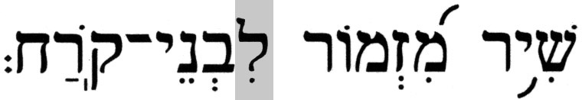(shir mizmor li'vnei korah)].

Then there is Psalms 72, composed by King David for his son Solomon:

Psalms 72:1,20 – (1) A Psalm for Solomon [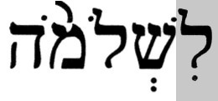(li'shlomoh)]. O G-d, give your judgments to a king; and your righteousness to a king’s son.
(20) The prayers of David the son of Jesse are completed.

In both cases, the preposition (l^{e}) changes to  (li) due to a grammatical rule[1]. These two examples demonstrate that the assumption on which the Christian view of this psalm is based, namely, that David must be its author, is not necessarily valid since it is not the only possibility here. Because this psalm is not written in the 1st-person relative to David, it could have been composed by someone else, perhaps someone who served under David.

It is interesting to note that, in Psalms 72, King David speaks about himself in the 3rd-person in the opening and closing verses, something that is also found in other Psalms written by David:

Psalms 144:1,10 – (1) A Psalm of David [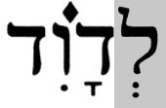(l^{e}David)]. Blessed is the L-rd my rock, Who trains my hands for the battle; my fingers for the war;
(10) Who gives salvation to the kings; Who delivers David His servant from the evil sword.

It is, therefore, reasonable to posit that King David authored Psalms 110, writing about himself in the 3rd-person, or prophetically about the future King/Messiah. As a result, any one of the Jewish interpretations can be validated vis-à-vis the Hebrew Bible. Moreover, the Jewish interpretations do not support the Christian perspective, since it is founded on mistranslations and on concepts that are not part of the Hebrew Bible.

- Who Is Speaking to Whom in Psalms 110:1?

In the two renditions of Psalms 110:1 shown below, the equivalent Hebrew terms and their respective transliterations are placed in brackets following the highlighted translated phrases.

The KJV and other Christian translations render the opening verse this way:

Psalms 110:1(KJV) - The LORD [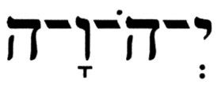(Y-H-V-H)] said unto my Lord [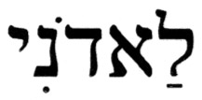(ladoni)], Sit thou at my right hand, until I make thine enemies thy footstool.

The common Jewish translation of the opening verse is:

Psalms 110:1 - Of David a psalm. The word of the L-rd [(Y-H-V-H)] to my lord/master [(ladoni)]: "Sit at/[Wait for] My right hand, until I make your enemies a footstool at your feet."

Clearly, both translations cannot be correct, and a further analysis of this verse will help determine which of these is the correct one.

The first phrase in the Hebrew text, the Tetragrammaton, (yod-heh-vav-heh), Y-H-V-H, is rendered as The LORD in the KJV, and as The L-rd in the Jewish translation. Both Christian and Jewish interpretations agree on this term as representing the Creator.

The next term in the Hebrew text, (ladoni, is rendered as unto my Lord in the KJV (note the capital "L"), and as to my lord/master in the Jewish translation (note the lower-case "l"/"m"). The Hebrew word (ladoni), pronounced as la-doh-nee), consists of two components: the preposition (l^{e}), which was encountered in Sec. IV.A, and which can only mean to in this case; and (adoni), which is the 1st-person, singular conjugation (in the possessive) of the noun/title 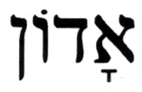 (adon). Rules of Hebrew grammar cause several changes in the noun/title (adon) when it is both conjugated in the possessive and combined with the preposition (l^{e})[2].

Table IV.B-1 shows the four different applications or the term (adon) in the Hebrew Bible, of which there are 334 instances.

Table IV.B-1 – Applications of (adon) in the Hebrew Bible

Term | Meaning(s) | # | Sample Citations | Remarks
 | a ruler, a governor, a head of state | 6 | Genesis 45:9;  Jeremiah 34:5 | ---
 | appellation for addressing G-d | 26 | Isaiah 1:24;  Psalms 114:7 | (adoni) is never used in this application.
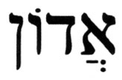 | a title for a superior | 202⁽¹⁾ | Genesis 23:6;  1 Samuel 16:16 | Appears only in possessive forms.
 | master of …, owner of … | 103⁽²⁾ | Genesis 24:51;  Job 3:19 | Appears only in plural forms, but may be in singular context.
(1) This includes all instances of (adoni)
(2) This includes three cases from the 26 instances of an appellation for addressing G-d

Of the 334 cases of the term (adon) in the Hebrew Bible, 195 are conjugated in the 1st-person possessive form (adoni), which occur with and without attached prepositions. This subset of 195 cases is broken out in terms of the various forms (with and without prepositions) in Table IV.B-2.

Table IV.B-2 – Applications of (adon) in the Hebrew Bible

Term | Pronunciation | # | Sample Citations | Correct Translation | KJV Rendition
 | ah-do-NEE | 162 | Genesis 24:18;  Isaiah 36:9;  Daniel 10:17 | my lord [or master] | All but three have:  my lord/master.  The three exceptions have⁽¹⁾: my Lord (Joshua 5:14; Judges 6:13; Daniel 12:8)
 | lah-do-NEE | 24⁽²⁾ | Genesis 24:36,54,56, 32:5,6,19[4, 5, 18], 44:9,16(x2),33;  1 Samuel 25:27;  2 Samuel 19:29[28];  1 Kings 1:2(x2), 20:9 | to/unto/for my lord [or master] | to/unto/for my lord/master
 | lah-do-NEE | 24⁽²⁾ | 1 Samuel 24:6*, 25:28*,30*,31(x2)*;  2 Samuel 4:8*;  1 Kings 18:13*;  1 Chronicles 21:3* | the L-rd & to/for my lord [or master] | All but one have:  the LORD & to/for my lord/master.
 | lah-do-NEE | 24⁽²⁾ | Psalms 110:1* | the L-rd & to/for my lord [or master] | The exception is:  Psalms 110:1, which has: The LORD & unto my Lord
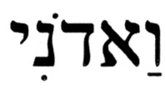 | vah-do-NEE | 6 | Genesis 18:12;  2 Samuel 11:11 | and my lord [or master] | and … my lord; my lord also …
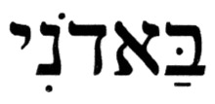 | bah-do-NEE | 2 | 1 Samuel 24:11[10];  2 Samuel 18:28 | at/against my lord [or master] | against my lord
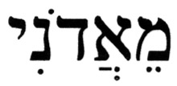 | me-ah-do-NEE | 1 | Genesis 47:18 | from my lord [or master] | from my lord
(1) These three instances of my Lord correspond to Joshua, Gideon, and Daniel,
respectively, addressing an angel.
(2) Since the specific term of interest is (ladoni), all 24 citations are shown. Moreover,
since Psalms 110:1 is one of nine verses among these 24 citation which contain both the
Tetragrammaton , and the term , all nine verses are marked with an asterisk (*).

The data in Table IV.B-2 demonstrate that the KJV translators understood that the term (adoni), with and without prepositions, means my lord or my master. Specifically, as it concerns the term in Psalms 110:1, (ladoni), in 23 cases the KJV has it correctly translated as to/unto my lord/master, and only in Psalms 110:1 it is rendered unto my Lord (with the capital L) which imparts to it the desired Christological significance. This manipulation by the KJV translators becomes even more obvious when the nine cases in which both the Tetragrammaton, , and the term (ladoni) appear in the same verse are analyzed. On eight occasions, the KJV has LORD & lord/master, respectively. In the remaining case, at Psalms 110:1, the combination LORD & Lord appears in the KJV.

According to both Biblical and Modern Hebrew, there is no connection between (adoni) and (A-donai), because the appellation (adoni) is never used to address G-d; it is used in addressing a (mortal) man or an angel. On the other hand, as can be seen from Table IV-B-1, the term (adon) is applied to both G-d and (mortal) men.

The above information clearly demonstrates that the Christian rendition with its imputed Christological implications cannot be valid.

It is an interesting exercise to trace this mistranslation in the KJV and other popular Christian Bibles to its possible source. The manner in which some ancient translations of the Hebrew Bible render the terms (Y-H-V-H)/(adoni) in Psalms 110:1 provides a valuable clue to the answer. Table IV.B-3 shows three ancient translations:

Table IV.B-3 – The terms (Y-H-V-H)/(adoni) as rendered in ancient translations

Source | Language | Terms | Transliteration | Translation (in context)
Targum Yonathan | Aramaic | */ | Y-H-V-H/li | [Said] the L-rd [in words] to me, [master over all of Israel]
Christian LXX | Greek | ο κυριος/κυριω μου | o kurios/kurio mou | [Said] The LORD [to] my Lord
Jerome's Vulgate** | Latin | Dominus/Domino meo | (as shown in Latin) | [Spoke] The LORD [to] my Lord
* is a common (non-sacred) notation used in place of the (sacred) Tetragrammaton, .
** This is Psalm 109 in both the Christian LXX and Jerome's Latin Vulgate.

The alleged "quotations" of Psalms 110:1 in the Greek language of the three Synoptic Gospels (Matthew, Mark, and Luke) all have the same usage that appears in the Christian LXX. Upon reading the relevant passages in the Gospels, the source of the problem – the erroneous translations in Christian Bibles – is discovered. Two separate and distinct Hebrew terms, , (Y-H-V-H) and (adoni), generate the same Greek term, κυριος (kurios), and thereby the distinction is erased. In other words, each Gospel's rendering utilizes the same Greek word κυριος (kurios), lord/master, twice in the same verse. In the Greek text, the first occurrence of κυριος (kurios) [actually, ο κυριος (o kurios)], is the translation of , (Y-H-V-H), and the second κυριος (kurios) [actually, κυριω μου (kurio mou)], is the translation of (ladoni), of which (adoni) is a component. Since the Christian LXX utilizes solely the lower-case Greek alphabet, the exegetical problems to which the Gospels' Jesus refers are apparent only in the Greek rendering. Subsequently, these propagate into translations made from the Greek. The resultant confusion this problem creates in the Greek text does not exist in the Hebrew text and, therefore, Jesus' discourse is only possible if he and those with whom he spoke were conversing in Greek. His exegesis in the Gospels is non-existent in the Hebrew, and it is flawed in its understanding of the Greek rendering. Christian translators seize on this ambiguity and separate the two instances according to Christian theology. The ο κυριος (o kurios) becomes The LORD, a reference to G-d the Father; whereas the κυριω μου (kurio mou) becomes my Lord, a reference to the Son, Jesus, the messiah of Christianity.

Though there is nothing in the Hebrew language of this verse to positively indicate that King David was referring to the Messiah when he wrote (adoni), my lord/master, in reality, there is no problem with David realizing that the Messiah will be greater than he is. Moreover, there is nothing in David's words to indicate that the individual to whom he refers as my lord/master is a divine being. If he authored this psalm, David refers to himself in the 3rd-person for someone else to chant about him. If the author was someone other than David, he refers to King David. Nothing in the text of this psalm supports the Christian claim that (adoni) refers to Jesus.

Who is speaking to whom in Psalms 110:1? The analysis demonstrates that the Christian interpretation of G-d the Father addressing "G-d" the Son (Jesus) does not work; while any of the common Jewish interpretations is plausible. It definitely cannot be Jesus relating what G-d said to him, yet it could be King David relating what G-d had promised him (in response to his pleas in Psalms 109). Or, perhaps, an anonymous author from the king's court speaking about the promises G-d made to his master, King David.

- Can One Find the Trinity in Psalms 110:1?

Christian apologists and missionaries also claim that Psalms 110:1 supports the Doctrine of the Trinity. The question is: "From a Christian perspective, does the Tetragrammaton, , (Y-H-V-H), rendered The LORD in the KJV (and many other Christian translations), refer to G-d the Father, or to "G-d" the Son, or to the full Trinity?" To help put this claim into its proper perspective, consider the Sh^{e}ma, often regarded as the "creed" of Judaism (the Hebrew is shown under the English version):

Deuteronomy 6:4 - Hear, O Israel; the L-rd is our G-d, the L-rd is One.

The Hebrew term 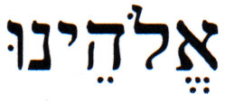 (E-loheinu), our G-d, is the 1st-person, plural conjugation of 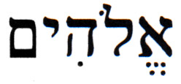 (E-lohim), G-d. Christian apologists and missionaries maintain that the Hebrew term (E-lohim) is plural and should be understood in its literal sense as gods, thereby reflecting a triunity. Using this line of reasoning, the (translated) Sh^{e}ma should be interpreted as:

Hear, O Israel; the L-rd is our gods, the L-rd is a compound unity.

This Christian understanding of the Sh^{e}ma leads to the conclusion that the expression the L-rd, [, (Y-H-V-H)] can refer to neither G-d the Father nor "G-d" the Son individually. Rather, it must refer to all three members of the Trinity at once. Therefore, this would invalidate the Christian claim that the phrase unto my Lord (as translated in KJV and many other Christian Bibles) refers to Jesus! If, according to the common Christian interpretation of Psalms 110:1, the expression my Lord refers to Jesus, the second member of the Trinity, then who is The LORD at the beginning of Psalms 110:1? Because, if the L-rd [, (Y-H-V-H)] in the "modified" Sh^{e}ma, i.e., "the L-rd (who is) our gods", were a triunity united in the divine name, then The LORD in the KJV rendition of Psalms 110:1 would also have to refer to this triunity. Yet, if this were the case, then the phrase unto my Lord in the KJV's rendition of Psalms 110:1 would automatically exclude Jesus, who would have already been included in the first part of the verse, The LORD.

Another curious issue is created by the attempt to impute the Trinity into Psalms 110:1. If my Lord (allegedly Jesus) is sitting next to The LORD, who represents the triune godhead or any aggregate of it, then he cannot be part of it, since that which exists outside of G-d cannot be G-d. And, lastly, where is the third component of the Trinity, the Holy Spirit, in all of this?

- Has the Melchizedek Priesthood Replaced Israel's Aaronic Priesthood?

As noted in Sec. III.A, Psalms 110:4 is used as a "proof text" by Christian apologists and missionaries to support the notion that Jesus is both the king (Messiah) and high priest, as Melchizedek was. This notion supplants the Aaronic priesthood with a new priesthood, claimed to be superior to it, the priesthood according to Melchizedek. To support these claims, passages such as the following, are cited:

Hebrews 7:3(KJV) - Without father, without mother, without descent, having neither beginning of days, nor end of life; but made like unto the Son of God; abideth a priest continually.

Hebrews 7:21(KJV) - (For those priests were made without an oath; but this with an oath by him that said unto him, The Lord sware and will not repent, Thou art a priest for ever after the order of Melchisedec:)

Are these claims consistent with what the Hebrew Bible teaches? In order to answer this question, it is important to note that, at the time of the crucifixion of Jesus, the New Testament did not exist; it was written over a period of many years, starting at least a decade after the event. The Hebrew Bible was the Scripture in force at that time. An analysis of some terminology will demonstrate that the author of the Epistle to the Hebrews took some editorial liberties in transforming material that he learned from reading some Greek translation of the Hebrew Bible into the message he was generating.

One term of interest is the name/title Malki-Tzedeq (the transliteration from the Hebrew is used here instead of Melchizedek from the common Christian renditions of Psalms 110:4). The Hebrew expression 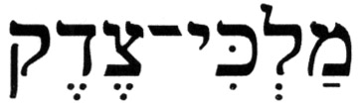 (malki-tzedeq), my king [he] is righteousness or my righteous king, appears only twice in the Hebrew Bible, at Psalms 110:4 and at Genesis 14:18, the latter of which is:

Genesis 14:18 - And Malki-Tzedeq [(malki-tzedeq)], king of Shalem, brought out bread and wine; and he is a priest of the Most High G-d.

[There is also found in the Hebrew Bible, at Joshua 10:1,3, a related, but not identical, name/title, 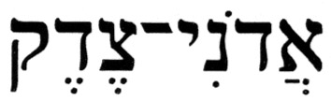 (adoni-tzedeq), my lord/master [he] is righteousness or my righteous lord/master; the King of Jerusalem.] At Genesis 14:18, (malki-tzedeq) is a reference to the King of Shalem (an earlier designation for the city of Jerusalem) in Abraham’s days. Malki-Tzedeq was a Gentile priest-king who worshipped the "One True G-d" as one of the righteous Gentiles who, like some other Biblical personalities (e.g., Noah, Jethro, and Job), was not connected with Israel, as is the case with the righteous Gentiles of today, the B'nei Noach (Noahides). At Psalms 110:4, (malki-tzedeq) is likely to be a reference by the psalmist to King David, whose legendary power came with the help of Divine favor that was earned through his righteousness.

Another term of interest is 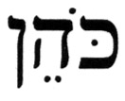 (koheyn), which, in its most common usage in the Hebrew Bible, is correctly translated as a priest. However, the literal English translation of this term as a priest at Psalms 110:4 can be challenged for several reasons. First, according to the Hebrew Bible, the plan for Israel is one that separates the functions of priesthood and monarchy; an idea that is similar to the concept known today as "separation of church and state". The Torah defines in Deuteronomy 17:14-20 the selection, qualifications, and duties of the king – the political leader. Starting with King David (2 Sam 7:12-16), it was required that kings of the Davidic dynasty had to be from the Tribe of Judah and biological descendants of King David through King Solomon. Deuteronomy 18:1-8, the passage in the Torah that immediately follows the passage about a king of Israel, describes the other category of leadership, the Priests and Levites - the spiritual leaders, who will all be from the Tribe of Levi. Therefore, in addition to their listed qualifications, the two positions, king and priest, are mutually exclusive. In other words, in Israel, a king cannot be a priest, and a priest cannot be a king, and this is evident from the following passage:

Leviticus 4:22-26 – (22) When a ruler [of Israel] sins; and, without intention, does one of the commandments of the L-rd his G-d which may not be done, and he incurs guilt; (23) Or if he is informed of his sin that he has sinned; then he shall bring his offering, a male goat without blemish; (24) And he shall lay his hand firmly upon the head of the goat, and slaughter it in the place where he would slaughter the burnt offering before the L-rd; it is a sin offering. (25) And the priest shall take some of the blood of the sin offering with his finger, and place [it] upon the horns of the altar [used] for burnt offerings; and [the remainder of] its blood he shall pour out onto the base of the altar [used] for burnt offerings. (26) And all its fat he shall burn upon the altar as the fat of the peace offering; and the priest shall make atonement for his [the ruler's] sin, and he will be forgiven.

This passage, which describes the sin-offering ritual for a king, shows that the king is subservient to the priest, just as any commoner is, in the performance of the ritual. A king is barred from certain functions performed by a priest.

Second, the term (koheyn) [plural, 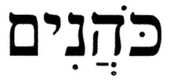 (kohanim)], in addition to its common application of ministering as a priest, may be applied to describe serving in an official [ruling] capacity, a context in which it is occasionally used in the Hebrew Bible, and even correctly translated in the KJV, as the following examples demonstrate:

2 Samuel 8:18(KJV) - And Benaiah the son of Jehoiada was over both the Cherethites and the Pelethites; and David's sons were chief rulers [(kohanim)].

2 Samuel 20:26(KJV) - And Ira also the Jairite was a chief ruler [(koheyn)] about David.

1 Kings 4:5(KJV) - And Azariah the son of Nathan was over the officers: and Zabud the son of Nathan was principal officer [(koheyn)], and the king's friend:

Moreover, King David is recorded in the Hebrew Bible as having performed some priestly functions:

2 Samuel 6:14,17 – (14) And David danced with all his might before the L-rd; and David was girded with a linen ephod.
(17) And they brought in the ark of the L-rd, and set it in its place, inside the tent that David had pitched for it; and David offered burnt offerings and peace offerings before the L-rd.

This, too, will be the case with the Jewish King/Messiah of Israel in the messianic era:

Ezekiel 45:17 - And on the Prince shall be [the responsibility to bring] the burnt offerings, and meal offerings, and drink offerings, on the Festivals, and the New Moons, and the Sabbaths, on all the appointed times of the House of Israel; he shall prepare the sin offering, and the meal offering, and the burnt offering, and the peace offering, to atone for the House of Israel.

Ezekiel 46:12 - And when the Prince shall prepare a free-will offering, a burnt offering or a peace offering as a free-will offering to the L-rd, one shall open the gate that faces east, and he shall prepare his burnt offering and his peace offering as he does on the Sabbath day; and he shall exit, and one shall close the gate after he has left.

Psalms 110:4 defines the status of King David, which also confirms that his distinctive monarchy would be continued in his successors. In addition to his regal dignity, he would also perform certain priestly functions, albeit not of the same standing as Aaron and his descendants, the Priests, (kohanim). Neither Malki-Tzedeq nor King David were consecrated into the Aaronic priesthood; but David ruled his people in the light of G-d's will and, as such, was a priest-king of sorts, portraying the ideal for the Davidic dynasty, that a Jewish king should be like a priest, drawing the Jewish people closer to G-d.

The Hebrew Bible rules out the possibility of having a valid priestly order outside of the Aaronic priesthood. Any priesthood that predates Levi, the son of Jacob/Israel and progenitor of the priestly Tribe of Levi, remains outside the realm of Judaism, since the priesthood that emerged out of Levi has been established for eternity:

Exodus 40:15 - And you shall anoint them [Aaron's sons], as you anointed their father, and they shall serve [as priests] unto Me; and their anointing shall surely be an everlasting priesthood throughout their generations.

Numbers 25:12-13 – (12) Therefore say, "Behold, I give him [to Phineas] My covenant of peace; (13) And it shall be for him and for his descendants after him a covenant of an eternal priesthood; because he was zealous for his G-d, and atoned for the Children of Israel.

Consequently, the references in the Letter to the Hebrews to Jesus being a priest of the order of Melchisedec (Melchizedek) are irrelevant to Psalms 110.

Finally, there is the matter of the claim that the Melchizedek priesthood is superior to the Aaronic priesthood of Israel because Melchizedek conferred a blessing on Abraham. Christian apologists and missionaries maintain that, through this act, Melchizedek also blessed Levi, one of Abraham's great-grandsons. A careful reading of the actual passage reveals the flaw in this claim. While it is, indeed, Malki-Tzedeq who was acknowledged as a priest-king of the “… Most High G-d …” (Gen 14:18), it was Abram, not Abraham, who “… gave him a tenth of all …” (Gen 14:22). The salient point here is that the tithing took place prior to Abram's name being changed to Abraham and his formal entry into Hebrew monotheism via the covenant of circumcision (Gen 17:5-14). In other words, since Abram was a Gentile at the time he received the blessing from Malki-Tzedeq, there is no basis to the claim that Melchizedek's priesthood is superior to Aaron's priesthood; they are independent priesthoods – one for Gentiles and one for Jewish people.

V. Summary

The analysis of Psalms 110 demonstrates that Christian apologetic and missionary claims about this important component in their portfolio of "proof texts" are based on mistranslations, misinterpretations, and flawed reasoning.

Even though several different Jewish interpretations of Psalms 110 exist, they are all consistent with the teachings of the Hebrew Bible. On the other hand, the common Christian interpretation of this psalm, with its imputed Christology, falls apart under rigorous scrutiny. Not only can Jesus not be the one sitting to the right of G-d, his supposed priesthood according to the order of Melchizedek is a self-defeating argument, since Melchizedek was a Gentile, not a Jewish, priest.

The bottom line is this:

- If, as Christian apologists and missionaries often claim, Jesus was a Jew, then he cannot be a priest in an order that is outside of Judaism, such as the Melchizedek priesthood, since the Aaronic priesthood was established exclusively and eternally for Israel.

- If, on the other hand, Jesus was not a Jew, then, according to Torah, he cannot rule as king of Israel.

The case is closed!

Source: www.messiahtruth.com/ps110.html

"The Lord Said to My Lord . . . ." To Whom Was the Lord Speaking in Psalm 110:1 ?

By Out Reach Judaism

Question:
Dear Rabbi Singer,
A co-worker and friend of mine, who I know is a fundamentalist Christian, recently asked me what Jews think about the Trinity. I told him that the concept is not part of our religion and that Jews believe in only one God. He went on to ask me to explain Psalm 110 to him, which starts in English, "The Lord said unto my Lord . . . ." To him this is yet another proof of the trinity. I could not give him an answer to his question. Would you please explain the meaning of this.
Thank You.
Answer:
Psalm 110 represents one of the New Testament's most stunning, yet clever mistranslations of the Jewish scriptures. Moreover, the confusion created by the Christianization of this verse was further perpetuated and promulgated by numerous Christian translators of the Bible as well. As you will soon see, some Christian translators, to their credit, refrain from rewriting this text in Psalm 110.
The story of the church's tampering with Psalm 110 is so old that it begins in the Christian canon itself. In the Gospels we find the church's first use of Psalm 110, and it begins with a question. In Matthew 22:41-44 Matthew's Jesus turns to the Pharisees and asks them,
What do you think about the Christ? Whose son is he?
The question in laymen's terms is, "Of whom is the messiah supposed to be a descendant?"
They said to him, "The son of David." He said to them, "How then does David in the spirit call him 'Lord,' saying, 'The Lord said to my Lord, "Sit at My right hand, till I make your enemies your footstool"?' If David then called him Lord, how is he his son?" No one was able to answer him a word, neither did any man from that day forth ask him any more questions.
Although the above conversation could never have occurred, I am certain this narrative has been replayed over and over again in the imagination of countless Christians for nearly 1,900 years.
It's an inspiring story to the Christian believer. Jesus really showed those Pharisees how little they knew! Yet, this is precisely why this story could never have transpired. No Jew who had even a superficial knowledge of the Jewish scriptures would have ever found Jesus' argument compelling, let alone a conversation stopper. The depth of knowledge that the Pharisees possessed of Tanach was astounding.
Let's take a closer look at the original verse from which Matthew's Jesus quoted so that you have a sense of how the original Hebrew text was masked. The New American Standard Bible (NASB), one of the most widely read Christian Bibles in use today, translates Psalm 110:1 in the following manner,
The Lord said unto my Lord, "Sit thou on my right hand, till I put thine enemies underneath thy feet."
It appears from the NASB translation that the "Lord," which is God, "said unto to my Lord" -- who missionaries would have you believe is Jesus (David's "Lord") -- "Sit thou on my right hand, till I put thine enemies underneath thy feet."
Is the above verse speaking about Jesus? Not at all, yet look at the first word "Lord" in the verse. Now look at the second word "Lord" (they are only three words apart). Did you notice any difference between them? You didn't because the Christian translator carefully masked what it actually says in the text of the original Hebrew.
Although the two English words in the NASB translation are carefully made to appear identical, in the original Hebrew text they are entirely different. Whereas the first word "Lord" in the Hebrew is a correct translation of ,1, which is the Tetragrammaton (YHWH), the ineffable name of God, the second word "Lord" is a complete and deliberate mistranslation of the text. The second word "Lord" in the verse is an appalling translation of the Hebrew word (pronounced ladonee). The correct translation of ladonee is "to my master" or "to my lord." The Hebrew word adonee never refers to God anywhere in the Bible. It is only used for the profane, never the sacred. That is to say, God, the Creator of the universe, is never called adonee in the Bible. There are many words reserved for God in the Bible; adonee, however, is not one of them.
To illustrate this, let's look for a completely different place in the Bible where the exact same Hebrew word appears and find out how the same New American Standard Bible translates it there.
For example, we find the same word, (ladonee), used in the following two verses which have been translated by the same New American Standard Bible where the identical word is used as in Psalm 110:
Then he and the men who were with him ate and drank and spent the night. When they arose in the morning, he said, "Send me away to my master (ladonee: )." (Genesis 24:54, New American Standard Bible)
He also commanded them saying, "Thus you shall say to my lord (ladonee: ) Esau, 'Thus says your servant Jacob, "I have sojourned with Laban, and stayed until now." ' " (Genesis 32:4, New American Standard Bible)
The Hebrew word ladonee used in the above two verses is referring to Abraham and Esau, respectively. Notice that the Hebrew word used in both verses is identical to the Hebrew word in Psalm 110:1. Why did the New American Standard Bible translate ladonee correctly in Genesis 24:54 as "to my master," or in Genesis 32:4 as "to my lord," yet, for some reason, in Psalm 110:1 mistranslate it as "Lord"?
The answer is obvious. Both Genesis 24:54 and Genesis 32:4 are not texts used by the church to "prove" Jesus from the Jewish scriptures and therefore they had no reason to tamper with them. Psalm 110:1, on the other hand, is a verse that is flaunted by the New Testament and its missionaries as a verse that evangelicals insist "unquestionably points only to Jesus," and it therefore was deliberately mistranslated.
Some Christian translations are more transparent in their rendering of Psalm 110 than the New American Standard Bible. For example, the King James Version and a few other Bibles still render the second "Lord" as if it were sacred; however, they translate the first "LORD" in upper case. This is a helpful hint to the keen observer that there is a distinction between them. Of course, it's up to the curious Bible student to then look up the second "Lord" in a Hebrew Bible. Only such a deliberate and thorough investigation would uncover how the text was doctored.
It should be noted that while many Christian translators indulge in this manipulation of Psalm 110:1, some do not. Numerous modern Christian Bibles have corrected Matthew's mistranslation. For example, the Revised Standard Version and the New English Bible correctly render the Hebrew word ladonee as " to my lord," in Psalm 110:1, indicating that it is not speaking of God.
As mentioned above, this tampering with Psalm 110:1 began long ago in the Christian Bible itself. The Christian translators, who would later also mistranslate this verse, simply followed in the footsteps of the author of the first Gospel. If we look at the original Greek of Matthew 22:44 we find the same doctoring of the text in later Christian translations of the Book of Psalms. When Matthew has Jesus quote Psalm 110:1 to the Pharisees, the identical Greek word kurios 2 (pronounced koo-re-os) is used both times the word "Lord" appears in Matthew 22:44.
Finally, it is essential that I explain the meaning of Psalm 110:1. Of whom is this Psalm really speaking? To whom are the words "my master" or "my lord" referring?
The Psalm begins with the opening Hebrew words "Mizmor l'David." The word "Mizmor" means "a song," and thus the opening phrase of this Psalm is, "A Song of David." In fact, the word Psalms comes from the Greek word psalmos, which means "a song." This is unknown to many Bible readers.
Why would King David be writing these songs? For whom was he writing them? By whom were they to be sung? With these questions in mind, we can begin to understand the intent of Psalm 110.
One of the great disappointments in King David's illustrious life occurred when God refused his request to build the first Temple in Jerusalem. Although David's son Solomon undertook that task and eventually constructed the first Temple, David's connection to it was significant.
For example, David founded the city of Jerusalem, the city where the Temple was built. In fact, both the city and the Temple were called after him, the City and Temple of David. Moreover, he made preparations for the building of the Temple, and even arranged for the Temple service (II Samuel 7; I Chronicles 14-17, 22-26). This is where the Book of Psalms played its central role. King David was a faithful servant of God who possessed extraordinary skills as a teacher, musician, and poet. In fact, King David authored most of the Book of Psalms. The original purpose for which King David composed the Book of Psalms was for the Levites to sing them in the Temple. The Levites would stand on a platform and joyfully chant these spiritually exhilarating Psalms to an inspired people. King David composed Psalm 110 for liturgical recitation by the Levites in the Temple years after his death. Therefore, the Levites would read this lyric,
The Lord [God] said to my master [King David] "Sit thou at my right hand . . . ."
For the church, however, the Psalmist's original intent was superseded by its interest in Christianizing this verse. Thus, the opening verse in Psalm 110 was altered in order to paint Jesus into the Jewish scriptures.
Here is some advice. The only way to recognize such rampant Christian tampering of the Bible is to be able to read it in the original, without the aid of the Christian translator. Therefore, give your children a good Jewish education. Remember, the success of the missionaries who target us represents the unpaid bills of the Jewish people.
Sincerely yours,
Rabbi Tovia Singer
Footnotes:
Click on the footnote to return to the article
1: The hyphens which appear between the last two Hebrew letters, the vav and the hey, were inserted by the author for the purpose of not inappropriately placing the sacred name of God on a web site where it might be printed out and then eventually discarded.
2: Although the two Greek words kurios in this verse are the same, they are written with a slightly different syntax. Whereas the Greek word for the first word "Lord" in Matthew 22:44 is kurios, the Greek word for the second word "Lord" is kurio, because the latter is in the dative case, indicating "to" or "for" which an action occurs. This Greek syntax functions similarly to how the lamed does as a prefix in the Hebrew language.

Source: http://www.outreachjudaism.org/psalm110.html

In Defense of Rabbi Singer... Psalm 110
by Bendad
The Lord said to my master “Sit thou at my right hand . . . .”

One missionary website that I have seen takes great issue with what Rabbi Singer has argued on his website about Psalm 110. I hope that this article will demonstrate that their issues have little basis.
First of all, Rabbi Singer’s article claims that the missionaries have deliberately tampered with the translation of the verse by rendering the word “Adoni” into “Lord” (leading to the false impression that it means G-d) instead of “master”. They proceed to argue quite vigorously that it was not a deliberate tampering and that other Jewish based translations also render the word “Adoni” as “lord”. What they don’t seem to realize is that the main thrust of the argument is not to demonstrate that it was deliberately mistranslated. It is actually a moot point whether the translation of the word was deliberate or not. What is at issue is how the missionaries misinterpret the meaning of this verse. In other words, the main thrust is to show that their “interpretation” is wrong when you examine the verse critically in the original Hebrew. And, in this case, Rabbi Singer’s arguments hold up well.
Secondly, they present the fantastic argument that in several places, the “scribes of the Mesorah” deliberately changed the name of G-d from YH-WH to the word “Adoni” in over 100 places because they didn’t want people to be confused. Their only source for this is to quote a single article written by another missionary. In addition to the fact that this makes little sense, it seems to me that the only “proof” they have to this is the fact that the word “Adoni” exists in these places instead of the word “YH-WH”. However, there is no evidence that the word “YH-WH” existed in those places originally and then it was changed. This is only their wishful thinking. However, I wish to focus more closely on exactly what the word “Adoni” is doing in those places.
The first verse on their list is Genesis 18:3.
And he said, “My Lord, if I find favor in your eyes, please pass not away from your servant.” (Artscroll translation)
There are two standard Jewish explanations of this verse. One explanation is that Abraham is talking with the three men (who were really angels) who had come to visit him. Thus, the “Lord” in the verse, the “Adoni” is in reference to the angel, not G-d. The other explanation was that in a previous verse, Abraham was conversing with G-d and was now “excusing” himself so he could serve the three men.
The next example from Exodus 4:10 is more interesting.
Moses replied to Hashem, “Please my Lord, I am not a man of words…” (Artscroll translation)
In this case, the “Hashem” is “YH-WH” and the “Lord” is “Adoni”. Now, why is this the case? If you examine all of the cases where it says “Adoni”, you will realize the following: That in the case where it is someone addressing G-d in speech or prayer, as is the case where Moses is addressing G-d here or Abraham when was addressing G-d (according to the second explanation), then the word “Adoni” may be used. But, in cases where we are referring specifically to G-d by name and not addressing Him, then “Adoni” is never used.
Additionally, there are cases where the word “Adonai” is used to refer to G-d but the word is always in conjunction with another name of G-d such as “Adonai YH-WH”.
Now, in the case of Psalm 110 the author of the psalm is clearly not addressing G-d or any other “lord”. He is relating what happened (and that is G-d saying to someone else, “Sit thou at my right hand…”). Thus, the Adoni in this case is clearly not G-d (or part of G-d) but rather some other “lord” or “master” who is not G-d.
Another point the missionaries try to refute Rabbi Singer on is by quoting a Jewish source that identifies the “Adoni” with Abraham. Frankly, I don’t know why they bother with quoting this as an argument against Rabbi Singer (who said that the “Adoni” was David), when it is more of an argument against them. If the “Adoni” is Abraham, then it, again, cannot be G-d (or part of G-d). They themselves brought down an alternative explanation when they contend that it can only be referring to the “son of G-d”.
Lastly, the missionaries try to argue that the verse is messianic in nature. In other words, they are saying that David’s “lord” is really the Messiah (who they identify as Jesus). Putting aside whether their arguments have any validity or not, let us examine what they miss by saying that. They specifically miss two points.
The first point they miss is the reason why they brought down this verse in the first place. The reason why they brought it down was to bring a prooftext to the concept of the “son of G-d” not as a proof to the messiahship of Jesus. That is why the whole counter argument has been that the second “lord” (or master) is not G-d. Now, they switch and say it is referring to the messiah. But, that does not help them in their argument. It still does not prove that the “Adoni” was the son of G-d or that there even is such a thing as a son of G-d (in the literal sense).
The second point they miss is that even if this “Adoni” was the messiah, then where does it identify in this verse that this messiah was Jesus? Nowhere!
Thus, in conclusion, Rabbi Singer’s main arguments that this verse cannot be talking about the son of G-d are still valid and they contain no proof whatsoever.

Source: http://www.geocities.com/cmr613/psalm110.html

Feel free to contact me at b_zawadi@hotmail.com

Return to Refuting Alleged Old Testament Prophecies Pointing to Jesus

Return to Homepage

[1] In cases where two consecutive schwa punctuations, would occur by adding the preposition, the schwa on the preposition changes to another vowel; in this case into a hiriq, the ee sound.
[2] The noun/title (adon) has the vowel qamatz, under the letter (aleph), thereby imparting to it the sound ah. However, when (adon) is used in the possessive form, the vowel qamatz, changes to the pseudo-vowel hataf-patah, which has the same ranking as the schwa, except that it carries the sound ah. However, since having the schwa and any schwa-like pseudo-vowel in succession violates rules of Hebrew grammar, a change in vowels is required. In this particular case, the (aleph) becomes silent, and the preposition (l^{e}) changes to  (la).

