Psalm 22: Nailing An Alleged Crucifixion Scenario

by

Messiah truth

I. Introduction

A casual reading of Psalms 22, either in the Hebrew or in an accurate translation from the Hebrew, is not likely to raise many eyebrows or draw much attention as having some special and unique significance to Christianity. It is only when reading any one of many Christian translations of this psalm, that the reasons for its being dubbed the "Crucifixion Psalm" by Christians, start to surface. This, of course, makes the 22nd chapter in the Book of Psalms an important component of the portfolio of the Christian apologist and missionary. In fact, some Christian sources list as many as 22 passages from Psalms 22, which are claimed to "messianic prophecies" (i.e., "proof texts") that were "fulfilled" by Jesus.[1]

In this essay, only the significant and most commonly used "proof texts" are examined. For each of these, the Christian perspective is contrasted with the Jewish perspective by analyzing the respective Hebrew texts. The analysis demonstrates that Psalms 22 is an historic account by its author, King David, rather than "messianic text" that foretells the suffering and crucifixion of Jesus.

II. English Translations of Psalms 22

Table II-1 displays English translations of Psalms 22. Note that the respective verse numbers are not synchronized since the superscription is not numbered separately as a verse in Christian Bibles.[2] The King James Version (KJV) rendition contains references to key passages in the New Testament, where the respective portions of this psalm are cross-referenced. [The references are found in the New American Standard Bible (NASB), but the corresponding passages, quoted below the table, are taken from the KJV.]

Table II-1 – English translations of Psalms 22

King James Version Translation |  |  | Jewish Translation from the Hebrew
Psalms 22
1 | [To the chief Musician upon Aijeleth Shahar, A Psalm of David.] My God, my God, why hast thou forsaken me? [why art thou so] far from helping me, [and from] the words of my roaring?⁽¹⁾ | 1 |  | For the conductor, on the Ayeleth HaShahar, a Psalm of David.
2 |  | My G-d, my G-d, why have You forsaken me? [You are] so far from my salvation, from the words of my loud moaning?
2 | O my God, I cry in the daytime, but thou hearest not; and in the night season, and am not silent. | 3 |  | My G-d, I call out in the daytime, and You do not reply; and at nigh I do not keep silent.
3 | But thou [art] holy, [O thou] that inhabitest the praises of Israel. | 4 |  | But You are holy, You await the praises of Israel.
4 | Our fathers trusted in thee: they trusted, and thou didst deliver them. | 5 |  | Our ancestors trusted in You; they trusted, and You rescued them.
5 | They cried unto thee, and were delivered: they trusted in thee, and were not confounded. | 6 |  | They cried out to You, and they escaped; they trusted in You, and they were not shamed.
6 | But I [am] a worm, and no man; a reproach of men, and despised of the people. | 7 |  | But I am a worm, and not a man; a reproach of man and despised by the people.
7 | All they that see me laugh me to scorn: they shoot out the lip, they shake the head, [saying], | 8 |  | All those who see me will mock me; they will open their lip, they will shake their head, [saying],
8 | He trusted on the LORD [that] he would deliver him: let him deliver him, seeing he delighted in him. | 9 |  | He should cast his trust upon the L-rd so that He will rescue him; He will save him because he delights in Him.
9 | But thou [art] he that took me out of the womb: thou didst make me hope [when I was] upon my mother's breasts. | 10 |  | For You took me out of the womb; You made me secure upon my mother’s breasts.
10 | I was cast upon thee from the womb: thou [art] my God from my mother's belly. | 11 |  | Upon You, I was cast from the womb; from my mother’s belly, You are my G-d.
11 | Be not far from me; for trouble [is] near; for [there is] none to help. | 12 |  | Do not distance Yourself from me, for distress is near; for there is none to help.
12 | Many bulls have compassed me: strong [bulls] of Bashan have beset me round. | 13 |  | Great bulls have surrounded me; the mighty ones of Bashan surrounded me.
13 | They gaped upon me [with] their mouths, [as] a ravening and a roaring lion. | 14 |  | They opened wide their mouths at me, [like] a ravening and a roaring lion.
14 | I am poured out like water, and all my bones are out of joint: my heart is like wax; it is melted in the midst of my bowels. | 15 |  | I was spilled like water, and all my bones were separated; my heart was like wax, melting within my innards.
15 | My strength is dried up like a potsherd; and my tongue cleaveth to my jaws; and thou hast brought me into the dust of death. | 16 |  | My strength became dried out like a potsherd, and my tongue cleaves to my palate; and You set me down in the dust of death.
16 | For dogs have compassed me: the assembly of the wicked have inclosed me: they pierced my hands and my feet. | 17 |  | For dogs have surrounded me; a band of evildoers encompassed me; like a lion [they are at] my hands and my feet.
17 | I may tell all my bones: they look [and] stare upon me. | 18 |  | I can count all my bones. They look and stare at me.
18 | They part my garments among them, and cast lots upon my vesture.⁽²⁾ | 19 |  | They divide my garments among themselves, and cast lots for my raiment.
19 | But be not thou far from me, O LORD: O my strength, haste thee to help me. | 20 |  | But You, O L-rd, do not distance Yourself; my strength, hasten to my help.
20 | Deliver my soul from the sword; my darling from the power of the dog. | 21 |  | Save my soul from the sword; my only one from the grip of the dog.
21 | Save me from the lion's mouth: for thou hast heard me from the horns of the unicorns. | 22 |  | Save me from the lion’s mouth; for You have answered my call from the horns of the wild oxen.
22 | I will declare thy name unto my brethren: in the midst of the congregation will I praise thee.⁽³⁾ | 23 |  | I will declare Your Name to my brothers; in the midst of the congregation will I praise You.
23 | Ye that fear the LORD, praise him; all ye the seed of Jacob, glorify him; and fear him, all ye the seed of Israel. | 24 |  | You who fear the L-rd, praise Him; all the seed of Jacob, honor Him; and fear Him, all the seed of Israel.
24 | For he hath not despised nor abhorred the affliction of the afflicted; neither hath he hid his face from him; but when he cried unto him, he heard. | 25 |  | For He has neither despised nor loathed the suffering of the poor; neither has He hidden His countenance from him; and when he cried to Him, He hearkened.
25 | My praise [shall be] of thee in the great congregation: I will pay my vows before them that fear him. | 26 |  | Because of You is my praise in the great congregation; I will pay my vows in the presence of those who fear Him.
26 | The meek shall eat and be satisfied: they shall praise the LORD that seek him: your heart shall live for ever. | 27 |  | The humble shall eat and be sated; they shall praise the L-rd, those who seek Him; may your heart live forever!
27 | All the ends of the world shall remember and turn unto the LORD: and all the kindreds of the nations shall worship before thee. | 28 |  | All the ends of the earth shall remember and turn to the L-rd, and all the families of the nations shall prostrate themselves before You.
28 | For the kingdom [is] the LORD'S: and he [is] the governor among the nations. | 29 |  | For the kingship is the L-rd’s; and He rules over the nations.
29 | All [they that be] fat upon earth shall eat and worship: all they that go down to the dust shall bow before him: and none can keep alive his own soul. | 30 |  | They shall eat all the best of the earth and prostrate themselves; before him shall kneel all those who descend to the dust, and He will not quicken his soul.
30 | A seed shall serve him; it shall be accounted to the Lord for a generation. | 31 |  | The seed that worships Him shall be the L-rd's, as told to the next generations.
31 | They shall come, and shall declare his righteousness unto a people that shall be born, that he hath done [this]. | 32 |  | They shall come and declare His righteousness to a newborn people, for He has done [this].
1. Matthew 27:46(KJV) - And about the ninth hour Jesus cried with a loud voice, saying, Eli, Eli,
lama sabachthani? that is to say, My God, my God, why hast thou
forsaken me?
Mark 15:34(KJV) - And at the ninth hour Jesus cried with a loud voice, saying, Eloi, Eloi, lama
sabachthani? which is, being interpreted, My God, my God, why hast thou
forsaken me?
2. Matthew 27:35(KJV) - And they crucified him, and parted his garments, casting lots: that it
might be fulfilled which was spoken by the prophet, They parted my
garments among them, and upon my vesture did they cast lots.
John 19:23-24(KJV) - (23) Then the soldiers, when they had crucified Jesus, took his
garments, and made four parts, to every soldier a part; and also [his]
coat: now the coat was without seam, woven from the top throughout.
(24) They said therefore among themselves, Let us not rend it, but cast
lots for it, whose it shall be: that the scripture might be fulfilled, which
saith, They parted my raiment among them, and for my vesture they did
cast lots. These things therefore the soldiers did.
3. Hebrews 2:12(KJV) - Saying, I will declare thy name unto my brethren, in the midst of the
church will I sing praise unto thee.

Upon comparing the two translations, it becomes evident that there are several significant differences between the KJV and Jewish renditions of several passages. The particular verses in question are shown in boldface (key phrases within them are highlighted), and are the focus of the analysis that follows.

III. The Christian Perspective

Only a summary of the Christian perspective is presented here. Standard Christian sources, such as commentaries by Matthew Henry and Jamieson, Fausset, & Brown, provide detailed verse-by-verse Christian interpretations of Psalms 22, which are beyond the scope of this essay.

The Church has long regarded Psalms 22 as a prophetic messianic psalm that describes the agony of the Passion (Ps 22:2[1]), the Crucifixion (Ps 22:17[16]), and Resurrection (Ps 22:23[22]) of Jesus, the Messiah of Christianity. These passages are "quoted" in the New Testament as "evidence" of the fulfillment of the messianic prophecies allegedly contained in this psalm. Perhaps the most notable "quote" from this psalm found in the New Testament is its opening verse, one that is used by the authors of the Gospels of Matthew (Mt 27:46) and Mark (Mk 15:34) as the passionate statement of the crucified Jesus and his last words as he was dying on the cross. In the Gospels of Matthew (Mt 27:35) and John (Jn 19:24), verse 19[18] is "quoted" in the "Crucifixion narrative"; while the author of the Book of Hebrews (He 2:12) "quotes" Psalms 22:23[22] to explain that Jesus needed to suffer in order to triumph, celebrate, and publish G-d's gracious dealings upon his resurrection.

These passages are revisited in the analysis that follows. It is interesting to note that one of the most important verses from the Christian perspective, Psalms 22:17[16], is not cited by any of the New Testament authors. Their silence on this verse would suggest that this verse might not have had the same form as that found today in most Christian translations.

- IV. The Jewish Interpretation

As was done with the Christian perspective, this will be a summary of the Jewish interpretation. A detailed verse-by-verse analysis and commentary is beyond the scope of this essay.

The Jewish perspective rests on the context as well as on the consistency of the themes described in this psalm with those found elsewhere within the Hebrew Bible. The overall theme of Psalms 22 depicts the plight of the Jew who, as an individual, prays for an end to Israel’s long exile from its land and from the Temple in Jerusalem. A reading of this psalm in the original Hebrew or in a correct translation reveals that King David is its author (Ps 22:1) and that he is the "voice" throughout. David describes his own pain, anguish, and longing during those times when he was a fugitive from his enemies. Consequently, this is an historical rather than a messianic psalm. When he refers to himself as a worm (Ps 22:7[6]), a helpless creature, whose only salvation can come from G-d, it becomes abundantly clear that the author does not consider himself to be someone who can provide salvation, and certainly not one who is divine!.

King David speaks of the powerful empires that have constantly tried to conquer his kingdom, Israel, and dispossess him of his mantle of royalty. He utilizes a series of metaphorical references to what he endured (Ps 22:12-22[11-21]); this is similar to Isaiah's use of a series of metaphorical references to describe what King Hezekiah experienced during his illness (Is 38:12-14). David's use of animal motifs of lions, dogs, and bulls/bison, to describe his adversaries is not unique to this psalm; he employs similar metaphors on many other occasions (e.g., Ps 17:11,12, 35:17, 59:2-7,15).

V. The Christian Perspective vis-à-vis the Hebrew Text

A comparison of the Christian and Jewish perspectives on Psalms 22 indicates that both cannot be simultaneously valid interpretations. The question is, “Which of these two views is consistent with the Hebrew Bible (and Israel's history)?”

The analysis focuses on the verses being “quoted” in the New Testament. The respective renditions of each verse are taken from Table II-1 above, and are augmented by the corresponding Hebrew text.

A. Psalms 22:2[1]

King James Version Translation |  | Jewish Translation from the Hebrew |  | Hebrew Text
Psalms 22 |  |  |  | 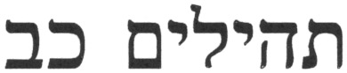
1 | [To the chief Musician upon Aijeleth Shahar, A Psalm of David.] My God, my God, why hast thou forsaken me? [why art thou so] far from helping me, [and from] the words of my roaring? | 1 | For the conductor, on the Ayeleth HaShahar, a Psalm of David. | 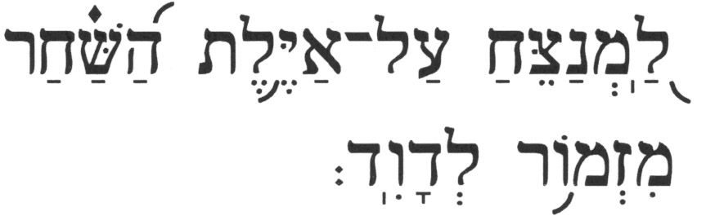 | 
1 |  | 2 | My G-d, my G-d, why have You forsaken me? [You are] so far from my salvation, from the words of my loud moaning? | 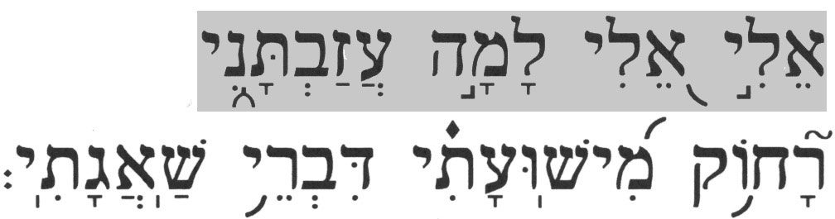 | 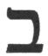

As noted earlier, this verse is used in both the Gospel of Matthew and the Gospel of Mark, and it appears there as follows:

Matthew 27:46(KJV) - And about the ninth hour Jesus cried with a loud voice, saying, Eli, Eli, lama sabachthani? that is to say, My God, my God, why hast thou forsaken me?

Mark 15:34(KJV) – And at the ninth hour Jesus cried with a loud voice, saying, Eloi, Eloi, lama sabachthani? which is, being interpreted, My God, my God, why hast thou forsaken me?

These two verses are now compared; first against each other and, then, against the Hebrew text and, finally, against the context of the original verse.

- 1. Comparing Matthew 27:46 with Mark 15:34

The variations between the two renditions in the Gospels are rather minor, with perhaps, Eli vs. Eloi, showing the most variance. This is, however, only a superficial problem since:

- ▪ Some of the old manuscripts have either Eli or Eloi or a mix in both sources
- ▪ This is a transliterated word from the Hebrew (or Aramaic), and transliteration is inherently subject to variation

  - 2. Comparing Matthew 27:46 & Mark 15:34 with Psalms 22:2

The transliterated phrases in the Gospels are, "… Eli/Eloi, Eli/Eloi, lama sabachthani …". The Hebrew text of the corresponding phrase in Psalms 22:2 reads, 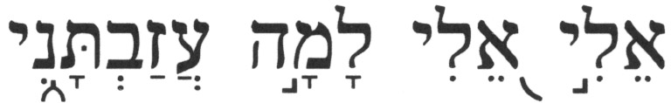 (Eli, Eli, lama azavtani). The question is: "Does sabachtani have the same meaning as 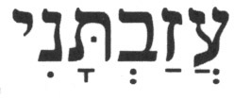 (azavtani)?"

The conjugated verb (azavtani) derives from the root verb 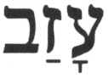 (azav), [to] abandon/forsake/leave. The word sabachtani exists neither in Hebrew nor in Aramaic. Two possibilities exist here:

- ▪ The closest Hebrew/Aramaic term to sabachtani would be 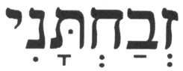 (z^{e}vahtani), a conjugated verb that derives from the root verb 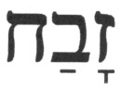 (zavah), [to] sacrifice/slaughter [a sacrificial animal], but which is never used in the Hebrew Bible. Making this association would render this phrase as "My G-d, My G-d, why have you slaughtered me?". Clearly, the two terms and, therefore, the phrases, are not equivalent. If this identification is correct then one could speculate that using sabachtani in the two Gospels was designed ostensibly to depict the scene of the Passion as a sacrificial offering.
- ▪ The Targum Yonathan, an ancient interpretive translation of the Hebrew Bible into the Aramaic vernacular, has 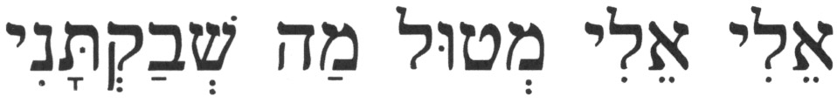 (Eli, Eli, m^{e}tul mah sh^{e}vaqtani). The phrase 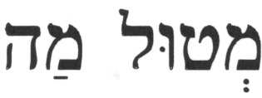 (m^{e}tul mah) is interchangeable with the word 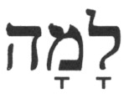 (lama), why. The conjugated verb 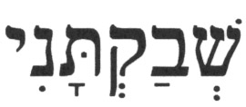 (sh^{e}vaqtani) derives from the Aramaic root verb 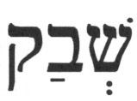 (sh^{e}vaq), [to] leave/forsake. Because the Greek language does not have the "sh" sound, the letter  (shin) is usually transliterated as an "s". Moreover, the use of "ch" for the letter  (qof) is plausible, since the actual alphabetic cognate in the Greek language for the letter (qof) – the koppa, not the 😐 (kappa) – had been lost centuries earlier, and the letter  (chi) was used here instead. Given these facts, one could conclude that, even though the way the term appears in the Greek text is not precise or consistent in its transliteration from Aramaic, the Aramaic (sh^{e}vaqtani) could have become sabachtani in the process of transliteration.

The conclusion drawn from the former view does not necessarily survive under the latter perspective. However placing this verse into the mouth of a dying Jesus, creates more theological difficulties for the Christian paradigm than it solves. For example, King David makes the following statement:

Psalms 37:25(KJV) - I have been young, and [now] am old; yet I have not seen the righteous forsaken, nor his seed begging bread.

This would imply that Jesus was not righteous, i.e., a sinner, since he complained to G-d about being forsaken.

Attributing this verse to Jesus creates a conflict with another common claim by Christian apologists and missionaries concerning a passage in Isaiah 53. According to this claim, the "Suffering Servant", alleged to be Jesus, was silent:

Isaiah 53:7(KJV) - He was oppressed and afflicted, yet he did not open his mouth; he was led like a lamb to the slaughter, and as a sheep before her shearers is silent, so he did not open his mouth.

Other issues concerning the Christian claims about Psalms 22:2[1] are:

- ▪ As an integral part of Christianity's triune godhead, why would Jesus be complaining, "… [why art thou so] far from helping me, [and from] the words of my roaring?"?
- ▪ How could G-d (the Father), the first person in the Trinity, not hear the cries of G-d (the Son), the second Person in the Trinity?
- ▪ To whom is this god complaining?
- ▪ How can G-d not understand his own predicament?

Finally, even the four Gospels do not agree on the last words of the dying Jesus on the cross:

Matthew 27:46(KJV) - And about the ninth hour Jesus cried with a loud voice, saying, Eli, Eli, lama sabachthani? that is to say, My God, my God, why hast thou forsaken me?

Mark 15:34(KJV) – And at the ninth hour Jesus cried with a loud voice, saying, Eloi, Eloi, lama sabachthani? which is, being interpreted, My God, my God, why hast thou forsaken me?

Luke 23:46(KJV) - And when Jesus had cried with a loud voice, he said, Father, into thy hands I commend my spirit: and having said thus, he gave up the ghost.

John 19:30(KJV) - When Jesus therefore had received the vinegar, he said, It is finished: and he bowed his head, and gave up the ghost.

It is evident that attributing Psalms 22:2[1] to a dying Jesus on the cross creates more theological difficulties for Christianity than it solves.

- 3. The Correct Context of Psalms 22:2[1]

The speaker, King David, questions his feelings of abandonment as he recounts the times that G-d had listened and intervened on behalf of his ancestors, as he is grieved that G-d is not listening to at all times.

- Psalms 22:19[18]

King James Version Translation |  | Jewish Translation from the Hebrew |  | Hebrew Text
Psalms 22
18 | They part my garments among them, and cast lots upon my vesture. | 19 | They divide my garments among themselves, and cast lots for my raiment. | 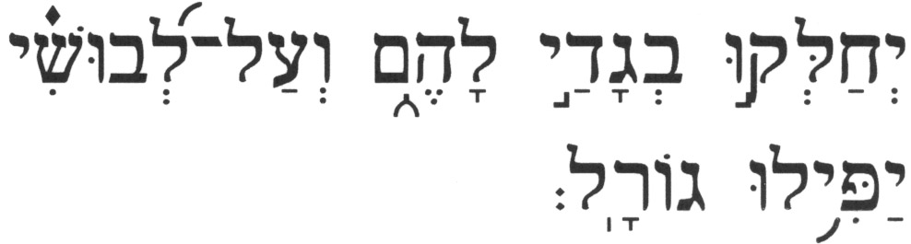 | 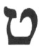

The author of the Gospel of John points to this verse as being a prophecy that became fulfilled when Jesus was on the cross:

John 19:23-24 – (23) Then the soldiers, when they had crucified Jesus, took his garments, and made four parts, to every soldier a part; and also [his] coat: now the coat was without seam, woven from the top throughout. (24) They said therefore among themselves, Let us not rend it, but cast lots for it, whose it shall be: that the scripture might be fulfilled, which saith, They parted my raiment among them, and for my vesture they did cast lots. These things therefore the soldiers did.

The previous verse, Psalms 22:18[17], is critical to a correct understanding of the true context of this verse. Psalms 22:18[17] describes the person whose clothes are being divided as counting his bones while those who are taking his garments look on gloating. This starving man is so skinny that his bones are visible and can be counted. The "voice" here is still King David, as it is throughout the psalm, and he uses the act of taking and dividing his garments as a metaphorical reference to the desires of his enemies to take away his mantle of royalty and make it their own.

- Psalms 22:23[22]

King James Version Translation |  | Jewish Translation from the Hebrew |  | Hebrew Text
Psalms 22
22 | I will declare thy name unto my brethren: in the midst of the congregation will I praise thee. | 23 | I will declare Your Name to my brothers; in the midst of the congregation will I praise You. | 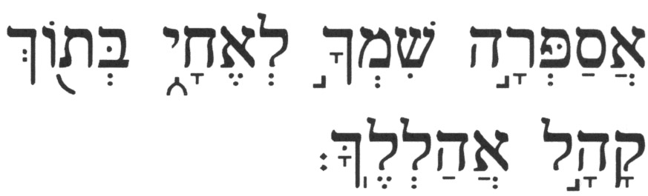 | 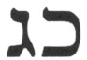

The author of the Epistle to the Hebrews "quotes" this verse at Hebrews 2:12 to help explain why Jesus needed to suffer for humanity. However, the one who speaks here is the same person that speaks throughout the psalm, including Psalms 22:7[6], where he refers to himself as being worm:

Psalms 22:7[6] - But I am a worm, and not a man; a reproach of man and despised by the people.

In the Christian scenario, it would be Jesus calling himself a worm. This reference to a worm as a metaphor for people is not unique within the Hebrew Bible. Isaiah likens the Jewish people to a worm:

Isaiah 41:14 - Fear not, O worm of Jacob, the number of Israel; "I have helped you," says the L-rd, and your redeemer, the Holy One of Israel.

Bildad the Shuhite, one of Job's friends, does the same:

Job 25:6 - How much less, man, who is a worm, and the son of man, who is a maggot!"

In Psalms 22:7[6], King David uses this metaphor as he writes about the plight of his own people. Does the worm metaphor fit Jesus? Would anyone, other than pagans who worship worms, use this metaphor to characterize a divine being?

The theme in Psalms 22:23[22] is the praising of G-d's name for being so good and benevolent, a theme that is often used by King David in his other psalms (e.g., Ps 9:3, 54:8, 61:9, 69:31).

- Psalms 22:17[16]

King James Version Translation |  |  | Jewish Translation from the Hebrew |  |  | Hebrew Text
Psalms 22
16 |  | For dogs have compassed me: the assembly of the wicked have inclosed me: they pierced my hands and my feet. |  | 17 | For dogs have surrounded me; a band of evildoers encompassed me; like a lion [they are at] my hands and my feet. |  | 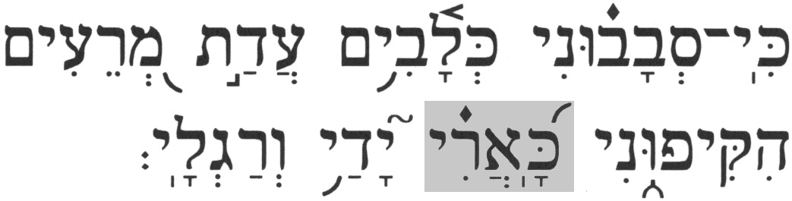 | 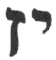

This is, perhaps, one of the verses from the Christian "Old Testament" most frequently referenced by Christian apologists and missionaries when claiming that the crucifixion of Jesus was foretold. Yet, as was noted above, none of the authors of the New Testament ever point to this verse, which is such an important component in the evangelical portfolio. A comparison of the above two translations reveals a major discrepancy in the respective renditions of the term 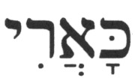 (ka'ari), like a lion. The typical Jewish rendition of this term is like a lion, while the KJV (typical of most Christian translations) has they pierced. Which is the correct translation?

A simple word study on the Hebrew term (ka'ari) helps answer this question. For simplicity, the word study concerns only on cases where the same form of the term appears, i.e., excluding conjugations of the root noun 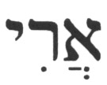 (ari) in the singular and plural, and combinations with various prepositions other than that which occurs here [the  {or } (ka-) here is the Hebrew preposition equivalent to like/as]. In addition to the application at Psalms 22:17[16], three other instances of (ka'ari) are present in the Hebrew Bible, and all are shown in Table IV.D-1 below, along with their respective KJV translations. There is also a single instance of the term 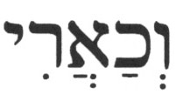 (v^{e}cha'ari), which is the equivalent of (ka'ari) with the preposition (v^{e}-), and, in front of it to make it, and like a lion. This term is included in Table IV.D-1 for completeness since it contains the original term (ka'ari), though it is not critical for illustrating the point to be made here.

Table IV.D-1 – Comparisons of KJV renditions of (ka'ari) in the Hebrew Bible

Reference | KJV Rendition | Comment
Psalms 22:17[16] | (ka'ari), they pierced | Incorrect
Numbers 24:9 | 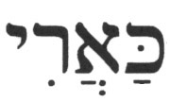 (ka'ari), like a lion | Correct
Isaiah 38:13 | (ka'ari), like a lion | Correct
Ezekiel 22:25 | (ka'ari), like a lion | Correct
Numbers 23:24 | (v^{e}cha'ari), and … as a young lion | Correct

It appears that the KJV translators had a special reason for rendering the term (ka'ari) at Psalms 22:17[16] differently. Why did the KJV translate the Hebrew term (ka'ari) as they pierced only at Psalms 22:17[16]?

Is there a connection between the Hebrew term (ka'ari) and a Hebrew verb that describes the act of piercing? The word (ari), lion, is related to another word for lion, 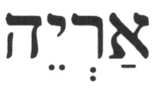 (aryeh); both are used in the Hebrew Bible. Several verbs are used in the Hebrew Bible to describe an act of piercing: 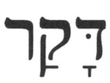 (daqar; e.g., Zech 12:10), 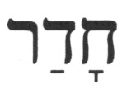 (hadar; e.g., Ezek 21:19), 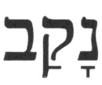 (naqav; e.g., Hab 3:14), 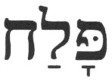 (palah; e.g., Job 16:13), and 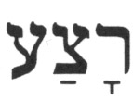 (ratza; e.g., Exod 21:6). A knowledge of Hebrew is not required to recognize that none of these root verbs resembles the terms (ka'ari), (ari), or (aryeh).

Could there be another linguistic explanation? Two fragments containing Psalms 22:17[16] were discovered among the Dead Sea Scrolls (DSS). In the first fragment, which was found at Qumran (4QPs-f; known as the Qumran MS, the word in question is not preserved. In the second fragment, found at Nahal Hever (HHev/Se 4 (Ps); known as the Bar Kochba MS, the word is preserved. The fragment HHev/Se 4 (Ps) shows the Hebrew letters  (kaf), (aleph), 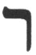 (resh), and what appears to be a somewhat elongated letter (yod), which some perceive to be the letter  (vav).[3] Thus, the reading of this word would be either 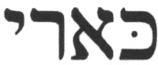 (ka'ari) or 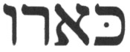 (ka'aru), respectively. Although the latter of these two renditions of the term has been the focus of much controversy and discussion, it is a fact that no root verb exists which contains the letter (aleph) in it, conjugated in this fashion (3rd-person, plural masculine gender, past tense), with the meaning of they pierced, as rendered in most Christian translations. Without the letter (aleph), and using, for the moment, the argument that the last letter [the elongated (yod)] is a (vav), the word would be 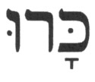 (karu), for which the Hebrew root verb is 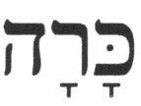 (karah), [to] dig [in dirt], such as digging a ditch (e.g., Ps 57:7). In other words, (karu) has the meaning [they] dug [in dirt]. This verb is never used in the context of piercing, either literally or metaphorically, in any of its 15 applications in the Hebrew Bible.

What could cause such a variation between the two terms (ka'ari) and (ka'aru), i.e., with an elongated letter (yod) that resembles the letter (vav)? Since the word (ka'aru) does not exist in the Hebrew language, the most plausible explanation is that such discrepancy is simply a case of scribal variation (or error).

Another possibility, one that has been alleged by Christian apologists and missionaries, is textual revisionism by the Masorites, who added vowels and melodic trope marks to the Hebrew Bible around the 10th century C.E., i.e., the claim is that the Masorites changed the original (ka'aru) to the current (ka'ari) in order to remove any resemblance to a crucifixion scenario. Given the strict prohibitions in the Hebrew Bible concerning any tampering with its text (e.g., Deut 4:2, Pr 30:6), and the fact that the term (ka'aru) does not exist in the Hebrew language, this is a rather preposterous claim regarding an unlikely action by the trained scribes.

Given the late dating of the Nahal Hever fragment[4], the discrepancy could be the result of exactly the reverse of the previous claim. Namely, this could be the result of an attempt by second century C.E. (early) Christians to edit the original (ka'ari) to be (ka'aru), thereby making it appear like the term (karu), they dug. This would have accomplished the effect of aligning the word with the events of the early first century C.E. It is also interesting to note that in the LXX (the Christian translation into Greek of the Hebrew Bible), where this verse is numbered as Psalms 21:17, the reading is ωρυξαν (oruksan), which stems from the root ορύσσω (orusso), to dig, as in [to] dig a trench. Liddell & Scott (Henry George Liddell, Robert Scott, An Intermediate Greek-English Lexicon) do not list a meaning of pierce for this word, and the identical usages occur only in early Christian renditions (Arndt and Gingrich, Lexicon of the Greek Testament). This LXX reading could possibly stem from a presumed, though non-existent, Hebrew reading (which makes no sense in context) of (karu) [i.e., without the (aleph) - not the reading (ka'aru)]. As noted above, the Hebrew word (karu) means [they] dug [in dirt], and it is never used in the Hebrew Bible with the context of piercing.

A final clue is found within the New Testament itself. The New Testament authors are silent on Psalms 22:17[16], a verse so central to Christianity in the description of the crucifixion itself. Given its significance to the Church, the question is: "Why is the New Testament silent on this verse?".

One possible answer is that none of the authors of the four Gospels, all of which provide a narrative of the crucifixion, was aware of this verse. That answer is not likely, however, since all of them referenced other parts of this psalm. Another possibility is that none of the authors saw this verse as being significant, or even relevant, to their respective crucifixion narratives. But this answer would be inconsistent with the important role this verse plays in the Christian perspective.

Perhaps the most likely answer is that the common Christian rendition, they pierced in the "Old Testament", came after the New Testament was written, i.e., the authors of the New Testament were unaware of a future revision of Psalms 22:17[16], in which the Church attempted to create a better fit with the crucifixion narrative. There was no need to mistranslate the term (ka'ari) in Numbers 23:24, 24:9, Isaiah 38:13, and Ezekiel 22:25, since these passages, unlike Psalms 22:17[16], had no Christological value to the Church, and could not help improve the fit into the Hebrew Bible of any component of Christian theology. This is a serious charge to make. However, given the hard evidence of tampering by the Church with other passages from the Hebrew Bible, it certainly is a plausible scenario for the disparity between the two renditions of this particular verse.

- VI. Summary

The linguistic and thematic analyses demonstrate that it is possible to derive a plausible explanation for the significant difference between the Jewish and standard Christian perspectives and, thereby, affirm the validity of the Jewish understanding of Psalms 22. The Christian perspective appears to have been fashioned with hindsight, i.e., knowing what the narratives in the New Testament have described, Psalms 22, perhaps enhanced through editing, was a close enough passage to be claimed as a template for the prophetic description of the crucifixion that would take place a millennium after these words were recorded. This assessment is supported by the fact that, Psalms 22:17[16], perhaps the most important passage relative to the crucifixion, is not referenced by any of the authors of the New Testament.

Whereas the Christian perspective on Psalms 22 may be acceptable to Christians, as it is also based on passages from their New Testament, which allegedly represent accounts of "prophetic fulfillments", this scenario conflicts with both the text and context in the Hebrew Bible and, therefore, is unacceptable within Judaism.

Source: http://www.messiahtruth.com/psa22.html

Feel free to contact me at b_zawadi@hotmail.com

Return to Refuting Alleged Old Testament Prophecies Pointing to Jesus

Return to Homepage

[1] 300+ Messianic Prophecies: Prophecies From the Old Testament that Reveal that Jesus is the Messiah - http://www.gotell.gracenet.org/gbn12.htm
[2] The notation for cases where verse numbers differ between the Hebrew Bible and the Christian "Old Testament" shows the verse number in the Hebrew Bible followed by the verse number in the Christian "Old Testament" in brackets. Example: Psalms 22:17[16].
[3] An image of this fragment, in which the line with the word in question has been "enhanced", is shown in an article by a Christian apologist, Tim Hegg, Psalm 22:16 – "like a lion" or "they pierced"? - http://www.torahresource.com/Newsletter/Ps22.16.pdf. The reader should be cautioned that the Hebrew linguistic analysis in the article is seriously flawed. The article contains other questionable items. For example, the fragment also shows the next word as being misspelled, having an extra letter "heh" attached at the end, which makes no grammatical sense. The author shows this incorrect spelling in the text, but in a later segment in which he compares the Masoretic Text with the text from HHev/Se 4 (Ps), he drops the extra letter "heh".
[4] The Nahal Hever papyri are dated as late as the second century C.E. according to DSS scholars and researchers; e.g. G. Vermes, An Introduction to the Complete Dead Sea Scrolls, p. 29.

