False Prophets, Farmhands, and Lovers
[Zechariah 13:1-6]

by

Messiah Truth

I. Introduction

A single verse in the 13th chapter in the Book of Zechariah, Zechariah 13:6, has long been a favorite so-called "proof text" in the standard portfolio of Christian apologists and missionaries. As part of this portfolio being used to support the claim that the advent of Christianity is foretold in the Hebrew Bible, this verse has been promoted as a passage that prophetically foretells the crucifixion of Jesus.

A careful analysis of the verse, in its proper context, refutes this claim and, in fact, turns this passage into a powerful "counter proof text".

II. Comparison of Christian and Jewish English Translations

The Hebrew text and side-by-side English renditions of the short 13th chapter in the Book of Zechariah 13 are displayed in Table II-1. The King James Version (KJV) translation in the left column, a Jewish translation in the middle column, and the Hebrew text appears in the right column. The KJV rendition also contains several references to key passages in the New Testament, where the respective portions of Zechariah 13 are cross-referenced. The information on these New Testament/"Old Testament" cross-references in the Christian Bible was taken from the New American Standard Bible (NASB). The highlighted words and phrases will be discussed later as part of the analysis.

Table II-1 – Zechariah 13

King James Version Translation |  |  |  | Jewish Translation from the Hebrew |  |  | The Hebrew Text
Zechariah 13 |  |  |  |  |  |  |  | 
1 |  |  | In that day there shall be a fountain opened to the house of David and to the inhabitants of Jerusalem for sin and for uncleanness. |  | On that day, a spring shall be opened for the House of David and to the inhabitants of Jerusalem, for [purification of] sin and [for cleansing of] uncleanness. |  |  | 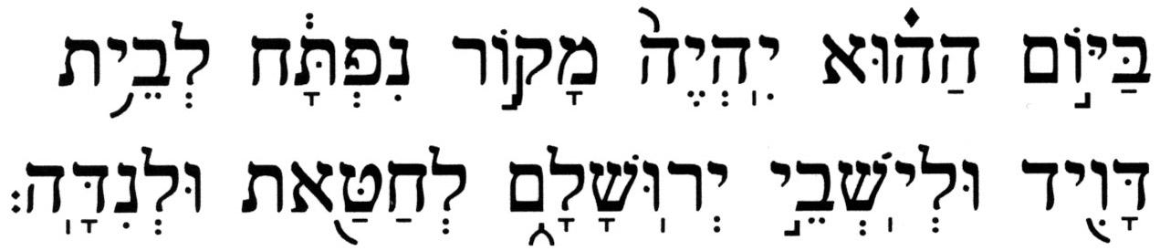 |  | 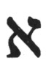
2 |  |  | And it shall come to pass in that day, saith the LORD of hosts, that I will cut off the names of the idols out of the land, and they shall no more be remembered: and also I will cause the prophets and the unclean spirit to pass out of the land. |  | And it shall come to pass on that day, says the L-rd of Hosts, that I will cut off the names of the idols from the earth, and they shall no more be remembered; and also the prophets and the unclean spirit I will remove from the earth. |  |  | 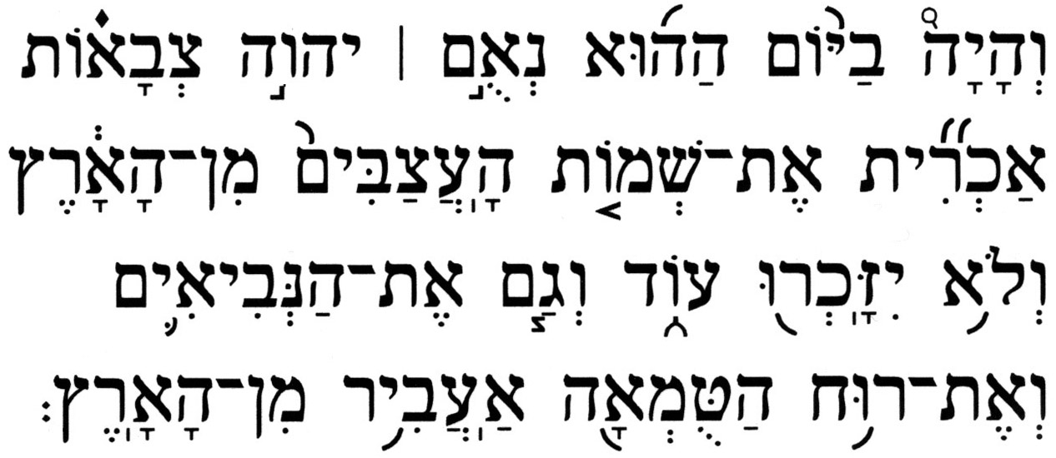 |  | 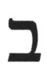
3 |  |  | And it shall come to pass, that when any shall yet prophesy, then his father and his mother that begat him shall say unto him, Thou shalt not live; for thou speakest lies in the name of the LORD: and his father and his mother that begat him shall thrust him through when he prophesieth. |  | And it shall come to pass, if a man still prophesies, then his father and his mother, who bore him, shall say to him, "You shall not live; for you have spoken falsely in the name of the L-rd;" and his father and his mother, who bore him, shall thrust him through while he prophesies. |  |  | 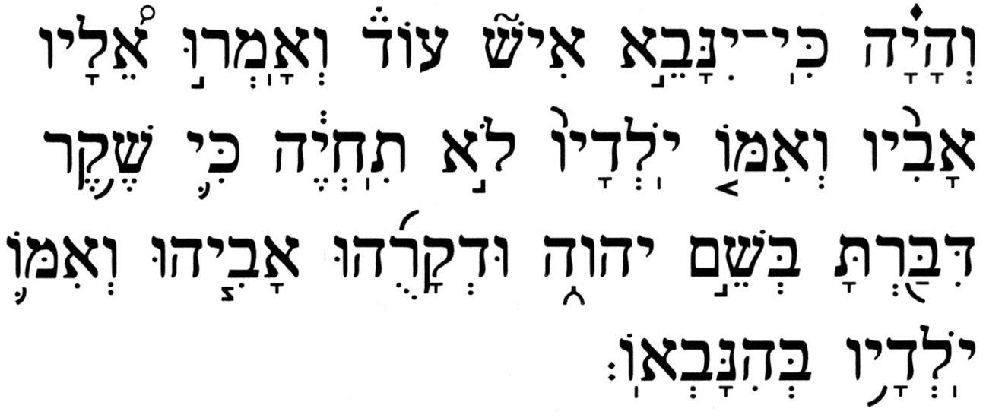 |  | 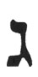
4 |  |  | And it shall come to pass in that day, that the prophets shall be ashamed every one of his vision, when he hath prophesied; neither shall they wear a rough garment to deceive.⁽¹⁾ |  | And it shall come to pass on that day, that the prophets shall be ashamed, each one of his vision when he has prophesies; and they will not wear a hairy mantle in order to deceive; |  |  | 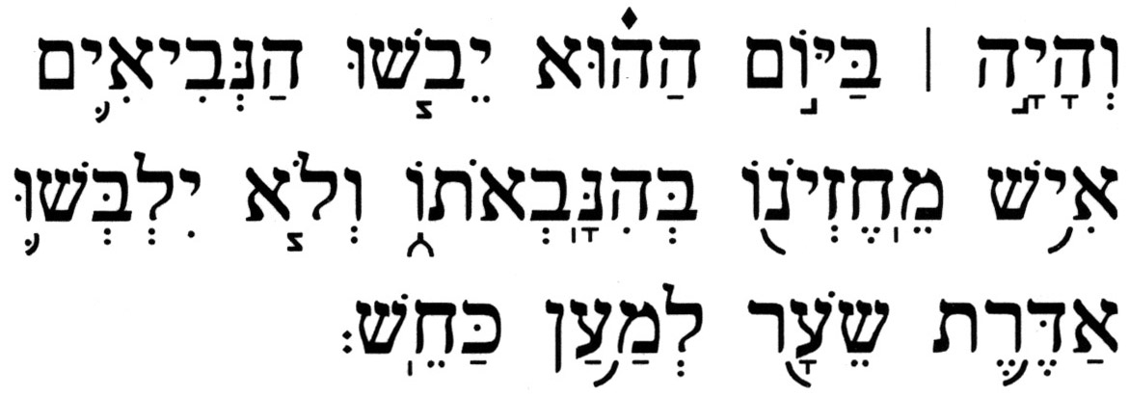 |  | 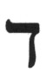
5 |  |  | But he shall say, I am no prophet, I am an husbandman; for man taught me to keep cattle from my youth. |  | And he shall say, "I am not a prophet; I am a tiller of the soil, for a man entrusted me with his cattle from my youth." |  |  | 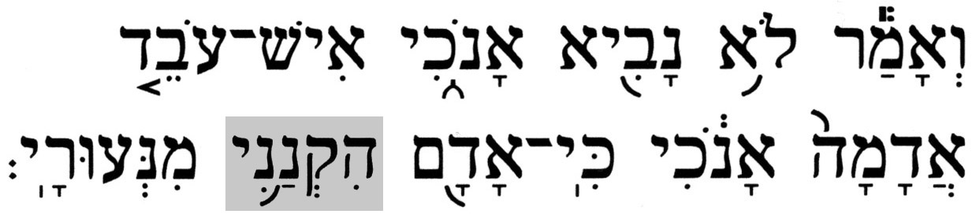 |  | 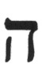
6 |  |  | And one shall say unto him, What are these wounds in thine hands? Then he shall answer, Those with which I was wounded in the house of my friends. |  | And someone will say to him, "What are these wounds between your hands?" And he shall say, "Because I was beaten in the house of those who love me." |  |  | 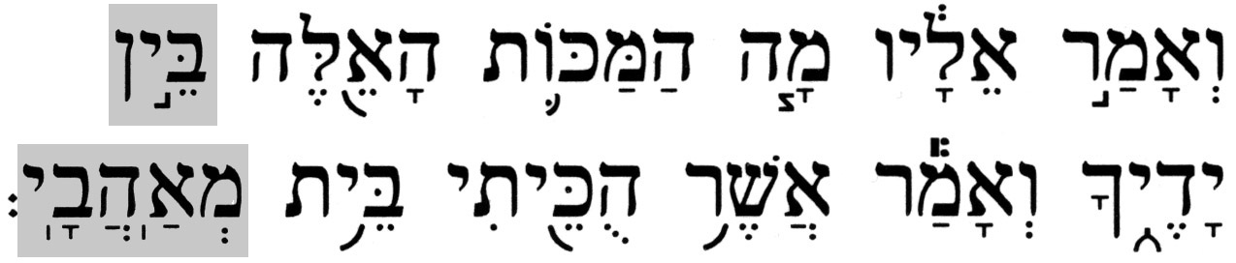 |  | 
7 |  |  | Awake, O sword, against my shepherd, and against the man that is my fellow, saith the LORD of hosts: smite the shepherd, and the sheep shall be scattered: and I will turn mine hand upon the little ones.⁽²⁾ |  | O sword, awaken against My shepherd, and against the man who is associated with Me! says the L-rd of Hosts. Smite the shepherd, and the flock shall scatter, and I will return my hand upon the lower ones. |  |  | 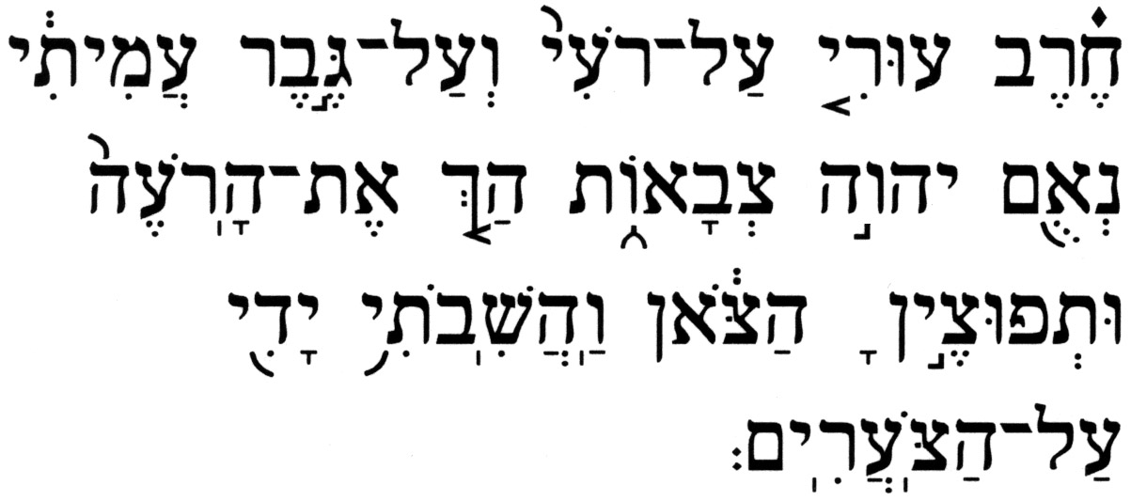 |  | 
8 |  |  | And it shall come to pass, that in all the land, saith the LORD, two parts therein shall be cut off and die; but the third shall be left therein. |  | And it shall come to pass throughout all the land, says the L-rd, two parts shall be cut off and will die; and the third shall remain therein. |  |  | 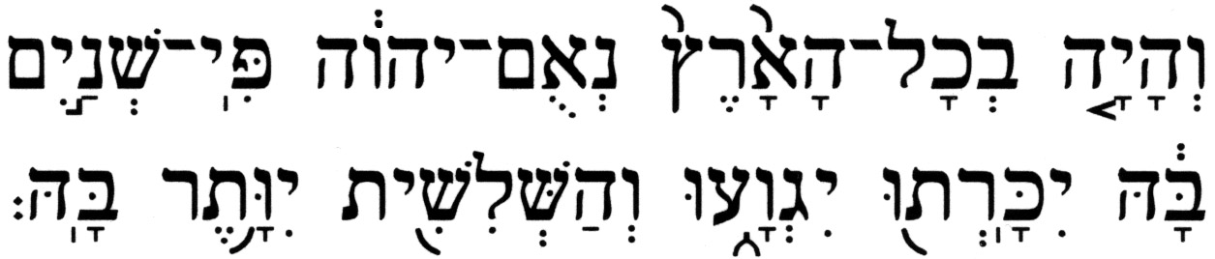 |  | 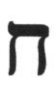
9 |  |  | And I will bring the third part through the fire, and will refine them as silver is refined, and will try them as gold is tried: they shall call on my name, and I will hear them: I will say, It is my people: and they shall say, The LORD is my God. |  | And I will bring the third through the fire, and I will refine them as one refines silver, and I will test them as tests gold; they shall call on My name, and I will respond to them; I will say, "They are My people;" and they shall say, "The L-rd is my G-d". |  |  | 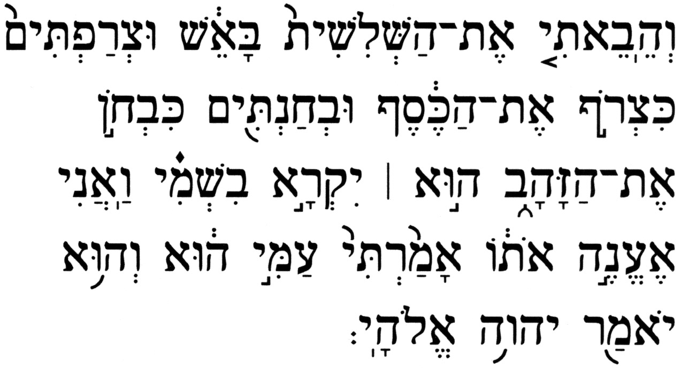 |  | 
1. Matthew 3:4(KJV) - And the same John had his raiment of camel's hair, and a leathern girdle about
his loins; and his meat was locusts and wild honey.
2. Matthew 26:31(KJV) - Then saith Jesus unto them, All ye shall be offended because of me this
night: for it is written, I will smite the shepherd, and the sheep of the flock
shall be scattered abroad.
Mark 14:27(KJV) - And Jesus saith unto them, All ye shall be offended because of me this night: for
it is written, I will smite the shepherd, and the sheep shall be scattered.

With one notable exception, the two translations are reasonably consistent. Even the portions that are cross-referenced in the New Testament do not contain any gross mistranslation by the KJV translators. The exception is in Zechariah 13:6, where the KJV, among a small number of other Christian translations, falsely translates the Hebrew word 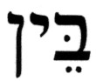 (bein), between, as in, thereby effecting a contextual change in the question from, " … What are these wounds between thine hands? … ", to, " What are these wounds in thine hands? … ". The result of this mistranslation is that a rather obvious Christological significance has been infused into the entire verse. It is interesting to note that most other Christian translations have retained the more general concept of someone with contusions on his upper body – chest, back - which is consistent with the context of the Hebrew text.

III. Overview of Christian and Jewish Interpretations

  - A. Overview of the Christian Perspective

According to the Christian view, Chapter 13 of Zechariah is fertile with Christological innuendo. The foretelling of the remission of sins and the silencing of false prophets point to the initial Christian "messianic era", i.e., the first century C.E. This idea is further amplified with a claim of the prophetic suffering of Jesus and the dispersion of his disciples, of the destruction of the greater (unbelieving) part of the Jewish nation not long thereafter, and of the purifying of a (believing) remnant of them, a distinctive group of people to G-d.

The New Testament reference passages quoted below Table II-1 appear to be invoking phrases found in various verses in the chapter. In Matthew 3:4, the "raiment of camel's hair" worn by John the Baptist alludes to a garment traditionally worn by Jewish prophets, mentioned in Zechariah 13:4. Matthew 26:31 and Mark 14:27 contain the phrases, "I will smite the shepherd, and the sheep of the flock shall be scattered abroad" and "I will smite the shepherd, and the sheep shall be scattered ", respectively. These allegedly represent the fulfillment of a prophecy concerning the suffering of Jesus and the dispersal of his followers, found in a similar phrase in Zechariah 13:7, "Smite the shepherd, and the flock shall scatter".

It is interesting to note that Zechariah 13:6, the one verse from this chapter most often applied by Christian apologists and missionaries as a so-called "proof text", was not invoked or alluded to in the New Testament by any of the authors. From their silence on this contemporary Christian missionary "proof text", it appears that the authors of the New Testament did not perceive it as having any Christological significance.

More detailed commentary may be found in the standard Christian commentaries such as, Matthew Henry and Jamieson, Fausset, & Brown.

- The Jewish Perspective

The 13th chapter in the Book of Zechariah includes a collection of messianic prophecies and, in that respect, the Christian and Jewish perspectives are consistent. The major gap between the two views concerns the identity of the Messiah.

The era in which the events described in this chapter will take place is identified in Zechariah 13:1 as being the messianic era. The description of the spring of living water that will be flowing in Jerusalem, something that has never been there before, is an allusion to the messianic era. A reference to this spring is found again in the next chapter:

Zechariah 14:8 - And it shall be on that day, that living water shall go out from Jerusalem - half of it toward the eastern sea, and half of it toward the western sea; in summer and in winter it shall be.

Ezekiel also speaks of this flowing water in his description of the Third Temple:

Ezekiel 47:1 - And he brought me back to the door of the house and, behold, water flowed from under the threshold of the house eastward, for the front of the house faced to the east; and the water came down from beneath, from the right side of the house, from south of the altar.

The first six verses in this chapter deal with the removal of impurity from Judah. The Prophet speaks of a false prophet whose parents thrust him through for his deceitful activities. He also describes the lamenting by the false prophets about being farm hands and shepherds from their youth, and having been assaulted and beaten up in familiar surroundings.

The last three verses in the chapter describe the punishment of (a sword turned against) the enemies of Israel. The leaders of the (Gentile) nations were the shepherds, G-d’s colleagues, to whom He entrusted the fate of His people Israel (the flock). When they harm instead of help, G-d will unleash the sword against them. Then, the flock will be free to escape, and G-d will turn His vengeance even against the subordinates who helped molest Israel.

- IV. A Closer Look at the Passage Zechariah 13:6

- The Traditional Approach: The False Prophet and Foolish Shepherd

As noted above, Zechariah 13:6 is used by Christian apologists and missionaries as a "proof text" that foretells the crucifixion of Jesus:

Zechariah 13:6 - And someone will say to him, "What are these wounds between your hands?" And he shall say, "Because I was beaten in the house of those who love me."

Zechariah 13:6(KJV) - And one shall say unto him, What are these wounds in thine hands? Then he shall answer, Those with which I was wounded in the house of my friends.

When this verse is read alone, without the rest of the verses around it, it could leave the (false) impression of an allusion to the suffering that Jesus endured around the time of his crucifixion. However, when the verse is read in context, a rather different picture emerges about this wounded individual. The backdrop for the scenario is set up two preceding verses:

Zechariah 13:4-5 – (4) And it shall come to pass on that day, that the prophets shall be ashamed, each one of his vision when he prophesies; and they will not wear a hairy mantle in order to deceive. (5) And he shall say, "I am not a prophet; I am a tiller of the soil, for a man entrusted me with his cattle from my youth."

This individual in Zechariah 13:6, the one with the contusions from being beaten, turns out to be a false prophet, even though he wore the hairy mantle, which was a distinctive garment worn by prophets of Israel (see, e.g., 1 Kgs 19:13,19; 2 Kgs 2:8,13,14). These false prophets will disown their "calling" and claim to belong to the humblest working class. A similar declaration, though reversed – a true prophet declaring he does not profit from his prophecies, i.e., unlike a false prophet who is remunerated for prophesying – is found in the Book of Amos:

Amos 7:14 - And Amos replied and said to Amaziah, "I am neither a prophet nor the son of a prophet; but I am a cattle herder and an examiner of sycamores."

Zechariah 13:7 is also a verse that is important to the context, particularly as it applies to the claims made by Christian missionaries:

Zechariah 13:7 - "O sword, awaken against My shepherd, and against the man who is associated with Me!" says the L-rd of Hosts. "Smite the shepherd, and the flock shall scatter, and I will return My hand upon the lower ones."

This shepherd is also the one previously described as foolish and worthless:

Zechariah 11:15-17 – (15) And the L-rd said to me, "Take for yourself yet another thing, the instrument of a foolish shepherd. (16) For, behold! I am setting up a shepherd in the land, he will not remember [to count] those who are missing, nor will he seek the young ones, nor heal the broken one; nor will he feed the one which stands still, but he will eat the meat of the healthy ones, and break their hoofs into pieces. (17) Woe to My worthless shepherd who abandons the flock; may a sword strike his arm and his right eye; his arm shall surely wither, and his right eye will go completely blind.

The fate of this foolish and worthless shepherd a certainty; he will be smitten.

Does Zechariah 13:6 still "point" to Jesus when read in context? It is not likely that Christians will agree to characterize Jesus, their lord and savior, as being a false prophet and a foolish and worthless shepherd.

- An Alternate Approach: The False Prophet and Promiscuous Farmhand

Another way of reading the passage, especially Zechariah 13:4-6, gives an interesting twist to this prophecy. The stage is set in the opening verse of the chapter, which implies that sins, such as idolatry and other abominations, will be rampant in the land. Zechariah prophesies that, when the day comes, parents will turn against their own sons, who acted as false prophets and perverted the Word of G-d, and slay them (Zech 13:3). The Prophet adds that all false prophets, when they see that their visions did not materialize, will be ashamed of all they did to deceive the people and will discard their special garb (Zech 13:4).

The conventional translation for Zechariah 13:5 reads:

Zechariah 13:5 - And he shall say, "I am not a prophet; I am a tiller of the soil, for a man entrusted me with his cattle from my youth."

However, the term 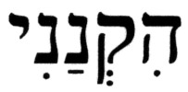 (hiqnani), commonly translated as [he] entrusted me with his cattle, also has another meaning. (hiqnani) derives from the root 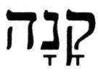 (qanah), [to] buy, and is conjugated here in the hiph'il stem in the past tense, which is an active verb construct that renders this term as, [he] who has made [others] buy me. When combined with the reference to the subject's youth, this could easily mean that these people, in addition to being farmhands, were also hired out for some other purpose.

For what purpose might these youthful tillers of the land have been hired out? The next verse, Zechariah 13:6, has the key to the answer. The conventional translation of this verse is:

Zechariah 13:6 - And someone will say to him, "What are these wounds between your hands?" And he shall say, "Because I was beaten in the house of those who love me."

However, the term 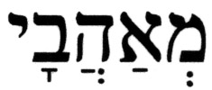 (m^{e}ahavai), commonly translated as those who love me, or my friends, also has another meaning that is lost in the common renditions. This word (m^{e}ahavai) means my lovers, or my paramours, i.e., those who desire me [sexually]. The term (m^{e}ahavai) is the conjugation of the plural form of the singular masculine noun 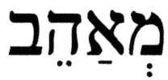 (m^{e}ahev), lover [in the romantic context; the plural is 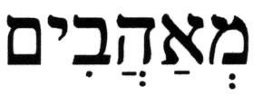 (m^{e}ahavim), could be applied in either the masculine or the generic context], in the 1st-person singular, masculine (and feminine) gender, my [male] lovers. The noun (m^{e}ahev), lover, is derived from the root verb 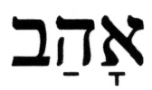 (ahav), [to] love, conjugated in the pi'el stem, which is a causative and denominative verb form. There are 16 applications of this noun, in various conjugations, in the Hebrew Bible, where in all cases it is used with the romantic connotation that goes along with sexual desire or lust. Table IV.B-1 shows these 16 instances of the noun along with the common English translations in both Jewish and Christian renditions of the respective passages..

Table IV.B-1 – Applications of the Hebrew noun (m^{e}ahev), lover, in the Hebrew Bible

Hebrew Term | # | Pronunciation | Noun Conjugation | Citation | Typical translations  (KJV/ArtScroll Stone Tanach)
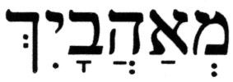 | 7 | m^{e}a-ha-VA-yich | 2nd-person, singular, feminine | Jeremiah 22:20,22,  30:14; Ezekiel 16:33,36,37, 23:22 | thy lovers/your paramours
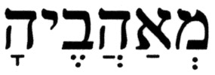 | 5 | m^{e}a-ha-VE-ha | 3rd-person, singular, feminine | Ezekiel 23:5,9;  *Hosea 2:9,12,15 | her lovers/her paramours
 | 4 | m^{e}a-ha-VA-i | 1st-person, singular, masculine/feminine | *Hosea 2:7,14;  Lamentations 1:19 | my lovers/my paramours
 |  |  |  | Zechariah 13:6 | my friends/those who loved me
*The verses Hosea 2:7,9,12,14,15 correspond to Hosea 2:5,7,10,12,13 in Christian Bibles

The proper term to be used in describing those who love someone, not necessarily in the romantic sense, and conjugated in the 1st-person, singular, masculine or feminine gender, is 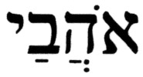 (ohava'i), those who love me. This noun also derives from the root verb (ahav), [to] love, except that it is conjugated in the pa'al/qal stem, the basic Hebrew verb form. This application is used on 20 occasions, in various conjugations, in the Hebrew Bible, and in five cases in this specific conjugation – at: Exodus 20:6**, Deuteronomy 5:10**, Psalms 38:12, Proverbs 8:17,21 [** - includes the preposition  (l^{e}), to or for].

Sidebar note: Who were the (true) prophets and prophetesses of Israel? What distinguished them from the others? While the gift of prophecy included an ability to foretell the future, a prophet was far more than a person with that capability. A prophet was a spokesperson for G-d, a person ostensibly "chosen" by Him to speak to people on His behalf and convey a message or teaching. [True] prophets were role models of holiness, scholarship, and closeness to G-d, setting the standards for the entire community. Moreover, the primary job of a prophet was not to foretell the future, but to arouse the people and the government to repentance and observance. In the process of executing their primary mission, the prophets often resorted to the description of future events - some in the near future, some in the intermediate future, and some in the distant (messianic era) future.

Considering the conditions of rampant idolatry and other abominations that will prevail in the land just prior to the day when the prophecies in the 13th chapter in the Book of Zechariah come to pass, it would make one wonder in what kind of activities these individuals – those who were identified as false prophets – were engaging. While it is a fact that tilling the land can cause wounds on hands and arms, perhaps even on legs and feet; from where would wounds "between the hands", i.e., across the chest and perhaps on one's back, come? In what type of activities did these youthful shepherds, farmhands, and false prophets engage when they were not tilling the land and watching the herds?

Under these circumstances, could Zechariah 13:6 still apply to Jesus? Surely, Christians will not want to have a false prophet and a youthful farmhand hired out to engage in acts of abomination as a "type and shadow" of their lord, savior, and messiah Jesus.

These two perspectives on Zechariah 13:6 in context, should serve as sobering "food for thought" to all who attempt to use this verse as a prophecy of Jesus' death.

- V. Summary

The analysis of the 13th chapter in the Book of Zechariah demonstrates the importance of reading and understanding a verse or passage in its proper context.

The claims made by Christian apologists and missionaries concerning Zechariah 13:6 have been refuted, and this verse, when read in context, turns out to be an excellent "counter proof text". Moreover, it is noteworthy that the authors of the New Testament, in their silence on this verse, found no Christological significance in it. This would indicate that the use of this verse by Christian apologists and missionaries is a much more recent development. Perhaps these are some of the reasons that many legitimate Christian apologists no longer use it as a "proof text".

Source: http://www.messiahtruth.com/zec13.html

Feel free to contact me at b_zawadi@hotmail.com

Return to Refuting Alleged Old Testament Prophecies Pointing to Jesus

Return to Homepage

