*26. > table(round(iris$Sepal.Length), iris$Species)*

|  |
| --- |
| *setosa versicolor virginica*  *4 5 0 0*  *5 40 6 1*  *6 5 36 27*  *7 0 8 16*  *8 0 0 6* |
|  |
| |  | | --- | | *>* | |

*27.*

*table(round(iris$Sepal.Length*2)/2, iris$Species)*

|  |
| --- |
| *setosa versicolor virginica*  *4.5 11 0 0*  *5 28 5 1*  *5.5 10 16 2*  *6 1 15 10*  *6.5 0 11 20*  *7 0 3 9*  *7.5 0 0 7*  *8 0 0 1* |
|  |
| |  | | --- | | *>* | |

*28. hist(iris$Sepal.Length)*

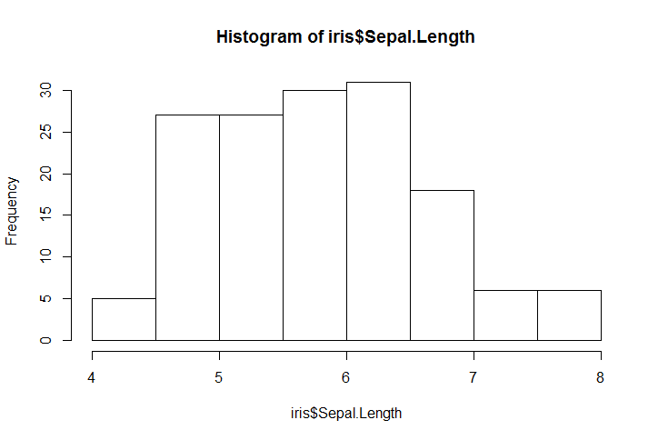

*29.*

*hist(iris$Sepal.Length, breaks=20,*

*col="tomato",*

*xlab="Length of Iris Sepal",*

*ylab="Occurence of Length",*

*main="Frequency of Iris Sepal Length")*

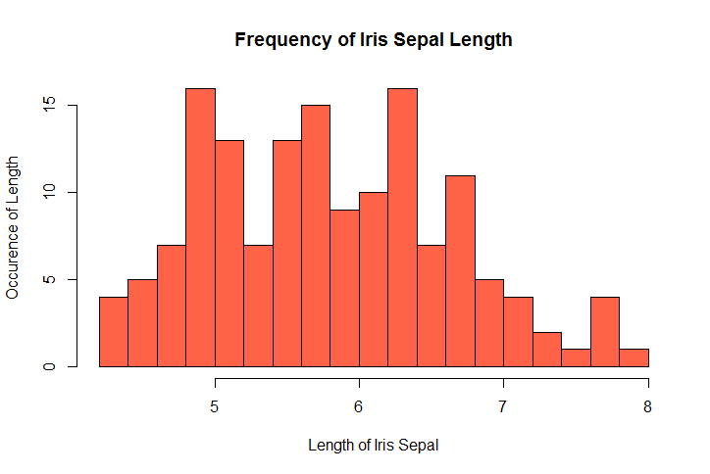

*30*

*31*

*> quantile(iris$Petal.Length,prob=seq(0,1, by=.1))*

*1.00 1.60 4.35 5.10 6.90*

*> quantile(iris$Petal.Length,prob=seq(0,1, by=.1))*

*0% 10% 20% 30% 40% 50% 60% 70% 80% 90% 100%*

*1.00 1.40 1.50 1.70 3.90 4.35 4.64 5.00 5.32 5.80 6.90*

*32.*

*table(iris$Species, iris$Petal.Length > quantile(iris$Petal.Length,prob=seq(0,1, by=.1))[8])*

*FALSE TRUE*

*setosa 50 0*

*versicolor 49 1*

*virginica 9 41*

*33,*

*breakpoints <- quantile(iris$Petal.Length,*

*prob=seq(0,1, length.out = 11),*

*names=FALSE)*

*bin <- cut(iris$Petal.Length, breakpoints, labels=FALSE,*

*include.lowest=TRUE)*

*table(iris$Species, bin)*

*1 2 3 4 5 6 7 8 9 10*

*setosa 24 13 7 6 0 0 0 0 0 0*

*versicolor 0 0 0 11 14 14 10 1 0 0*

*virginica 0 0 0 0 0 1 8 11 17 13*

*34*

*breakpoints <- quantile(iris$Petal.Length,*

*prob=seq(0,1, length.out = 11),*

*names=FALSE)*

*binlength <- cut(iris$Petal.Length, breakpoints, labels=FALSE,*

*include.lowest=TRUE)*

*area <- iris$Petal.Length * iris$Petal.Width*

*breakpoints <- quantile(area,*

*prob=seq(0,1,length.out = 11),*

*names=FALSE)*

*binarea <- cut(area, breakpoints, lables=FALSE,*

*include.lowest=TRUE)*

*table(binlength, binarea)*

*binarea*

*binlength [0.11,0.28] (0.28,0.32] (0.32,0.628] (0.628,4.52]*

*1 18 0 6 0*

*2 2 7 4 0*

*3 0 5 0 2*

*4 0 0 3 11*

*5 0 0 0 2*

*6 0 0 0 0*

*7 0 0 0 0*

*8 0 0 0 0*

*9 0 0 0 0*

*10 0 0 0 0*

*binarea*

*binlength (4.52,5.62] (5.62,6.75] (6.75,8.64] (8.64,10.2] (10.2,12.4]*

*1 0 0 0 0 0*

*2 0 0 0 0 0*

*3 0 0 0 0 0*

*4 3 0 0 0 0*

*5 11 1 0 0 0*

*6 1 11 3 0 0*

*7 0 4 9 5 0*

*8 0 0 2 5 5*

*9 0 0 1 4 6*

*10 0 0 0 0 4*

*binarea*

*binlength (12.4,15.9]*

*1 0*

*2 0*

*3 0*

*4 0*

*5 0*

*6 0*

*7 0*

*8 0*

*9 6*

*10 9*

*35*

*middlesetosa <- quantile((iris$Petal.Length[iris$Species == "setosa"]), prob=.5)*

*middlevirginica <- quantile((iris$Petal.Length[iris$Species == "virginica"]), prob=.5)*

*middleveriscolor <- quantile((iris$Petal.Length[iris$Species == "veriscolor"]), prob=.5)*

*medianpetal <- c(middlesetosa, middlevirginica, middleveriscolor)*

*names(medianpetal) <- c("setosa", "virginica", "leveriscolor")*

*> medianpetal*

*setosa virginica leveriscolor*

*1.50 5.55 NA*

*36.*

*species <- unique(iris$Species)*

*ans <- rep(0, length=3)*

*for (i in 1:3) {*

*ans[i] <- quantile(iris$Petal.Length[iris$Species == species[i]],*

*probs=.5)*

*}*

*names(ans) <- c("setosa", "veriscolor", "virginicia")*

*ans*

*setosa veriscolor virginicia*

*1.50 4.35 5.55*

*37*

*tapply(iris$Petal.Length, iris$Species, quantile, prob=0.5)*

*setosa versicolor virginica*

*1.50 4.35 5.55*

*38. ask <- function() {*

*for (i in 1:3) {*

*abb = readline("Enter a state abbreviation: ")*

*ans <- state.name[abb == state.abb]*

*if (length(ans) == 0) ans = "not a proper state abbreviation"*

*print(ans)*

*}*

*}*

|  |
| --- |
| *> ask()*  *Enter a state abbreviation: MD*  *[1] "Maryland"*  *Enter a state abbreviation: NM*  *[1] "New Mexico"*  *Enter a state abbreviation: WY*  *[1] "Wyoming"* |
|  |
| |  | | --- | | *>* | |

*39.*

*ask <- function() {*

*for (i in 1:666) {*

*abb = readline("Enter a state abbreviation: ")*

*ans <- state.name[abb == state.abb]*

*if (length(ans) == 0) ans = break*

*print(ans)*

*}*

*}*

|  |
| --- |
| *> ask()*  *Enter a state abbreviation: SD*  *[1] "South Dakota"*  *Enter a state abbreviation: NY*  *[1] "New York"*  *Enter a state abbreviation: NM*  *[1] "New Mexico"*  *Enter a state abbreviation: WY*  *[1] "Wyoming"*  *Enter a state abbreviation: FL*  *[1] "Florida"*  *Enter a state abbreviation: UT*  *[1] "Utah"*  *Enter a state abbreviation: CA*  *[1] "California"*  *Enter a state abbreviation: AL*  *[1] "Alabama"*  *Enter a state abbreviation: poopypants* |
|  |
| |  | | --- | | *>* | |

*40.*

*ask <- function() {*

*for (i in 1:666) {*

*abb = readline("Enter State name: ")*

*ans <- state.abb[abb == state.name]*

*if (length(ans) == 0) ans = "Not a proper State Name, please try again"*

*print(ans)*

*}*

*}*

*> ask()*

*Enter State name: Gaza City*

*[1] "Not a proper State Name, please try again"*

*Enter State name: Crazy Town*

*[1] "Not a proper State Name, please try again"*

*Enter State name: Paris*

*[1] "Not a proper State Name, please try again"*

*Enter State name: Minnesota*

*[1] "MN"*

*41.*

*for (i in 1:100) {*

*print(i +1)*

*}*

*[1] 2*

*[1] 3*

*[1] 4*

*[1] 5*

*[1] 6*

*[1] 7*

*[1] 8*

*[1] 9*

*[1] 10*

*[1] 11*

*[1] 12*

*[1] 13*

*[1] 14*

*[1] 15*

*[1] 16*

*[1] 17*

*[1] 18*

*[1] 19*

*[1] 20*

*[1] 21*

*[1] 22*

*[1] 23*

*[1] 24*

*[1] 25*

*[1] 26*

*[1] 27*

*[1] 28*

*[1] 29*

*[1] 30*

*[1] 31*

*[1] 32*

*[1] 33*

*[1] 34*

*[1] 35*

*[1] 36*

*[1] 37*

*[1] 38*

*[1] 39*

*[1] 40*

*[1] 41*

*[1] 42*

*[1] 43*

*[1] 44*

*[1] 45*

*[1] 46*

*[1] 47*

*[1] 48*

*[1] 49*

*[1] 50*

*[1] 51*

*[1] 52*

*[1] 53*

*[1] 54*

*[1] 55*

*[1] 56*

*[1] 57*

*[1] 58*

*[1] 59*

*[1] 60*

*[1] 61*

*[1] 62*

*[1] 63*

*[1] 64*

*[1] 65*

*[1] 66*

*[1] 67*

*[1] 68*

*[1] 69*

*[1] 70*

*[1] 71*

*[1] 72*

*[1] 73*

*[1] 74*

*[1] 75*

*[1] 76*

*[1] 77*

*[1] 78*

*[1] 79*

*[1] 80*

*[1] 81*

*[1] 82*

*[1] 83*

*[1] 84*

*[1] 85*

*[1] 86*

*[1] 87*

*[1] 88*

*[1] 89*

*[1] 90*

*[1] 91*

*[1] 92*

*[1] 93*

*[1] 94*

*[1] 95*

*[1] 96*

*[1] 97*

*[1] 98*

*[1] 99*

*[1] 100*

*[1] 101*

*42.*

*sum(c(1:100 + 1))*

*[1] 5150*

*43.*

*ask <- function() {*

*num <- readline("Enter your birth year")*

*num <- as.numeric(num)*

*age <- 2016 - num*

*for (i in 1:age) {*

*print(paste("You turned", i, "in", 2016-age+i))*

*}*

*}*

*> ask()*

*Enter your birth year1988*

*[1] "You turned 1 in 1989"*

*[1] "You turned 2 in 1990"*

*[1] "You turned 3 in 1991"*

*[1] "You turned 4 in 1992"*

*[1] "You turned 5 in 1993"*

*[1] "You turned 6 in 1994"*

*[1] "You turned 7 in 1995"*

*[1] "You turned 8 in 1996"*

*[1] "You turned 9 in 1997"*

*[1] "You turned 10 in 1998"*

*[1] "You turned 11 in 1999"*

*[1] "You turned 12 in 2000"*

*[1] "You turned 13 in 2001"*

*[1] "You turned 14 in 2002"*

*[1] "You turned 15 in 2003"*

*[1] "You turned 16 in 2004"*

*[1] "You turned 17 in 2005"*

*[1] "You turned 18 in 2006"*

*[1] "You turned 19 in 2007"*

*[1] "You turned 20 in 2008"*

*[1] "You turned 21 in 2009"*

*[1] "You turned 22 in 2010"*

*[1] "You turned 23 in 2011"*

*[1] "You turned 24 in 2012"*

*[1] "You turned 25 in 2013"*

*[1] "You turned 26 in 2014"*

*[1] "You turned 27 in 2015"*

*[1] "You turned 28 in 2016"*

*44.*

*sprays <- unique(InsectSprays$spray)*

*par(mfrow=c(2,3))*

*for (j in1:length(sprays)) {*

*hist(InsectSprays$count, breaks=seq(0,30,by=5))*

*}*

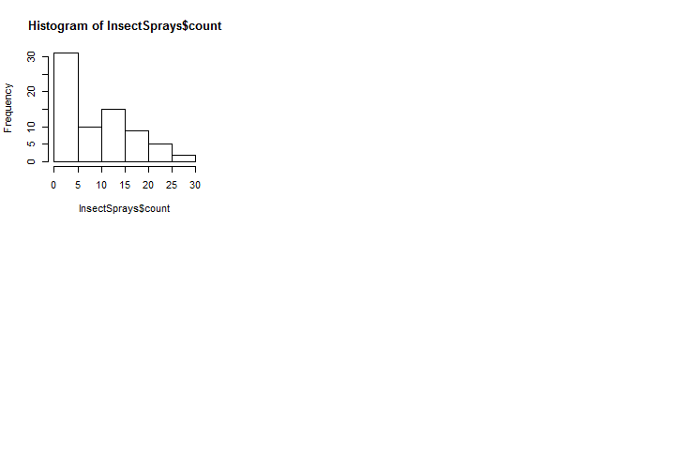

*45*

*sprays <- unique(InsectSprays$spray)*

*par(mfrow=c(2,3))*

*par(mar=c(0,0,0))*

*for (j in 1:length(sprays)) {*

*hist(InsectSprays$count, breaks=seq(0,30,by=5),*

*axes=FALSE, xlab="", ylab="", main="")*

*box()*

*text(20, 25, paste("Sprays='", sprays[j], "'", sep=""))*

*}*

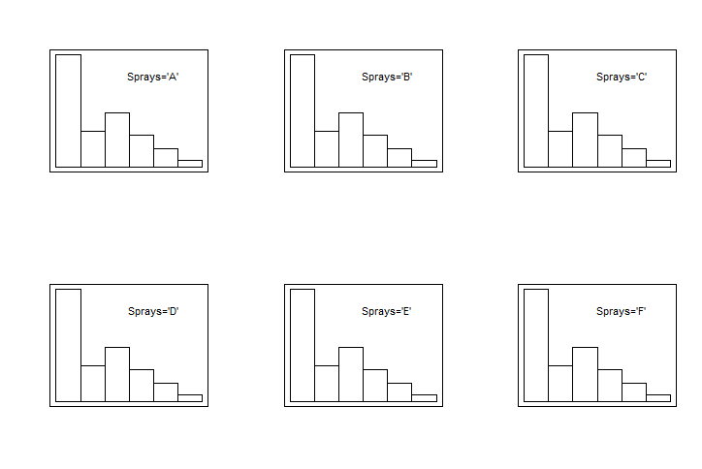

*tapply(InsectSprays$count, InsectSprays$spray, quantile, probs=.5)*

A B C D E F

14.0 16.5 1.5 5.0 3.0 15.0

*48.* *apply(WorldPhones, 1, sum)*

|  |
| --- |
| 1951 1956 1957 1958 1959 1960 1961  74494 102199 110001 118399 124801 133709 141700 |
|  |
| |  | | --- | |  | |

*49.*

*100 * WorldPhones[,2] / apply(WorldPhones, 1, sum)*

1951 1956 1957 1958 1959 1960 1961

28.96072 29.34471 29.55428 29.74518 30.12636 30.17074 30.46789

*50*

*100 * WorldPhones / apply(WorldPhones, 1, sum)*

> 100 * WorldPhones / apply(WorldPhones, 1, sum)

N.Amer Europe Asia S.Amer Oceania Africa Mid.Amer

1951 61.66805 28.96072 3.860714 2.436438 2.209574 0.1194727 0.7450264

1956 59.12289 29.34471 4.606699 2.512745 2.315091 1.3806397 0.7172282

1957 58.83674 29.55428 4.754502 2.449978 2.296343 1.4054418 0.7027209

1958 57.84170 29.74518 5.626737 2.402892 2.272823 1.4045727 0.7060870

1959 57.53079 30.12636 5.493546 2.403827 2.298059 1.4174566 0.7299621

1960 56.86678 30.17074 6.147679 2.352123 2.284065 1.4247358 0.7538760

1961 56.33804 30.46789 6.388850 2.355681 2.275229 1.4149612 0.7593507