51.

plot(iris$Sepal.Length, iris$Petal.Length)

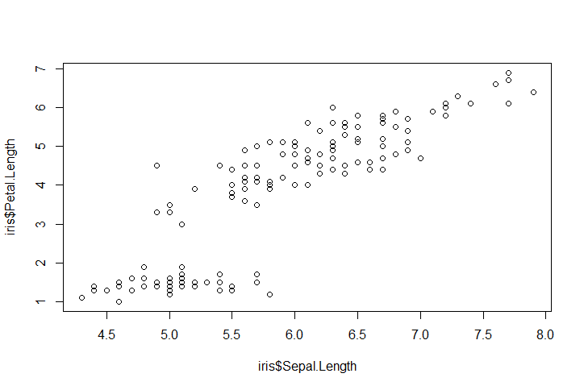

52.

species <- unique(iris$Species)

colVals <- c("olivedrab", "turquoise", "salmon")

cols <- colVals[match(iris$Species, species)]

plot(iris$Sepal.Length, iris$Petal.Length, col=cols, pch=19)

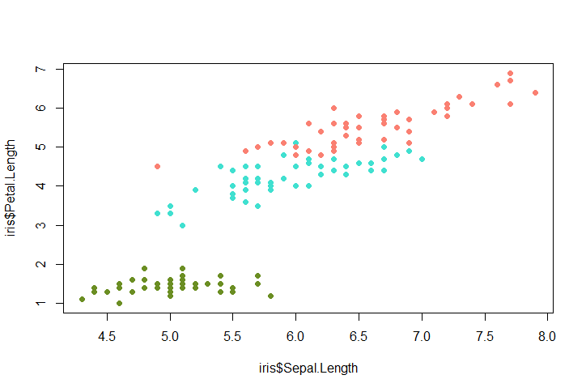

53.

species <- unique(iris$Species)

colVals <- c("olivedrab", "turquoise", "salmon")

cols <- colVals[match(iris$Species, species)]

sizes <- iris$Sepal.Width/quantile(iris$Sepal.Width, probs=.5)

plot(iris$Sepal.Length, iris$Petal.Length, col=cols, pch=19, cex=sizes)

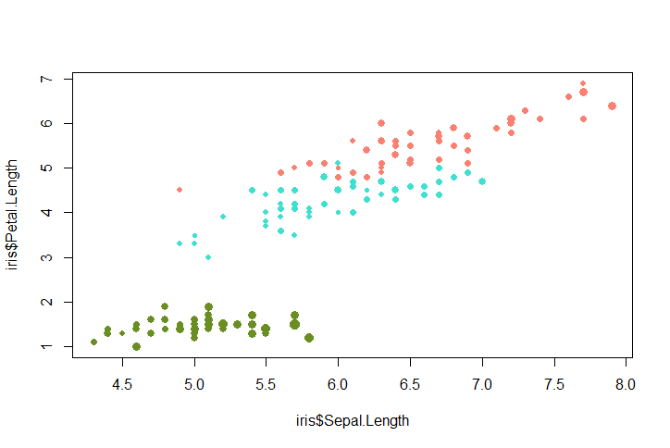

54.

plot(iris$Sepal.Length, iris$Petal.Length, col=cols, pch=19)

text(iris$Sepal.Length, iris$Petal.Length, iris$Species, col=cols, pch=19, cex=.5)

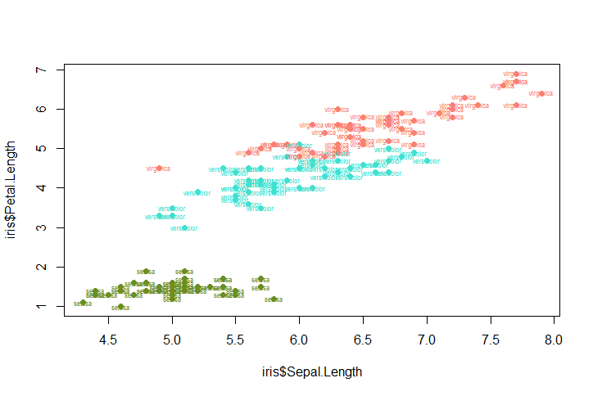

55.

abline(v=quantile(iris$Sepal.Length,probs=.5,), lty="dashed")

abline(h=quantile(iris$Petal.Length, probs=.5), lty="dashed")

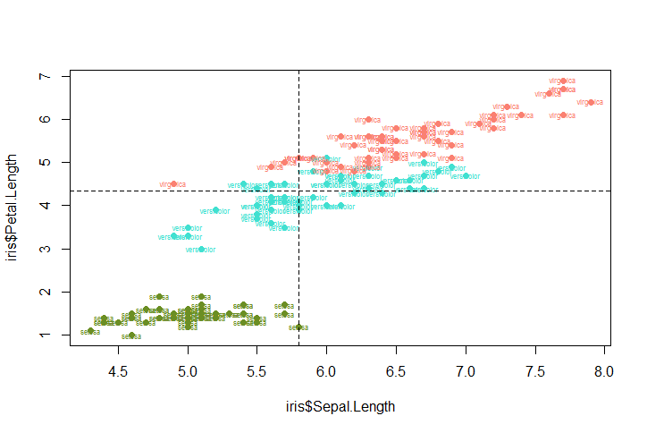

56.

Petalavs <- tapply(iris$Petal.Length, iris$Species, quantile, probs=.5)

Sepalavs <- tapply(iris$Sepal.Length, iris$Species, quantile, probs=.5)

abline(v=Sepalavs, lty="dashed", col=cols)

abline(h=Petalavs, lty="dashed", col=cols)

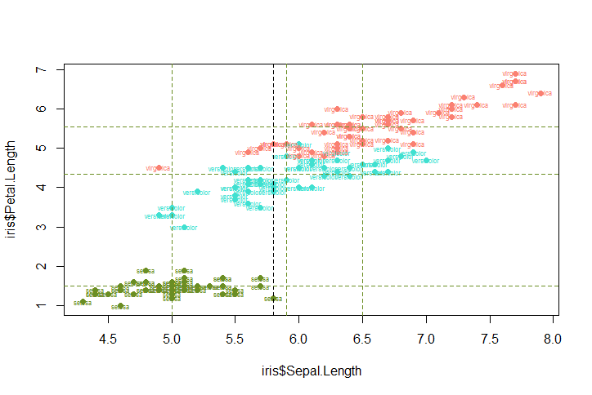

57.

species <- unique(iris$Species)

colVals <- c("olivedrab", "turquoise", "salmon")

cols <- colVals[match(iris$Species, species)]

sizes <- iris$Sepal.Width/quantile(iris$Sepal.Width, probs=.5)

plot(iris$Sepal.Length, iris$Petal.Length, col=cols, pch=19)

Petalavs <- tapply(iris$Petal.Length, iris$Species, quantile, probs=.5)

Sepalavs <- tapply(iris$Sepal.Length, iris$Species, quantile, probs=.5)

text(Sepalavs, Petalavs, species, cex=1)

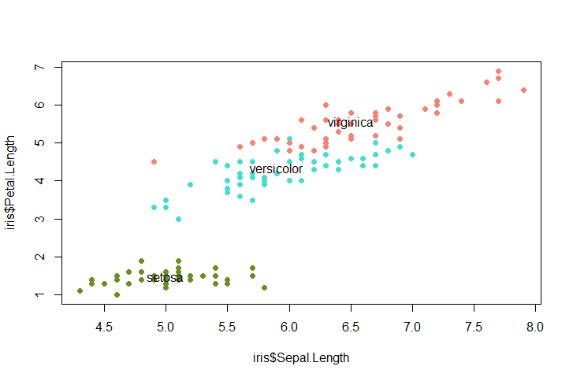

58. plot(iris$Petal.Length, iris$Sepal.Width)

groups = rep(2L,nrow(iris))

groups[iris$Petal.Length < 2] = 1L

groups[iris$Petal.Length > 2 & iris$Sepal.Width < 2.5] = 3

par(mfrow=c(1,2))

colVals <- c("salmon", "turquoise", "olivedrab")

plot(iris$Petal.Length, iris$Sepal.Width, col=colVals[groups], pch=19)

plot(iris$Sepal.Length, iris$Petal.Length, col=colVals[groups], pch=19)

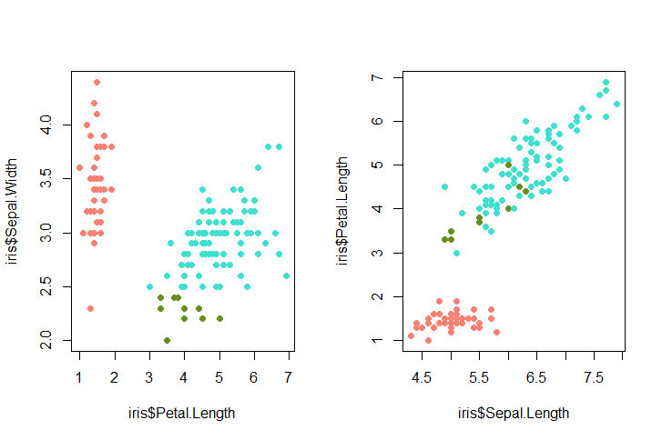

59.

par(mfrow=c(4,4))

par(mar=c(1,1,1,1))

par(oma=c(2,2,2,2))

for (i in 1:4) {

for(j in 1:4) {

plot(iris[,1], iris[,j], pch=19, cex=.5)

}

}

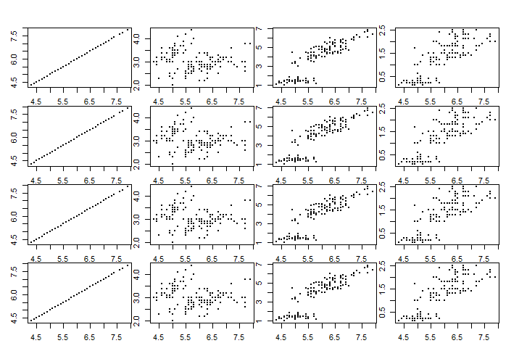

60.

par(mfrow=c(4,4))

par(mar=c(1,1,1,1))

par(oma=c(2,2,2,2))

for (i in 1:4) {

for(j in 1:4) {

plot(iris[,1], iris[,j], pch=19, cex=.5)

if (i == j) hist(iris[,i], main="")

}

}

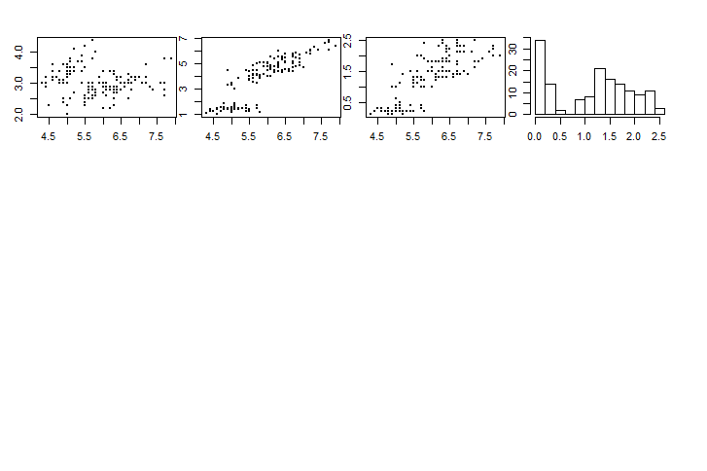

61.

plot(InsectSprays$count, col="white")

lines(InsectSprays$count)

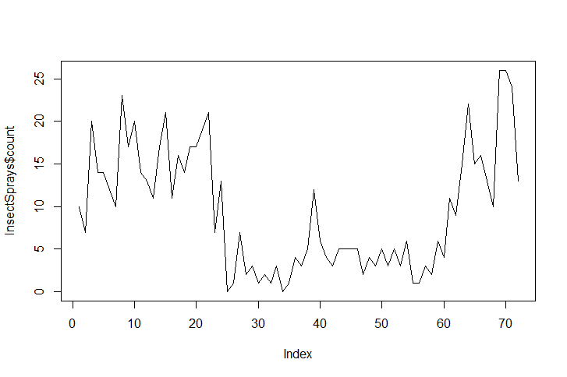

62.

points(rep(1,10), 1:10, pch=19)

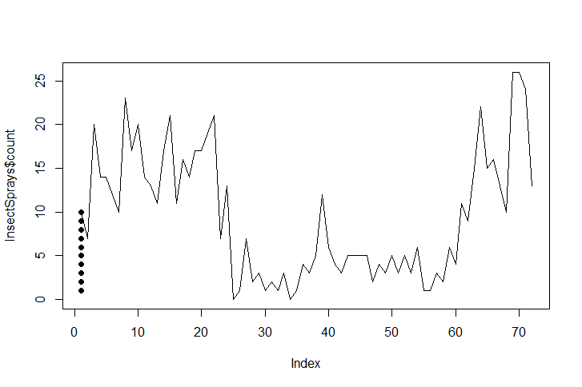

63.

plot(InsectSprays$count, col="white")

for (i in 1:nrow(InsectSprays)){

thisCount = InsectSprays$count[i]

if (thisCount > 0) points(rep(i, thisCount), 1:thisCount, pch=19)

}

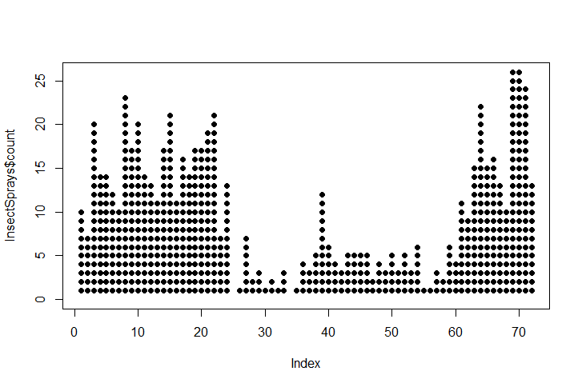

64,

plot(InsectSprays$count, col="white")

for (i in 1:nrow(InsectSprays)) {

thisCount = InsectSprays$count[i]

thisSpray = InsectSprays$spray[i]

if (thisCount > 0) text(rep(i, thisCount), 1:thisCount, 1:thisSpray)

}

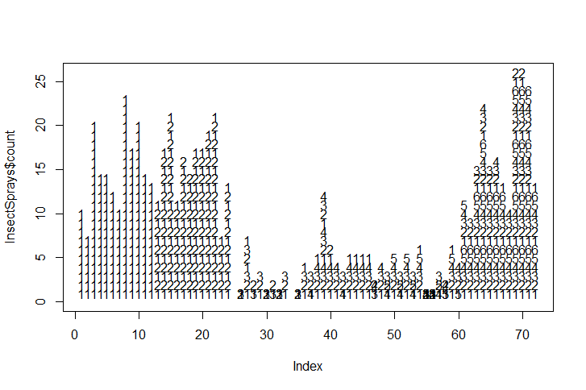

65.

abline(v=seq(.5,72.5, by=12))

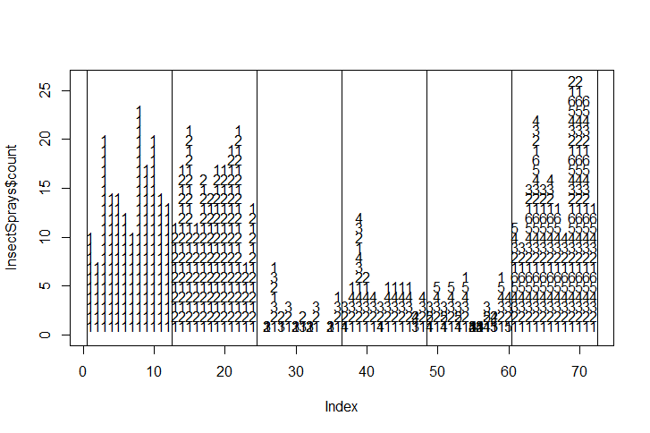

66.

plot(floor(InsectSprays$count/3), col="white")

for (i in 1:nrow(InsectSprays)) {

thisCount = floor(InsectSprays$count/3)[i]

thisSpray = InsectSprays$spray[i]

if (thisCount >0) points(rep(i, thisCount), 1:thisCount, pch= 19)

}

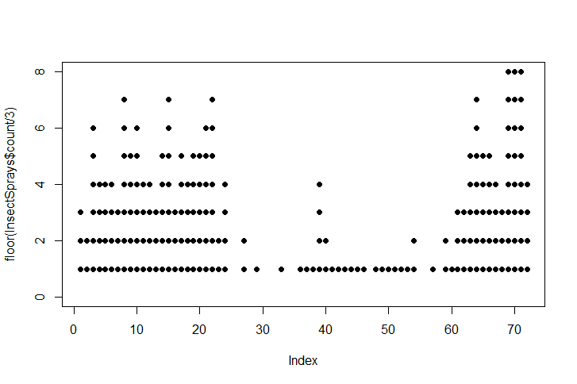

67.

plot(floor(InsectSprays$count/3), col="white")

for (i in 1:nrow(InsectSprays)) {

thisCount = floor(InsectSprays$count/3)[i]

thisSpray = InsectSprays$spray[i]

if (thisCount >0) points(rep(i, thisCount), 1:thisCount, pch= 19)

fracPart = (InsectSprays$count/3)[i] -

floor(InsectSprays$count/3)[i]

points(i, thisCount + 1, pch=19, cex=fracPart)

}

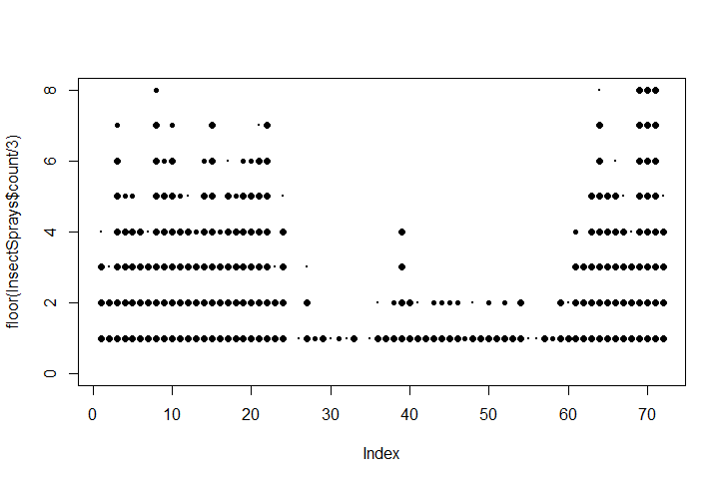

68.

|  |
| --- |
| > apply(ap, 1, sum)  Jan Feb Mar Apr May Jun Jul Aug Sep Oct Nov Dec  2901 2820 3242 3205 3262 3740 4216 4213 3629 3199 2794 3142  > apply(ap, 2, sum)  1949 1950 1951 1952 1953 1954 1955 1956 1957 1958 1959 1960  1520 1676 2042 2364 2700 2867 3408 3939 4421 4572 5140 5714 |
|  |
| |  | | --- | |  | |

69.

plot(1:12, ap[,1], col="white", axes=FALSE)

axis(2)

axis(1, at=1:12, rownames(ap))

lines(1:12, ap[,1])

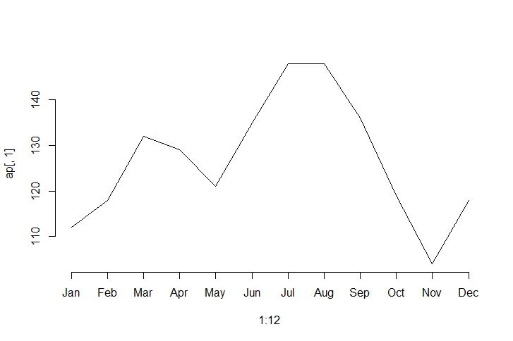

70.

plot(1:12, ap[,1], col="white", axes=FALSE, ylim=range(ap))

axis(2)

axis(1, at=1:12, rownames(ap))

for (j in 1:nrow(ap))

lines(1:12, ap[j])

text(rep(7,12), ap[7,], colnames(ap), cex=.5)

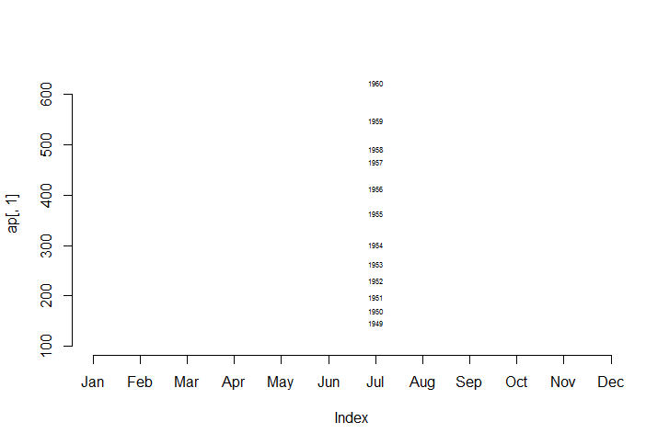

71.

plot(ap[,1], ap[,2])

text(ap[,1], ap[,2] +2, rownames(ap))

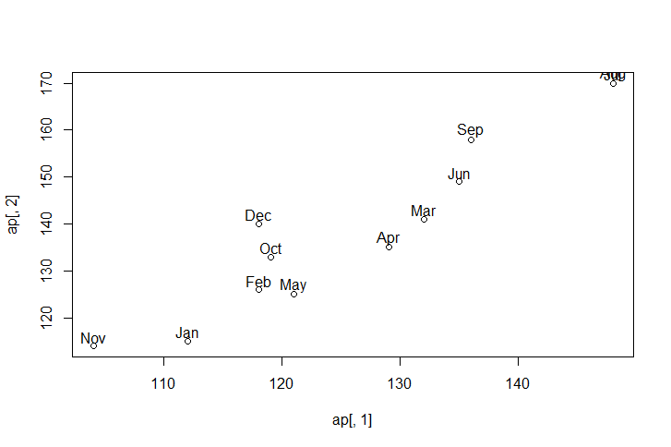

72.

|  |
| --- |
| > for (i in 1:ncol(ap)){  + scaledA <- 100*(ap[,i]/sum(ap[,i]))  + }  > scaledA  Jan Feb Mar Apr May Jun Jul  7.297865 6.842842 7.332867 8.067903 8.260413 9.362968 10.885544  Aug Sep Oct Nov Dec  10.605530 8.890445 8.067903 6.825341 7.560378 |
|  |
| |  | | --- | |  | |

73.

|  |
| --- |
| > scaledAP <- as.data.frame(scaledA)  > plot(1:12, scaledAP[,1], col="white", axes=FALSE,  + ylim=range(scaledAP))  > axis(2)  > axis(1, at=1:12, rownames(scaledAP))  > for (i in 1:nrow(scaledAP))  + lines(1:12, scaledAP[,i])  Error in `[.data.frame`(scaledAP, , i) : undefined columns selected  > text(rep(7,12), scaledAP[7,], colnames(scaledAP), cex=.5) |
|  |
| |  | | --- | | > | |

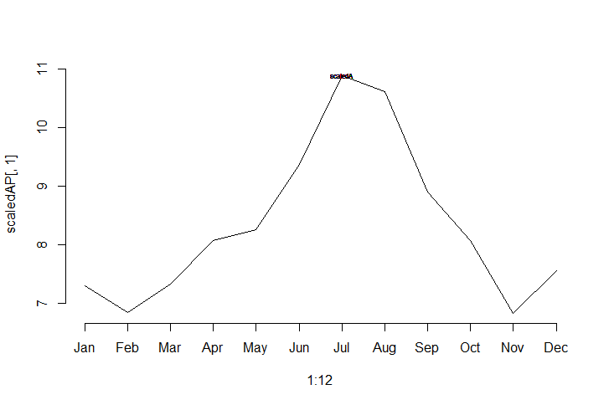

74. plot(0,0,xlim=c(1,12), ylim=c(1,12), col="white",

axes=FALSE, main="", xlab="", ylab="")

box()

axis(1, at=1:12,colnames(ap), las=2)

axis(2,at=1:12,rownames(ap), las=2)

for(i in 1:12) {

points(rep(i,12), 1:12, cex = ap[,i] / mean(ap), pch=19)

}

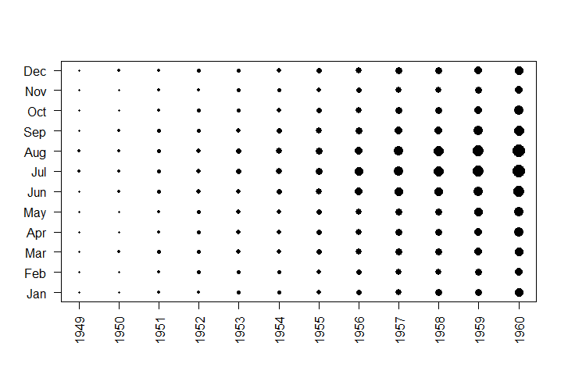

75.