1. Hello World
Pseudocode:
START
Print "Hello World"
END
Flowchart:
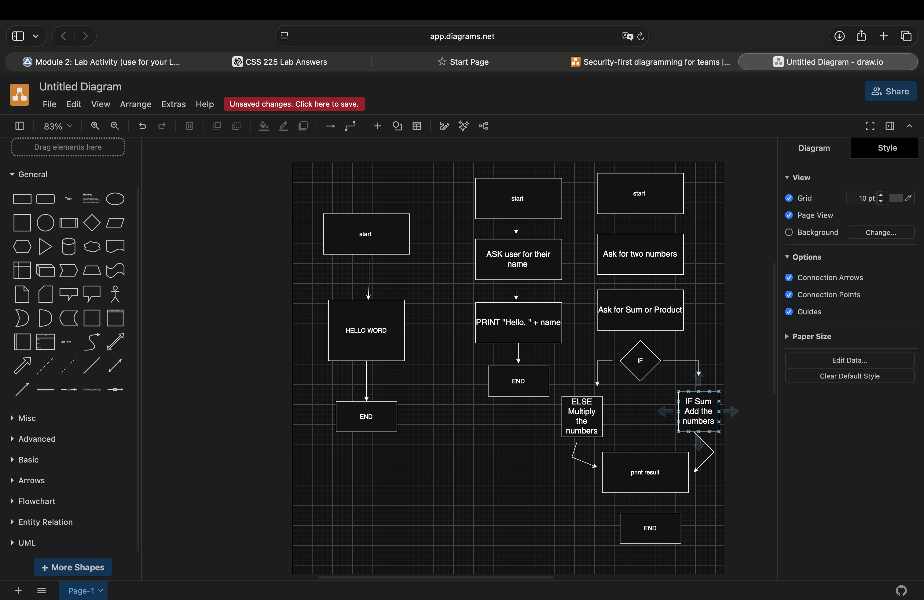

2. Ask for the User's Name
Pseudocode:
START
Ask for name
Print "Hello " + name
END
Flowchart:

3. Sum or Product
Pseudocode:
START
Ask for two numbers
Ask for Sum or Product
IF Sum
Add the numbers
ELSE
Multiply the numbers
Print result
END

Flowchart:

4. BMI Program

Variable Name | Purpose
height | Stores the person's height
weight | Stores the person's weight
bmi | Stores the calculated BMI

5. Login and Password Program
Variable Name | Purpose
username | Stores the username entered by the user
password | Stores the password entered by the user
storedUsername | Stores the correct username
storedPassword | Stores the correct password

6. English ↔ Morse Code Program
Variable Name | Purpose
englishText | Stores the English text
morseCode | Stores the Morse code
convertedText | Stores the converted result
conversionType | Stores the type of conversion

7–9. Resources
7. W3Schools – Programming tutorials and examples. https://www.w3schools.com/
8. GeeksforGeeks – Programming, algorithms, and data structures. https://www.geeksforgeeks.org/
9. Programiz – Beginner-friendly programming tutorials and examples. https://www.programiz.com/

End of Lab

