This file includes the documentation of the project through screen shots of the project flow:

1) landing page:

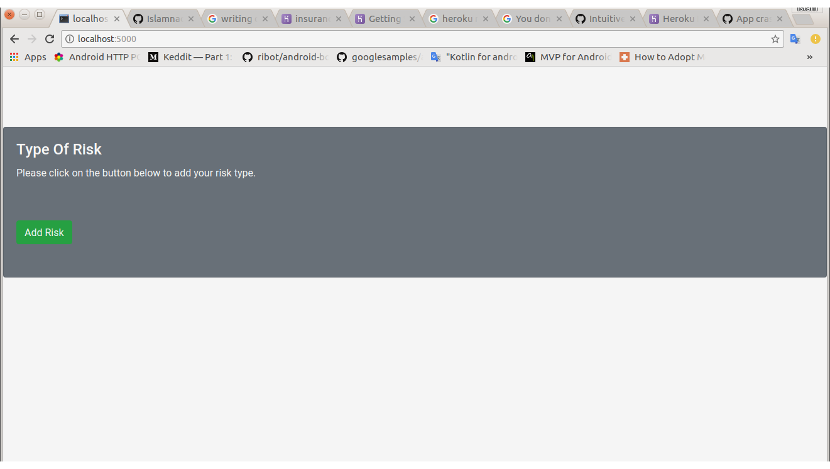

2) Adding Risk Type:

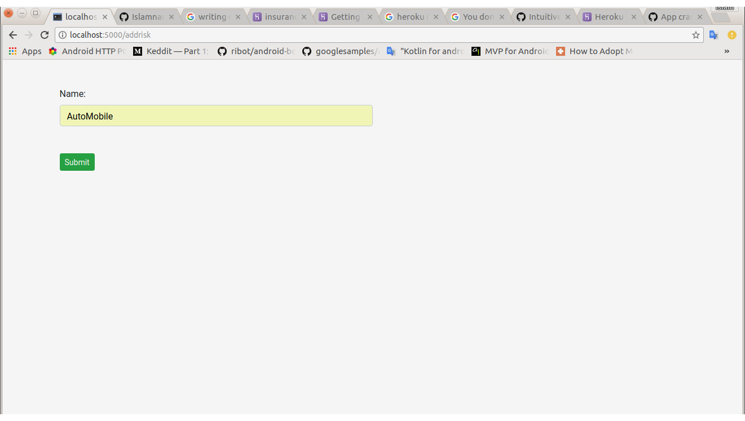

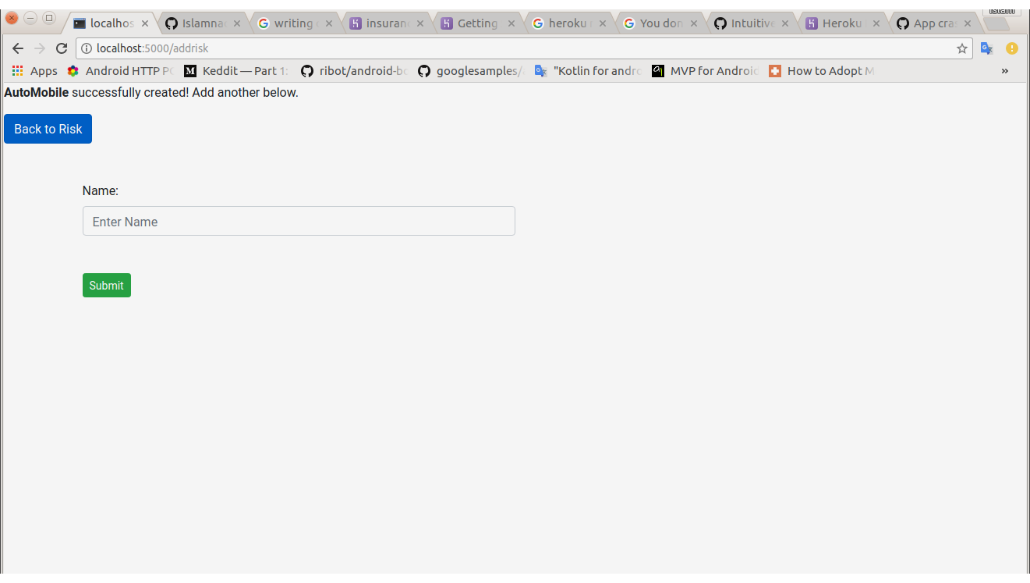

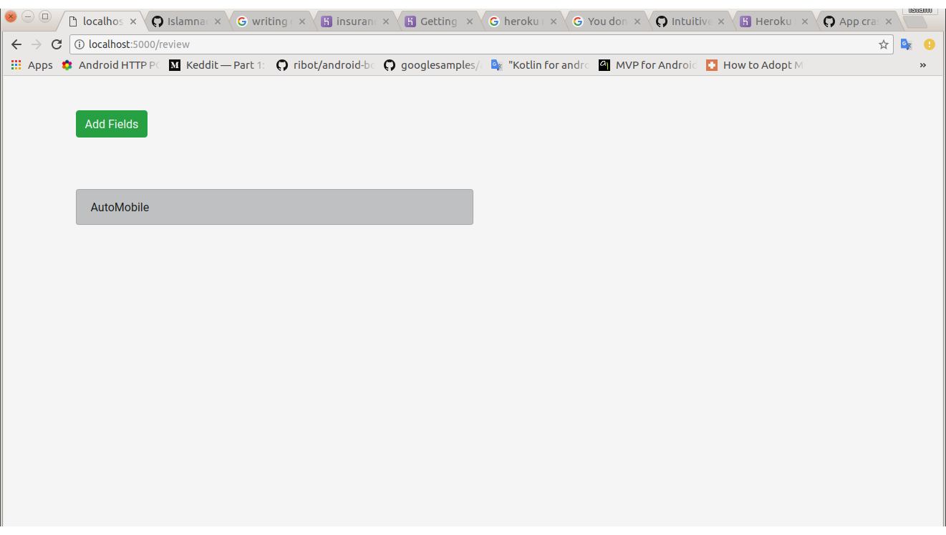3) Reviewing the Risk Type Added:

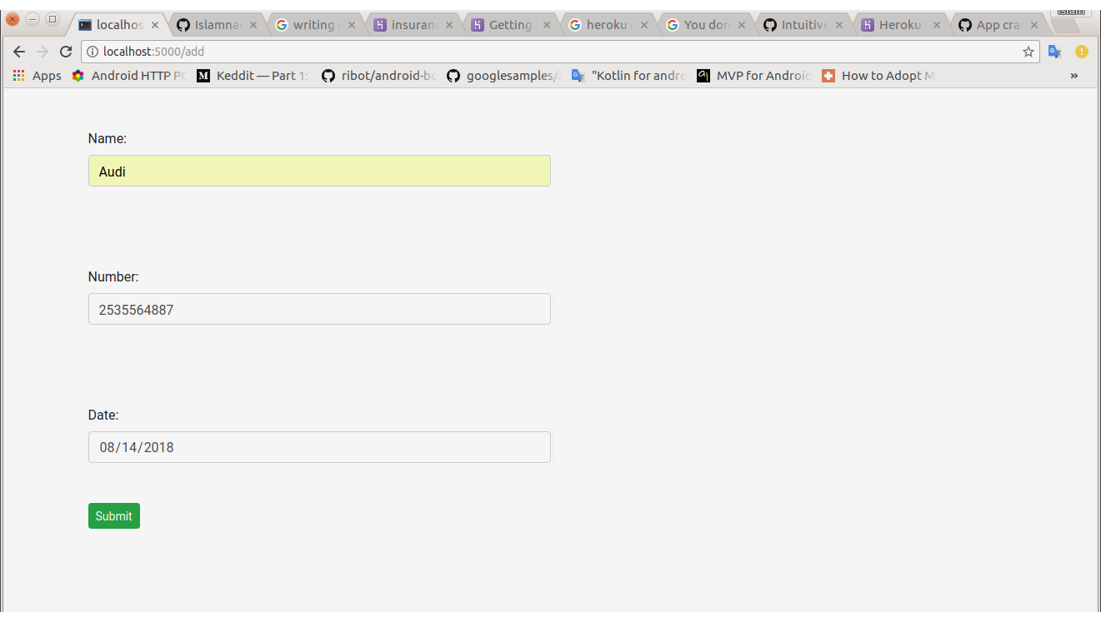4)Adding Risk Fields:

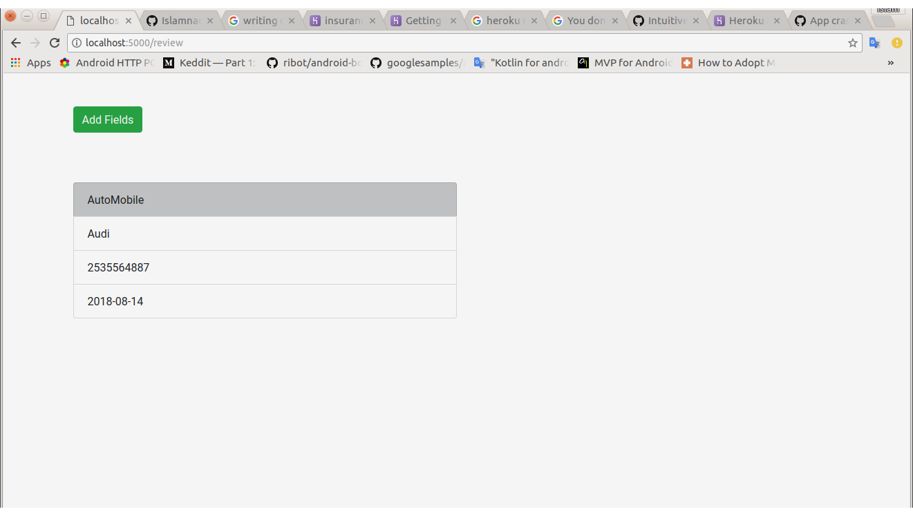5)Submitting Risk Fields &Reviewing all the data provided: