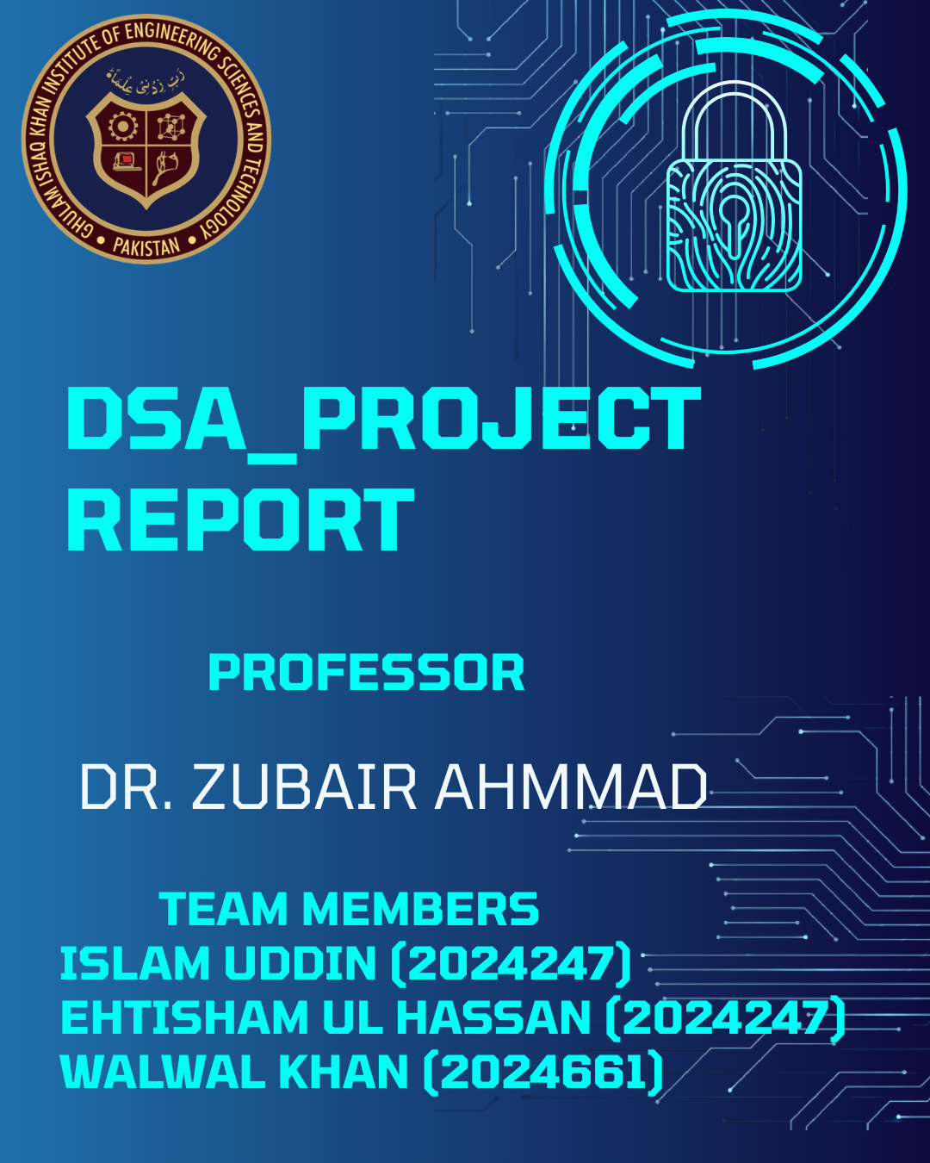

1. Project Overview

1.1 Introduction
Modern operating systems rely heavily on efficient data management and security protocols. Our project is a simulation of a file system just like window’s and Linux file system but of course a lite version with limited features. It integrates core Data Structures and Algorithms (DSA) concepts to create a secure environment where users can upload, organize, search, and secure files.
Unlike a standard file explorer, this project emphasizes the "backend" logic of file management. It demonstrates how abstract data types (ADTs) like Stacks, Queues, Linked Lists, and Binary Search Trees (BSTs) interact to solve real-world problems like file retrieval latency, operation history tracking, and data integrity verification.

1.2 Objectives
The primary aim was to replace inefficient linear data structures with optimized hierarchical structures while introducing cybersecurity elements. The key objectives were:
- Optimization: Implementing a Binary Search Tree (BST) to reduce file search time from linear O(n) to logarithmic O (log n).
- Security: Implementing a custom hashing algorithm and Vigenère Cipher style encryption to demonstrate data integrity and confidentiality.
- Automation: Using Queues to handle batch file processing (uploads) in a First-In-First-Out (FIFO) manner.
- Integrity: Scanning file contents against a database of known threat signatures using Vectors and pattern matching.

2. Implemented Data Structures and Algorithms
This system is built upon five distinct data structures, each chosen to solve a specific problem domain within the application.

2.1. Binary Search Tree (BST)
Searching for a file normally in a list/Queue takes O(n) time but that would be slow for hundreds of files. To solve this, we implemented a Binary Search Tree .
- Logic: The file names serve as the "key" for the tree. When a file is created or uploaded, it is compared lexicographically (alphabetically). If the name is "smaller" than the current node, it moves left; if "larger," it moves right.
- Recursion: We utilized recursive functions for insert, search, and inOrder traversal. This demonstrates the "Divide and Conquer" strategy learned in class.
- Sorting: By performing an In-Order Traversal (Left-Root-Right), the system automatically prints the file directory in alphabetical order without needing a separate sorting algorithm like Bubble Sort or Merge Sort.

2.2. Hashing – Data Integrity
To ensure files have not been corrupted or tampered with, we implemented a hashing function inside File Handler.
- Algorithm Design: The hash function reads the file line-by-line. We implemented a custom bitwise shift algorithm:
Hash = ((Hash <<5) + Hash) + c
This shifts the bits to the left by 5 positions (multiplying by 32) and adds the character value. This technique (similar to the djb2 algorithm) creates a "avalanche effect," where changing a single character in the file results in a completely different hash output.
- Hexadecimal Conversion: The integer hash is manually converted to a hexadecimal string, which serves as the file's unique fingerprint.

2.3. Queue – Upload Scheduling
The File Handler class utilizes the STL queue to manage file uploads.
- FIFO Principle: This ensures fairness in resource allocation. The first file selected by the user is the first one processed and indexed into the system. This prevents "starvation" of earlier tasks.

2.4. Stack – Encryption History
The Stack class (custom implemented) manages the encryption workflow.
- LIFO Principle: When a file is encrypted, its name and the key used are pushed onto the stack. This allows for immediate retrieval of the most recently secured files, facilitating a "Quick Decrypt" or "Undo" feature for the most recent operations.

2.5. Singly Linked List – System Logging
The Logger class uses a singly linked list (LogNode) to track user actions.
- Dynamic Growth: Unlike an array, the logs can grow indefinitely as the user interacts with the system.
- O(1) Insertion: New logs are inserted at the head of the list. This is a strategic choice: in a real-world log viewer, the user wants to see the most recent error or action first. Inserting at the head is an O(1) constant time operation, whereas appending to an array would be O(n) or require resizing.

3. Algorithm & Code Logic Analysis

3.1. Complex BST Deletion Logic
One of the most algorithmically complex parts of the code is the deleteNode function in the BST. Deleting a file from the index requires handling three distinct scenarios:
- Leaf Node: If the node has no children, we simply delete it and return nullptr.
- One Child: If the node has only one child (left or right), we delete the node and link its parent directly to its child.
- Two Children: This is the critical case. We cannot simply delete the node, or the tree would disconnect.
  - Solution: We find the In-Order Successor (the smallest value in the right subtree) using the minValueNode helper function.
  - We copy the successor's data to the current node.
  - We then recursively delete the successor node from the right subtree.
3.2. Malware Scanning Logic (Pattern Matching)
The scan File function implements a linear search pattern matching algorithm.
- It loads a database of virus signatures into a vector<string>.
- It reads the target file line-by-line, converting content to lowercase to ensure case-insensitive matching.
- It checks for the presence of any signature using string::find.

5. Challenges Faced & Solutions
During the development of the updated system, several technical challenges were encountered:

Challenge 1: Managing Memory in Linked Structures
- Issue: Implementing the Linked List for logs and the BST manually meant we had to carefully manage heap memory using new and delete. Early versions of the code had memory leaks where nodes were removed from the structure but not deleted from memory.
- Solution: We implemented a recursive destructor in the Logger and careful pointer management in the Stack::pop and BST::deleteNode functions to ensure every new has a corresponding delete.

Challenge 2: BST Node Deletion Complexity
- Issue: Implementing the "Two Children" deletion case in the BST was difficult. Specifically, updating the parent pointers correctly after replacing the target node with its inorder successor caused segmentation faults.
- Solution: We utilized a recursive approach where the deleteNode function returns the updated root pointer of the subtree. This ensured that parents automatically linked to the correct new child after a deletion.

Challenge 3: Hashing & Hex Conversion
- Issue: C++ does not have a built-in "to_hex" function for raw large integers easily accessible without external libraries.
- Solution: We implemented a manual algorithm using modulo 16 (hash % 16) and a lookup string "0123456789abcdef" to build the hex string character by character.

6. Application of Class Topics
This project served as a comprehensive practical application of the theoretical concepts covered in the semester:
- Pointers & References: The entire BST and Linked List infrastructure relies on pointers (Node* next, Node* left, Node* right). Understanding how to pass pointers by reference was crucial for the recursive modification of the tree.
- Recursion: The insert, search, and delete functions in the FileSearchTree class are direct applications of recursive definitions taught in class.
- Encapsulation (OOP): The code separates concerns strictly. FileHandler does not manage the log pointers; the Logger class does. The Manager class acts as an interface. This demonstrates Object-Oriented Programming principles alongside DSA.
- File I/O: We extensively used fstream to read/write persistent data, bridging the gap between volatile memory (RAM) structures and permanent disk storage.

7. Future Improvements
While the current system is functional, there are areas for optimization in future iterations:
- AVL Tree Integration: Currently, if a user uploads files in alphabetical order (A, B, C, D), the BST becomes a "skewed tree" (essentially a linked list), degrading performance to O(n). Implementing an AVL Tree would ensure the tree automatically balances itself (rotation), guaranteeing O(log n) performance regardless of input order.
- Graph Implementation: To support a folder-within-folder structure (subdirectories), we could upgrade the BST to a Graph or N-ary Tree structure, allowing for a true hierarchical file system.

8. Conclusion
This project successfully demonstrates the critical importance of Data Structures in software design. By replacing linear searches with a Binary Search Tree, we optimized retrieval times. By implementing Stacks and Queues, we managed operation flow logic efficiently. Finally, by integrating Hashing and Encryption, we showed how data structure manipulation forms the basis of cybersecurity. The project bridges the gap between theoretical algorithmic complexity and practical application development.

