GARNET

The Reconciliation of Rust and Ruby

Paper III (v2.1 redline) - Gap Analysis, Language Synthesis Proposal, and Market Viability Assessment
Prepared for: Jon - Island Development Crew
Date: April 2026
Series: Garnet Language Research Series
Revision note: This v2.1 pass incorporates the Grok consensus review, promotes Swift to the central comparator set, and tightens the boundary between language-core claims and runtime-platform claims.

Executive summary
This redline revision preserves the original comparative insight - that Rust and Ruby sit at opposite poles of programming language design - while strengthening the synthesis where the previous corpus remained under-specified. The v2.1 result is a more precise thesis: Garnet is strongest as a proposed dual-mode, agent-native language platform rather than merely as a merged language. Rust remains the reference for safe-mode rigor, ownership, and systems trust. Ruby remains the reference for humane syntax, DSL design, and orchestrative velocity. Swift becomes the missing production comparator for the managed side, clarifying how ARC, actors, and a coherent package/tooling story can coexist in a mainstream language. The update also introduces a formal scope boundary: TurboQuant motivates runtime design, but it is not treated as a hard semantic feature of the language core.

Abstract
The original Garnet synthesis argued that Rust and Ruby’s weaknesses mirror one another’s strengths so closely that a genuine reconciliation is plausible. That thesis still holds. This v2.1 revision refines the proposal in three ways. First, it adds Swift as the most important production comparator for Garnet’s managed mode, because Swift demonstrates that automatic reference counting, actor-based concurrency, and mainstream ergonomics can cohere in a serious language with durable tooling. Second, it redefines Garnet as a language-platform proposal for safe, expressive, memory-aware agentic software, bringing memory cores, memory managers, and domain-specific harnesses into the architecture. Third, it introduces a credibility boundary around model-side memory innovations such as TurboQuant, treating them as runtime and implementation influences rather than as direct language guarantees. The result is a more defensible synthesis, a sharper product wedge, and a clearer implementation roadmap.

1. The revised synthesis question
The original question was whether Rust and Ruby could be reconciled without collapsing into compromise. The v2.1 question is narrower and more practical:
Can a dual-mode language platform combine Ruby-like surface fluency, Rust-like safety, Swift-like managed ergonomics, and first-class memory abstractions for long-horizon agent systems?
This revision changes the evaluation criteria. Garnet is no longer judged only by how elegant its syntax sounds on paper. It is judged by whether the proposal can support reliable work across three layers at once:
- the language core,
- the runtime and memory system, and
- the harness/product layer built above it.

2. Updated comparison matrix
The original 34-dimension matrix remains useful, but the v2.1 revision highlights the dimensions most affected by the new comparator set and the memory-engineering addendum.
Dimension | Rust | Ruby | Swift | Garnet v2.1
Default memory model | Ownership + borrowing | Garbage collection | ARC for reference types | ARC default in managed mode; ownership in safe mode
Performance ceiling | Near C/C++ | Modest, improving with JIT | High, with managed defaults | Managed mode near Go/Swift class; safe mode near Rust target
Concurrency posture | Compile-time race freedom | GVL + experimental actors | Actors + Sendable | Typed actors + structured async + safe hot paths
Syntax posture | Explicit and rigorous | Humane and expressive | Moderate, mainstream ergonomic | Ruby-leaning managed surface with explicit safe boundary
Toolchain coherence | Cargo | RubyGems + Bundler + external tools | SwiftPM + Xcode | Unified CLI should be part of the product
Metaprogramming | Compile-time macros | Runtime reflection and DSLs | Limited compared with Ruby | Compile-time macros plus explicit @dynamic escape hatch
Agent-memory fit | Great for hot paths | Great for orchestration fluency | Strong precedent for managed isolation | Designed around memory units, traces, and shared memory core
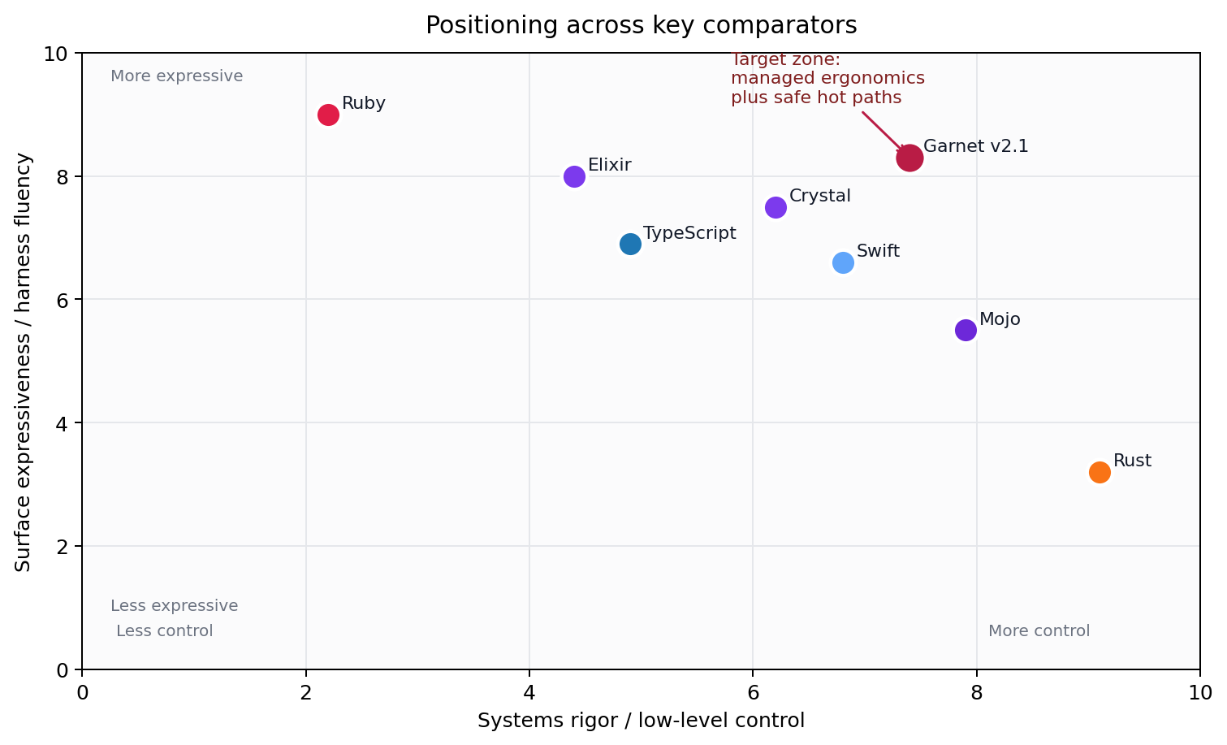
Positioning across key comparators

3. Swift as the missing production comparator
Swift matters because it validates the part of the Garnet proposal that neither Rust nor Ruby can validate alone.

3.1 What Swift proves
Swift shows that:
- automatic reference counting can be predictable and serious rather than a toy abstraction;
- actors and Sendable can move concurrency discipline into the mainstream;
- package tooling and language ergonomics can reinforce one another rather than competing for attention.

3.2 What Swift does not solve for Garnet
Swift does not replace Rust or Ruby in the argument.
- It does not match Rust’s ownership semantics as the core safe-mode substrate.
- It does not match Ruby’s metaprogramming range, DSL density, or REPL and orchestration culture.
- It does not by itself answer the agent-memory and harness-design question.

3.3 Why the comparator changes the proposal
The addition of Swift removes a blind spot in the original corpus. Without Swift, the managed side risked sounding like a hand-wavy compromise between GC languages and systems languages. With Swift in the frame, Garnet can argue from a real precedent: a language can have approachable syntax, automatic memory management, serious concurrency isolation, and mainstream tooling discipline without giving up ambition.

4. From LLM-native to agent-native
The v2.0 corpus argued that Garnet should be readable and generable by modern coding models. The v2.1 revision accepts that point, but makes a larger move: LLM-native is no longer enough. The stronger claim is that Garnet should be agent-native.
That means the proposal must represent more than code syntax. It must also account for:
- what the system remembers,
- how memory is stored and retrieved,
- how workflow traces become reusable,
- how tools and policies are described,
- and how the harness around the model keeps the work reliable.

4.1 Memory primitives
The memory-engineering transcripts supplied for this revision make a four-part distinction that fits Garnet well:
- working memory for short-lived execution context and semantic caches,
- episodic memory for interaction history and session summaries,
- semantic memory for facts, entities, and knowledge stores,
- procedural memory for workflow traces, skills, and tool schemas.
The language therefore benefits from first-class memory declarations:
memory episodic SessionLog : EpisodeStore<Interaction>
memory semantic Knowledge : VectorIndex<Fact>
memory procedural Workflows : WorkflowStore<Trace>
agent BuildAgent uses SessionLog, Knowledge, Workflows
tool deploy(input: BuildSpec) -> DeployResult
workflow ReleaseFlow persists Trace

4.2 Dual-mode architecture, updated
In managed mode, Garnet uses ARC with cycle-awareness and keeps syntax close to Ruby-like fluency. In safe mode (@safe), ownership and borrowing apply directly to memory units, buffers, and typed messages. The compiler/runtime boundary provides the bridges, diagnostics, and metadata hooks needed to move between those two worlds without pretending they are identical.

5. What belongs in the language core vs. the runtime
A stronger proposal needs a sharper boundary. The v2.1 corpus therefore divides claims into the following categories.
Layer | Garnet should standardize | Garnet should leave flexible
Language core | Managed vs. safe mode boundary; typed actors; memory primitive syntax; explicit dynamic escape hatches | Exact storage engines; exact compression algorithms; vendor-specific APIs
Compiler/runtime | Diagnostics; bridging; scheduling hooks; runtime metadata interfaces | Concrete serving stack; model-specific policies; backend-specific optimizers
Memory system | Interface expectations for memory units and traces | Whether storage is relational, vector, graph, or hybrid in a given implementation
Harness/product layer | Reference architecture and design guidance | UX, approvals flow, deployment surface, enterprise packaging

5.1 TurboQuant boundary
Google Research’s TurboQuant work is relevant because it shows how severe model-side memory pressure is becoming. It motivates Garnet’s runtime direction. It should not be treated as a hard semantic guarantee of the language itself. The proposal is stronger when it says:
- the language may expose annotations or runtime hooks compatible with compression-aware implementations,
- the runtime may exploit serving innovations as they mature,
- but the semantics of Garnet do not depend on one specific compression method.

6. What Garnet is / what Garnet is not
Garnet is | Garnet is not
A dual-mode language-platform proposal | Merely a chat frontend or CLI wrapper
A platform for safe, expressive, memory-aware software | A claim that every aspect of agent infrastructure belongs in syntax
A migration-aware design with Rust, C, and Ruby interop | A guarantee that one runtime strategy will fit all model stacks
A substrate for harnesses and long-horizon execution | A claim that it should replace every existing language at once
A research program with clear implementation phases | A finished compiler product today

7. Updated product wedge and market framing
The strongest commercial reading of Garnet remains cautious but promising. Mordor Intelligence’s January 2026 update places the software development tools market at USD 7.44B in 2026 and USD 15.72B by 2031. That scale is meaningful, but new languages do not win by market size alone. They win when they pair technical identity with either a killer application or a backer strong enough to manufacture ecosystem gravity.
Garnet’s sharper wedge is therefore agent infrastructure with a shared memory core and migration-friendly hot paths.
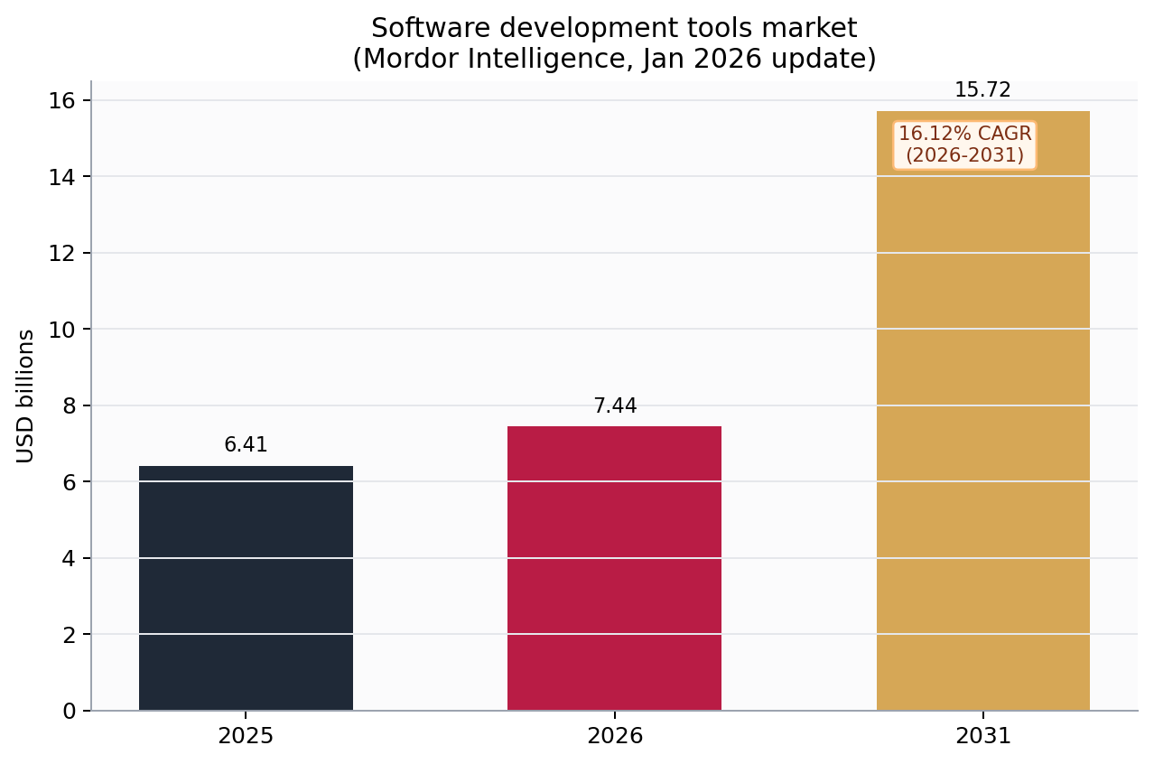
Software development tools market

7.1 Scenario framing
The v2.1 redline keeps the original market estimates but treats stretch cases as scenarios rather than settled forecasts.
Scenario | Description | Five-year implication
Base research case | Strong thesis, prototypes, early community traction | No reliable revenue claim yet
Focused wedge case | Harness runtime + memory-core SDK gain enterprise traction in a niche | Plausible low-to-mid tens of millions if adoption is real
Mature ecosystem case | Garnet becomes a top-15 ecosystem with real tooling, training, and hosting layers | Large upside, but only with exceptional execution or backing

8. A more credible implementation roadmap
The prior corpus ended close to the compiler question. The v2.1 pass makes the intermediate work explicit.

Phase 1 - formalize the model
- specify memory units, message protocols, and mode boundaries;
- define what is syntax, what is runtime metadata, and what is implementation-specific.

Phase 2 - prototype the language core
- parser + AST for a narrow subset;
- managed-mode interpreter and REPL;
- safe-mode lowering path to Rust or a Rust-like IR.

Phase 3 - build the platform wedge
- reference memory core;
- memory-manager SDK;
- harness runtime with approvals, traces, and policies;
- Rust/C interop from the beginning.

Phase 4 - validate the killer application
- choose a domain where the shared memory core matters enough to create pull;
- test whether Garnet is more compelling there than TypeScript plus tooling, Elixir plus BEAM, or Rust plus a custom harness.

Conclusion
The v2.1 redline does not overturn the Garnet thesis. It strengthens it. Swift clarifies the managed side. The memory transcripts clarify the runtime side. TurboQuant sharpens the systems argument without being overclaimed. The result is a narrower, more credible, and more product-ready proposal:
Garnet is strongest as a proposed dual-mode, agent-native language platform with Ruby-like expressive surfaces, Rust-like safe hot paths, Swift-like managed precedent, and a shared memory-core architecture that can support long-horizon agent systems.

Selected references
- Swift.org. Documentation. https://www.swift.org/documentation/
- Apple Developer Documentation. Sendable. https://developer.apple.com/documentation/swift/sendable
- Google Research. TurboQuant: Redefining AI efficiency with extreme compression. March 24, 2026. https://research.google/blog/turboquant-redefining-ai-efficiency-with-extreme-compression/
- Ruby. Official Ruby FAQ. https://www.ruby-lang.org/en/documentation/faq/1/
- Create T3 App. Introduction. https://create.t3.gg/en/introduction
- TypeScript Team. A 10x Faster TypeScript. March 11, 2025. https://devblogs.microsoft.com/typescript/typescript-native-port/
- TypeScript Team. Progress on TypeScript 7 - December 2025. December 2, 2025. https://devblogs.microsoft.com/typescript/progress-on-typescript-7-december-2025/
- Mordor Intelligence. Software Development Tools Market Size and Share Analysis 2031. Updated January 2026. https://www.mordorintelligence.com/industry-reports/software-development-tools-market
- User-supplied April 2026 transcripts on memory engineering, memory units, long-context retrieval, and harness design.

