GARNET FOR AGENTIC SYSTEMS

Addendum IV (v2.1 redline) - Memory Core, Harness Architecture, and Runtime Design
Prepared for: Jon - Island Development Crew
Date: April 2026
Series: Garnet Language Research Series
Revision note: This v2.1 pass keeps the addendum’s memory-engineering focus while removing overclaims and drawing a firmer line between language semantics and runtime strategy.

Executive summary
The Addendum IV material remains the most important conceptual expansion in the Garnet corpus. The supplied April 2026 transcripts reveal that the agent problem is not only a code-generation problem. It is a memory problem and a systems-composition problem. The redline revision therefore retains the ideas of memory core, memory manager, harness architecture, workflow memory, and memory units, but tightens three points:
- Garnet should be described as a proposed agent-native language platform, not as the singular first language of its kind.
- TurboQuant is best treated as a runtime and serving influence rather than as language-core semantics.
- The design must standardize only what needs standardization; otherwise it should remain implementation-flexible.

Abstract
This addendum develops the strongest new idea in the Garnet corpus: memory engineering as the decisive bridge between language design and long-horizon agent systems. Building from the supplied April 2026 transcripts, it organizes the space into working, episodic, semantic, and procedural memory; defines memory units as the minimal representation of useful stored information; and distinguishes the memory core (persistent substrate), memory manager (CRUD plus policy layer), and agent harness (orchestration and product layer). It then places Google Research’s March 2026 TurboQuant announcement into context as a motivating signal about model-side memory pressure, while clarifying that compression algorithms belong to runtime implementation choices rather than to language semantics. The resulting proposal is a sharper Garnet architecture in which syntax, runtime, storage, and harness layers each have a clear role.

1. Why the proposal had to move beyond LLM-native
The earlier Garnet material correctly noted that syntax regularity and explicit boundaries could help modern coding models generate safer code. That remains useful. The transcripts supplied for this revision, however, show why that point is no longer enough.
If a system is expected to operate over long horizons, it must do more than produce locally plausible code. It must decide:
- what to keep in context,
- what to summarize,
- what to retrieve,
- what to forget,
- and how to represent prior trajectories so later work becomes more reliable rather than more polluted.
That is why the move from prompt engineering to context engineering to memory engineering matters. Garnet’s agent-native turn is credible only if it reflects that hierarchy.

2. The transcript-derived memory model
The supplied April 2026 Richmond Alake transcript outlines a practical memory taxonomy for agent systems.
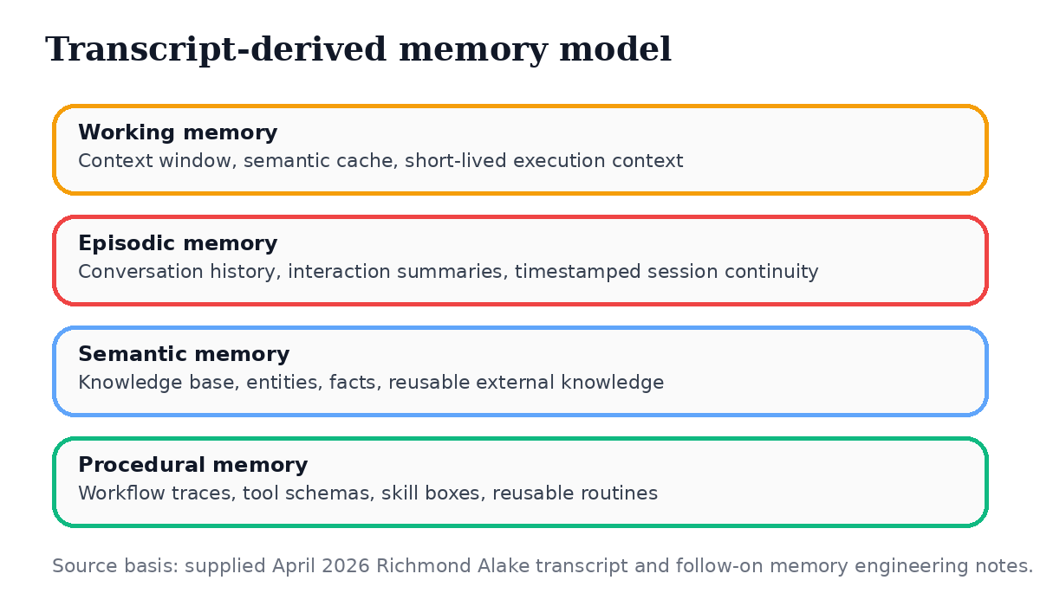
Transcript-derived memory model

2.1 Working memory
Working memory captures short-lived execution context. In agent systems this can mean the model’s active context window or a semantic cache used to answer repeated or near-duplicate requests without a full round-trip through the entire system.

2.2 Episodic memory
Episodic memory stores interaction history, summaries, session continuity, and timestamped records of what happened in a particular thread or task sequence.

2.3 Semantic memory
Semantic memory stores facts, entities, knowledge-base records, and reusable external knowledge about the world, the product, or the user.

2.4 Procedural memory
Procedural memory stores routines, tool schemas, skill boxes, and especially workflow traces - the stored steps and outcomes of prior executions that can later be reused, inspected, or ranked.

2.5 Memory units
One of the most useful transcript abstractions is the idea of a memory unit: the smallest representation of information that remains useful to the system. Different memory types use different units. A conversation unit might require content, timestamp, and role. A workflow unit might require step, function, outcome, and embedding metadata. This concept is valuable because it keeps the design grounded in the practical shape of stored information.

3. Memory core, memory manager, and agent harness
The addendum’s architectural center remains the same:
- Memory core - the persistent substrate where heterogeneous memory can live;
- Memory manager - the software layer that creates, reads, updates, ranks, summarizes, expires, and governs memory units;
- Agent harness - the orchestration layer that turns shared memory into domain-specific products and workflows.
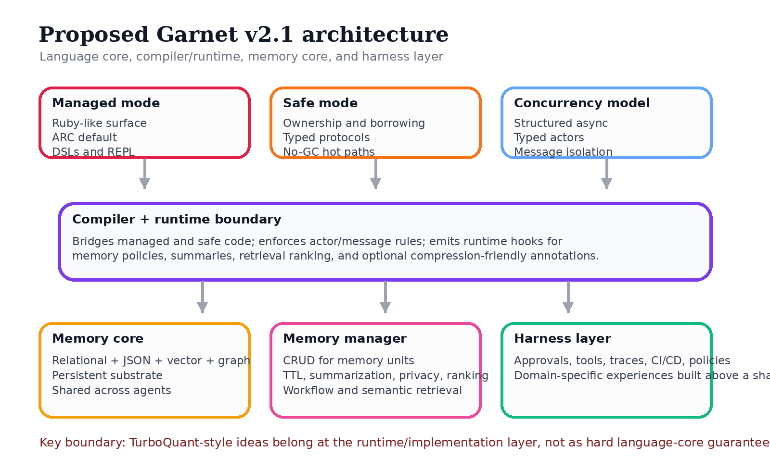
Proposed Garnet v2.1 architecture

3.1 Why one memory core, many harnesses is powerful
This phrase is still the strongest platform-level insight in the revised corpus. It matters because it separates shared memory infrastructure from domain-specific harness experience.
That enables:
- shared data governance,
- shared retrieval and policy infrastructure,
- domain specialization at the harness layer,
- and a product family built over one substrate instead of many disconnected silos.

3.2 Why the memory manager should not disappear into marketing language
The transcripts are correct to call out the memory manager as a real engineering layer. CRUD, ranking, TTL, privacy, and summarization are not incidental. They are what make external memory practical rather than decorative. Garnet does not need to make every one of these operations syntax-level, but the platform proposal should explicitly account for them.

3.3 Canonical illustrative example
The shape of Garnet’s memory-aware surface is easiest to see through a single canonical example. The following block is illustrative, not normative. It shows the intended developer experience of declaring typed memory units, composing them into an agent, and attaching a persisted workflow — all in managed mode, without any ownership ceremony.
# Managed mode — Ruby-like surface, ARC default
memory episodic SessionLog : EpisodeStore<Interaction>
memory semantic Knowledge : VectorIndex<Fact>
memory procedural Workflows : WorkflowStore<Trace>

agent BuildAgent uses SessionLog, Knowledge, Workflows
tool deploy(input: BuildSpec) -> DeployResult
workflow ReleaseFlow persists Trace
end
Three things about this example are worth naming explicitly, because they are what makes the surface agent-native rather than merely memory-flavored:
- The memory kind is part of the declaration, not the library. A developer declaring memory episodic SessionLog is telling both the compiler and the reader that this store holds time-stamped interaction history. The compiler can use that tag to enable kind-appropriate diagnostics; the reader can use it to reason about intent without opening the store’s implementation.
- agent ... uses ... is a composition primitive. An agent is, in this surface, an object that declaratively references the memory units it depends on. The compiler can therefore reason about which memory units any given agent touches — which is the foundation for later static analysis of retention, privacy, and retrieval behavior.
- workflow ... persists Trace ties procedural memory to execution. A workflow is not a free-floating function; it is an execution pattern whose trace is routed to a named procedural store. This is the language-level expression of Alake’s workflow memory concept, and it is the specific feature that most differentiates Garnet’s surface from a library-level agent framework.

What this example does and does not guarantee
This is important enough to state explicitly, because it is the boundary the v2.1 corpus holds as a discipline.
What the language guarantees. The surface above is a language-level commitment to three things: (a) memory kinds are nameable and typeable, (b) agents can statically declare the memory units they depend on, and (c) workflows can statically declare the procedural store that receives their traces. These are syntactic and type-system commitments that a Garnet compiler must enforce.
What the language does not guarantee. The language does not commit to any specific retention policy, ranking algorithm, persistence backend, wire format, replication model, privacy scope, or compression technique. In particular, the language does not guarantee that any part of this surface will be compressed using TurboQuant, QJL, PolarQuant, or any other specific algorithm. Those decisions belong to the runtime, the memory core, and the harness layer, not to the language core.
This boundary is deliberate. Coupling the language to a specific compression technique — or any other specific runtime tactic — would freeze the language to a moment in a rapidly evolving research landscape. Keeping the commitment at the surface level (“memory units exist, are typed, and can be statically reasoned about”) while leaving the tactics to the runtime allows both layers to evolve independently. That separation is the reason Paper IV treats memory engineering as a platform discipline rather than as a language feature.

4. Model-side memory pressure and TurboQuant
Google Research’s March 24, 2026 TurboQuant announcement is one of the clearest public signals that memory has become a bottleneck in the model stack itself.
The blog post describes:
- large compression gains for KV-cache and vector-search workloads,
- at least 6x KV-memory reduction on needle-in-a-haystack tasks,
- operation at around 3 bits without training or fine-tuning in the reported settings,
- and up to 8x speedup for attention-logit computation on H100s.
These are important results, but the redline revision makes the following caution explicit:
TurboQuant motivates Garnet’s runtime strategy; it does not define Garnet’s syntax or semantics.
This distinction keeps the proposal credible. A language can expose hooks, hints, metadata, or runtime interfaces compatible with compression-aware systems. It does not need to guarantee a specific compression method in the language definition.

5. Long-context retrieval, dependency graphs, and sub-agent guardrails
The supplied transcript material on long-context retrieval also adds a practical systems lesson: naive retrieval is not enough for heavily self-referential corpora. The discussion of virtualized memory objects, dependency graphs, and intelligent slicing suggests that some future Garnet runtimes may need richer retrieval structures than simple keyword or semantic lookup.
At the same time, the same transcript warns against unconstrained recursion and unchecked sub-agent proliferation. The relevant practical lesson is not “spawn agents everywhere.” It is:
- build explicit guardrails for recursion depth,
- cap asynchronous fan-out,
- attach metadata that helps the system know what a memory object contains,
- and validate whether more complex retrieval is actually cheaper or more reliable than simpler baselines.
That systems realism improves the Garnet proposal because it grounds memory ambition in deployment discipline.

6. Proposed Garnet runtime architecture
The v2.1 architecture can therefore be described as follows.

6.1 Language core
The language core should standardize:
- managed mode and safe mode,
- typed actors and message protocols,
- memory primitive declarations,
- explicit @dynamic or equivalent escape hatches,
- and the interop boundary for Rust, C, and Ruby.

6.2 Compiler/runtime boundary
The compiler/runtime boundary should provide:
- bridging between managed and safe components,
- scheduling and actor metadata,
- runtime hooks for memory policies and diagnostics,
- and stable interfaces that allow implementations to evolve without changing syntax.

6.3 Memory subsystem
The memory subsystem should include a reference model for:
- memory units,
- workflow traces,
- retrieval interfaces,
- summarization and retention policies,
- and privacy / governance expectations.

6.4 Harness layer
The harness layer should remain product-specific. It is where approvals, policies, CI/CD, security prompts, enterprise workflows, and domain-specific user experiences belong.

7. What Garnet should standardize vs. leave open
Standardize | Leave open
Mode boundaries | Exact storage engine
Typed actor/message semantics | Exact compression method
Memory primitive declarations | Vendor-specific serving stack
Interop contracts | UI / product surface
Runtime hooks and metadata interfaces | Enterprise packaging and deployment patterns
This table captures the core discipline of the redline revision. Garnet should be precise where precision improves composability and safety. It should remain open where over-specification would age poorly.

8. A more credible research and implementation agenda
The v2.1 revision recommends a staged program instead of a leap directly to a finished compiler story.

Phase 1 - specification
- define memory units formally,
- define typed message protocols,
- define what belongs in syntax versus runtime metadata.

Phase 2 - reference implementation
- parser + AST,
- managed-mode interpreter,
- workflow-memory reference store,
- typed-actor prototype.

Phase 3 - safe-mode path
- lower safe-mode fragments into Rust or a Rust-like IR,
- validate the bridge between managed orchestration and owned hot paths.

Phase 4 - platform validation
- test the shared memory core with at least one real harness domain,
- measure whether the architecture reduces orchestration cost or failure modes compared with existing stacks.

Conclusion
The strongest contribution of Addendum IV survives the redline intact: memory engineering is the missing bridge between language synthesis and long-horizon agent systems. What changes in v2.1 is the precision of the claim. Garnet should not promise that one paper or one compression technique solves everything. It should propose a platform in which syntax, runtime, storage, and harness layers are each well defined.
That yields the most durable statement in the revised corpus:
Garnet is most compelling when it is presented as a proposed agent-native language platform with a shared memory core, a real memory-manager layer, domain-specific harnesses, and a dual-mode language core that joins Ruby-like expressiveness to Rust-like safety.

Appendix B — PolarQuant and QJL: mathematical mechanics
This appendix provides the mathematical and architectural detail for the two-stage TurboQuant pipeline that §4 of the body cites only at headline level. It is included because the v2.1 redline takes a strong position on where compression techniques like TurboQuant should live in the Garnet stack (the runtime, the memory core, and the harness layer — not the language core), and that position is most defensible when the underlying mathematics is laid out clearly enough for the reader to evaluate the boundary on its own merits. The mechanics described here are drawn from Google Research’s March 2026 TurboQuant publication and from the Gemini 3.1 Pro Deep Research synthesis preserved in the Garnet v2.1 corpus.

B.1 Position and scope
TurboQuant is a training-free, data-oblivious vector quantization algorithm published by Google Research in March 2026. The headline numbers are large and are repeated here for context: approximately 6× KV-cache memory reduction on long-context tasks, operation at roughly 3 bits per value without any fine-tuning, and up to 8× speedup in attention-logit computation on H100-class accelerators. These results are real and they are large enough to reshape the cost curve of long-horizon agent inference. They are also the reason memory engineering — Paper IV’s central concern — is no longer optional infrastructure.
None of that, however, makes TurboQuant a language feature. The redline discipline of Paper IV holds, and Paper V (§5.4 and §8.4) makes the same separation formally on the type-theoretic side: the Garnet language core commits to the existence, kinds, and static composition of memory units, and to typed actor protocols around them. It does not commit to any specific quantization, ranking, retention, persistence, or compression strategy. Those choices live one layer down, in the runtime, the memory core, and the harness. This appendix exists to make that boundary easier to defend, not to soften it.
The reason for the boundary is straightforward. TurboQuant was published nine months before this paper’s revision; the next algorithm in this lineage will almost certainly arrive within the year. A language whose grammar names PolarQuant or QJL would freeze itself to a single moment in a fast-moving research area. A language whose grammar names memory units and exposes runtime hooks for compression-aware metadata can host PolarQuant today and its successor tomorrow without changing a line of user code. That second posture is the one Garnet adopts.

B.2 PolarQuant: geometric simplification via random projection
PolarQuant is the first of TurboQuant’s two stages. It addresses the central practical problem of vector quantization: real-world input distributions are messy, anisotropic, and require expensive per-tensor normalization and discretization constants before any uniform quantizer will give acceptable accuracy. PolarQuant’s contribution is to replace that messy preprocessing with a geometric trick that produces a predictable distribution by construction.
The mechanics proceed in three steps. First, PolarQuant applies a random projection matrix to each input vector. The projection is data-oblivious — it does not depend on the statistics of the input — and its effect is to redistribute the energy of an arbitrary input vector across all of its projected coordinates. The projection matrices used in TurboQuant are drawn from families with strong concentration properties, so that the projected coordinates are approximately isotropic regardless of the structure of the input.
Second, the squared coordinates of the projected vector follow a concentrated Beta distribution. This is the key analytic property that makes the approach work: once the data has been pushed through a suitable random projection, the marginal distribution of the squared coordinates is no longer dependent on the input distribution but only on the projection geometry. The system now knows, in closed form and ahead of time, what the value distribution will look like at quantization time.
Third, PolarQuant transforms each pair of projected coordinates from Cartesian form into polar form: a radius and an angle. Because the radial distribution is now known to be Beta-distributed by construction, the radius can be quantized against a fixed, mathematically predetermined grid — no per-tensor normalization, no scale calibration, no learned codebook. The angle can be quantized uniformly on the circle. The result is that an arbitrary input vector has been mapped onto a regular circular lattice whose geometry is fixed in advance, and the cost of doing so is a single matrix multiply followed by a coordinate transformation. Both operations are highly accelerator-friendly.
The architectural consequence is the elimination of the two most expensive parts of a traditional quantization pipeline: the per-tensor statistics pass that computes scale and zero-point, and the calibration step that fits a discrete codebook to the data. PolarQuant replaces both with a closed-form geometric guarantee. That is the source of most of the speedup TurboQuant reports on the attention-logit path.

B.3 QJL: residual error correction via Quantized Johnson–Lindenstrauss
PolarQuant alone is fast and approximate. The residual error it produces is small but biased in characteristic ways, and over the very long sequences typical of agent inference workloads that bias compounds. QJL is the second stage of the pipeline and exists to correct that residual without paying for it in storage.
QJL stands for Quantized Johnson–Lindenstrauss. The Johnson–Lindenstrauss lemma is the classical result that a set of points in a high-dimensional space can be embedded into a much lower-dimensional space by a random linear map while approximately preserving pairwise distances, with the dimensionality of the target space depending only logarithmically on the number of points. That property is what makes random projection a viable compression primitive in the first place.
QJL applies a second, smaller Johnson–Lindenstrauss-style projection to the residual left over after PolarQuant has done its work, and then quantizes the result of that projection extremely aggressively. In TurboQuant’s configuration the residual projection is reduced all the way to a single bit per coordinate — a sign bit, +1 or −1. Because the Johnson–Lindenstrauss guarantee preserves inner products on average, summing the sign-bit contributions back into the reconstructed value supplies an unbiased correction to the residual error. The mathematics is the high-speed equivalent of an error-correcting checksum: it does not store the residual exactly, but it stores enough of its statistical structure to cancel the bias.
The storage cost of this correction is essentially zero on accelerators that already pack low-bit values densely, because a sign bit fits inside the same byte that holds the PolarQuant output with no additional alignment overhead. The compute cost is one extra inner product per coordinate at decode time, which is cheap relative to the attention computation it is feeding. The accuracy benefit is what allows TurboQuant to claim near-zero accuracy loss on long-context retrieval tasks despite operating at roughly 3 bits per value — the headline result that motivates its inclusion in this paper at all.

B.4 Engineering implications and the language-core boundary
With the mechanics laid out, the position the body of this paper takes on TurboQuant becomes easier to defend on the merits rather than as a stylistic choice. Three observations are load-bearing.
- The PolarQuant + QJL pipeline is a runtime artifact, not a semantic one. Nothing in the description above touches on what a memory unit is, what kind it has, or how an agent composes it. The pipeline operates over numerical tensors at the point where they enter or leave the attention mechanism. It is invisible to type-checking, invisible to compiler diagnostics about memory composition, and invisible to the user who has written memory episodic SessionLog. Putting it in the language would not give it any new powers; it would only freeze the implementation choice.
- The pipeline is replaceable. Both stages are modular. PolarQuant could be replaced by a different geometric simplification that achieves the same predictable post-projection distribution; QJL could be replaced by a different residual correction that achieves the same unbiased reconstruction. There is nothing in the published TurboQuant architecture that suggests its specific factorization is the only valid one. The literature on data-oblivious quantization is moving quickly. A language commitment would obstruct that motion; a runtime commitment will absorb it.
- The right Garnet hook is metadata, not grammar. What TurboQuant-style techniques actually need from the language is a stable way to receive hints — expected access patterns, importance signals, retention windows, accuracy budgets — that let the runtime choose how aggressively to compress a given memory unit. Garnet’s position is that those hints belong on the metadata side of the compiler/runtime boundary defined in §6.2 of this paper, not inside the grammar. A memory unit declaration carries its kind and its type, and optionally carries metadata annotations that the runtime is free to honor, ignore, or reinterpret as the underlying implementation evolves.
This is the same separation Paper V states in formal terms. There it is expressed as a property of the type system: the language core’s soundness theorem applies to syntactic and type-system commitments about memory units and actor protocols, and it deliberately does not extend to claims about runtime compression behavior. Paper V’s §5.4 spells out what is not claimed by the soundness sketch, and Paper V’s §8.4 makes the same disclaimer for the actor and memory-primitive sections. This appendix is the engineering-side counterpart to those formal disclaimers: it shows what a runtime-layer technique actually looks like, so the reader can see for themselves why language-core rules cannot — and should not try to — reach down to govern it.
The conclusion of this appendix is therefore the same as the conclusion of §4 of the body, restated with the mathematics now visible: TurboQuant motivates Garnet’s memory-engineering posture, and Garnet’s memory-engineering posture is exactly the right shape to host TurboQuant and the algorithms that will succeed it. The two layers fit because they were designed by separate communities with separate concerns, and the language layer’s discipline is to stay out of the runtime layer’s way while giving it everything it needs.

Selected references
- Google Research. TurboQuant: Redefining AI efficiency with extreme compression. March 24, 2026. https://research.google/blog/turboquant-redefining-ai-efficiency-with-extreme-compression/
- Swift.org. Documentation. https://www.swift.org/documentation/
- Apple Developer Documentation. Sendable. https://developer.apple.com/documentation/swift/sendable
- Ruby. Official Ruby FAQ. https://www.ruby-lang.org/en/documentation/faq/1/
- TypeScript Team. A 10x Faster TypeScript. March 11, 2025. https://devblogs.microsoft.com/typescript/typescript-native-port/
- Create T3 App. Introduction. https://create.t3.gg/en/introduction
- User-supplied April 2026 transcripts on memory engineering, workflow memory, dependency graphs, retrieval guardrails, and harness design.

