# Petal and Pixel Site Plan

# Chloe Tranquill

## WDD 130

## Overview

### Purpose

I will use this website as my personal portfolio!

### Audience

Target audience will be future employers and professors.

## Branding

### Website Logo

## Style Guide

### Color Palette

|  |  |  |  |
| --- | --- | --- | --- |
| **Primary** | **Secondary** | **Accent 1** | **Accent 2** |
| #f4a9b8 | #ffe5ec | #d6c1d9 | #f8f1f1 |

### Typography

#### Heading Font: 'Great Vibes', cursive

#### Paragraph Font: 'Quicksand', sans-serif

### Navigation

Home My Vision Projects

**Content**

**Projects: Page 2**

“Chibi versions of myself I drew for my English final in 2024”

“My D&D character I drew for a session back in 2023.”

“Character I drew for a comic in 2024.”

My Vision: Page 1

“My dream for the future is to create my very own video game. Something that brings people together, tells a story worth remembering, and allows players to fully immerse themselves in a world I've imagined and built from the ground up. I envision a game that not only entertains but resonates emotionally, with meaningful characters, new creatures, and interesting environments. In addition to game development, I hope to explore the world of animation and voice acting. Animation excites me because it’s a powerful way to breathe life into the worlds that I’ve envisioned since I was a child. I’ve always wanted to give shape and motion to what once only lived only in my mind. Voice acting on the other hand, allows for the expression of emotion and personality in a unique, intimate way, it's the heart and soul behind the characters that players grow attached to. Ultimately, my goal is to be a storyteller across multiple mediums, blending technology and art to create experiences that leave a lasting impact. Whether through pixels, voices, or moving frames, I want to share stories that inspire others the way I've been inspired by games and animation throughout my life.”

Family picture:

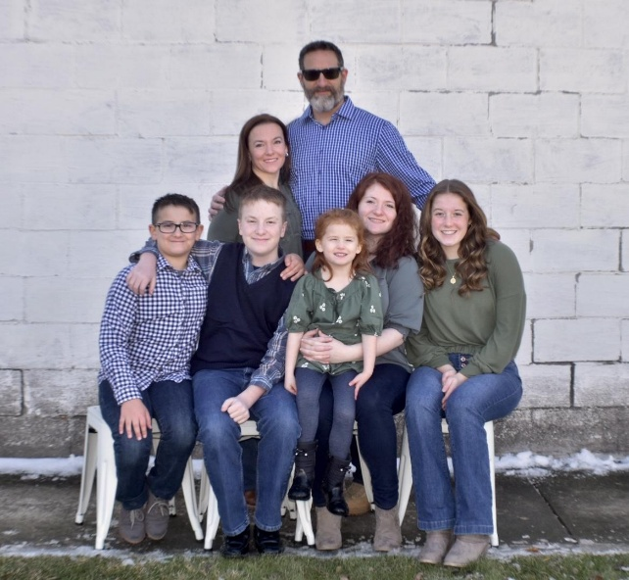

**Wireframes**

### Home

