Assessment 1 – Part 1: Requirements Analysis
Islombek Abdumutalib Ugli Sultonov
StudentID:25506686
1- User-Story Backlog
You should read the customer (university) requirements thoroughly and transform the requirements into user stories. The user story should be simple and generic so that each story is later translated into a function (or action). Each story will have a unique 3 digit ID. Stories related to the same feature will share the same hundreds digit.

ID | User | Action | Result | Function
101 | Student | Register with name, email, and password | System validates credentials and generates unique 6-digit ID | Register Student
102 | Student | Enter email in correct format (ends with @university.com) | Registration succeeds | Validate Email
103 | Student | Enter password with uppercase, ≥5 letters, and ≥3 digits | Registration succeeds | Validate Password
104 | System | Generate student ID automatically (padded to 6 digits) | Student receives unique ID | Generate Student ID
105 | Student | Login using email & password | Access granted to student subsystem | Student Login
201 | Student | Enrol in a subject | Subject added to enrolment list | Enrol Subject
202 | System | Auto-generate subject ID (3-digit) | Subject stored with unique ID | Generate Subject ID
203 | System | Auto-generate random subject mark (25–100) | Grade calculated (Z, P, C, D, HD) | Auto Assign Grade
204 | Student | Attempt to enrol in more than 4 subjects | System blocks and notifies student | Enrolment Limit
205 | Student | View current enrolment list | System displays all subjects with marks & grades | View Enrolment
206 | Student | Remove subject from enrolment list | Subject deleted | Remove Subject
207 | Student | Change password | Password updated securely | Change Password
301 | Admin | View all registered students | System displays student list | View Students
302 | Admin | Organize students by grade | System categorizes by grade (Z, P, C, D, HD) | Organize by Grade
303 | Admin | Categorize students into PASS/FAIL | PASS/FAIL list generated | Categorize Students
304 | Admin | Remove individual student | Student removed from data file | Remove Student
305 | Admin | Clear entire student database | All student data deleted | Clear Database
401 | Student | Login into GUIUniApp | System checks credentials and opens enrolment window | GUI Login
402 | Student | Enrol in subjects via GUI | Subjects added to GUI enrolment list | GUI Enrol Subject
403 | GUIUniApp | Handle empty login fields | Show error message | Handle GUI Login Error
404 | GUIUniApp | Prevent >4 enrolments in GUI | Show error message | GUI Enrolment Validation

Table 1 User-Story Backlog
2- UML Use Case Diagram
Your team will develop a comprehensive UML use case diagram by identifying the actors, goals, use cases, and their relationships. Provide explanation for each actor, goal, use case and relationship and ensure your diagram is consistent and aligned with the explanations
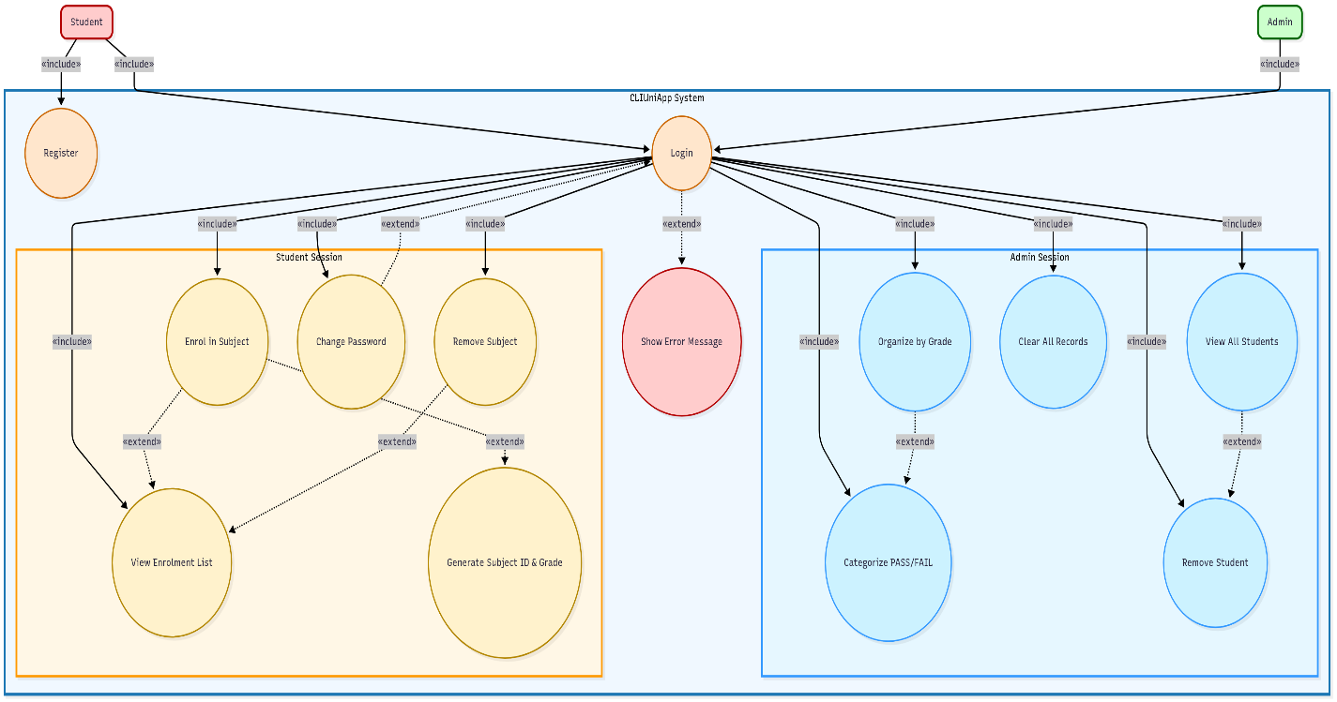
Diagram 1 UML Use Case Diagram

Explanation of the UML Use Case Diagram
1. Actors
Student: Can register, log in, enrol or remove subjects, view enrolment list, and change password.
Admin: Manages all student records, organizes grades, categorizes PASS/FAIL, removes students, and clears system data.
2. Goals
Student: Manage subjects efficiently and have subject IDs and grades automatically generated.
Admin: Maintain student data, organize results, and ensure system is up-to-date.
3. Use Cases
Student: Register, Login, Enrol/Remove Subject, View Enrolment, Change Password, Generate Subject ID & Grade (extends Enrol).
Admin: View All Students, Organize Grades, Categorize PASS/FAIL, Remove Student, Clear Records.
System: Show Error Message (extends Login).
4. Relationships
«include» → Mandatory steps (e.g., Login → Student/Admin session).
«extend» → Optional or automatic actions (e.g., Enrol → Generate ID & Grade, Login → Show Error).
Arrows show who initiates each action and how use cases connect.

3- UML Class Diagram
UML class diagram by identifying the classes, fields,
methods, visibility, multiplicity, and their relationships. Provide explanation for each of these and ensure your diagram is consistent and aligned with the explanations
Explanation of UML Class Diagram
1. Classes and Attributes
- Student: A system user who can register, log in, enrol or remove subjects, view their enrolment list, and change their password. Attributes: studentID, name, email (public), password (private).
- Admin: Manages student data and system records. Attributes: adminID, name, email (public), password (private).
- Subject: Represents a course with subjectID, subjectName, and grade.
- System: Handles login, registration, and error messages.
2. Methods
- Student: enrol(), removeSubject(), viewEnrolment(), changePassword().
- Admin: viewAllStudents(), organizeByGrade(), categorizePassFail(), removeStudent(), clearAllRecords().
- Subject: generateIDGrade().
- System: login(), registerStudent(), showError().
3. Visibility
- Public (+): Can be accessed by other classes.
- Private (-): Hidden for security, e.g., passwords.
4. Multiplicity
- A student can enrol in multiple subjects.
- An admin can manage multiple students.
5. Relationships
- Association: Students enrol in subjects; Admins manage students.
- Dependency: Subjects rely on the system to generate IDs and grades.
- Interaction: Both students and admins interact with the system for login and registration

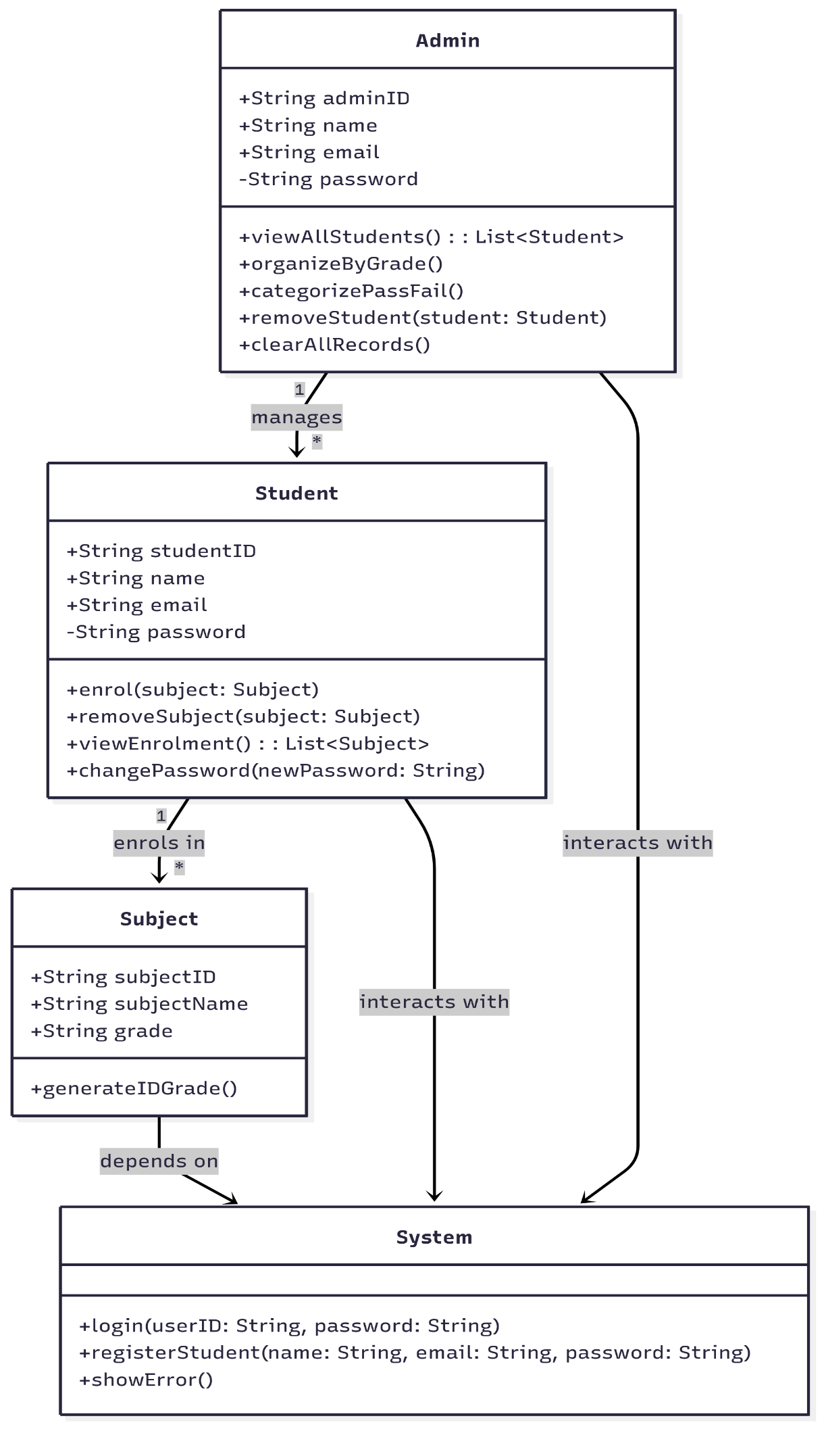
Diagram 2 UML Class Diagram
References
https://www.mermaidchart.com/app/projects/421ea52e-b4bf-428e-b99c-c3852ca9b211/diagrams/18226dd9-494d-4fff-844a-ffe6df23405f/version/v0.1/edit

