Experimental Execution Summary: EMCAD Replication on Kvasir-SEG

1. Introduction
This report presents the experimental verification of the EMCAD medical image segmentation framework using the official open-source implementation. The experiment was performed on the Kvasir-SEG dataset for binary polyp segmentation. The objective was to reproduce the reported framework setup, train the model, evaluate benchmark performance, and analyze the replication findings.

2. Experimental Setup
Component | Configuration
Platform | Kaggle Notebook
Framework | PyTorch
Dataset | Kvasir-SEG
Task | Binary Polyp Segmentation
Encoder | PVTv2-B2
Decoder | EMCAD
Input Image Size | 352 x 352
Batch Size | 8
Epochs | 5
Optimizer | AdamW
Learning Rate | 0.0005

3. Model Configuration
The implemented EMCAD model used PVTv2-B2 as the backbone encoder. The decoder used multi-scale convolution and attention components with the following settings.
Parameter | Value
Kernel Sizes | [1, 3, 5]
Depthwise Mode | Parallel
Aggregation | Add
LGAG Kernel Size | 3
Expansion Factor | 2
Activation Function | ReLU6

4. Dataset Preparation
The Kvasir-SEG dataset was arranged according to the required directory structure of the EMCAD dataloader. The final dataset split contained:
Split | Number of Images
Training | 700
Validation | 150
Testing | 150

5. Training Execution Log
The model completed training successfully. The following section contains the execution logs collected from the Kaggle environment.
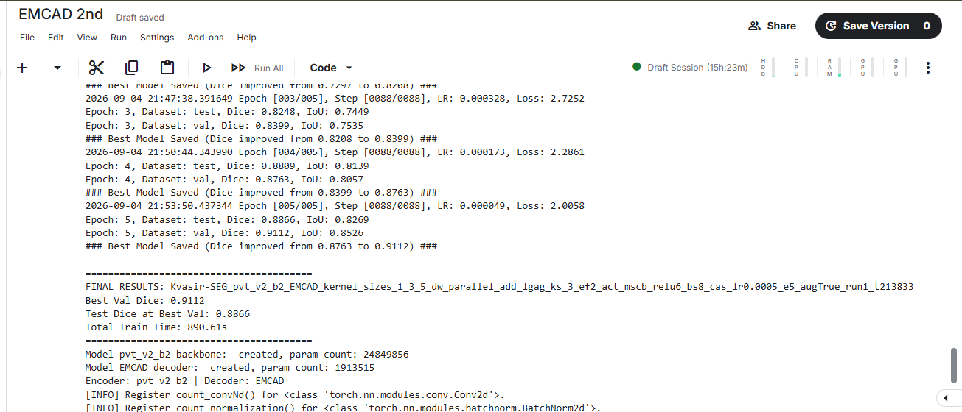
Important training observation: the model improved during training and achieved the best validation Dice score at the final evaluation stage.

6. Benchmark Results
Dataset | Best Validation Dice | Test Dice | Model Complexity
Kvasir-SEG | 0.9112 | 0.8866 | 26.76M Parameters / 10.58G FLOPs
The benchmark values were obtained from the final trained EMCAD model evaluation.

7. Qualitative Results
Qualitative analysis was performed by comparing original endoscopic images, ground truth segmentation masks, and EMCAD prediction masks.

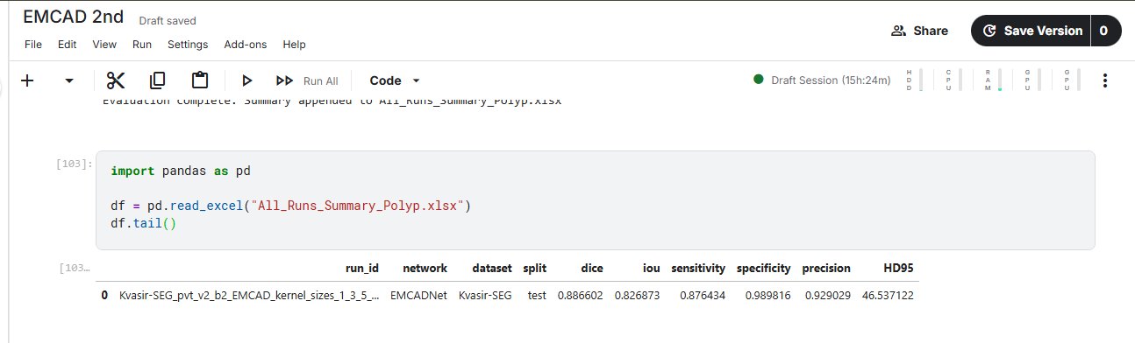8. Replication Findings
During replication, the main challenges were dataset organization, dependency installation, and matching the expected input paths of the original codebase. After resolving these issues, the complete training and testing pipeline successfully executed. The obtained results verify that the EMCAD implementation can be reproduced on the Kvasir-SEG dataset.

9. Repository Information
The complete replication code, notebook, benchmark results, logs, and visualization files are provided in the accompanying GitHub repository.

