



Business Process Name

Process Definition Document

Contents

1. Introduction 3

1.1 Purpose of the document 3

1.2 Objectives 3

1.3 Process key contacts 3

2. Process Overview 4

2.1 Applications used in the process 5

2.2 Process Map 5

2.3 Process Steps 6

Pre-requisites

1. **Dedicated machine**
2. **Minimum machine requirements: Dual Core x64, 4GB, Win 7+, Monitor: 22”+, 1920x1080 Mouse & Keyboard**
3. **Internet connection**
4. **All applications in scope for the POC must be installed with credentials provisioned for each**
5. **Administrator rights**
6. **Process subject matter expert must be available**
7. **Test data to support development (if necessary)**

**UiPath platform installer:** [**https://download.uipath.com/UiPathPlatformInstaller.exe**](https://download.uipath.com/UiPathPlatformInstaller.exe)

## Introduction

### Purpose of the document

The Process Definition Document outlines the business process chosen for automation using UiPath Robotic Process Automation (RPA) technology.

The document describes the sequence of steps performed within the business process, the conditions and rules of the process prior to automation and how they are envisioned to work after automating it, partly or entirely. This specifications document serves as a base for developers, providing them the details required for applying robotic automation to the selected business process.

### Objectives

The positive business outcomes and benefits expected by the Business Process Owner after automation of the selected business process are:

*{replace the below bullet points that serve as example, with the specific, SMART objectives and benefits expected after automation }*

* *Reduce processing time per item by 80 %. The duration to process an invoice in AS IS state is 7 minutes.*
* *Logging and visualization of xyz sub activities*
* *100% accuracy*
* *Automatic robot scaling per demand*
* *Increased compliance*
* *Increased employee/customer satisfaction*

### Process key contacts

The specifications document includes concise and complete requirements of the business process and it is built based on the inputs provided by the **process** **Subject Matter Expert (SME)/ Process Owner.**

Names to be included in the table below:

|  |  |  |  |
| --- | --- | --- | --- |
| *Role* | *Name* | *Contact details*  *(email, phone number)* | *Notes* |
| ***Process SME*** | *Name, Surname* | [Name.surname@domain.com](mailto:Name.surname@domain.com)  *Mobile: 44 0735 325 209* | *Point of contact for questions related to business exceptions and passwords* |
| ***Process Reviewer*** | *Name, Surname* | [Name.surname@domain.com](mailto:Name.surname@domain.com)  *Mobile: 44 0735 325 209* | *Point of Contact for process exceptions* |

## Process Overview

General information about the process selected for RPA prior to automation.

|  |  |  |
| --- | --- | --- |
| # | Item | Description Procurement |
| 1 | **Process full name** | *Scanning and booking of invoices received* |
| 2 | **Process Area** | *Finance* |
| 3 | **Department** | *Procurement* |
| 4 | **Process short description**  (operation, activity, outcome) | *Invoices received are saved on a location and matched with Receipt ID in PeopleSoft* |
| 5 | **Role(s) required for performing the process** | *Procurement Offices* |
| 6 | **Process schedule and frequency** | *Daily, Monday to Friday, 9 am – 6 pm* |
| 7 | **# of items processes /reference period** | *~1000/ month (business as usual)* |
| 8 | **Average handling time per item** | *10 min* |
| 9 | **Peak period (s)** | *Beginning of month (1-5th of the month) and 22th to 28th day of each month* |
| 10 | **Transaction Volume During Peak period** | *600* |
| 11 | **Total # of FTEs supporting this activity** | *3-4* |
| 12 | **Expected increase of volume in the next reference period** | *Volumes will increase with 20%* |
| 1 | **Level of exception rate** | *No expected exceptions* |
| 12 | **Input data** |  |
| 13 | **Output data** |  |

*\*Add more rows to the table to include relevant data for the automation process. No fields should be left empty. Use “n/a” for the items that don`t apply to the selected business process.*

### 2.1 Applications used in the process

The table includes a comprehensive list all the applications that are used as part of the process automated, at various steps in the flow.

|  |  |  |  |  |  |
| --- | --- | --- | --- | --- | --- |
| # | Application name & version | System  Language | Thin/Thick Client | Environment/  Access method | Comments |
| 1 | *PeopleSoft 9.1* | *EN* | *Thick Client* | *Web Browser* | *Task management* |
| 2 | *SAP 4HANA* | *EN* | *Thick Client* | *Native Application* | *ERP* |
| 3 | *Salesforce* | *EN* | *Thin Client* | *Web Browser* | *CRM* |

*\*Add more rows to the table to include the complete list of applications.*

### 2.2 Process Map

This chapter depicts the AS IS business process in detail to enable the developer to build the automated process.

*{Detailed process map to be added here, with input/output flow at each stage. Divide the process into stages if required (for better readability)}.*

*Example:*

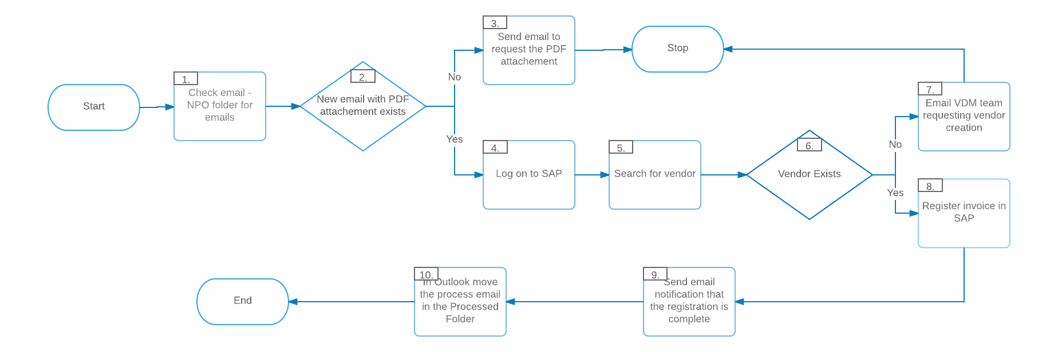

### 2.3 Process Steps

* Step by step walkthrough of the selected process. It is highly recommended to use screenshots from the process itself for maximum clarity. Each action taken by a person, should be a screenshot.

|  |  |  |
| --- | --- | --- |
| Step | **Short Description of Key Process Steps** |  |
| ***1*** | Check Outlook email, NPO Folder, for new emails to be processed |  |
| ***2*** | Pick new email, check the email for attachment and available information |  |
| ***3*** | If the PDF attachment is missing, reply to email requesting for the PDF to be sent attached |  |
| ***4*** | Logon to Salesforce, module ECC, navigate to menu |  |
| ***5*** | Search for the vendor name listed on the invoice |  |
| ***6*** | Check if the vendor entry exists in Salesforce |  |
| ***7*** | If the vendor doesn`t exist, send email to request for vendor entry to be created |  |
| ***8*** | If the vendor exists, proceed to register the invoice in Salesforce |  |
| ***9*** | After the invoice is processed, send an email notification that the action is complete |  |

*In the AVG TAT ( Average Turn Around Time) please fill in the current TAT of each transaction. More detailed information can be documented in a separate table and/or documented and embedded below.*

2.4 Business Exceptions Handling

The Business Process Owner and Business Analysts are expected to document below all the business exceptions identified in the automation process. These can be classified as:

|  |  |
| --- | --- |
| Known | Unknown |
| Previously encountered. A scenario is defined with clear actions and workarounds for each case. | New situation never encountered before. It can be caused by external factors. Cannot be predicted with precision, however if it occurs, it must be communicated to an authorized person for evaluation. |

|  |  |  |  |  |
| --- | --- | --- | --- | --- |
| **BE #** | **Exception name** | **Step** | **Parameters** | **Action to be taken** |
| ***1*** | *Missing attachment* | *Step # 2* | *If attachment is missing* | *send email by using* ***Reply email*** *function*  *“Hello,*  *The current email is missing the invoice in PDF/ XML format. Please resend the email with the correct file attached.*  *Thank you”* |
| *2* | *Invoice mandatory details are missing or incomplete (unidentifiable)* | *Step # 3* | *Fields missing or incomplete:*  *Company name*  *Invoice date*  *Invoice reference number*  *Description*  *Tax Rate*  *Total amount*  *Contact information* | *send email for additional details:* ***Reply email***  *“Hello,*  *The product details mentioned in the invoice are incomplete or missing. Please check the invoice details and re-send the correct invoice.*  *Thank you”* |
| *3* | *Vendor does NOT exist in SAP* | *Step # 6* | *Vendor name not found* | *Send email to* [*vendormasterdata@sapvmd.domain.com*](mailto:vendormasterdata@sapvmd.domain.com)  *“Hello ,The vendor presented in the attached invoice is missing from SAP. Please create one entry for it and confirm when it has been done. Thank you,”* |