# IT Helpdesk

## Background

In today’s context, ITSM is the most critical function to support the critical function and ensure availability of critical services/applications.

Many ITSM activities are manual, SOP driven and broken that requires dedicated human agents working 24*7 to support business functions.

ITSM function especially IT-Help Desk need to RE-THINK their operations using RPA.

## Challenges

1. High no. of tickets (mostly repetitive, highly transactional and ruled based)
2. Cost of per tickets is high (between $20 to 40$)
3. Multiple channels (email, self-service, chat, phone etc..)
4. Missing SLA, high response time and high ageing tickets
5. Manual concurrence, collaboration and approval process

## AS-IS Process

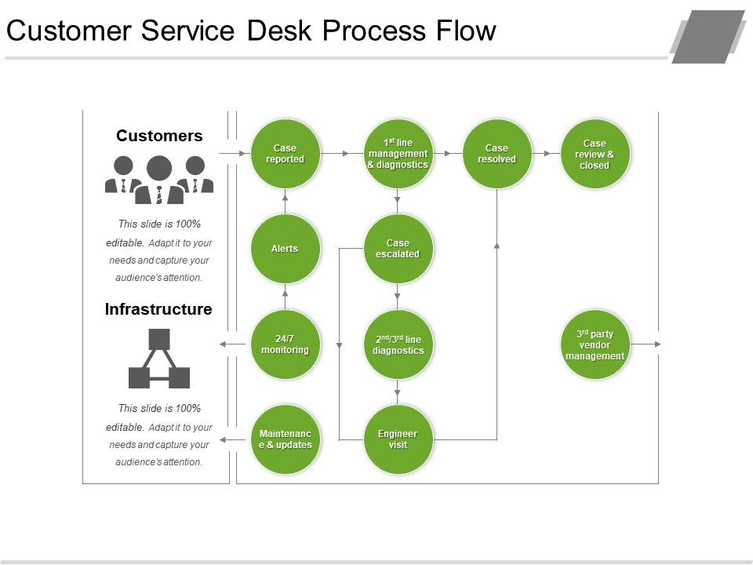

## Proposed Solution

A RPA based solution can be configured and deployed to handle all the repetitive, highly transactional and rule based activities.

1. Ticket Creation
2. Common Email Monitoring
3. SOP driven diagnostic and fixes
4. SLA, Response time and KPI monitoring and Reporting
5. Health check
6. Password reset/unlock
7. Service Request (Folder access, DL access etc..)

## Business Benefits

## References

JD Edwards <https://www.youtube.com/watch?v=wsXI2z-t2M0>

<https://www.youtube.com/watch?v=g4CS3gV1P7o>

<https://www.youtube.com/watch?v=5BecRoCr6uM>