

# CS 305 Project Two

**Practices for Secure Software Report**

Table of Contents

Document Revision History 3

Client 3

Instructions 3

Developer 4

1. Algorithm Cipher 4

2. Certificate Generation 4

3. Deploy Cipher 4

4. Secure Communications 4

5. Secondary Testing 4

6. Functional Testing 5

7. Summary 5

## Document Revision History

| **Version** | **Date** | **Author** | **Comments** |
| --- | --- | --- | --- |
| **1.0** | **2/20/2022** | **Ismael DeRocco** |  |

## Client



## Instructions

Deliver this completed Practices for Secure Software Report documenting your process for writing secure communications and refactoring code that complies with software security testing protocols.

Respond to the steps outlined below and replace the bracketed text with your findings in your own words. If you choose to include images or supporting materials, be sure to insert them throughout.

## Developer

Ismael DeRocco

## 1. Algorithm Cipher

Determine an appropriate encryption algorithm cipher to deploy given the security vulnerabilities, justifying your reasoning. Be sure to address the following:

* Provide a brief, high-level overview of the encryption algorithm cipher.
* Discuss the hash functions and bit levels of the cipher.
* Explain the use of random numbers, symmetric vs non-symmetric keys, and so on.
* Describe the history and current state of encryption algorithms.

The cipher chosen for this project was the SHA-256 protocol. This was chosen because of its low collision score of 0.1 percent. In addition, after reading more about the system, it also is a standard cipher for even the US government. The US government requires all agencies to use SHA-256. It also helps with preventing a brute force attack since it would take 2256 times to get in.

## 2. Certificate Generation

Generate appropriate self-signed certificates using the Java Keytool, which is used through the command line.

* To demonstrate that the keys were effectively generated, export your certificates (CER file) and submit a screenshot of the CER file below.

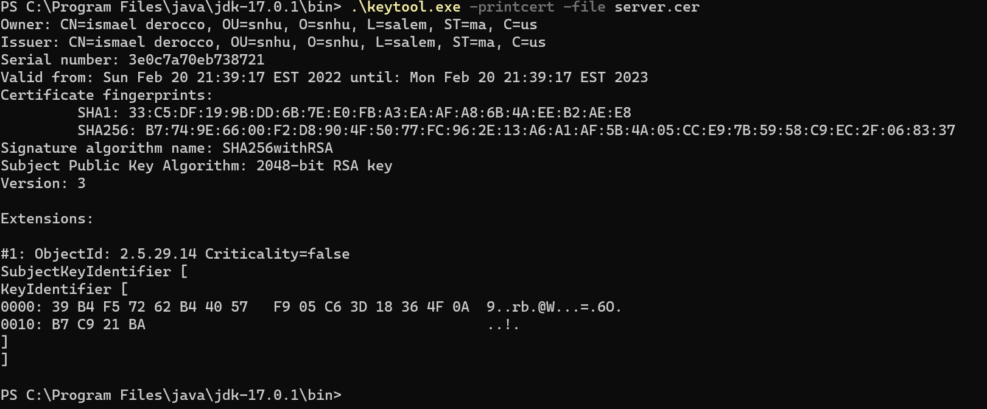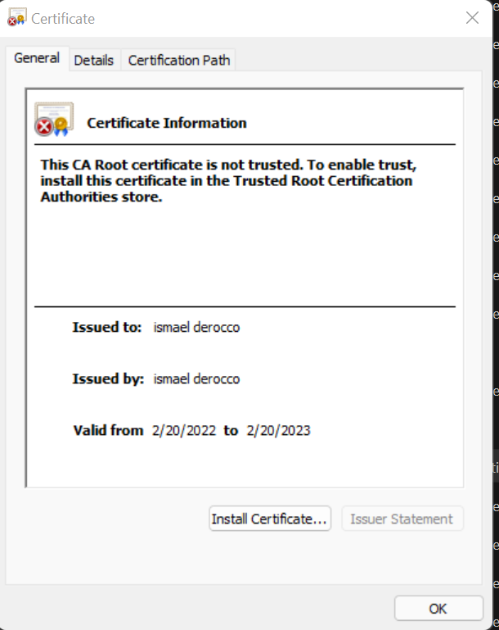

## 

## 3. Deploy Cipher

Refactor the code and use security libraries to deploy and implement the encryption algorithm cipher to the software application. Verify this additional functionality with a checksum.

* Insert a screenshot below of the checksum verification. The screenshot must show your name and a unique data string that has been created.

[Insert screenshot(s) here.]

## 4. Secure Communications

Refactor the code to convert HTTP to the HTTPS protocol. Compile and run the refactored code to verify secure communication by typing **https://localhost:8443/hash** in a new browser window to demonstrate that the secure communication works successfully.

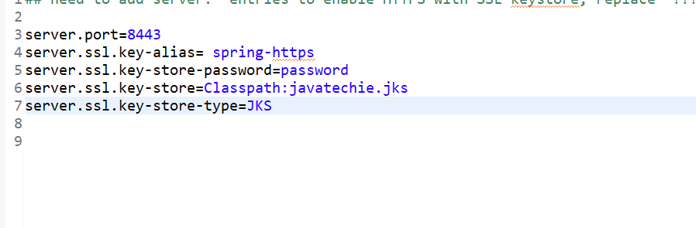

## 5. Secondary Testing

Complete a secondary static testing of the refactored code using the dependency check tool to ensure code complies with software security enhancements. You only need to focus on the code you have added as part of the refactoring. Complete the dependency check and review the output to ensure you did not introduce additional security vulnerabilities.

* Include the following below:
  + A screenshot of the refactored code executed without errors
  + A screenshot of the dependency check report
  + 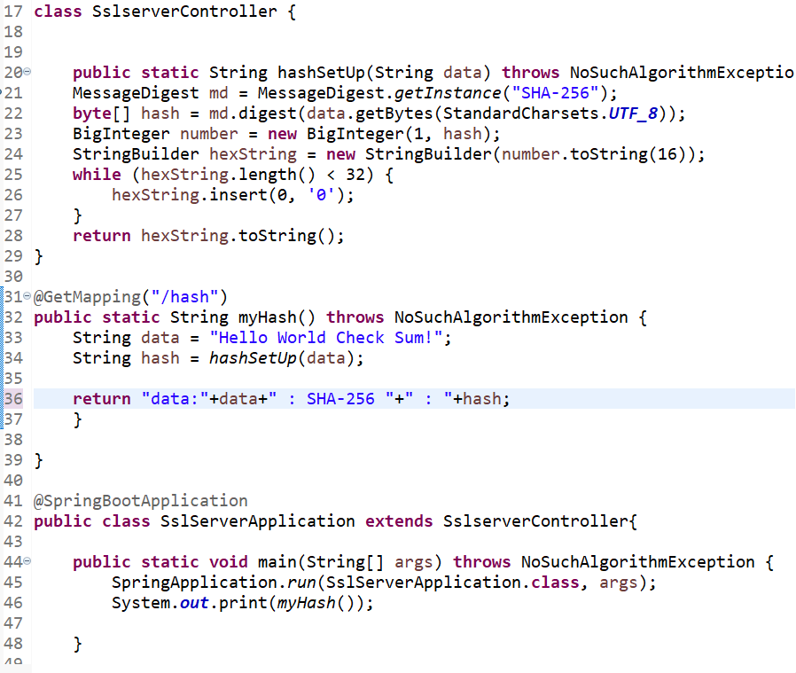

## 6. Functional Testing

Identify syntactical, logical, and security vulnerabilities for the software application by manually reviewing code.

* Complete this functional testing and include a screenshot below of the refactored code executed without errors.

## 7. Summary

Discuss how the code has been refactored and how it complies with security testing protocols. Be sure to address the following:

* Refer to the Vulnerability Assessment Process Flow Diagram and highlight the areas of security that you addressed by refactoring the code.
* Discuss your process for adding layers of security to the software application and the value that security adds to the company’s overall wellbeing.
* Point out best practices for maintaining the current security of the software application to your customer.

The way the code was written was that to provide the utmost security. By using SHA-256, the passcode is then encrypted with a random number so it would be nearly impossible for the hacker to steal information. By using a random number instead of a set number, this will allow for the encryption to be extra secure due to if the hacker finds out the set number, then can decrypt the information. SHA-256 has a 0.1 percent chance of collision so this would also help on the system breaking. Since being written in java, this class can be altered slightly and incorporated into any system. It will encrypt the passed information, from being passwords or personal information. By analyzing the Vulnerability Assessment Process flow diagram, this type of security highlights the input validation, and a secure API. It makes sure the information is security hashed to ensure that the user won’t get hacked.