# CS 255 System Design Document Template

## UML Diagrams

### UML Use Case Diagram

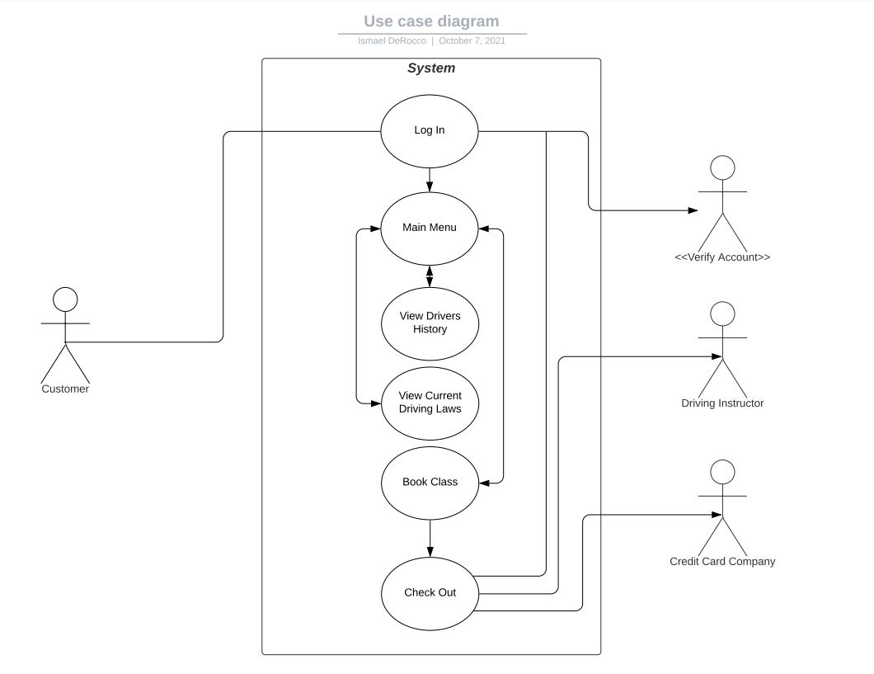

### UML Activity Diagrams

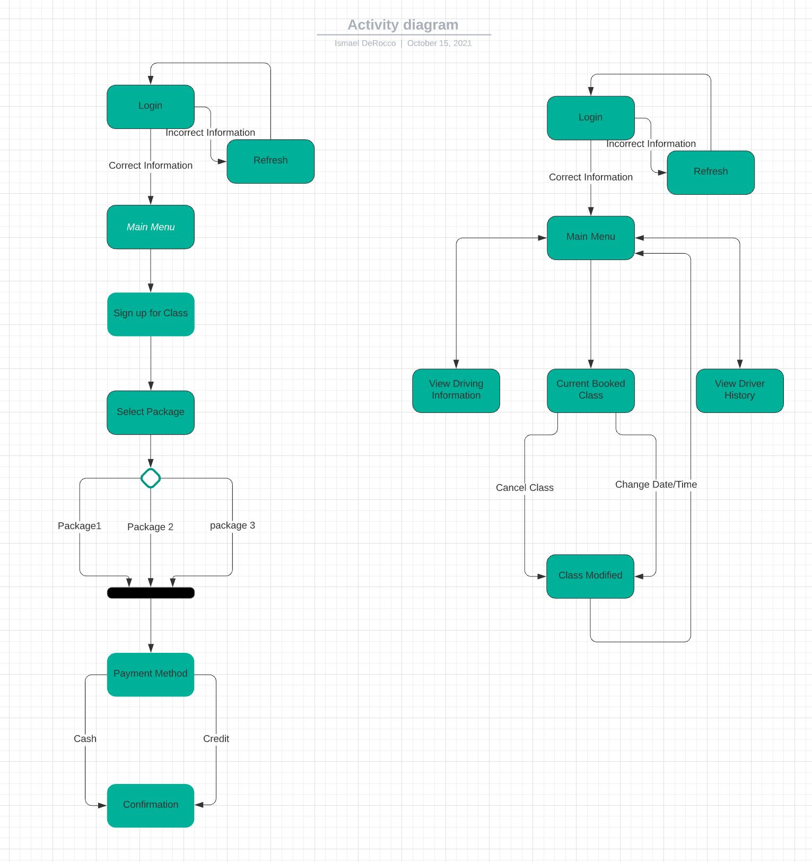

### UML Sequence Diagram

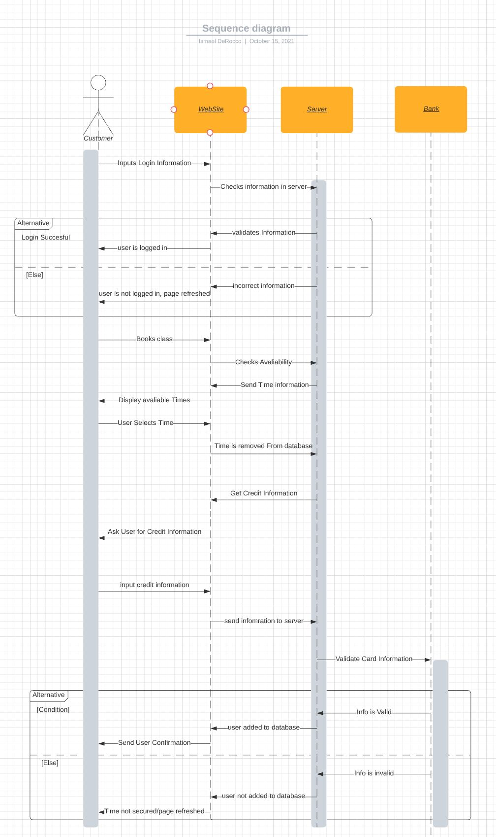

### UML Class Diagram

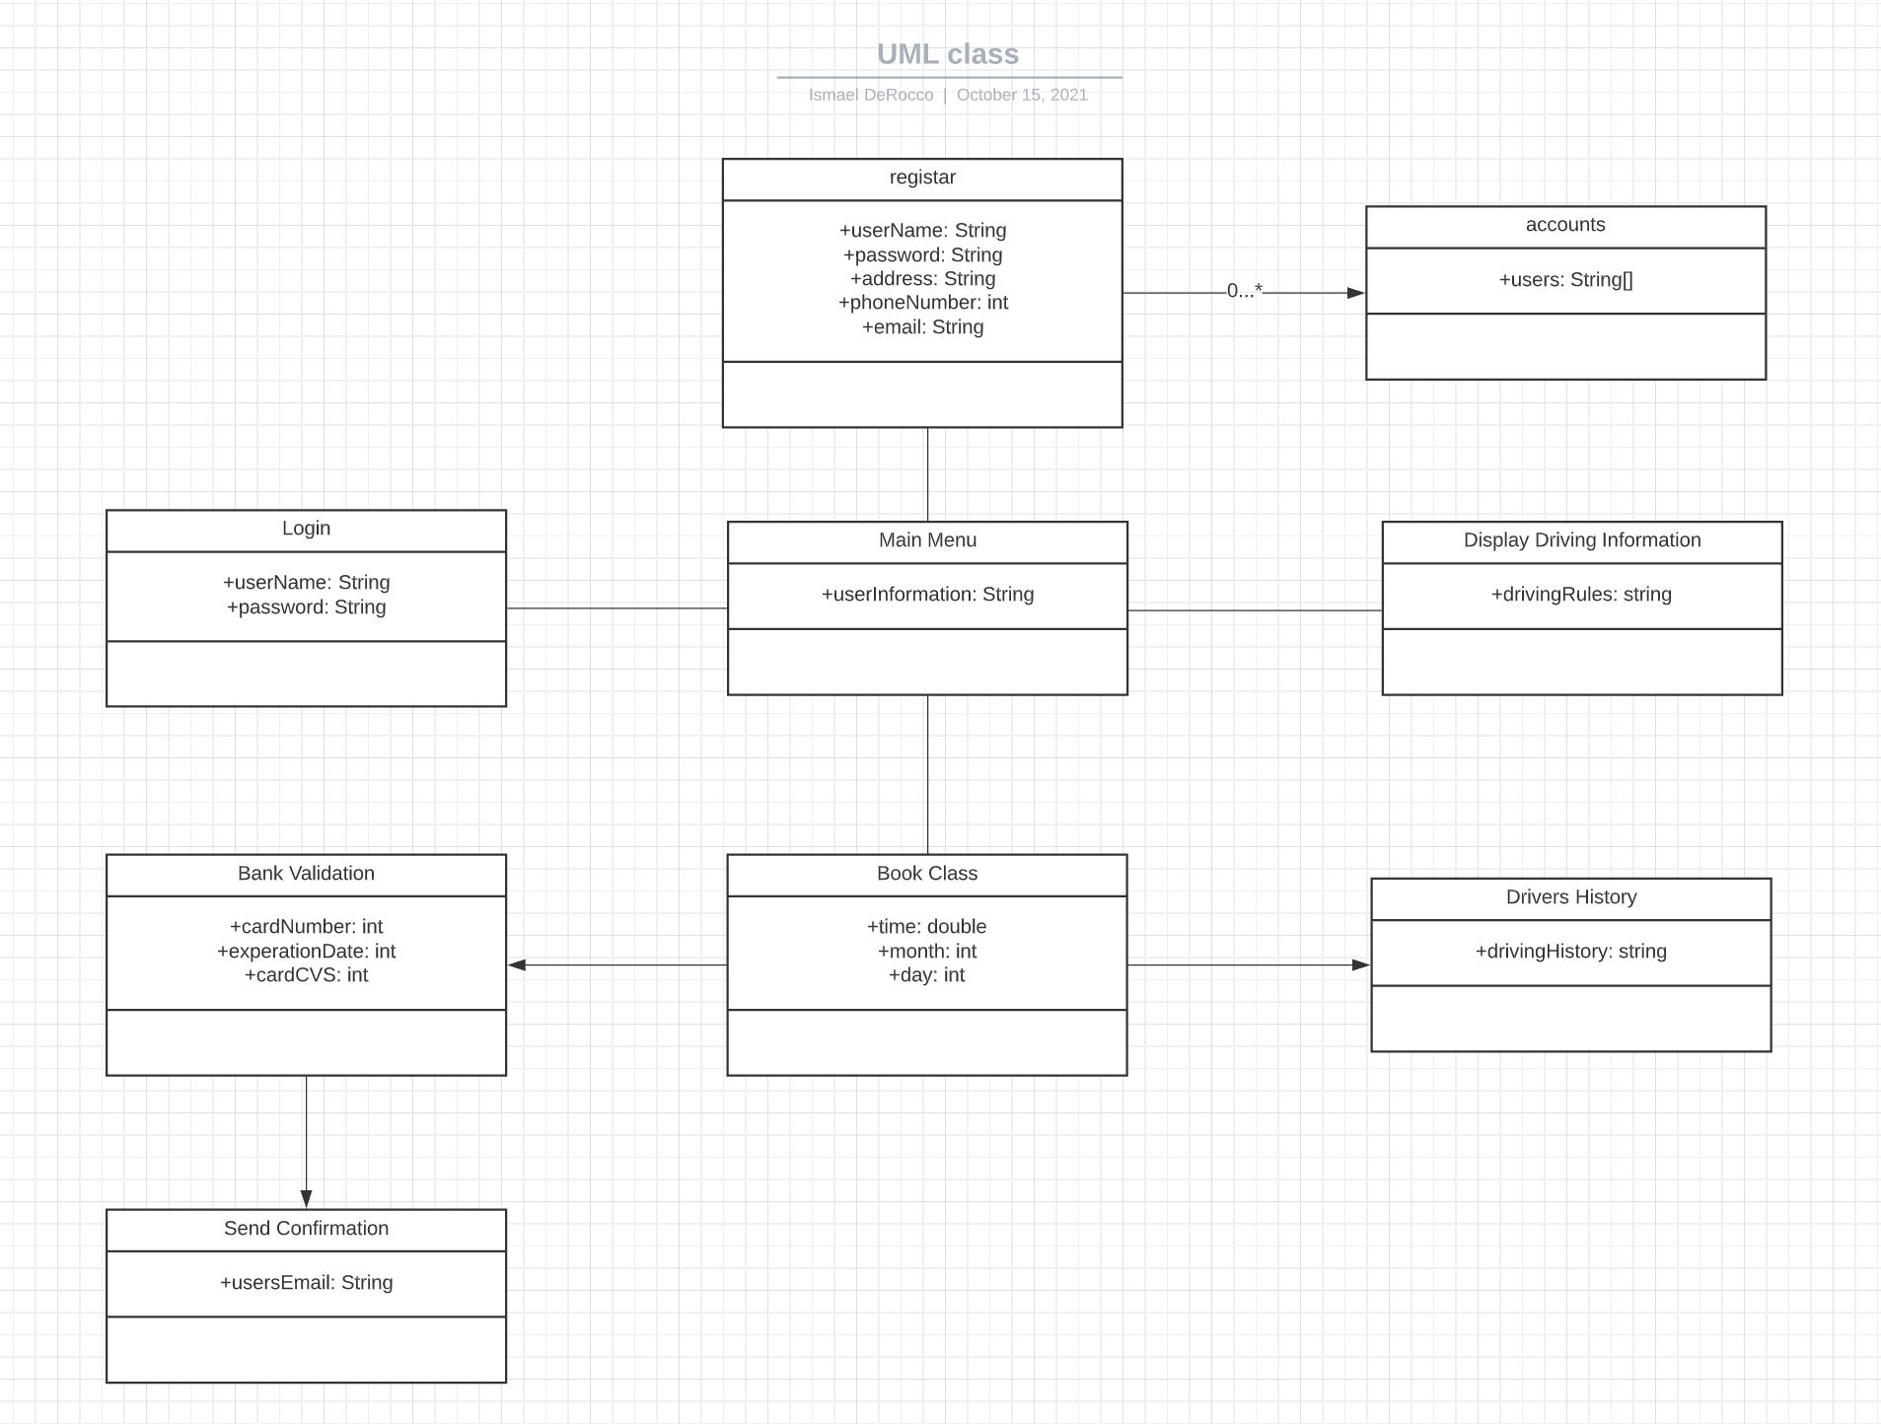

## Technical Requirements

The site should have a section to login or register so the user can be added to the database for easy access from the consumer. The page should have everything the user needs on the main menu for easy mobile access. The main page after login should have the current driving rules in addition to the driving history of the user that’s logged in. Another page of the site should have the ability to register for a class and allowing the user to select a day and time. On the same page there should be a option to also select from the 3 packages that were selected from the client. Once the class is booked, there should be an option to modify the class in case the consumer needs to edit the time or cancel it all together for any reason. When designing the site everything should be designed to allow for easy access for the consumer.

The website should be able to run on all major web browsers. In addition to the major web browsers, it must run on all operating systems including mobile systems. This will broaden the consumer base. The site will also not have to many resources, so it can run as fast as possible for the consumer. The server will be based off the cloud, which will ensure that the server will close to never be down to always allow for constant use.