**Model Architectures:**

ResNet50 is a powerful image classification model that can be trained on large datasets and achieve state-of-the-art results. One of its key innovations is the use of residual connections, which allow the network to learn a set of residual functions that map the input to the desired output. These residual connections enable the network to learn much deeper architectures than was previously possible, without suffering from the problem of vanishing gradients.

The architecture of ResNet50 is divided into four main parts: the convolutional layers, the identity block, the convolutional block, and the fully connected layers.

**Fine-tune by block:**

Loss : 0.35

Accuracy : 0.91

Recall : 0.89

Precision: 0.92

F1 score : 0.90

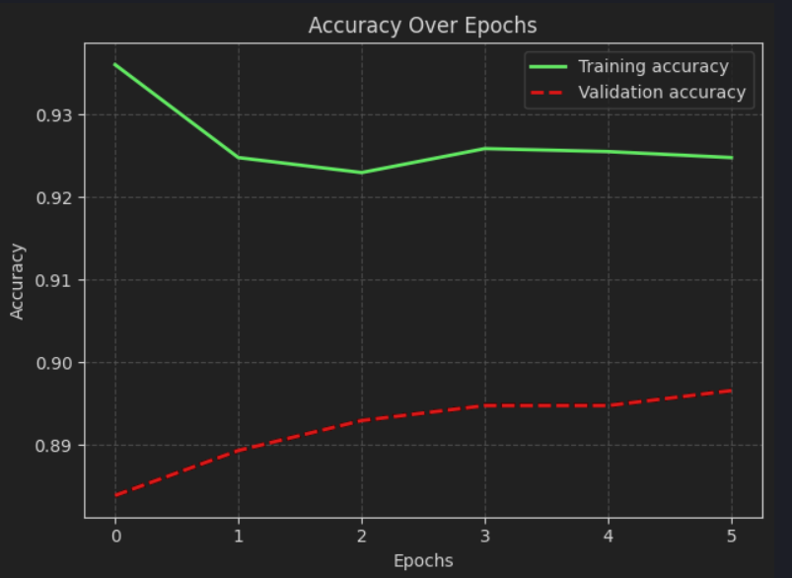

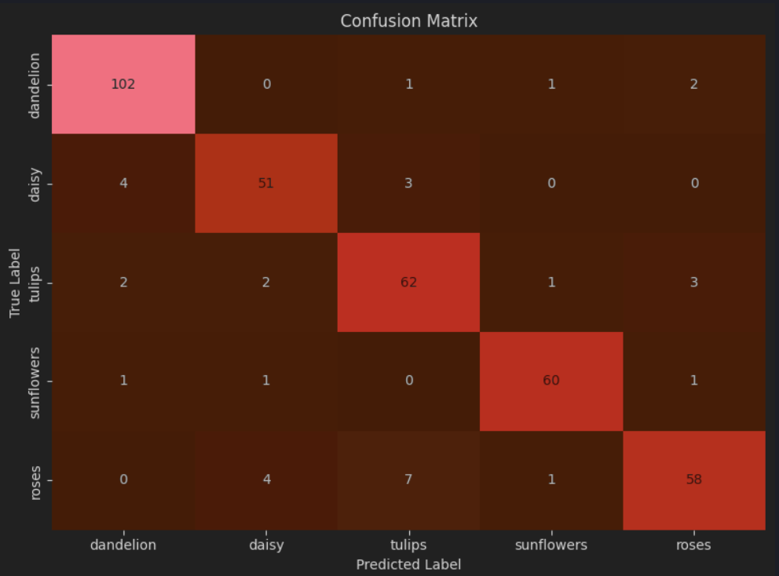

**Fine-tune by layers:**

**Loss : 0.49**

**Accuracy : 0.90**

**Recall : 0.90**

**Precision: 0.90**

**F1 score : 0.90**

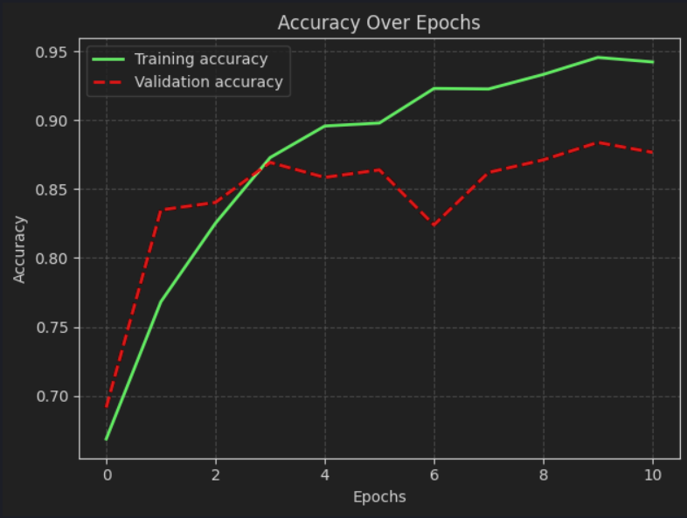

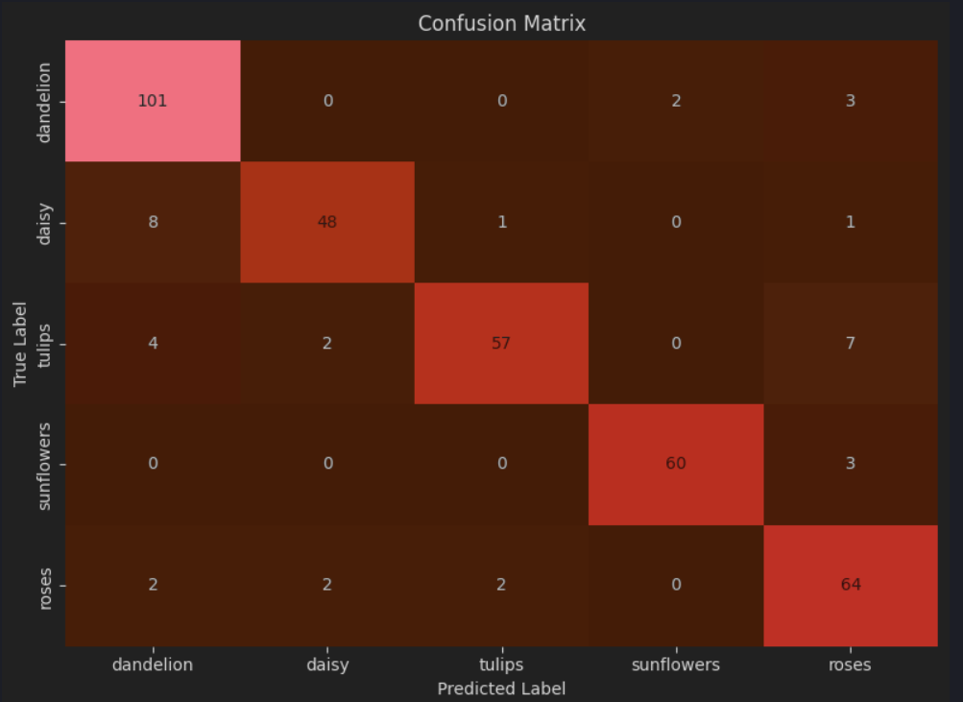

**Unfreezing Strategies:**

The best-performing unfreezing strategy for each model is based on unfreezing *individual layers*, which is more stable than unfreezing by *blocks*.  
When I unfreeze too many layers or entire blocks, the training process takes significantly more time and often results in poorer model performance.  
However, unfreezing only a few layers or a small portion of a block yields better results, both in terms of stability and accuracy.

**Optimal Strategy:**

For this dataset, the optimal unfreezing strategy is to unfreeze individual layers. This approach provides more stable training and better overall results.