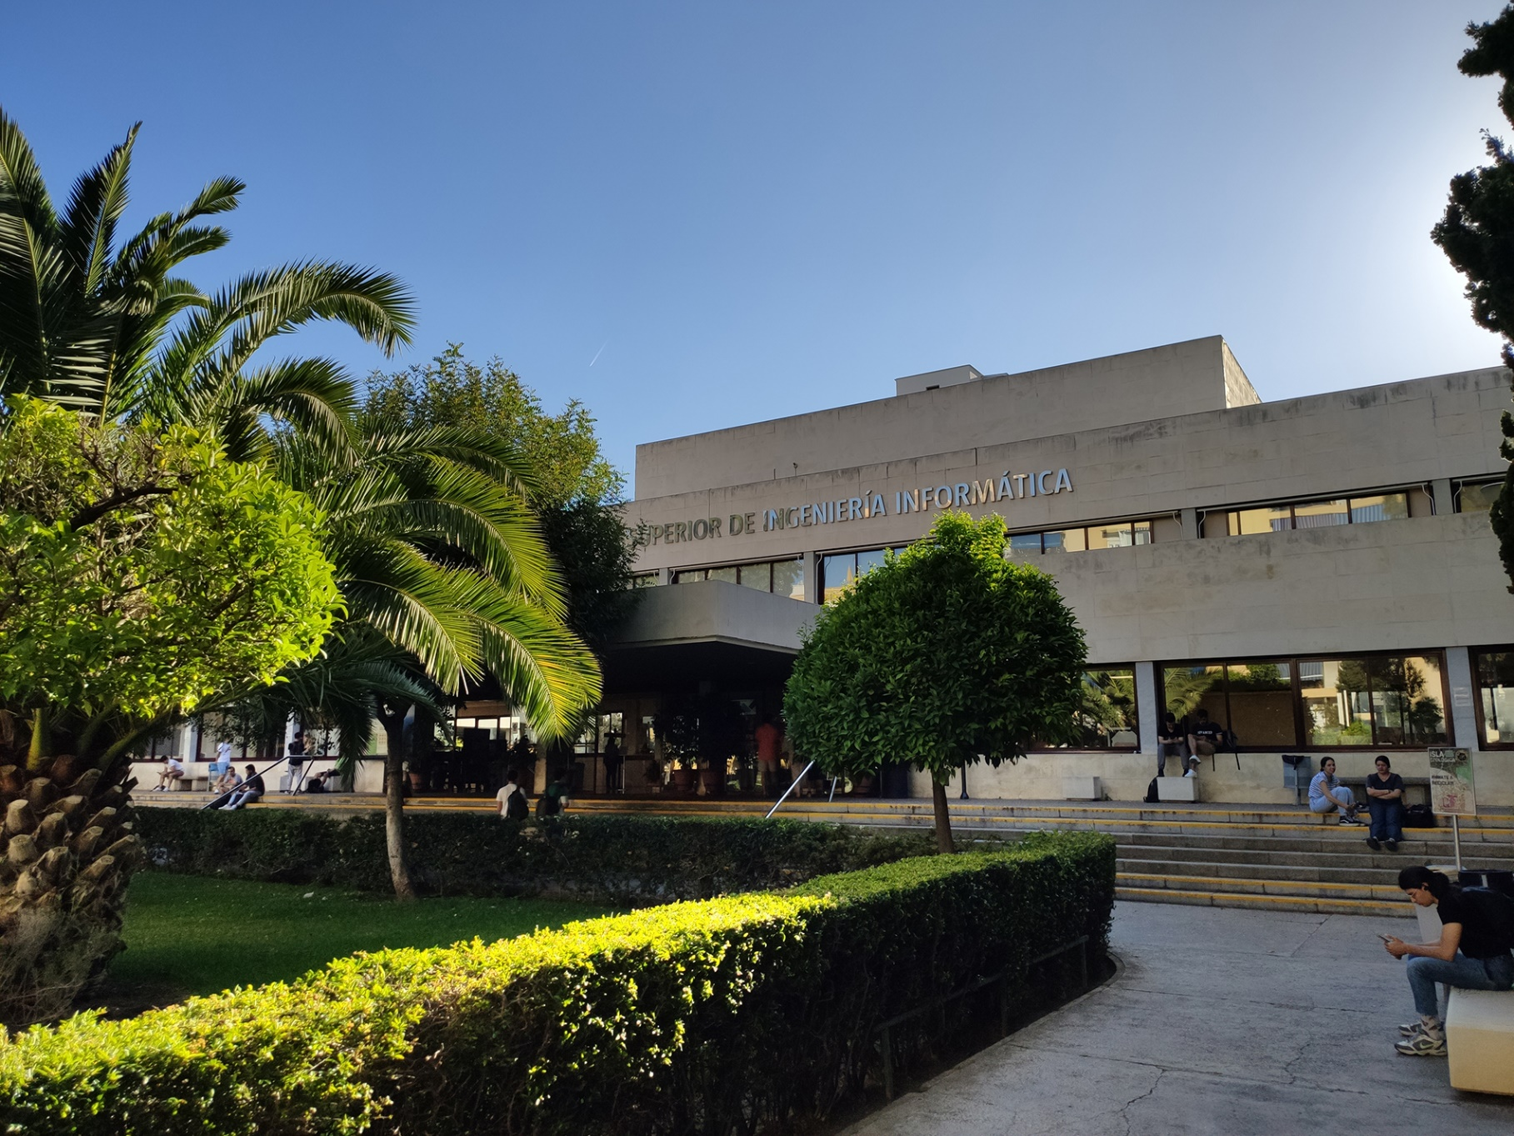

Members:

1. Jesús Cárdenas Conejo

(jescarcon@alum.us.es)

1. Antonio José López Cubiles

(antlopcub@alum.us.es)

1. Pedro Jesús Ruiz Aguilar

(pedruiagu1@alum.us.es)

1. Ismael Ruiz Jurado

(ismruijur@alum.us.es)

|  |
| --- |
| Charting Report |
|  |
| 17-02-2023  Group: C1.02.10  Repository: https://github.com/jescarcon/Acme-L3-D01-23.1 |



Table of Contents

Table of Contents 2

Executive Summary 3

Version History 3

Introduction 3

Contents 4

Conclusions 5

Bibliography 6

# Executive Summary

In this report you will find relative information about our first deliverable in a Charting Report structure. This document explains how the group starts, how the members met, how we plan to work together for the following deliverables, and how was our first try working on team helping each other for the starting base Project configuration.

# Version History

|  |  |  |
| --- | --- | --- |
| Version | Date | Description of changes |
| 1.0 | 17/02/2023 | Creation of the Charting Report Document. All the group helps filling it |

# Introduction

In this report we will describe how the members of our workgroup were recruited by the manager.

For every member of the workgroup, we will provide some contact data along with a recent picture of the member for the propose of identify us, we also are going to submit a statement in which we declare our intension of working together as a group and our wish of achieving a good grade on this work.

In this document we are going to define what for us performing well and performing badly means according to our performing indicators that we will also define.

In addition, we will reward a good performance and punish a bad one, even a non-functional member of the group can be fired if he fulfils the conditions in the ways that we specify in this report.

At the end of the document, we include our conclusion, in which we comment on our opinion about the state of the group and how we have worked for the moment.

# Contents

In order to create this team Pedro and Ismael were searching for a team that needed two more members, so Jesús, the manager, contacted them and asked them to join the team, which had 3 members by that time, which were Antonio and another member that ended being part of the theory group 3, so he left the team.

The group C1.02.10 is composed by the following members:

-Jesús Cárdenas Conejo: [jescarcon@alum.us.es](mailto:jescarcon@alum.us.es)



-Antonio José López Cubiles: [antlopcub@alum.us.es](mailto:antlopcub@alum.us.es)

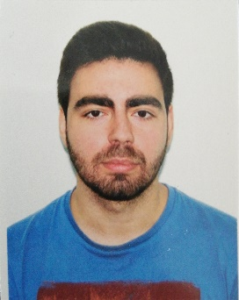

-Pedro Jesús Ruiz Aguilar: [pedruiagu1@alum.us.es](mailto:pedruiagu1@alum.us.es)



-Ismael Ruiz Jurado: [ismruijur@alum.us.es](mailto:ismruijur@alum.us.es)

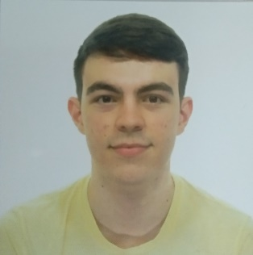

After our first meeting creating the group, we, as a team, are compromised to work together in order to achieve our goal in this subject, which is to approve each deliverable with a good mark (greater than 7), and greatly understand the syllabus provided in EV, including a superb understanding on the evaluation and grading process.

We established a 3-point system divided into: 80% Class assistance, 80% Team meetings assisted and 100% task assigned completed. If a member is on that margin will get 1 point for each category or 0 if not. We declare that a member is not being useful with less than 2 points on average. The result of not being useful can be an expel from the group.

In our team, members that work well will be rewarded with a great work environment, and a bit less work charge in the next delivery.

# Conclusions

It seems that the team works very well for the first time together despite it just met and there was one member who left. By the time we start working, we divided the tasks doing clean and fast work at the same time helping the ones who had any problem and finally we all give a global point of view/opinion of all the documents done checking if any changes are needed. At the moment, the team is ready with all the structure and work plans prepared.

# Bibliography

Intentionally Blank.

Signed:

Antonio José López Cubiles Pedro Jesús Ruiz Aguilar

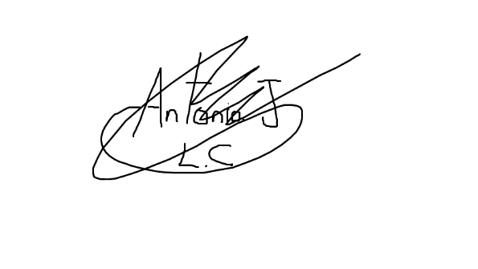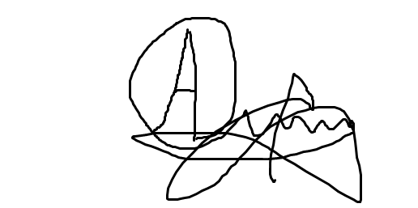

Jesús Cárdenas Conejo Ismael Ruiz Jurado

