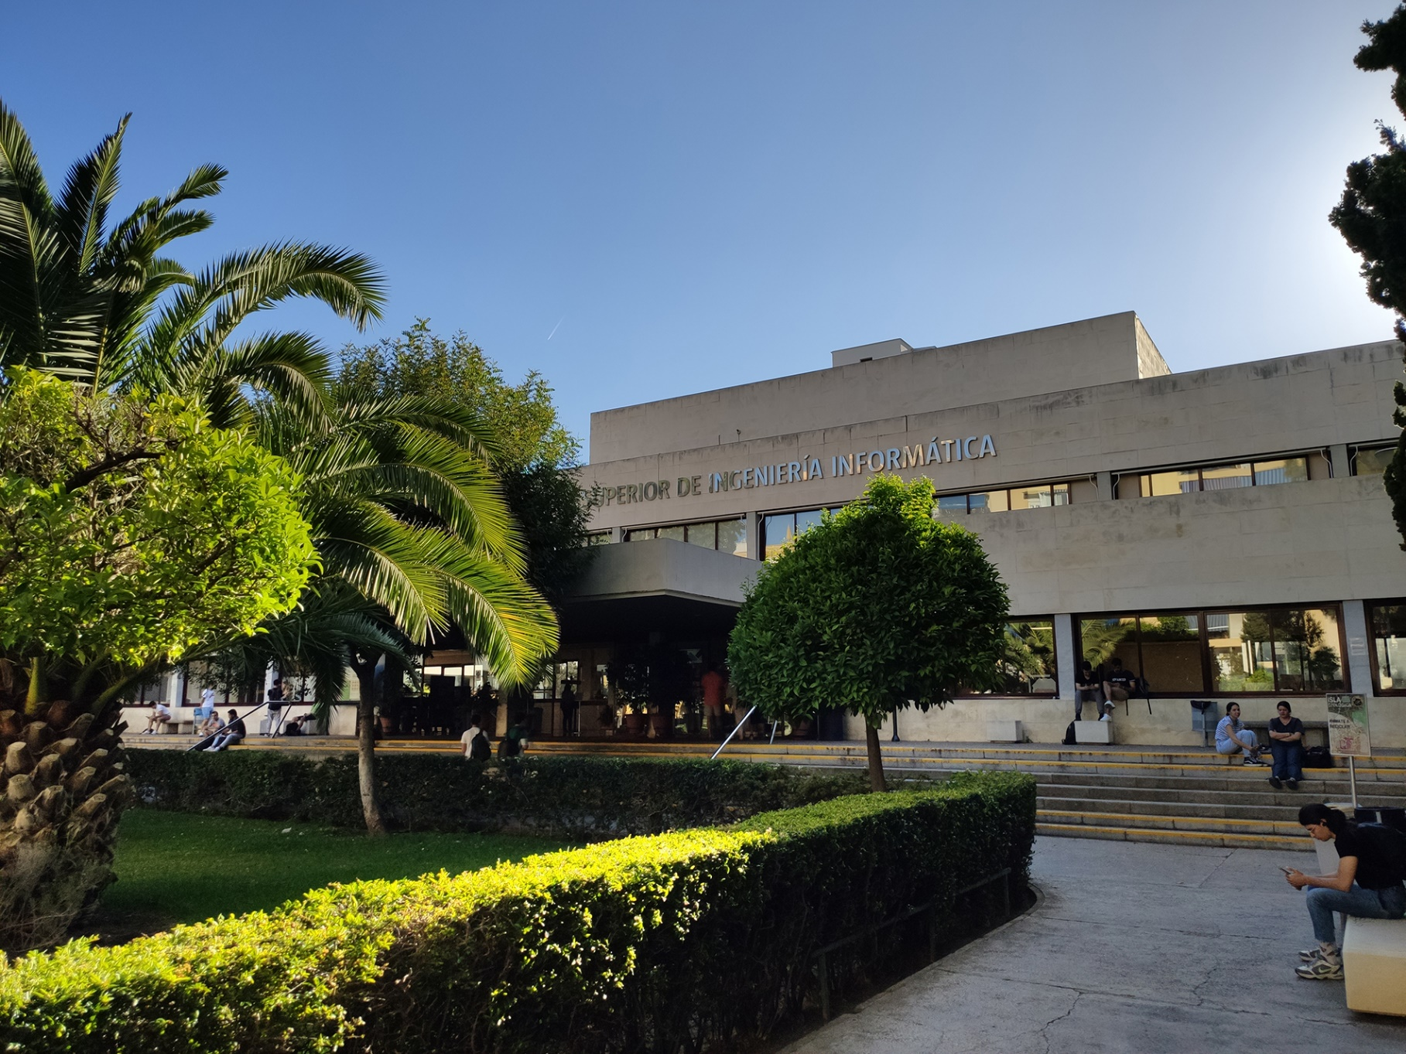

|  |
| --- |
| Development  Configuration  Report |
| Members:   1. Jesús Cárdenas Conejo   (jescarcon@alum.us.es)   1. Antonio José López Cubiles   (antlopcub@alum.us.es)   1. Pedro Jesús Ruiz Aguilar   (pedruiagu1@alum.us.es)   1. Ismael Ruiz Jurado   (ismruijur@alum.us.es) |
| 17-02-2023  Group: C1.02.10  Repository: https://github.com/jescarcon/Acme-L3-D01-23.1 |



Table of Contents

Executive Summary 3

Version History 4

Introduction 5

Contents 6

Conclusions 7

Bibliography 8

# Executive Summary

In this document you will find relative information about how is the project configured and how is every group member getting prepared their IDEs in their set ups.

# Version History

|  |  |  |
| --- | --- | --- |
| Version | Date | Description of changes |
| 1.0 | 17/02/2023 | Creation of the document |

# Introduction

In this document we will give a quick review of how every member set up is prepared to start working. Some screenshots will help to do the report. Each member has the same configuration at desktop, database and IDE.

# Contents

This is an example of how every group desktop is prepared to work. It counts with the main folder of the subject Design and Testing: It has the docs of the lecturer given in class if the student needed, the workspace of the project with all the tools we will use and a workspace backup if a problem happens.

Then we have a shortcut for starting the database and the main explorer we use to checking the project web view.

Before all the project starts, we need to get ready our database with Mariadb and Dbeaber, which we set up as the professor teached us. We have and script for a fast start and giving permissions to a new database if needed

In our IDE eclipse, we install every recommended plugin given by the lecturer . Furthermore we will find the framework and the main project connected to the repository in github for a well based team work.

When the project runs , we could check everything is working at Firefox (recommended) at: <http://localhost:8080/acme-l3-d01-23.1>

# Conclusions

Every member of the group follows the same structure because it helps having everything organized in every working situation, from checking some theory concept or checking the web view, to develop some requirements and also having the same structure helps resolving doubts faster because other group partner will find fast the file or folder which is giving troubles.

# Bibliography

Intentionally blank.