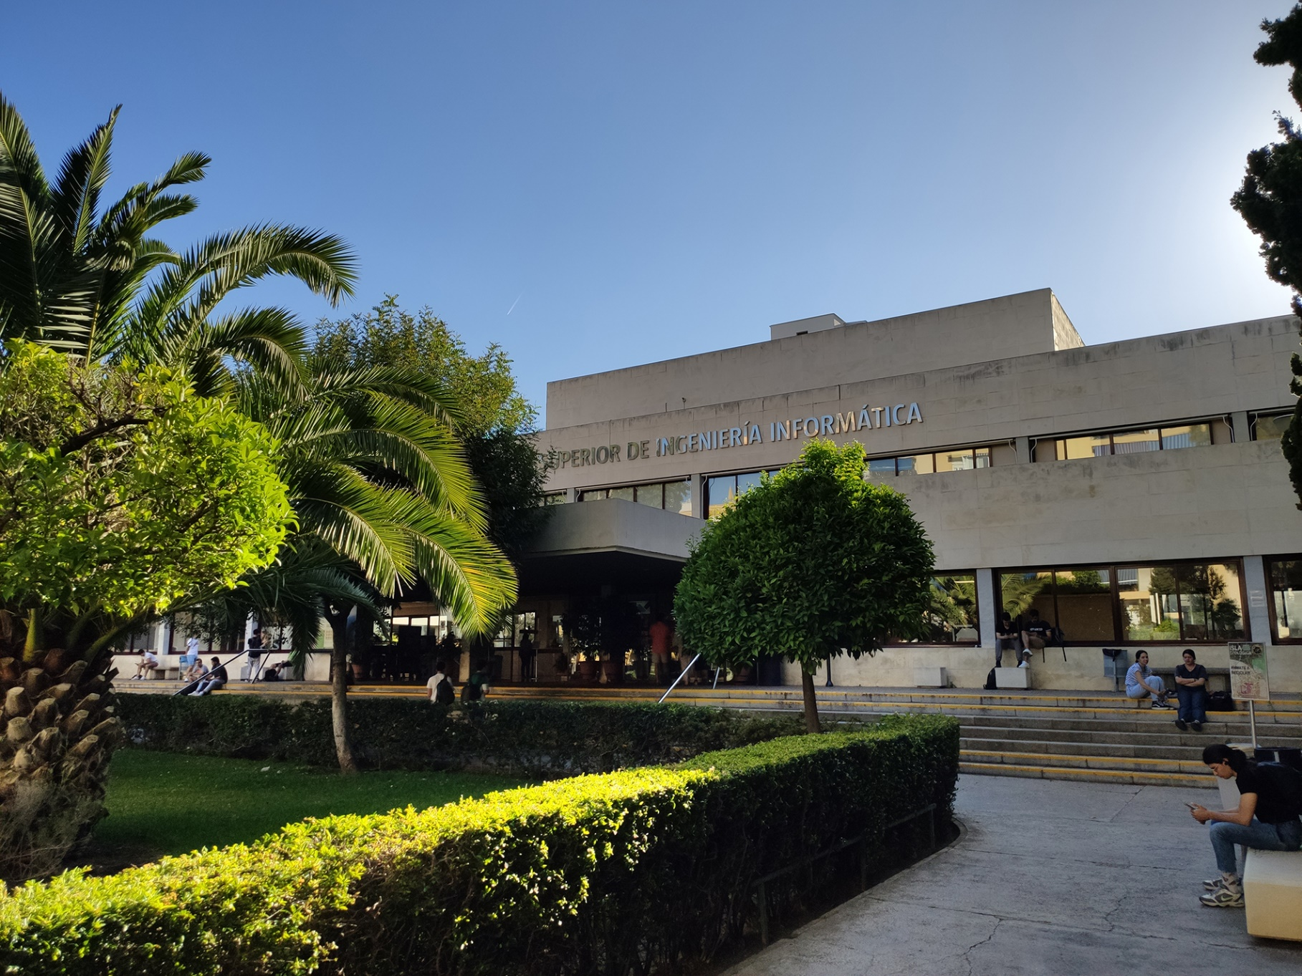

|  |
| --- |
| Planning Report |
| Members:   1. Jesús Cárdenas Conejo   (jescarcon@alum.us.es)   1. Antonio José López Cubiles   (antlopcub@alum.us.es)   1. Pedro Jesús Ruiz Aguilar   (pedruiagu1@alum.us.es)   1. Ismael Ruiz Jurado   (ismruijur@alum.us.es) |
| 17-02-2023  Group: C1.02.10  Repository: https://github.com/jescarcon/Acme-L3-D01-23.1 |



Table of Contents

Executive Summary 3

Version History 4

Introduction 5

Contents 6

Conclusions 7

Bibliography 8

# Executive Summary

In this document you will find relative information about how is the project split in tasks, we decide to write it in a table where you can find for every task : His Title, Succinct Description, Assignee/s and Role/s , Planned Time and Actual Time then we calculate the price of the work done .

# Version History

|  |  |  |
| --- | --- | --- |
| Version | Date | Description of changes |
| 1.0 | 17/02/2023 | Creation of the document |

# Introduction

In this document we introduce a table for the tasks of the project. Every new row includes the title of the task, a succinct description of the task , the role or the personal assignee , the planned time for doing the task and the final time for that task. At the final column is calculated the cost of that task.

The cost stablished for the task is 30 €/h for the manager and analyst tasks and 20 € for the developer ones.

# Contents

|  |  |  |  |  |  |
| --- | --- | --- | --- | --- | --- |
| Title | Succinct Description | Assignee/s and Role/s | Planned Time | Actual Time | Cost |
| Managerial requirements #1 | Instantiate and customise the appropriate starter project . Set the name of the project folder, maven configuration (pom.xml), and database as “Acme-L3-D〈dd〉”. | Developers | ~25’-30’ | 27’ | 9€ (develop) |
| Non-functional requirements #1 | The system must be internationalised at least in English and Spanish. | Developers | - | - | - |
| Reporting Templates | Create report templates for expedite the process to all the group | Ismael | ~35’-45’ | 45’ | 22,5€ (analyst) |
| Fixing IDE Problems | Some members helps each other to solve IDEs configuration problem | Pedro,Jesús,Antonio | ~20-25’ | 23’ | 7,6€ (develop) |
| Analysis Report | Create Analysis Report | Pedro | ~20’-30’ | 27’ | 13,5€(analyst) |
| Planning Report | Create Planning Report | Jesús | ~20’-30’ | 50’ | 25€(analyst) |
| Charting Report | Create Charting Report | Developers | ~35’-40’ | 1h | 30€(analyst) |
| Development Configuration Report | Create Development Configuration Report | Jesús | ~20’-30’ | 20’ | 10€(analyst) |
| Architecture of a WIS Knowledge Report | Create Architecture of a WIS Knowledge Report | Ismael | ~5’-10’ | 6’ | 3€(analyst) |
| Testing a WIS Knowledge Report | Create Testing a WIS Knowledge Report | Antonio | ~5’-10’ | 7’ | 3.5€(analyst) |

We organise this requirements using GitHub issues manager , which allows you to create new tasks with an according description, labels for each tasks and the posibility to assign a member to a task and also a specific branch for it.

This pictures shows the list of the task and the table displayed for change their status.

# Conclusions

This table will help the group to organize tasks giving a general view of all tasks division and calculate the final cost of every single requirement.

# Bibliography

Intentionally blank.