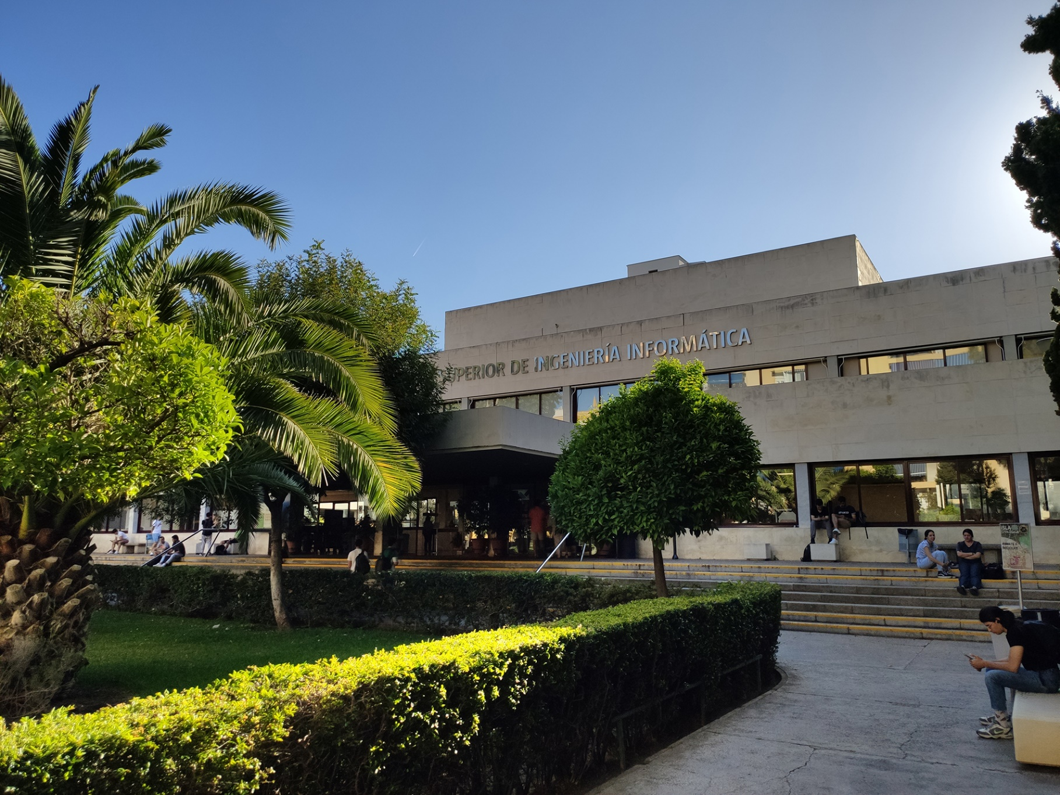

|  |
| --- |
| Previous WIS Testing Knowledge |
| Members:   1. Jesús Cárdenas Conejo   (jescarcon@alum.us.es)   1. Antonio José López Cubiles   (antlopcub@alum.us.es)   1. Pedro Jesús Ruiz Aguilar   (pedruiagu1@alum.us.es)   1. Ismael Ruiz Jurado   (ismruijur@alum.us.es) |
| 17-02-2023  Group: C1.02.10  Repository: https://github.com/jescarcon/Acme-L3-D01-23.1 |



Table of Contents

Executive Summary 3

Version History 4

Introduction 5

Contents 6

Conclusions 7

Bibliography 8

# Executive Summary

Intentionally blank. (Because in this specific report, is equivalent to the introduction)

# Version History

|  |  |  |
| --- | --- | --- |
| Version | Date | Description of changes |
| 1.0 | 17/02/2023 | Creation of the Previous WIS Testing Knowledge Document. |

# Introduction

In this report we are going to explain the concepts and knowledge that we have about the testing process in a WIS. The information we previously had about testing is sustained by the different subjects we have found in the Software Engineering Degree. However, the specific knowledge about the testing of a WIS might be limited to begin with, and too general to be accepted as specific knowledge about this subject.

# Contents

The general concept of testing:

We already know what testing is, and how to do it with some technologies. Testing is the process of finding errors or bugs in a software product. This process must be done through all the implementation phase, it must be continuous, and must be made with the intention of finding errors, not to show the absence of them. A test is performed on a SUT (Subject Under Test) by a Tester, applying test cases that match the expected behavior of the SUT by giving it some specific input data, and checking if the output given by the SUT matches the expected output.

About testing a WIS:

We have found similar informative systems before in other subjects like DP1 or IISSI, and we have tested them. So, about testing a WIS, we know how to design unitary test to find errors in the logical layer by demanding changes in the database and checking if they were effective. Also we know how to perform informal testing to find out if the presentation layer is working properly.

# Conclusions

In general terms, we know what a WIS architecture is about, and we previously knew about testing, but we refreshed our concept of testing it with the lesson.

# Bibliography

Intentionally blank.