**DEVELOPMENT OF A SMALL-SCALE WASTE TO ENERGY SYSTEM**

Ismail Moshood Opeyemi

*Department of Industrial and production engineering*

*School Of Engineering and Engineering Technology, Federal University Of Technology Akure, Ondo state Nigeria.*

# ABSTRACT

The project addresses the escalating challenges of waste management, environmental pollution, and energy scarcity by proposing and implementing a small-scale waste-to-energy system that can be used to reduce waste accumulation in a community. The system incorporates an efficient waste sorting mechanism, utilizing magnetic sorting for the removal of metals, and focuses on the incineration of waste materials such as nylons, papers, wood, leaves, and rags to generate and store electricity. It consists of seven different units/parts which include a hopper/Separation Unit, Compaction Unit, Combustion Unit, Power Storage and Conditioning Unit, Steam Conversion Unit, Custom boiler, and Exhaust System. The separation Unit serves as the entry point for the separation of the metals present in the waste with the help of a magnetic sorter before being passed to the compaction unit for compaction. The incineration chamber and combustion unit burn waste, producing thermal energy directed to a custom boiler with a water-filled boiler. The steam generated from the boiler powers a turbine connected to a generator, converting mechanical energy into electricity. The electricity is then conditioned, stored in batteries, and made available for future use through a power unit. To test the efficiency of the system, three bags of waste filled with nylon, papers, and wood were used and they showed a remarkable outcome by successfully being converted to electricity. By converting waste into electricity, the proposed system minimizes reliance on landfills, reduces environmental pollution, and contributes to sustainable energy practices. The economic feasibility was explored through calculations of potential revenue and indicated a promising payback period of 9 months and 15 days months. Future enhancements may involve optimizing component efficiency, responsibly scaling the system, minimizing environmental impacts, and integrating AI for an efficient sorting system.

# 1.0 Introduction

Waste, an inherent by product of human activity, has emerged as a pressing global concern due to its potential to impact the environment and public health adversely. Waste encompasses a diverse range of materials, varying from organic matter to hazardous substances and each posing unique challenges in its disposal and management. As societies continue to advance, the quantity and complexity of waste generated have escalated, necessitating innovative solutions to minimize pollution and promote sustainable waste management practices. Also, waste is any unwanted or discarded material that is no longer useful (Al-Zubaidy, 2015). But it can be made useful with proper management which include the collection, processing, and disposal of waste materials through recycling, composting, incineration, landfilling etc.

# LITERATURE REVIEW

## 2.1 Introduction

Waste management encompasses a series of coordinated activities designed to effectively handle and dispose of waste materials from their generation to their final disposal (World Health Organization, 2023). This process aims to minimize environmental impact, safeguard public health, and promote sustainable practices through various strategies and methods for addressing different types of waste (UNEP, 2021). It focuses on reducing waste volume and potential hazards while supporting the principles of a circular economy, where resources are kept in use for as long as possible (Ellen MacArthur Foundation, 2023).

**2.2.1 Overview of traditional waste management techniques.**

Traditional waste management techniques have evolved over time to address the challenges posed by increasing waste generation, urbanization, and industrialization. These techniques have been practiced for centuries to manage various types of waste, including household, agricultural, industrial, and hazardous waste. Here's an overview of some traditional waste management techniques:

1. Burning and Incineration: Burning waste, especially organic materials, has been a common practice to reduce its volume and minimize its impact. Incineration involves burning waste in controlled conditions at high temperatures to convert it into gases, smoke, and ash. However, this method has raised concerns due to air pollution, odors, and the release of harmful emissions into the atmosphere (Bharti, 2022).
2. Dumping and Landfills: Historically, waste was often disposed of in open dumps or landfills. These sites were essentially areas where waste was collected and left to decompose over time. While this approach helped contain waste, it often led to environmental pollution, groundwater contamination, and the attraction of pests and disease vectors.
3. Recycling: While not a recent concept, recycling has gained prominence as an essential waste management technique. Recycling involves collecting and processing materials such as paper, plastics, glass, and metals to create new products, reducing the demand for raw materials and energy.
4. Land Application: In agricultural settings, some types of waste, such as manure, were applied to fields as a fertilizer. While this practice can be beneficial when managed properly, it can also lead to nutrient runoff and water pollution if not carefully regulated.

**2.2.2 The Need for Sustainable and Efficient Waste Management Solutions**

The need for more sustainable and efficient waste management solutions is paramount in today's world due to a variety of environmental, social, and economic reasons. The current conventional waste management practices, often relying on landfills and incineration, are often insufficient to address the growing challenges posed by increasing waste generation and its associated impacts (Ghiglione *et al*., 2021). Here are some compelling reasons highlighting the importance of adopting sustainable and efficient waste management solutions:

**a) Environmental Protection:** Sustainable waste management practices prioritize reducing the negative environmental impacts of waste disposal. By minimizing waste generation, reusing materials, and recycling, these practices help prevent pollution of air, water, and soil (Campana & Lotito, 2015). This, in turn, preserves natural resources, conserves energy, and mitigates climate change (Ellen MacArthur Foundation, 2023).

**b) Resource Conservation:** Efficient waste management techniques emphasize the recovery and reuse of valuable resources present in waste materials, such as metals, plastics, and organic matter (Bensaid, 2018). This reduces the need for extracting and processing virgin resources, helping to preserve finite natural resources and promote a circular economy (Ghiglione *et al*., 2021).

**c) Reduction of Landfilling:** Sustainable waste management aims to reduce the amount of waste sent to landfills, thereby minimizing the negative impact on land use, soil quality, and groundwater contamination (World Bank, 2018). By diverting waste through recycling, composting, and other recovery methods, the burden on landfills is decreased (Ghiglione *et al*., 2021).

**d) Health and Safety:** Proper waste management, including recycling and safe disposal of hazardous materials, improves public health and safety (Bensaid, 2018). It reduces the potential for disease transmission, pests, and harmful chemicals in the environment, contributing to healthier communities (World Bank, 2018).

# METHODOLOGY

## **3.0 Introduction**

**The sources of the development of waste-to-energy setup are becoming more acute challenges in traditional practice approaches to wave management and a growing need for sustainable energy solutions. Traditional waste disposal approaches have their limitations as the volume of generated waste is continuously increasing while still requiring environmentally friendly and resource-efficient processes to be implemented. In this chapter, we analyze the methodology used in developing a waste-to-energy system that, not only overcome shortfalls of conventional solid waste management but also turns incineration into energy.**

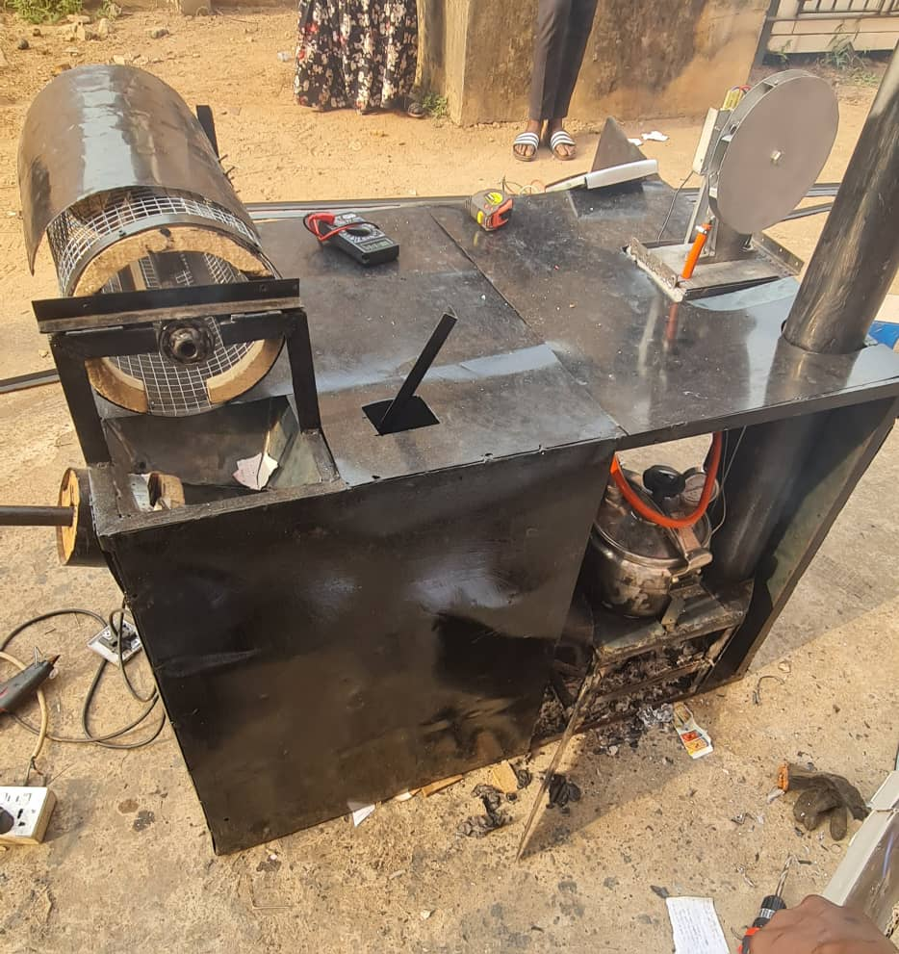

## 3.2 Experimental Setup

Exhaust System

Boiler

Combustion Unit

Hopper/ Separation Unit

Steam Conversion unit/ Generator

Power storage and conditioning unit

## 

## Fig 3.1 Process Flow Diagram

## 3.3 Description of Major Component Parts of the Machine

## 

The machine comprises of six parts/units which include: Hopper/Seperation Unit, Compaction Unit, Power Storage and Conditioning Unit, Steam Conversion Unit, Custom boiler and Exhaust System.

## 3.3.1 Hopper/Separation Unit

This unit serves as the primary entry point for waste input into the system, specifically designed to remove the metals in the waste and allow the free flow of the waste into the compartment chamber. The sorter consists of a middle magnetic separator, which is equipped with magnets in such a way that when rolled manually, it turns the waste inside, and as the waste turns along the middle separator, the metals inside are attracted to the separator and removed. The sorter can then be tilted at an angle to pass the sorted waste into the remaining part of the system, then channels it into the compartment chamber for compaction. This type of manual sorting is necessary considering the cost considerations associated with automated sorting processes.

### 3.3.2 Compaction Unit

The compaction of sorted waste is conducted at this stage to facilitate the removal of water, thereby optimizing the efficient combustion of the waste. The system comprises a tapered-hollowed cylinder with an internal rod connected to a flat, rounded wooden surface for manual compaction. A cut along the length of the cylinder enables the temporary blockage of the internal rod, facilitating the straightforward removal of water content from the waste before it is directed to the incinerator. The deliberate inclusion of manual compaction is intended to enhance the overall efficiency of energy generation in the subsequent stages.

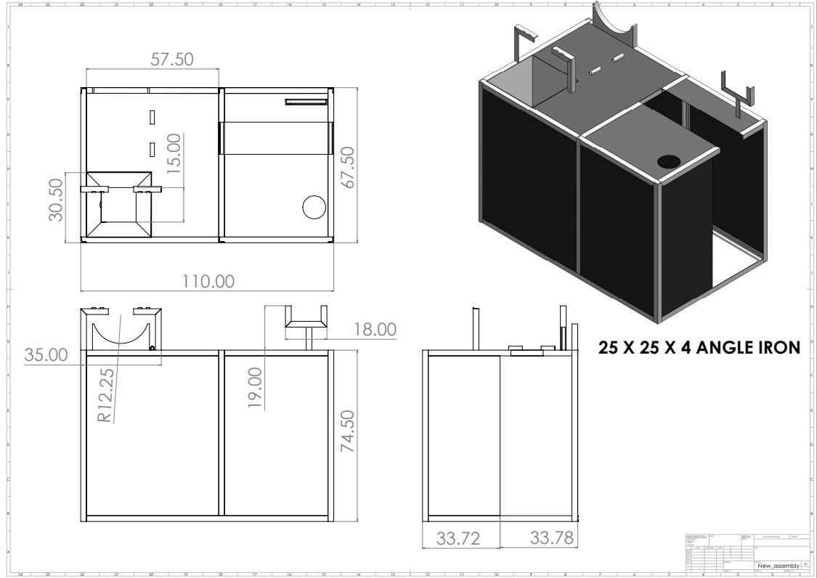

**Fig 3.2** Hopper Unit

### 3.3.2 Combustion Unit

In this chamber, the processed waste is incinerated, to generate heat that will be used to produce enough pressure in the boiler. The unit was designed to sustain a controlled burn, optimizing the amount of heat produced while minimizing unburnt waste and harmful emissions. It is placed immediately beneath the boiler so that the boiler can receive the heat directly as the heat is critical for the boiler to generate enough pressure and the quality of combustion directly impacts the efficiency of the steam generation process.

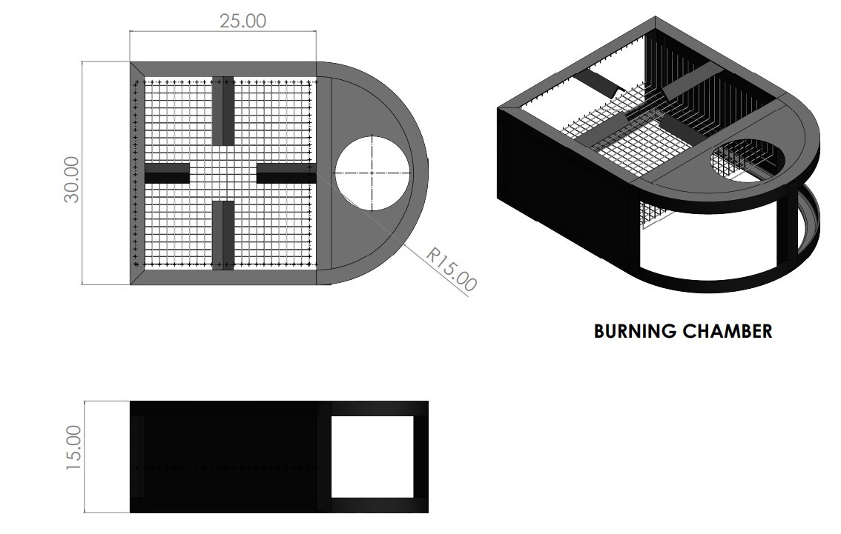

**Fig 3.3** Combustion Unit

### 3.3.3 Custom Boiler (5 Liters)

This is where the water turns into steam. It receives heat from the combustion unit and uses it to boil water in a closed system. A custom boiler with a 5-liter capacity was used for this process, with 75% of its volume filled with water and the remaining 25% left for steam generation. This is done to ensure that there is enough space for the pressure to build up before being sent to the steam-designed turbine. Safety measures like placing a Pressure Release Valve for managing excess pressure, a Water level gauge, and a Pressure Gauge for monitoring internal pressure levels to have proper control of the system and avoid catastrophic failure or hazards were implemented. 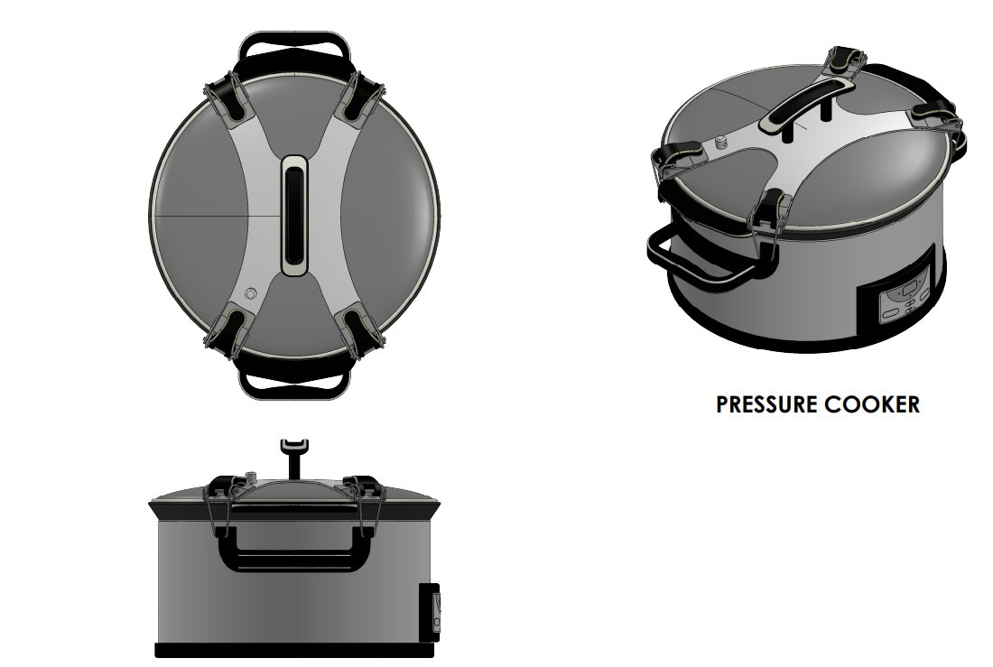

**Fig 3.4** Custom boiler (5 liters)

### 3.3.4 Exhaust System

This is where post-combustion gases are vented out at a controlled rate through the pipe connected to combustion chamber.

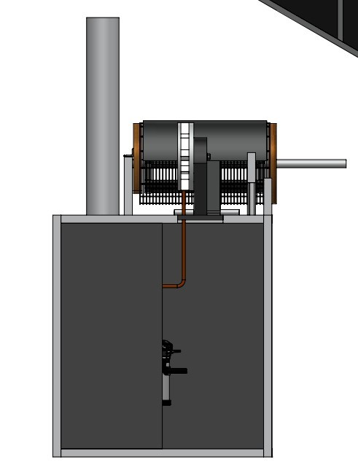

**Fig 3.5** Exhaust System

### 3.3.5 Steam Conversion Unit

The unit is crucial in the waste-to-energy system, as it is responsible for efficiently converting the thermal energy from the steam produced in the custom boiler into electrical energy. The process initiates with the directed flow of pressurized steam from the combustion chamber to the turbine. This unit integrates a steam turbine and a generator, working seamlessly to exploit the potential of the steam. As the steam flows from the boiler, it engages with the turbine blades. The thermal energy from the steam imparts kinetic energy to the turbine blades, setting them into motion. This motion is then transformed into electricity using a generator capable of generating up to 13.5 volts of electricity when conditioned.

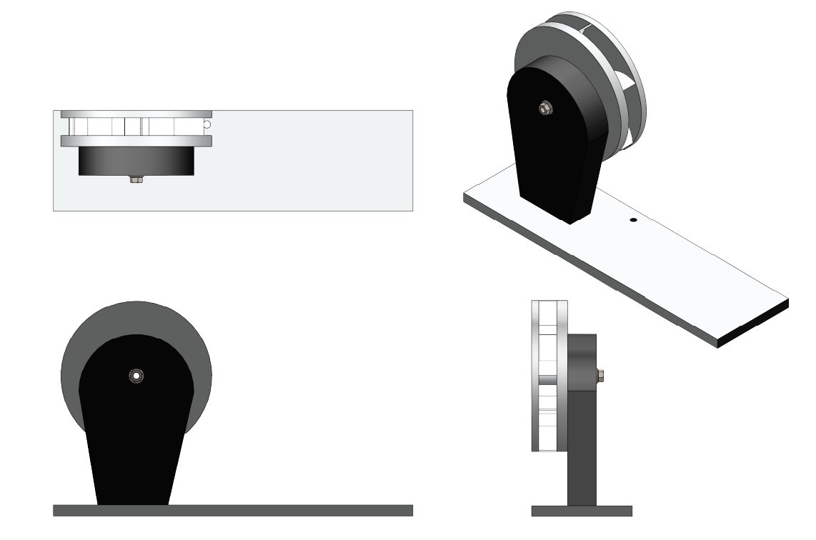

**Fig 3.6** Turbine blade

### 3.3.6 Power Storage and Conditioning Unit

Any generated electricity is conditioned to the correct voltage and frequency for use or distribution. This unit includes step transformers, inverters, LCD display, microcontroller and other electrical components necessary for this task. Additionally, the unit incorporate storage system (batteries), to store excess power for later use.

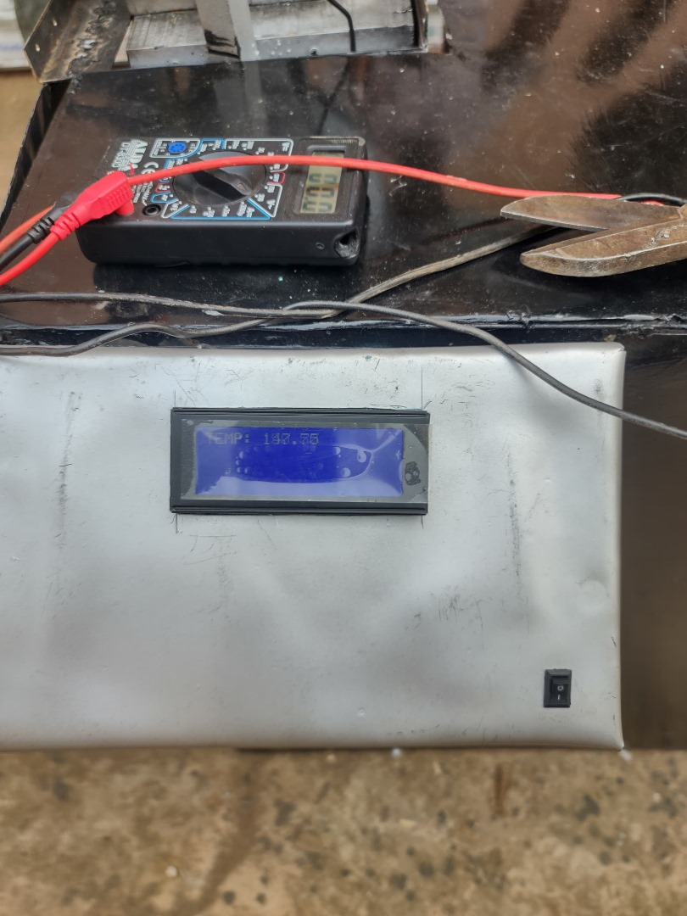

**Plate 3.2** LCD Display

The tests were designed to measure several key metrics, including.

1. The quantity of each sample of waste required to produce steam,
2. The time taken to heat the boiler to produce steam,
3. The temperature of the boiler,
4. The voltage generated by the system (both conditioned and unconditioned), and the efficiency of battery charging.

Additionally, the quantity of water used, and the volume of steam produced were monitored to assess the system's efficiency and the impact of different waste types on energy production.

This introduction sets the stage for a detailed exploration of the testing setup, methodology, and results. By conducting these tests, this research aims to contribute valuable insights into the feasibility and efficiency of waste-to-energy technologies, offering a potential pathway for sustainable energy development and waste management practices. The following sections will highlight the specifics of the testing process, presenting a comprehensive analysis of the data collected and discussing the implications of these findings for the advancement of waste-to-energy solutions.

***Table 4.1.1*** *Sample quantity in (kg)*

|  |  |  |
| --- | --- | --- |
| Sample | Initial Weight measured for feeding burner | Final Quantity used for steam |
| Wood | 0.9kg | 0.9kg |
| Paper | 0.7kg | 2kg |
| Nylon | 0.8kg | 1.5kg |

***Table 4.1.2*** *Results from testing/Design Analysis Results*

|  |  |  |  |  |  |  |  |
| --- | --- | --- | --- | --- | --- | --- | --- |
| Waste Type | Time to Reach 0.5 Bar (min) | Boiler Temperature (°C) | Max Unconditioned Voltage (V) | Conditioned Voltage for Battery (V) | Battery Status | Pressure Used for Turbine (Bar) | Volume of Steam Produced (m³) |
| Wood | 13 | 110.00 | 56.8 | 13.5 | Charging | 0.5 | 3.75 |
| Paper | 30 | 123.25 | 54.8 | 13.5 | Charging | 0.5 | 3.75 |
| Nylon | 25 | 119.75 | 53.5 | 13.5 | Charging | 0.5 | 3.75 |

## 4.2 Test Procedures

The testing for the waste-to-energy system was done with three different types of waste materials; paper waste, nylon waste and wood waste to asses the system's performance. This section outlines the preparation of the waste samples, the setup of the prototype system, and the initial procedures followed to initiate the testing process.

### 4.2.1 Prototype System Setup

The prototype system is composed of several key components critical to its operation and the subsequent analysis of its performance. These components include:

Steam Boiler: Equipped with a safety valve calibrated at 0.5 bar to ensure safe operation during the waste combustion process. The boiler is filled with water to 75% of its 5-liter capacity, equivalent to 3.75 liters, to produce steam.

Steam Turbine and Generator: The steam produced in the boiler drives a prototype steam turbine, which is coupled to a generator.

Voltage Rectification and Conditioning System**:** Converts the AC voltage generated by the turbine-driven generator into DC voltage, suitable for battery charging. The system's efficiency in conditioning the voltage to 13.5V DC for battery charging is a key metric.

Thermal Measurement and Monitoring: A thermocouple is installed in the boiler to monitor its temperature, providing data on the combustion efficiency and heat transfer properties of the waste materials.

Dashboard: Features an LCD and a microcontroller for real-time monitoring and display of critical parameters such as boiler temperature, steam pressure, and voltage output.

## 4.3 Preparation and Measurement of Waste Samples

To ensure the accuracy of the test results, the weight of the waste samples (paper, nylon, and wood) was measured before the testing begins. Each type of waste was first gathered from waste dumping site, segregated, dried (to standardize moisture content), and then weighed individually. The drying process was essential to minimize the variability in energy content due to moisture, which can significantly affect combustion efficiency.

The weights of the waste were recorded separately. This precise measurement ensured that the energy content derived from each waste type can be accurately compared, and it also facilitates the replication of tests under controlled conditions.

### 4.3.1 Detailed Procedure for Waste Addition

The methodology specifies a standardized procedure for adding the weighed waste to the combustion chamber. This process involves carefully distributing the waste to promote efficient burning and ensure that the heat is evenly distributed within the boiler.

For paper waste, the procedure includes shredding or tearing it into smaller pieces to enhance combustion efficiency.

Initiation of Testing

The testing procedure began with the boiler being filled to the predetermined water level (75% full) and the selected waste type being introduced into the combustion chamber. The boiler was then ignited, and the process of heating the water to produce steam commenced. The time taken to reach a boiler pressure of 0.5 bar for which useable steam is produced was recorded, serving as an initial indicator of the combustion efficiency of the waste material being tested.

## 4.4 Performance Evaluation and Efficiency

Once the waste was added and the combustion process begins, the system's performance is closely monitored. Key metrics such as the time taken for the boiler to reach 0.5 bar, the temperature of the boiler body, and the voltage generated by the turbine-driven generator are recorded. This data collection is vital for evaluating the prototype's efficiency and effectiveness in converting waste to energy.

$Efficiency=\frac{Theoretical volatge}{Actual voltage}x100$ ()

For bag A

$$Efficiency=\frac{54.8}{72.5}x100=75.59\%$$

For bag B

$$Efficiency=\frac{55.30}{81}x100=68.27\%$$

For bag C

$$Efficiency=\frac{40.12}{56.8}x100=70.63\%$$

**4.4.1 Efficiency**

The efficiency analysis revealed notable variations in the performance of the waste-to-energy system across different waste types. Bag A, primarily composed of paper, exhibited the highest efficiency at 75.59%. This indicates that the system effectively converted the energy content of paper waste into electrical energy, demonstrating its suitability for energy recovery. Bag B, containing predominantly nylon materials, displayed a slightly lower efficiency of 68.27%. While still considerable, this lower efficiency suggests potential challenges in the combustion and energy conversion processes for nylon-based waste. Bag C, comprising wood waste, demonstrated an efficiency of 70.63%, falling between the efficiencies of Bag A and Bag B. These efficiency values serve as crucial indicators of the system's ability to harness energy from diverse waste streams, highlighting the need for tailored processing methods to optimize performance.

**4.4.2 Performance Evaluation**

The performance evaluation of the waste-to-energy system encompasses various aspects, including energy conversion efficiency, operational reliability, and environmental impact. The observed efficiencies provide insights into the system's overall performance and inform strategies for enhancing its effectiveness. By analyzing operational data and efficiency metrics, the system's performance can be evaluated in terms of its ability to convert waste into usable energy while minimizing environmental harm. Additionally, the performance evaluation informs ongoing efforts to optimize system components, streamline waste processing procedures, and maximize energy recovery. Continuous monitoring and evaluation are essential for identifying areas of improvement and implementing targeted interventions to enhance system performance and meet sustainability objectives. Through rigorous performance evaluation, the waste-to-energy system can achieve greater efficiency, reliability, and environmental sustainability, contributing to a more sustainable waste management ecosystem.

### 4.4.1 System Performance Monitoring and Data Collection

***Table 4.5*** *System Performance Monitoring and Data Collection*

|  |  |  |  |  |  |
| --- | --- | --- | --- | --- | --- |
| Time (s) | Voltage Wood (V) | Voltage Paper (V) | Voltage Nylon (V) | Charging Voltage (V) | Status |
| 0 | 0.00 | 0.00 | 0.00 | 1.0 | Not Charging |
| 2 | 5.68 | 5.48 | 5.50 | 1.5 | Not Charging |
| 4 | 11.36 | 10.96 | 11.10 | 2.0 | Not Charging |
| 6 | 17.04 | 16.44 | 16.56 | 7.3 | Not Charging |
| 8 | 22.72 | 21.92 | 22.20 | 9.0 | Not Charging |
| 10 | 28.40 | 27.40 | 27.80 | 12.62 | Charging |
| 12 | 34.08 | 32.88 | 33.14 | 13.32 | Charging |
| 14 | 39.76 | 38.36 | 38.56 | 13.5 | Charging |
| 16 | 45.44 | 43.84 | 44.05 | 13.5 | Charging |
| 18 | 51.12 | 49.32 | 38.56 | 13.5 | Charging |
| 20 | 56.80 | 54.80 | 55.30 | 13.5 | Charging |

### 4.4.2 Efficiency and Measurement

**Fig 4.1** Voltage against Time Graph (For Wood, Paper and Nylon)

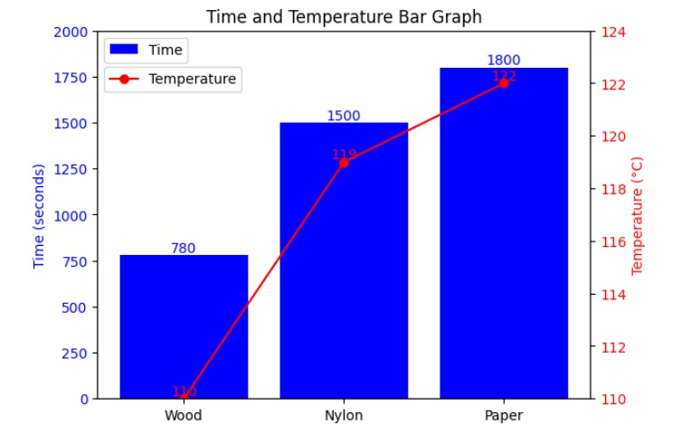

**Fig 4.2** Time against Temperature Bar Chart (For Wood, Paper and Nylon)

## 5.1 Conclusion

The waste-to-energy system has demonstrated its capability to efficiently convert various waste materials into electricity, thereby contributing to environmental sustainability and energy generation. Despite encountering challenges during the design and implementation phases, the project has proven successful in utilizing the potential of waste as a renewable energy source. The testing of different waste materials revealed their ability to generate electricity, affirming the system's efficacy in waste conversion. Moreover, the project exhibits a promising return on investment, with a favorable payback period of 9 months and 15 days. These findings reinforce the significance of waste-to-energy technologies in mitigating environmental pollution and advancing renewable energy solutions.

# REFERENCES:

Al-Zubaidy, A. A., Al-Ghamdi, M. R., & Al-Mutairi, W. A. (2015). Waste to energy: A review of technologies, environmental impacts, and economic aspects. Renewable and Sustainable Energy Reviews, 49, 1048-1066.

Bensaid, M., Bouallou, S., & Ayadi, M. (2018). Waste sorting: A review of technologies and challenges. Waste Management, 74, 23-36.

"Incineration of Municipal Solid Waste: A Review of Technologies, Environmental Impacts, and Economic Aspects." (2015) by A. A. Al-Zubaidy, M. R. Al-Ghamdi, and W. A. Al-Mutairi. Renewable and Sustainable Energy Reviews, 49, 1048-1066.

"Incineration of Municipal Solid Waste: A Review of Technologies, Emissions, and Control." (2013) by M. A. Khan and M. S. Islam. Renewable and Sustainable Energy Reviews, 25, 630-640.

"Incineration of Municipal Solid Waste: A Review of Technologies, Economics, and Environmental Impacts." (2012) by S. C. Jain and S. K. Jain. Renewable and Sustainable Energy Reviews, 16, 5234-5241.

"Waste to Energy: A Review of Technologies, Environmental Impacts, and Economic Aspects." (2015) by A. A. Al-Zubaidy, M. R. Al-Ghamdi, and W. A. Al-Mutairi. Renewable and Sustainable Energy Reviews, 49, 1048-1066.

"Waste to Energy Technologies: A Review." (2013) by S. C. Jain and S. K. Jain. Renewable and Sustainable Energy Reviews, 25, 630-640.

"Waste to Energy: Potential and Challenges." (2012) by M. A. Khan and M. S. Islam. Renewable and Sustainable Energy Reviews, 16, 5234-5241

Nidhi Kundariya a b, Swayansu Sabyasachi Mohanty a c, Sunita Varjani a, Huu Hao Ngo d, Jonathan W. C. Wong e, Mohammad J. Taherzadeh f, Jo-Shu Chang g h i, How Yong Ng j, Sang-Hyoun Kim k, Xuan-Thanh Bui(December 2022), A review on integrated approaches for municipal solid waste for environmental and economical relevance: Monitoring tools, technologies, and strategic innovations. Retrieved from <https://www.sciencedirect.com/science/article/abs/pii/S0960852421013249>

Bharti Agarw (2022), Traditional means of waste management, Retrieved from <https://www.preservearticles.com/education/traditional-means-of-waste-management/21697#:~:text=In%20the%20twentieth%20century%2C%20humans,impoundments%2C%20and%20most%20recently%20sanitary>

David Fahrion, What are the Key Advantages of Integrated Waste Management?(February 2023). Retrieved from <https://wastecontrolinc.com/2023/02/28/key-advantages-integrated-waste-management/>

United Nation Escap(November 2017), Sustainable Development Benefits of Integrated Waste Management. Retrieved from <https://repository.unescap.org/bitstream/handle/20.500.12870/3085/ESCAP-2017-RP-Sustainable-development-benefits-integrated-waste-management.pdf?sequence=1>

Liam Stannard ( October 2021), 8 Innovative Smart Waste Management Technologies. Retrieved from <https://www.bigrentz.com/blog/smart-waste-management>

Luís Seguí, Eric van Looy, Maximilian Gutmayr, Tom Jansen, Erik Kuenen, Tom Higginbottom, ()June 2023), Separation and Sorting Technology. Retrieved from <https://recyclinginside.com/recycling-technology/separation-and-sorting-technology/>

Dovilė Gimžauskaitė, ... Andrius Tamošiūnas(2022), Waste to Energy Conversion Technology. Retrieved from <https://www.sciencedirect.com/topics/engineering/waste-to-energy-conversion-technology>

Waste to energy. Retrieved from <https://studentenergy.org/conversion/waste-to-energy/#:~:text=WTE%20can%20occur%20through%20a,temperatures%20allowing%20for%20energy%20recovery>

Naomi B. Klinghoffer, Marco Castaldi (May 2013), Waste to Energy Conversion Technology. Retrived from <https://www.researchgate.net/publication/293008505_Waste_to_Energy_Conversion_Technology>

Ismaila Rimi Abubakar, Khandoker M. Maniruzzaman, Umar Lawal Dano, Faez S. AlShihri, Maher S. AlShammari, Sayed Mohammed S. Ahmed, Wadee Ahmed Ghanem Al-Gehlaniand Tareq I. Alrawaf(October 2022), Environmental Sustainability Impacts of Solid Waste Management Practices in the Global South. Retrieved from <https://www.ncbi.nlm.nih.gov/pmc/articles/PMC9566108/>

Campana, F., & Lotito, G. (2015). Energy from waste: The role of reciprocating engines. *Energy Procedia*, 61, 909-916.

IEA (International Energy Agency). (2019). Waste-to-Energy: Technology review. IEA, Paris.

Zaman, F. D., & Van der Voet, E. (2012). Waste-to-energy technologies and their impact on the environment. *Waste Management & Research*, 30(8), 773-782.

World Bank. (2018). What a waste 2.0: A global snapshot of solid waste management to 2050. <https://openknowledge.worldbank.org/handle/10986/30317>

Campana, F., & Lotito, G. (2015). Energy from waste: The role of reciprocating engines. Energy Procedia, 61, 909-916.

Ellen MacArthur Foundation. (2023). Circular economy. <https://ellenmacarthurfoundation.org/circular-economy>: <https://ellenmacarthurfoundation.org/circular-economy>

Ghiglione, C., Campana, F., & Salza, E. (2021). Integration of waste sorting and energy recovery: An experimental investigation for a more sustainable waste management system. Journal of Cleaner Production, 299, 126809.

Athanasiou, C. A., Panagopoulos, T., & Wang, M. H. (2018). Public perception of waste-to-energy plants: A critical review. Journal of Cleaner Production, 195, 956-966.

Bao, J., Yang, Y., Li, X., & Wang, R. (2020). Improving the performance of steam turbines in waste-to-energy plants: A review. Renewable and Sustainable Energy Reviews, 124, 109709.

Demirbas, A. (2011). Waste-to-energy technologies. Energy Conversion and Management, 52(4), 1468-1484.

Fontana, M., Monarca, D., Travaglini, V., & Macchi, E. (2021). Steam turbines for waste-to-energy plants: Design options and optimization strategies. Journal of Thermal Science, 60(8), 1719-1739.

Gomi, K., Iwasaki, A., & Shimazaki, K. (2018). Performance analysis of a waste-to-energy plant adopting a backpressure steam turbine. Energy Reports, 4, 84-89.

Moran, K., Holmberg, H., & Eriksson, O. (2021). Operational challenges of steam turbines in waste-to-energy plants: A state-of-the-art review. Renewable and Sustainable Energy Reviews, 140, 106305.

Rydahl, H., & Svensson, A. (2017). Waste-to-energy plants: An overview of design principles and performance. Journal of Waste Management, 69, 721-730.

Toffolo, G. M., Rizzi, G., & Marini, M. (2019). Design criteria for adapting steam turbines to the variability of waste-derived fuel properties in waste-to-energy plants. Applied Thermal Engineering, 155, 255-265.

Werther, J., Ogada, T., & Sato, K. (2018). Corrosion in waste-to-energy (WtE) systems: Mechanisms, implications, and solutions. Chemical Engineering Journal, 334, 1966-1988.