# 

[Manchester Untitled]

**Business Statement**

Version 1.0

[24.10.2022]

Design Studio Section:[3]

Presented by:

İlim Çelebioğlu

İsmail Hakkı Armutcu

Melis Gökşen

Niyazi Görkem Dener

Salih Mert Küçükakıncı

**Introduction**

Manchester Untitled Company was founded by five senior electrical and electronics engineering students in Metu on 5.10.2022. The partners' primary areas of expertise vary across engineering disciplines such as hardware and embedded software development, robotic control systems, communication protocols, RF, and 3D modeling. This variety of specialty allows the company to design and develop multifunctional and fully integrated systems with the collaborations of the company members.

**Mission and Vision of the Company**

**Mission**

Manchester Untitled Company aims to develop efficient, low-cost, user friendly, and robust systems which are preferable by customers from various fields.

**Vision**

To create 21st century’s most compelling technologies that combine computer vision and robotics.

**Human Resources**

**İlim Çelebioğlu:** Hardware and PCB Design, 3D modeling, Embedded Software Programming, FPGA/HDL Programming, Neural Networks, Quantum Computing and Neuromorphic Computation System Development

**İsmail Hakkı Armutcu:** GUI and Software Design, Algorithm Implementation, FPGA/HDL Programming, Electromechanical Energy Conversion, Real-time Data Processing and Visualization

**Melis Gökşen:** Communication Protocols, RF, Analog and Digital Communication, Microwaves, Antenna Design

**Niyazi Görkem Dener:** Robotic Algorithm Implementation, State Estimation, Object Tracking and Controller Design

**Salih Mert Küçükakıncı:** Game Development, Natural Language Processing, Embedded Software Programming, Image Processing, Full-Stack Development, FPGA/HDL Programming

**Description of Capstone Design Projects**

**Project 1: Aid for the Blind**

The Aid for the Blind Project wants to create a wearable gadget that would help the blind navigate the city. The tool should provide in-depth environmental monitoring and securely guide users. A variety of roadways, crosswalks, obstacles, traffic signs, and lights should be present in the environment, which should be static and artificially constructed. For the test environment, active pedestrian and vehicular traffic should be produced. The device should recognize the human crossing from the traffic signs and lines on the road. The device should then analyze the flow of vehicles and traffic signals to determine whether the pedestrian crossing is appropriate. The user should then be told if the crossing is secure or not. The tool should also direct the user to cross the street safely. In addition to these standards, users should be notified of impediments to avoid dangerous collisions and an alternate route should be suggested. A user-friendly, portable, and power-efficient consumer gadget should also be created.

The project heavily relies on image processing and object detection algorithms to solve the problem of environmental monitoring and guidance. However, due to the weight and cabling structure, creating a wearable and comfortable device will be difficult. Furthermore, creating an artificial and mobile test environment and detecting it by the system is challenging. However, it appears that the project's requirements will necessitate relatively low power consumption. Finally, the absence of robotic control systems is one of the project's advantages.

**Project 2: The Copycat**

The Copycat Project seeks to create an agent robot that can work in sync with a master robot without ever communicating with it directly. The agent robot should move at the same pace and in the same direction as the master robot. A computer-based graphical user interface system can be used to enter the master robot's motion path. The same interface can also be used to obtain the motion's speed information. These two robots initially begin their travel from disparate positions within a circle with a radius of one meter. The agent must initially catch the master in the first five seconds of motion. The agent then begins to imitate the master's movements. The agent should select the beginning of the copying motion during this phase of the motion, and the distance between them should always be between 27 cm and 33 cm. Additionally, each movement should be smooth and natural.

Due to the lack of direct communication between the two robots and robotic control algorithms, the project heavily relies on object tracking. To achieve the complex movement patterns of both the master and the agent naturally, sensitive control algorithms and a robust mechanical structure will be required, which will be a difficult task. Furthermore, because the observer's reference frame is not from the top of the area, mathematical and algorithmic complexity is created.

**Project 3: Gesture Mimicking Telepresence Robot**

The Gesture Mimicking Telepresence Robot Project's major goal is to create a telepresence robot that can imitate user hand motions by sensing them with a tool. The user writes or draws on a virtual plane, and the robot transfers that configuration to the paper upon receiving remote instruction from the perception tool. Any inclined surface, whether vertical, horizontal or at an angle, may be used to lay the paper. Three distinct pen modes will be available. The flexibility and thickness of each pen vary. As a result, the robot ought to be able to hold each pen securely. In order to provide the user with a realistic sense of how their hands are moving, the perception tool must also provide appropriate haptic feedback. The motion perception tool set must be simple to use and intuitive. The telepresence robot's movements should also be as natural-looking as feasible, and simultaneous real-time imitating should be carried out.

Motion detection, haptic feedback generation, and robotic control algorithms are heavily used in the project. Creating virtual reality sensations with electromechanical components and replicating them in another location will be a difficult task. Furthermore, due to simultaneous mimicking, proper motion data transfer between two units and data processing quality will be significant. Furthermore, mimicking the user's behavior naturally will necessitate sensitive control algorithms. Due to the lack of direct communication between the two robots and robotic control algorithms, the project heavily relies on object tracking. To achieve the complex movement patterns of both the master and the agent naturally, sensitive control algorithms and a robust mechanical structure will be required, which will be a difficult task. Furthermore, because the observer's reference frame is not from the top of the area, mathematical and algorithmic complexity is created.

**Project 4: Shadow fixing intelligent canopy**

The goal of the intelligent light barrier project called the "Shadow Fixing Intelligent Canopy" is to prevent users from being in the shadow regardless of the direction of the light source. The assumption is that the light source can be found between -45 and 45 degrees of the spherical sector, which the user references for various light orientations. The canopy's shadow area ought to be as consistent as feasible. At least three poles, each 30 cm long and extending to 50 cm, are required to accomplish that. Additionally, the space between neighboring poles on the ground must be 50 cm and their placement must be set.

This project necessitates extensive image processing experience or a high level of mathematics. It is stated that the shadow cast by the canopy should be as constant as possible and that the shadow should either be observed by a camera or calculated in terms of pole locations in 3D space with respect to the light source. It may be difficult to develop a mathematical model for the area of shadow and the locations of poles with light sources. Some simulation tools are required for the testing of mathematical models. A camera can be placed to detect shadows without the use of a harsh mathematical model. With machine learning algorithms, the area of the shadow may remain constant as the poles move.This project is highly about robotical joint movements and making it will give intense experience in the robotics area.

**Project 5: Training Buddy**

Qualified training is a major issue in almost all sports because it requires a skilled opponent. Table tennis is one of them. An interactive and intelligent ball launcher that will be positioned on a ping pong table will be designed to solve the training problem. The device should only respond to verbal commands. The device should have five different operation modes, including normal and randomized repetition practice, normal and randomized sequence practice, and game mode. The current launch mode influences ball launch characteristics such as serve speed, angle, frequency, and ball spin. In addition, the device should accurately launch the balls and track user performance data.

This project is mainly based on dynamics and speech processing. In the first step, the machine needs to recognize its state by processing the speech of the user. After that, according to speech observation, a desirable state is chosen and corresponding operations are executed for that state like throwing a ball at a certain speed with specified frequency and spin. At this point some dynamical mathematical models should be derived and implemented on machines. One of the main challenges about this project is making it with limited budget since the speech process should be done on CPU and following dynamical operations done with mechanical components. On the other hand, dealing with those kinds of problems will give plenty of experience in speech process and robotical areas.

**Conclusion**

In conclusion, as five senior electrical and electronics engineering students, we have collaborated to design a solution to one of the aforementioned projects. We briefly evaluated the pros and cons of each project at this stage. Following this, we will select one of the projects in the coming weeks, in accordance with the timetable outlined in Appendix 1. Because the projects are multi-disciplinary, we will be able to design a creative and functional solution due to our diverse experience and interests.

**Appendix 1**

EE493 Time Schedule:

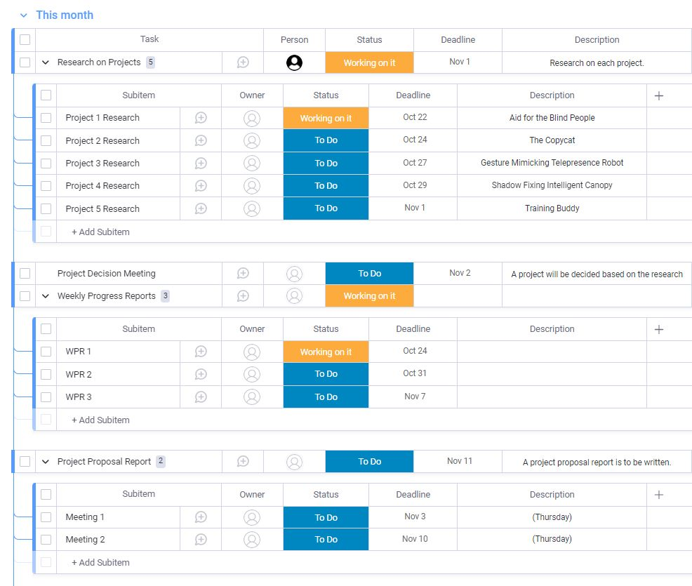

Gant Chart Display:

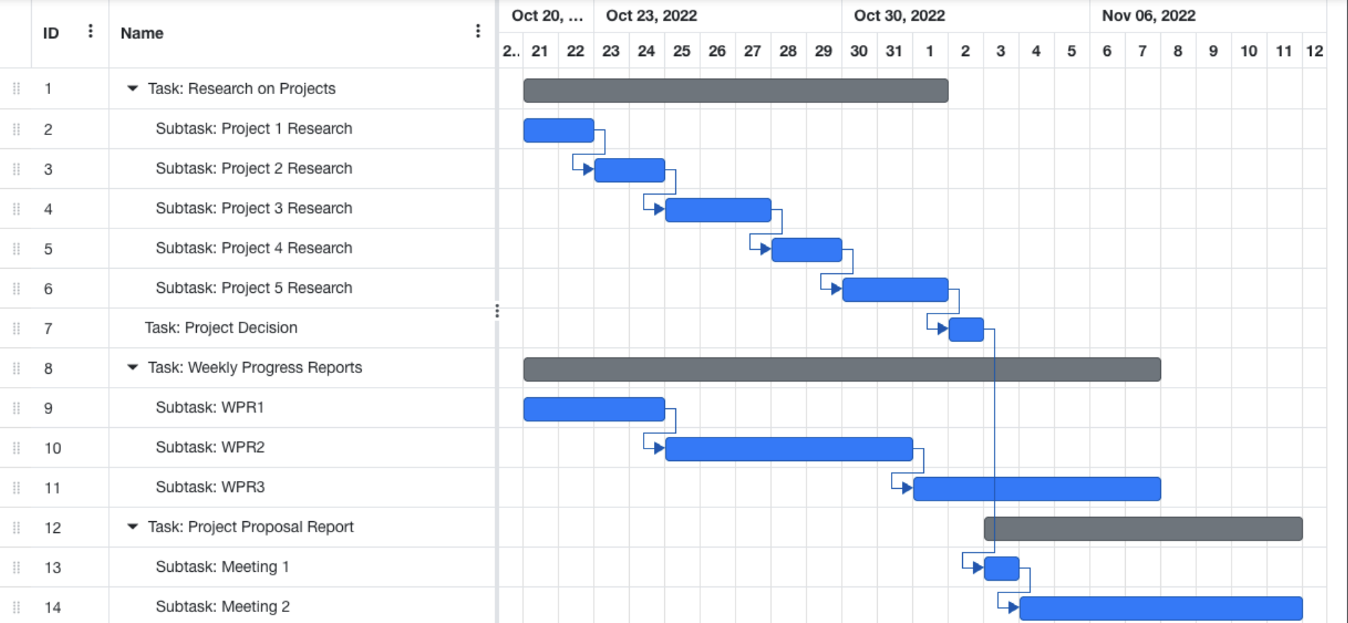

**Appendix 2**

İlim Çelebioğlu CV:

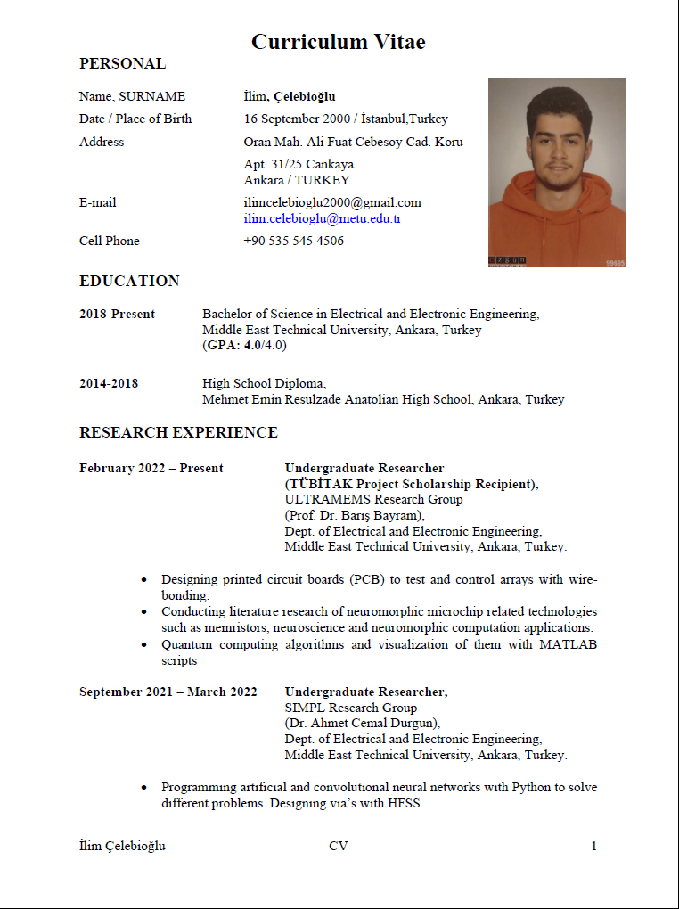

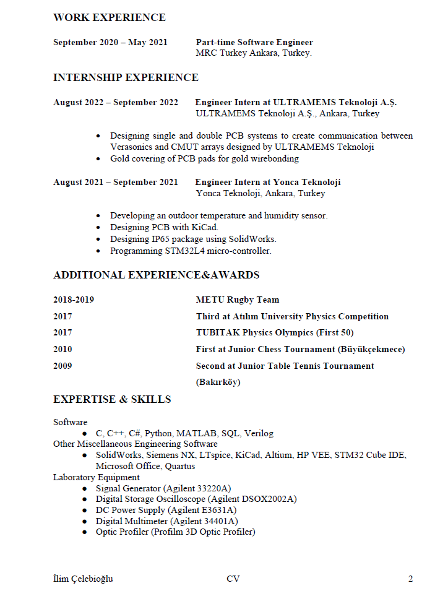

İsmail Hakkı Armutcu CV:

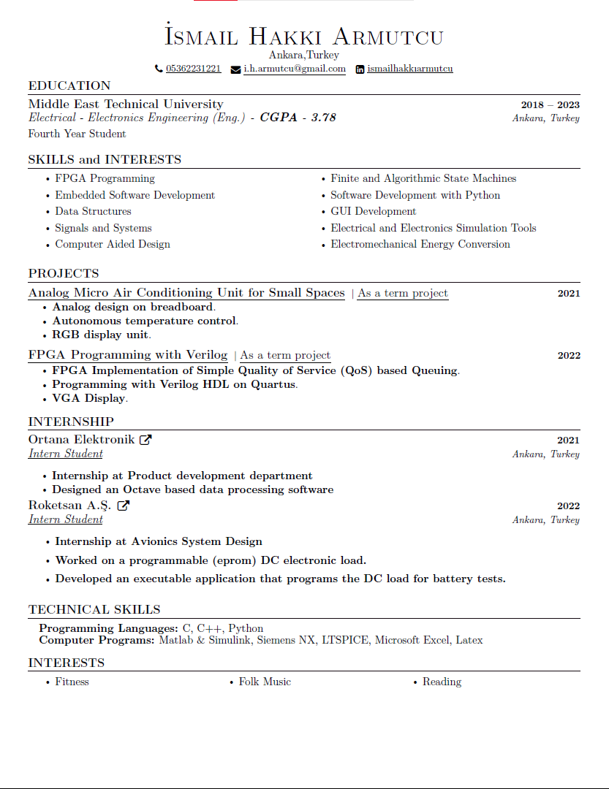

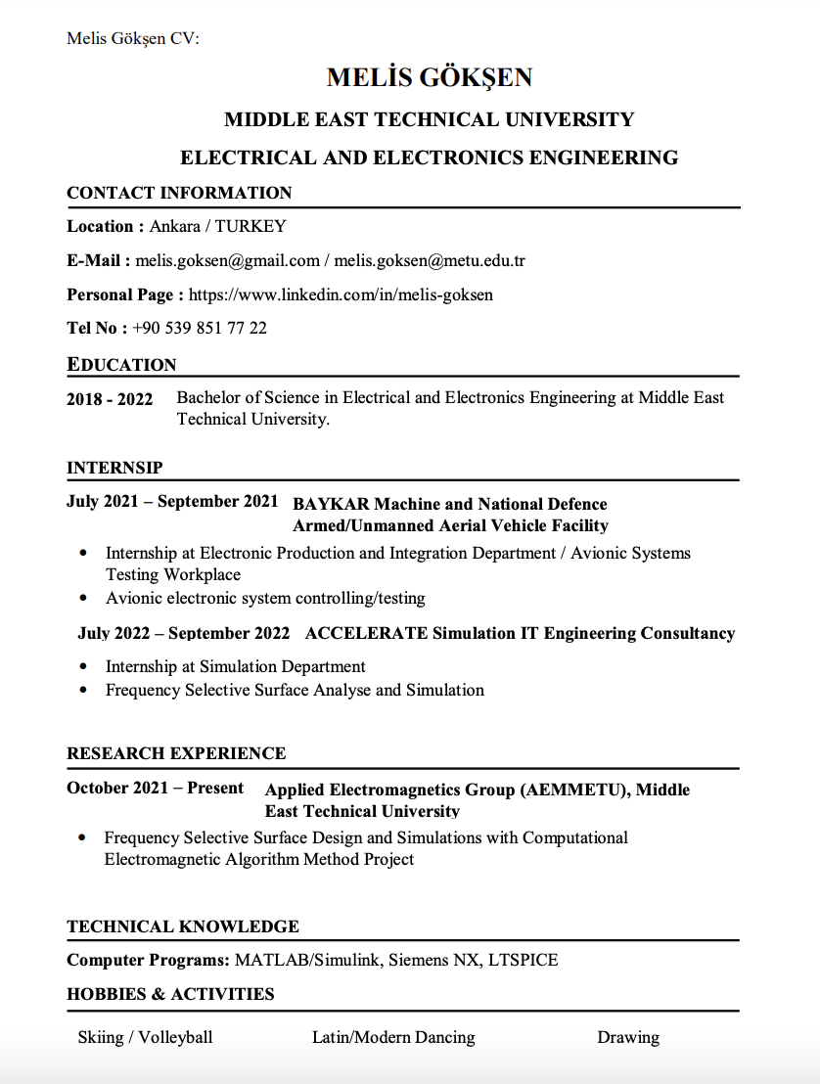

Niyazi Görkem Dener CV:

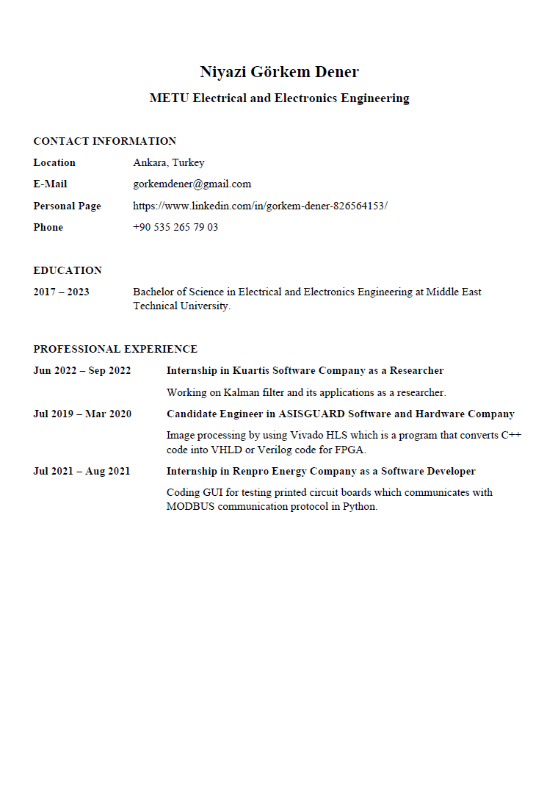

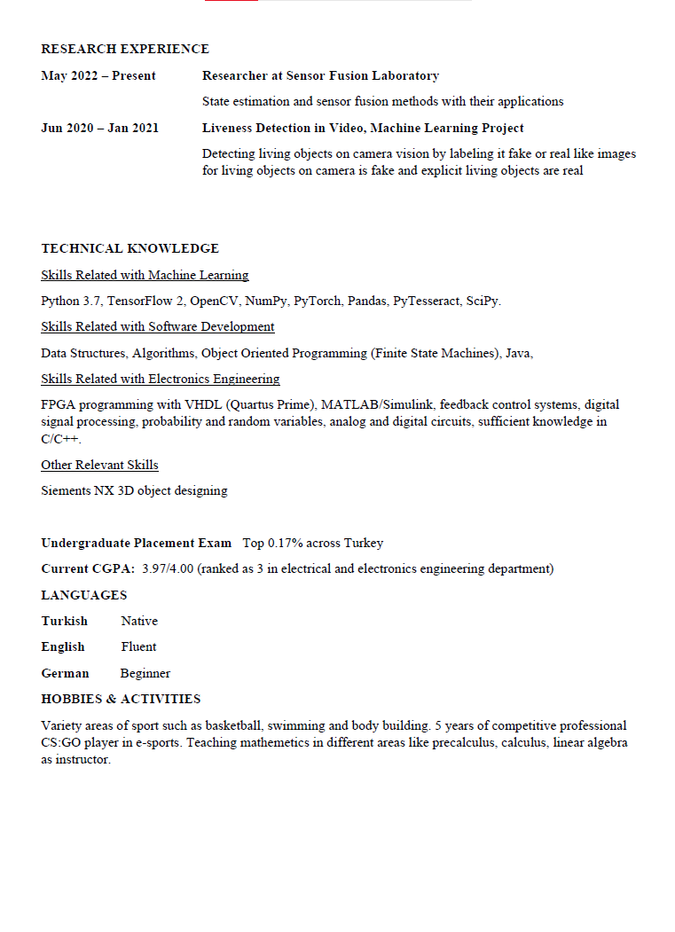

Salih Mert Küçükakıncı CV:

