# 

# 

# [Manchester Untitled]

**AID FOR THE BLIND PEOPLE**

Version 0.1

[11.11.2022]

Design Studio Section:

[3]

Presented by:

[İlim Çelebioğlu

İsmail Hakkı Armutcu

Melis Gökşen

Niyazi Görkem Dener

Salih Mert Küçükakıncı]

Table of Contents

Executive Summary

Introduction

Background of the project

Problem statement

Societal impact of the project

Scope and organization

Team Organization

Requirement Analysis

Solution Procedure

Expected Deliverables

Conclusion

# Executive Summary

A wearable device that would aid blind people in navigating cities is the aim of the Aid for the Blind Project. The tool should safely lead users while offering comprehensive environmental monitoring. There should be a variety of roads, crosswalks, obstacles, traffic signs, and lighting in the surrounding area. The technology should be able to tell a human crossing from the road's lines and traffic indicators. The device should then assess how traffic is moving and the strength of traffic lights to decide if the pedestrian crossing is safe. The user should subsequently be informed as to whether the crossing is secure. Additionally, the gadget should provide instructions on how to cross the street safely. In addition to these requirements, users should be informed of obstructions verbally to prevent potentially harmful collisions, and a different path should be recommended. Additionally, a user-friendly, transportable, and power-efficient consumer device needs to be developed.

The wearable design concept that we suggest has two primary parts. The head-set module, which is the initial part, contains the primary section that receives the image of the surroundings, processes it, finds the indicated obstructions, and signs, and speaks commands to the user. The walking stick module, which senses items like vehicles, bicycles, and obstacles and comprehends their distance, height, and speed information, is the second component. Additionally, two major components will be able to communicate wirelessly with one another.

The project content is appropriate for Manchester Untitled Company's perspective and capabilities. The company's members possess advanced knowledge and sufficiency in both hardware and software areas that are closely related to project requirements. To complete the project idea, technological knowledge in the fields of software engineering, wireless communication, electronic system design, and data optimization is required, which our group members can provide.

Test documentation and a module test demo are the project deliverables that are anticipated for the upcoming month. A conceptual design report and a project presentation must be provided by the end of December. Critical design report, project execution, final reports, and project demonstration are the long-term deliverables due in March. Periodic expense reports will be recorded in the group during this eight-month period, not to exceed the project budget of $200. The estimated cost of the device is such that the processor, and the camera cost $100, sensors cost $30, power supply and accessories cost $50, in total $180 which is below the $200 budget limit.

# Introduction

## Background of the project

Insufficient warnings for probable dangers cause many undesirable situations that may result in vital cases for the blind people. Considering the unsatisfactory conditions, we have decided to develop a beneficial, comfortably usable device, so that the blind people have equal living standards as others. The fundamental background of the project is to eliminate major drawbacks that blind people interact with in real life. From the motive we have, we consider common fields where our device is the most needed, and how it can be more beneficial for blind people, so that the properties of the device are formed with these bases.

## Problem statement

Blind people face numerous challenges in their daily lives, particularly when navigating the city as pedestrians. Some of the issues are related to poorly regulated warnings, heavy traffic, and obstacles on the sidewalks. These issues not only make it difficult for blind people to walk as pedestrians, but they also endanger their lives in some cases. The aid for the blind project seeks to assist blind people in such a way that they can freely walk down the street and safely arrive at their destination. The project will make life easier for people who are blind.

## Societal impact of the project

The issues that disabled people encounter are not recognized enough from the authorities. The applications and regulations that are applied to the city plans for the disabled people are inadequate in various manners. Many public areas such as traffic environments including sidewalks, pedestrian roads, streets, and parks are not arranged considering the disabled people. Furthermore, blind people face life threatening situations in the busy traffic. With our project, blind people can freely navigate in areas which can be normally comfortable and dangerous. The project will make it easier for the blind people to independently live their social lives. As a result, blind people can be more active in their social lives.

## Scope and organization

The Team Organization section of this report will first describe the team members, their responsibilities, and their places within the organizational structure. The needs for the project will then be quantitatively explained in the section on Requirements Analysis section. The Solution Procedure follows this section. The project's primary tasks will be listed and explained in this section. There will be a schedule for the project for the upcoming months. For the best device development progress, each work will be logically ordered in this section, and the reasons for that sequence will be thoroughly explained. The presentations, reports, and illustrative demos used to track the project's development will be discussed in the last part.

Team Organization

The company consists of five partners namely Niyazi Görkem Dener, İlim Çelebioğlu, İsmail Hakkı Armutcu, Melis Gökşen and Salih Mert Küçükakıncı. All the five members of the company are undergraduate electrical and electronics engineering students from different expertise.

**İlim Çelebioğlu**

İlim is an undergraduate researcher at METU (Middle East Technical University) right now. He conducted research on artificial and convolutional neural networks alongside Ahmet Cemal Durgun. Additionally, he is presently employed by Barış Bayram, and İlim has expertise in the design of printed circuit boards (PCB). Additionally, he has experience creating hardware cases that adhere to IP65 specifications. He is primarily in charge of PCB and hardware design. Additionally, he will help with programming, machine learning, and developing 3D objects responsibilities.

**İsmail Hakkı Armutcu**

İsmail is a current METU undergraduate student. He participated in two summer practices where he gained experience in real-time signal processing, data visualization, Python programming, building executable applications, and GUI (Graphical User Interface) design. İsmail is primarily in charge of the project's software. He will assist in the development of appropriate algorithms for the specific processor, such as image processing and object detection. He will also assist with general programming aspects of the project.

**Niyazi Görkem Dener**

Görkem is an undergraduate researcher who works with Emre Özkan on Estimation Theory and robotics. He has worked with Engin Tuncer in an IEEE star project namely “Liveness Detection in Video” which is about machine learning on image recognition. Moreover, he has a deep interest in coding and developing algorithms. Now, the main discipline that he studies is “Control Area”. Görkem manages image recognition objectives in our project. In addition to that, he is going to support the team while solving some programming problems and he tries to implement estimation algorithms.

**Melis Gökşen**

Melis is an undergraduate researcher at METU. She collaborates with the university research group of Özgür Ergül, called Applied Electromagnetics METU. She has been studying computational electromagnetics algorithms and simulations. The main aspect she has searched on is Frequency Selective Surface design and analysis. She has advanced knowledge of wireless communication, microwaves, and computational electromagnetic simulations. She also has knowledge of wireless communication protocols. Melis will be primarily responsible for the project's wireless communication aspects. She will also assist with the project's simulation and testing.

**Salih Mert Küçükakıncı**

Mert has deep experience in programming languages. Some of the important ones are C#, JavaScript, Python, and Java**.** In those languages, he has worked on OpenCV, TensorFlow, PyTorch, backend, and frontend development. Moreover, he has experience in object detection on aerial vehicles. Additionally, he has experience in embedded programming. Mert will be responsible for the programming aspects of the project. He will handle the integration of the required algorithms into our design.

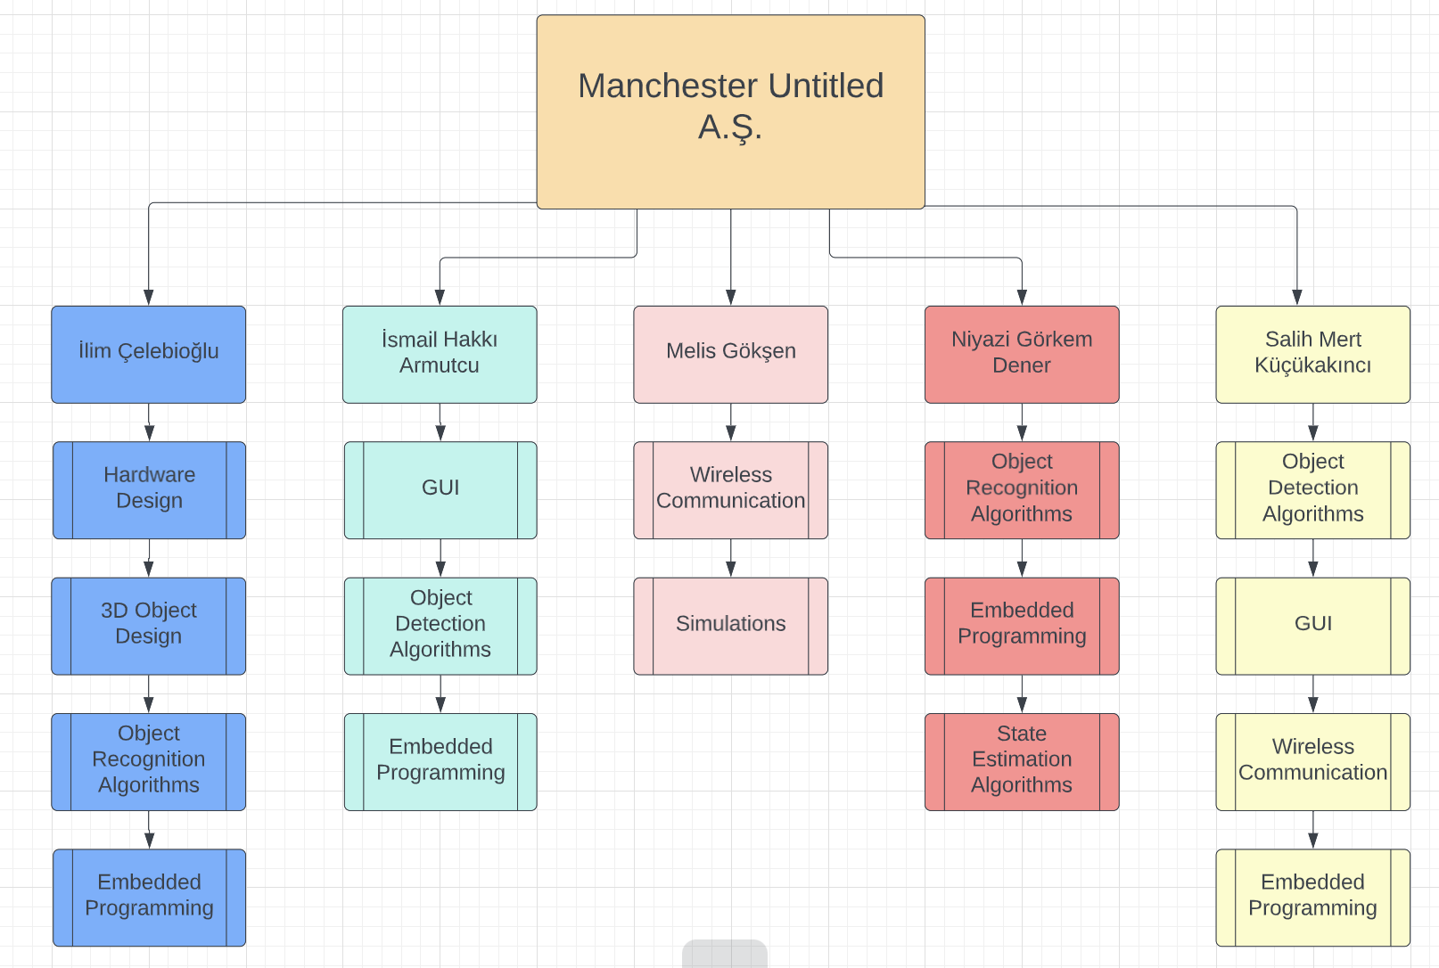

*Figure 1. Organizational Chart of the Company*

# Requirement Analysis

# The device has two separate units, headset unit and walking stick unit. The headset unit is responsible for detection of crossroads, pedestrian crossings, traffic signalization equipment, and cars. The walking stick unit is responsible for detection of obstacles. Hence functional, performance and physical expectations of the main units will be evaluated in various parts.

**Performance Expectations for the Headset Unit**

The battery life of the headset unit should be sufficient for at least one trip. Hence the battery should last for at least one and a half hours. For the object detection algorithms time is a critical factor. For the algorithms to work reliably and guide the user safely, a video capturing of 5 frames per second is set minimum for the project.

**Functional Expectations for the Headset Unit**

The headset unit is responsible for image processing. The headset unit will be expected to inform the user about the environment with voice commands whose level is optimal so that the user can hear it easily, but it is not disturbing for surroundings. Also, the headset unit is expected to communicate with the walking stick unit for necessary information.

**Physical Expectations for the Headset Unit**

The headset unit will be in the user's head. Hence its weight is a crucial factor. The expected weight of the headset unit will be at most 500 gr. Furthermore, since the unit will be in the user’s head, the device will not heat above 38 degrees.

**Performance Expectations for the Walking Stick Unit**

The battery life of this module will be at least ten hours with two AA batteries.

**Functional Expectations for the Walking Stick Unit**

This module is expected to detect obstacles. Moreover, this unit should communicate with the headset unit.

**Physical Expectations for the Walking Stick Unit**

The walking stick module will be integrated onto a walking stick of the blind people. Hence the weight of this module will not bother the user.

**Boundaries & Scope of the Design**

The fundamental responsibility of the modules is to receive image information correctly, but also measure the geometric and physical properties of the objects such as the distance, height, and velocity direction to prevent the collisions when the user passes from the crossroad and to inform the user about obstacles on sidewalks. Therefore, the device needs to recognize small obstacles whose minimum height is 25 cm from ground; moreover, the device should warn the user from moving objects such as cars, buses, trucks that are 30 m far away from the user location. It is assumed that the speed of the user is around 0.7 m/s as a design reference. All distance measurements are calculated with respect to this reference.

The device should inform the user of a safe pass across the road and for an alternative way due to obstacles. To inform the user, the information about the environment will be given with voice commands.

The device is expected to be able to work at the crossroads without traffic lights as well as the environment with traffic lights. The constraint of the device is that it cannot function properly at night without enough lighting intensity since it cannot recognize the objects accordingly. Without considering the lightning parameter, the user should be able to cross the road in such cases. Therefore, the device should recognize the crossroads and should differ their types. After detecting the type of the crossroad and its place, whether the crossroad is safe or not should be decided. According to type info and safety, the device starts to guide the user to pass from crossroad.

Some necessary information about the environment can be obtained from traffic signs. Therefore, the device is optimized and trained to recognize several types of necessary traffic signs, pedestrian crossings, and crossroads.

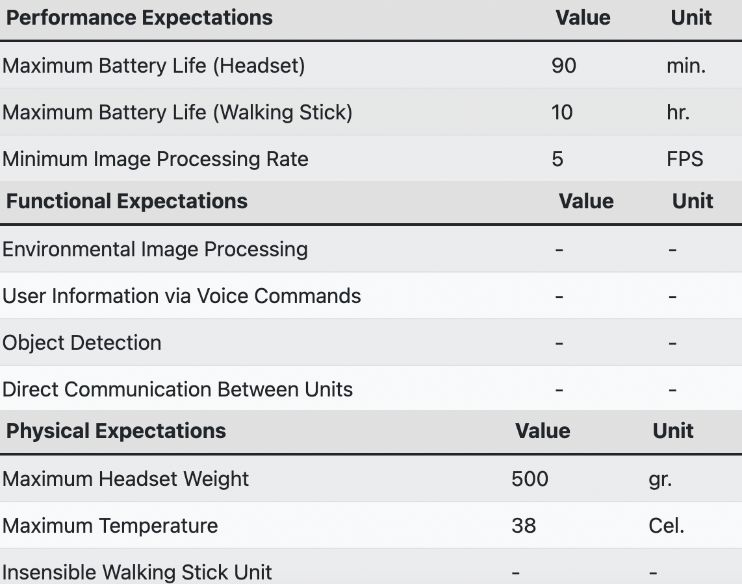 *Table 1. Expectation Table*

# Solution Procedure

To make progress on our project, we will prepare documentation for defining milestones, analyzing our research observations, and analyzing the results of our experiments from the implementation process. In order, the following documents will be created: test document, conceptual design report, critical design review report, final report, and poster. A module test demo and an oral presentation about the project's plan are also included. We will complete the general construction of the project before beginning to draft the final report. Following the completion of the final report, in addition to poster preparation, a live demo session and a video about our project will be held to present the design's final state. We will spend most of our time developing subsystems and testing them before integrating them into final form. Before beginning the implementation, a thorough investigation of the components, algorithms, and software languages will be conducted. Following that, we will begin developing our subsystems and performing tests to determine whether they are operational. We are currently planning to divide our project into two modules which are called the headset and walking stick modules. In the following two sections the solution procedure for them will be explained.

**Solution Procedure for Headset Module**

The headset module will include a processing unit, camera, speaker, and a frame to hold the equipment. The processing unit will be our design's brain, where all computational operations will take place. We intend to use CPUs such as the Raspberry Pi, Jetson Nano, or cell phones. We intend to begin with image processing, which involves object detection and recognition. We will build a frame to hold all the headset equipment at head level after implementing image processing in the process unit. We will also include a speaker to alert the user to any objects detected by the camera. There will be two choices for cameras. The first option is to use the phone's built-in camera. The second option is to use an external camera designed for microprocessors. For speakers we are planning to select a model for headphones or earphones. Also, the speaker of the cell phone can be used either.

**Solution Procedure for Walking Stick Module**

We will begin work on the walking stick module after we have completed most of the head unit module. The main idea behind this module is that it will include a battery that will provide power to the wireless communication unit, which will take data from the lidar sensor and send it to the process unit in the headset module. Firstly, we are planning to learn how to use the lidar sensor. After that, by using lidar sensors, object detection algorithms will be developed to detect obstacles. Following that, a 3D frame will be designed for the walking stick module to build a proper contact with a walking stick.

**Solution Procedure for Integration of Modules**

Firstly, we will build a battery to power the walking stick module. Then we will start working on a wireless communication unit which creates a communication line between the two main units. Finally, we integrate all the subunits of the walking stick module in the walking stick frame. After finishing all the implementations, we will test our model to make necessary adjustments.

After we have completed all the implementations, we will test our model and make any necessary changes. The estimated cost of the project is below $200. If we use a microprocessor for processing units, it might exceed the price limitation a bit. That is why our priority is trying to implement the process unit with a cell phone.

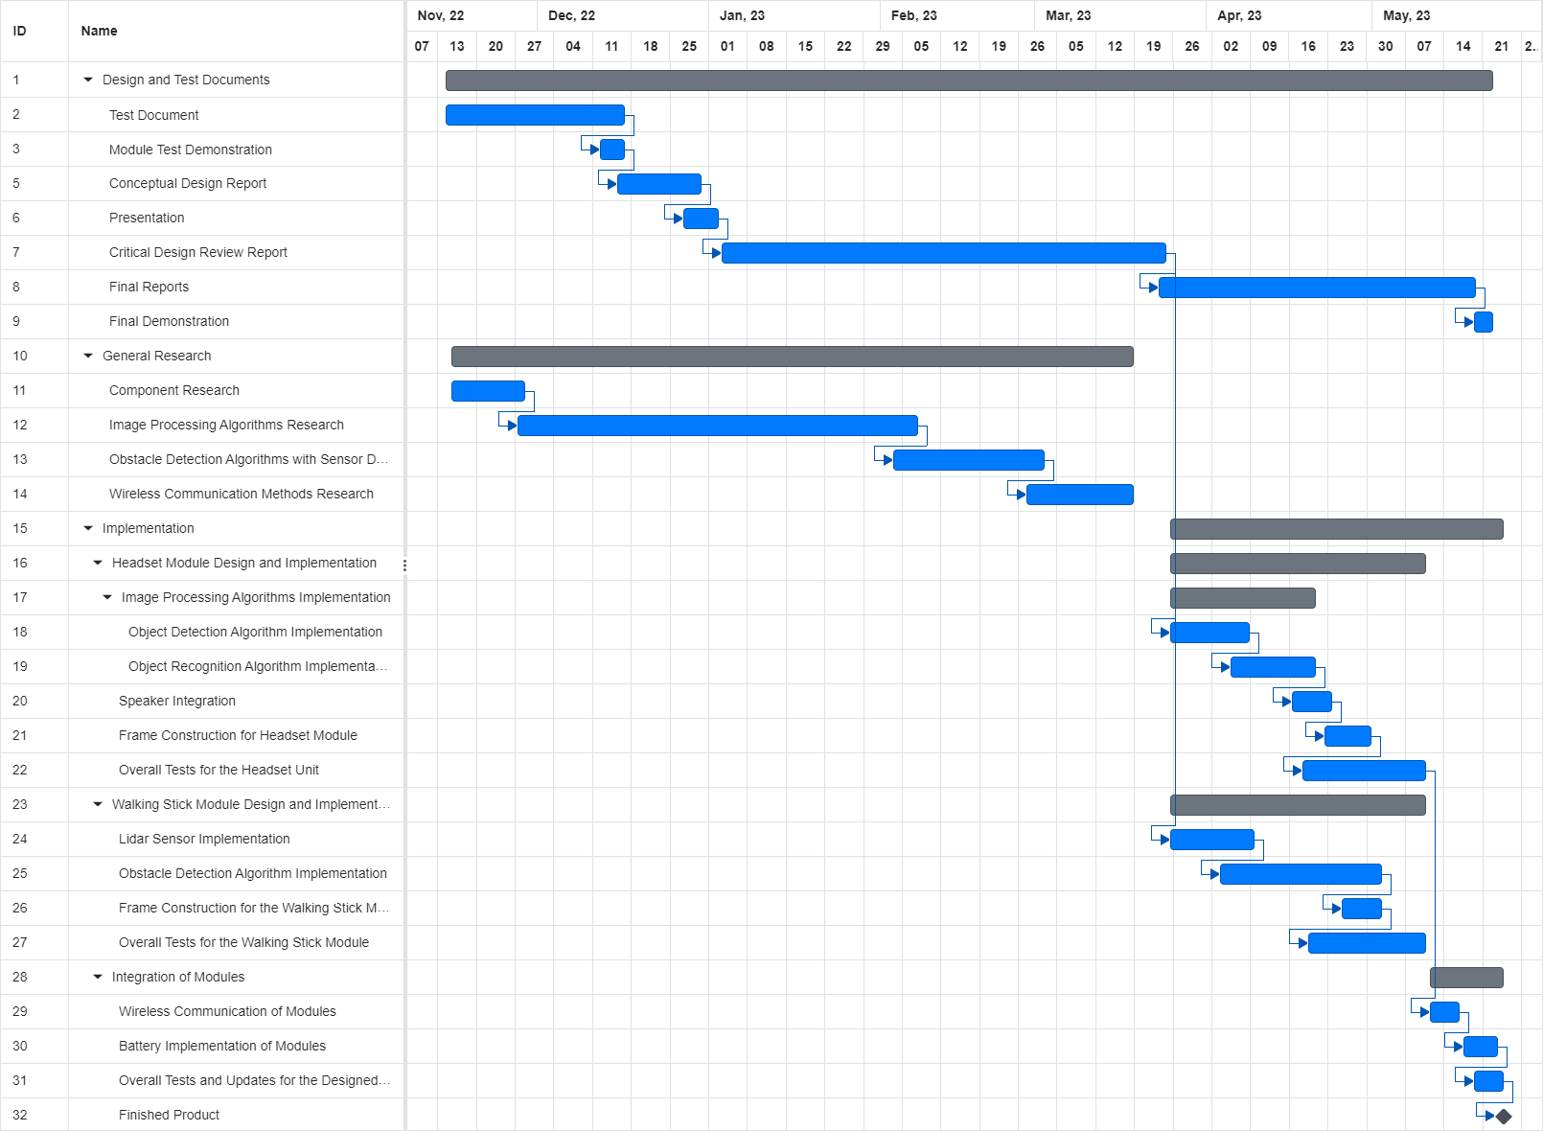

*Figure 2. Gantt Chart for the Project*

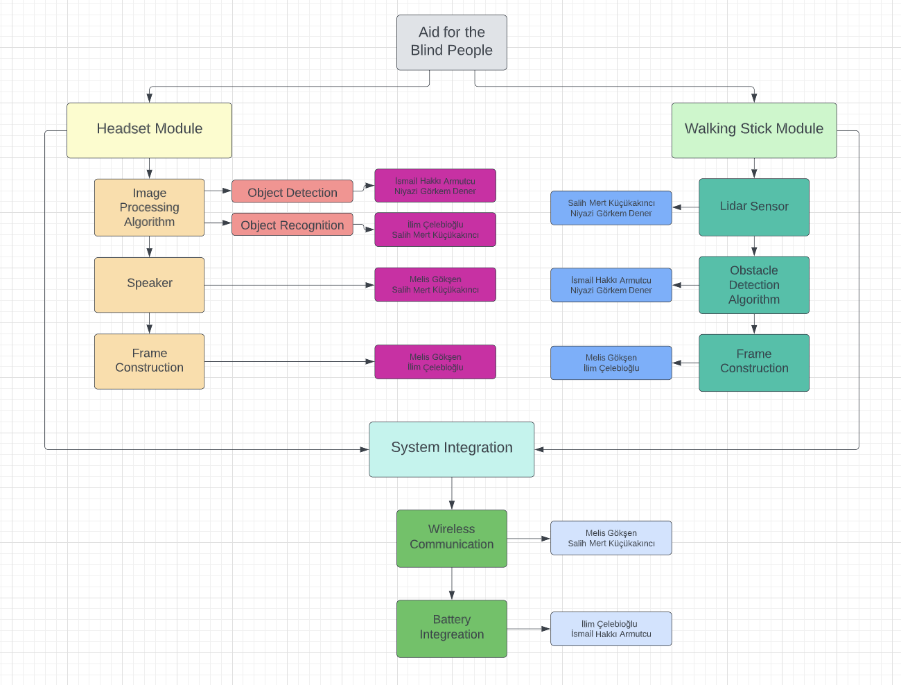

*Figure 3. Task Distribution Chart of the Project*

# Expected Deliverables

Documentation will include a test document, conceptual design report, critical design review report, final report, and a poster. In addition, a module test demo, an oral presentation, and a live demo session will be given about our design. The design procedure will be explained in detail in those documents. The first piece of equipment will be a camera, which will perform the same function as human eyes. We intend to place this camera in front of the user's head. To detect small obstacles, lidar sensors mounted on the leg or walking stick will be considered. The data generated from the camera and the lidar sensors must be processed to provide the user with information about the environment. These operations will be performed using either a cell phone or a microprocessor. Cameras from a cell phone or other external cameras can also be used. Processed data will be delivered to the user via speakers as a voice. These speakers can be thought of as earphones or headphones. The software that will be used is heavily dependent on the choice of operating units, which can be either a cell phone or a microprocessor. If a microprocessor is chosen, the Python, C, and C++ programming languages are included in the project. If cell phones are to be used, the project includes HTML, CSS, and JavaScript languages.

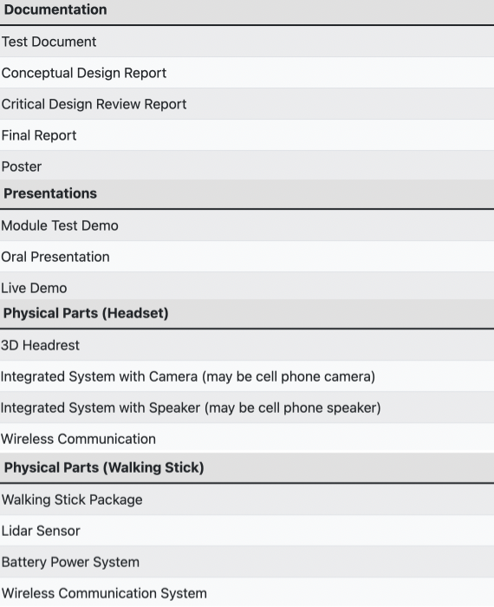

*Table 2. Deliverable Table*

# Conclusion

Blind people confront several difficulties every day, especially while trying to walk across the city. Some of the problems are caused by warnings that are not properly regulated, excessive traffic, and sidewalk obstructions. By employing the partner's skills, Manchester Untitled Company hopes to elegantly resolve the issue. The device that has been designed will have two modules. The system's mind and eyes are in the headset module which is the first module. The data from the camera will be received by and processed by the headset module. The second module is the walking stick module, a device that assists in detecting obstructions on sidewalks or at pedestrian crossings. Overall, the system will function like a person’s eyes, and it will make it easier for the blind people to live their social lives independently. As a result, blind people can be more active in their social lives.

# 