Rapport :
Exemples de Cours :
Exp 1:

#include <iostream>
using namespace std;

void function(int &a) { a++; }

int main()
{
cout << "Hello, World!" << endl;
string name;
cout << "What is your name? " << endl;
cin >> name;
int length = name.length();
cout << "My name is " << name << ", it's length is " << length << endl;
int s;
cout << "Give a value to our var 's' (int ): " << endl;
cin >> s;
cout << "Number is " << s << endl;

float *array = new float[length];
cout << "Give " << length << " float numbers to this array :" << endl;
for(int i = 0; i < length; i++){
cout << "Element number " << i << " : " << endl;
cin >> array[i];
}

cout <<"This is your array :" <<endl;
for(int i = 0; i < length; i++){
cout << "Element number " << i<< " is : "<< array[i] << endl;
}

delete array;

int i;
int &j(i);

i = 10;
cout << "i = " << i << " and j = " << j << endl;

j = 4;
cout << "i = " << i << " and j = " << j << endl;

function(i);
cout <<"Result of function : "<< endl;
cout << "i = " << i << " and j = " << j << endl;

return 0;
}

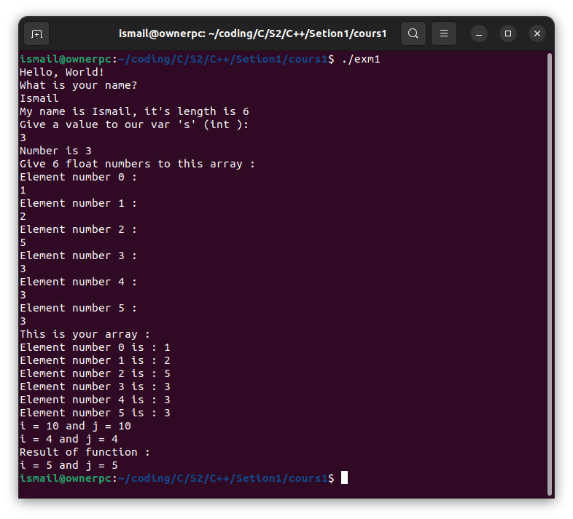

Exp 2:

#include <iostream>
using namespace std;

class point
{
int x;
int y;

public:
void initialis(int, int);
void deplace(int);
void display();
};

void point::initialis(int a, int b){
x = a;
y = b;
}

void point::deplace(int dxy){
x+=dxy;
y+=dxy;
}

void point ::display()
{
cout << "The coordinates of the point are (" << x << "," << y << ")" << endl;
}

int main()
{
int a, b;
point p;
cout << "We have just created a point so we need to enter its coordinates" << endl;

cout << "Give x= " << endl;
cin >> a;

cout << "Give y= " << endl;
cin >> b;

cout << "We have got the coordinates of the point" << endl;

p.initialis(a, b);
p.display();
int dp;

cout << "We want to deplace this point by dx give to us a value : " << endl;
cin >> dp;

p.deplace(dp);
p.display();
return 0;
}

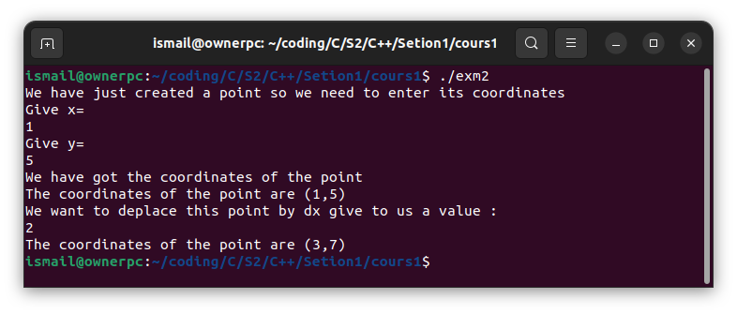

Exp 3:

#include <iostream>
using namespace std;

class point
{
int x;
int y;

public:
point();
point(int);
point(int, int);
~point();
void display();
};

point ::point()
{
x = y = 0;
}

point ::point(int a)
{
x = y = a;
}

point ::point(int a, int b)
{
x = a;
y = b;
}

point :: ~point() {
cout << "The coordinates of the point deleted now are (" << x << "," << y << ")" << endl;
}

void point ::display() {
cout << "The coordinates of the point are (" << x << "," << y << ")" << endl;
}

int main() {
point p0;
point p1(1);
point p2(2, 3);

p0.display();
p1.display();
p2.display();
}

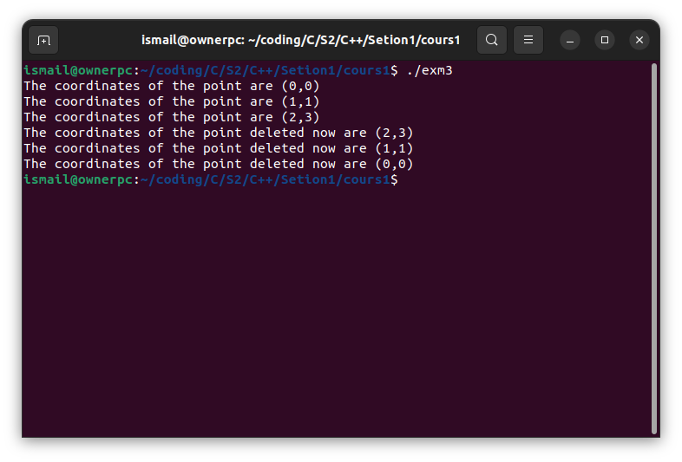

Exp 4:

#include <iostream>
#include <cstdlib>

using namespace std;

class Node
{
int nbval;
int *val;

public:
Node(int, int);
~Node();
void display();
};

Node :: Node (int nval, int max){
nbval = nval;
val = new int [nbval];
for(int i = 0; i < nbval; i++){
val[i] = rand() % max;
}
}

Node :: ~Node (){delete val;}

void Node :: display(){
for(int i = 0; i < nbval; i++){
cout << "Val number " << i << " is : "<< val[i] << endl;
}
}

int main() {
int n, max;
cout << "Entrer le nombre d'elements in my array : "<< endl;
cin >> n;

cout << "Donnez le max de cette array : " << endl;
cin >> max;

Node array1(n, max);
array1.display();

cout << "Entrer le nombre d'elements in my array : " << endl;
cin >> n;

cout << "Donnez le max de cette array : " << endl;
cin >> max;

Node array2(n, max);
array2.display();

return 0;
}

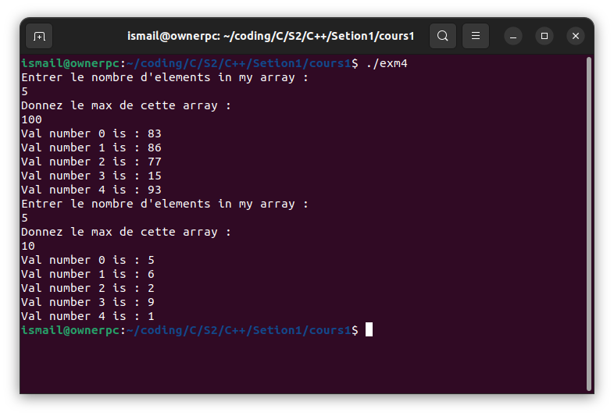

Exp 5:

#include <iostream>
using namespace std;

class obj
{
static int count;

public:
obj();
~obj();
static void counter();
};

int obj :: count = 0;

obj :: obj (){
cout << "Construction : il y a maintenant " << ++count <<" objets "<< endl;
}

obj :: ~obj (){
cout << "Destruction : il reste maintenant " << --count << " objets"<< endl;
}

void obj :: counter() {
cout <<"Vous avez maintenent " << count << " objets"<< endl;
}

int main() {
obj a;
obj b;
obj c;
obj d;
obj :: counter();
return 0;
}

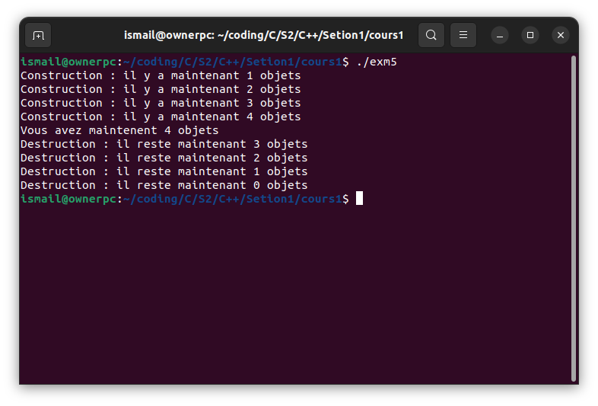
sl

Exp 6:

#include <iostream>
using namespace std;

int multiply(int a=1, int b=1) {return a*b;}

void display(string str="NONE") {
cout <<"Hello, " << str<< endl;
}

int main(){
cout << "The result of multiply(5, 2) is " << multiply(5, 2) << endl;
cout << "The result of multiply(5) is " << multiply(5) << endl;
cout << "The result of multiply() is " << multiply() << endl;

display();
display("Ismail");

return 0;
}

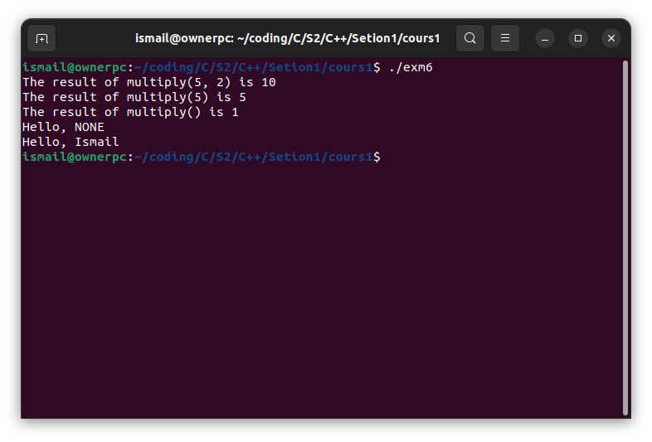

Exp 7:

#include <iostream>
using namespace std;

class point
{
int x;
int y;

public:
point(int, int);
void comp(point);
void comp(point *);
};

point ::point(int a = 0, int b = 0)
{
x = a;
y = b;
}

void point :: comp(point p) {
if (p.x == x && p.y == y)
{
cout << "Point is in the same position" << endl;
}
else
{
cout << "Point is not in the same position" << endl;
}
}

void point :: comp(point *p) {
if (p->x == x && p->y == y)
{
cout << "Point is in the same position" << endl;
}
else
{
cout << "Point is not in the same position" << endl;
}
}

int main (){
point p(1);
point q(1,0);
cout <<"Passage par Valeur :" << endl;
p.comp(q);

point r(1,1);

cout << "Passage par Adress :" << endl;
p.comp(&r);

return 0;
}

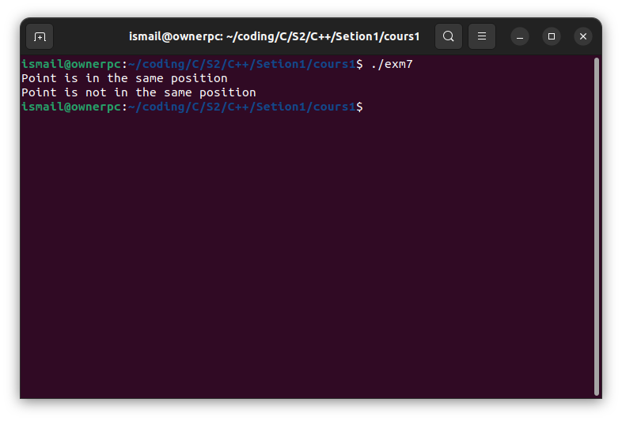
TP01 :
Ex 1:

#include <iostream>
using namespace std;

class point
{
float x;
float y;

public:
point(float, float);
void deplace(int);
void display();
};

point ::point(float a = 0, float b = 0)
{
x = a;
y = b;
}

void point ::deplace(int d)
{
x += d;
y += d;
}

void point ::display()
{
cout << "Les coordonnes de votre point est : (" << x << "," << y << ")" << endl;
}

int main() {
point p;
p.display();

point q(2.3 , -1);
q.display();

int dx;
cout <<"Donnez dx de point : " << endl;
cin >> dx;

q.deplace(dx);
q.display();

return 0;
}

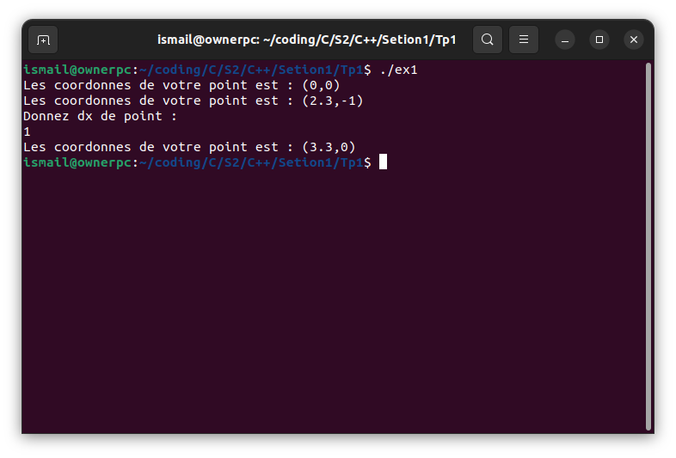
Ex 2:

#include <iostream>
#include <cmath>
using namespace std;

class point
{
float x, y;

public:
point(float, float);
void deplace(float, float);
float abscisse();
float ordonnee();
void homothetie(float);
void rotation(float);
float rho();
float theta();
void display();
};

float angle(float x, float y){
float ang = atan(fabs(y / x));
if ( x > 0 && y > 0 ) return ang;
if(x > 0 && y < 0) return -ang;
if(x < 0 && y > 0) return M_PI -ang;
return M_PI +ang;
}

point ::point(float a = 0, float b = 0)
{
x = a;
y = b;
}

void point ::deplace(float a, float b)
{
x += a;
y += b;
}

float point ::abscisse(){return x;}

float point ::ordonnee(){return y;}

void point ::homothetie(float a) {
x*=a;
y*=a;
}

float point ::rho() {return sqrt(x*x + y*y);}

float point ::theta() {return angle(x, y);}

void point ::rotation(float theeta) {
float ang = theta();
ang = ang + theeta;
float r =rho();

x= r*cos(ang);
y= r*sin(ang);
}

void point ::display()
{
cout << "Les coordonnes de votre point est : (" << x << "," << y << ")" << endl;
}

int main() {
int x, y;
cout << "Donnez x : " << endl;
cin >> x;

cout << "Donnez y : " << endl;
cin >> y;
point p(x, y);
p.display();

cout << "Donnez dx : " << endl;
cin >> x;

cout << "Donnez dy : " << endl;
cin >> y;
p.deplace(x, y);
p.display();

cout << "Donnez x d'homothetie : " << endl;
cin >> x;
p.homothetie(x);
p.display();

cout << "Donnez une angle de rotation : " << endl;
cin >> y;
p.rotation(y);
p.display();

return 0;
}

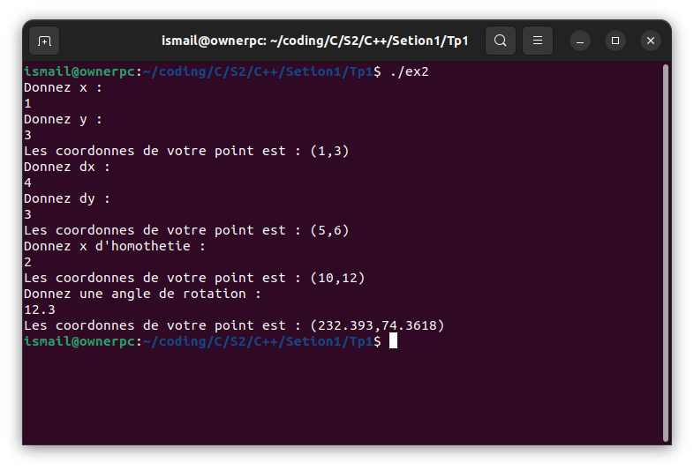

Ex 3:

#include <iostream>
#include <cmath>
using namespace std;

class point
{
float prho, ptheta;

public:
point(float, float);
void deplace(float, float);
float abscisse();
float ordonnee();
void homothetie(float);
void rotation(float);
float rho();
float theta();
void display();
};

float angle(float x, float y)
{
float ang = atan(fabs(y / x));
if (x > 0 && y > 0)
return ang;
if (x > 0 && y < 0)
return -ang;
if (x < 0 && y > 0)
return M_PI - ang;
return M_PI + ang;
}

point ::point(float a = 0, float b = 0)
{
ptheta = b;
prho = a;
}

float point ::abscisse(){return prho*cos(ptheta);}

float point ::ordonnee() { return prho * sin(ptheta); }

void point :: deplace(float a, float b){
float x = abscisse();
float y= ordonnee();

x += a;
y+= b;

prho = sqrt(x*x + y*y);
ptheta = angle(x, y);
}

void point ::homothetie(float a)
{
float x = abscisse();
float y = ordonnee();

x *= a;
y *= a;

prho = sqrt(x * x + y * y);
ptheta = angle(x, y);
}

void point ::rotation(float ang) { ptheta += ang;}

void point ::display()
{
cout << "Les coordonnes de votre point est : (r= " << prho << " ,Θ= " << ptheta << ")" << endl;
}

int main() {
int r, thet;

cout << "Donnez r : " << endl;
cin >> r;

cout << "Donnez thet : " << endl;
cin >> thet;
point p(r, thet);
p.display();

float x, y;

cout << "Donnez dx : " << endl;
cin >> x;

cout << "Donnez dy : " << endl;
cin >> y;
p.deplace(x, y);
p.display();

cout << "Donnez x d'homothetie : " << endl;
cin >> x;
p.homothetie(x);
p.display();

cout << "Donnez une angle de rotation : " << endl;
cin >> y;
p.rotation(y);
p.display();

return 0;
}

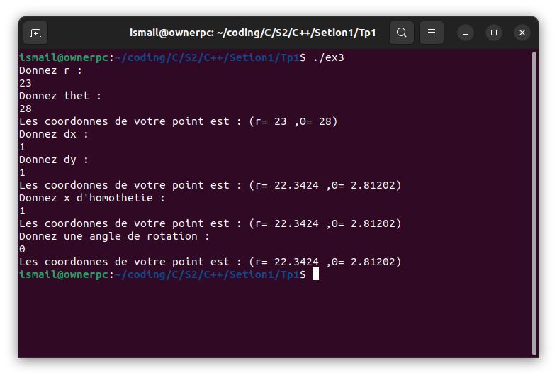

Ex 4:

#include <iostream>
using namespace std;

class point
{
static int count;
float x;
float y;

public:
point(float, float);
~point();
void deplace(int);
void display();
static void DisNumber();
};

int point::count = 0;

point ::point(float a = 0, float b = 0)
{
count++;
x = a;
y = b;
}

point ::~point(){
count--;
}

void point ::deplace(int d)
{
x += d;
y += d;
}

void point ::display()
{
cout << "Les coordonnes de votre point est : (" << x << "," << y << ")" << endl;
}

void point ::DisNumber(){
cout << "Number of objects is " << count << endl;
}

int main() {

point p;
p.display();

point q(2.3, -1);
q.display();

int dx;
cout << "Donnez dx de point : " << endl;
cin >> dx;

q.deplace(dx);
q.display();

point :: DisNumber();

return 0;
}
