Rapport :
TP04 :

Ex 1:

#include <iostream>
#include <cmath>
using namespace std;

class comp
{
float Re;
float Img;

public:
comp(float, float);
void display();
float module();
comp conjugue();
comp operator+(comp);
comp operator+(double);
comp operator*(comp);
comp operator*(double);
};

comp ::comp(float x = 0, float y = 0)
{
Re = x;
Img = y;
}

float comp ::module() { return sqrt(Re * Re + Img * Img); }

comp comp ::conjugue()
{
comp test;
test.Re = Re;
test.Img = -Img;
return test;
}

comp comp ::operator+(const comp temp)
{
comp test;
test.Re = Re + temp.Re;
test.Img = Img + temp.Img;
return test;
}

comp comp ::operator+(double temp)
{
comp test;
test.Re = Re + temp;
test.Img = Img;
return test;
}

comp comp ::operator*(const comp temp)
{
comp test;
test.Re = (Re * temp.Re) - (Img * temp.Img);
test.Img = (Re * temp.Img) + (Img * temp.Re);
return test;
}

comp comp ::operator*(double temp)
{
comp test;
test.Re = Re * temp;
test.Img = Img * temp;
return test;
}

void comp ::display() { cout << "This Is Your Number (" << Re << " + (" << Img << ")i) ;" << endl; }

int main()
{
comp A;
A.display();
comp B(5, 9);
B.display();
double num = 10;

cout << "The Modelu of your point is : " << A.module() << endl;
cout << "The Modelu of your point is : " << B.module() << endl;

cout << "The Conjugue of your point is : " << endl;
(B.conjugue()).display();

cout << " A + B = " << endl;

(A + B).display();

cout << " A + Num = " << endl;

(A + num).display();

cout << " A * B = " << endl;

(A * B).display();

cout << " A * Num = " << endl;

(A * num).display();

return 0;
}

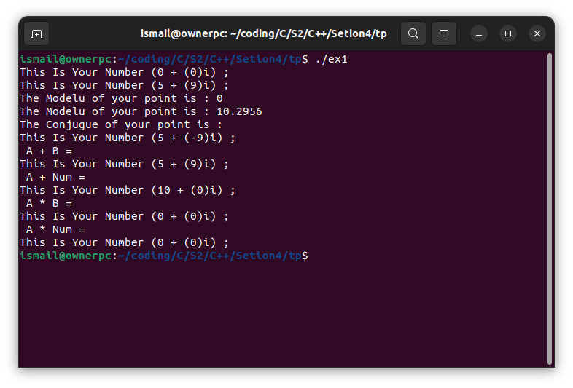

Ex 2:

#include <iostream>
#include <cstring>
using namespace std;

class chaine
{
int length;
char *name;

public:
chaine();
chaine(const char *);
chaine(chaine &);
chaine operator=(chaine);
int operator==(chaine);
chaine operator+(chaine);
char operator[](int);
void display();
};

chaine::chaine()
{
name = nullptr;
length = 0;
}

chaine::chaine(const char *ptr)
{
length = strlen(ptr);
name = new char[length + 1];
strcpy(name, ptr);
}

chaine::chaine(chaine &ptr)
{
length = ptr.length;
name = new char[length + 1];
strcpy(name, ptr.name);
}

chaine chaine::operator=(chaine ptr)
{
length = ptr.length;
name = new char[length + 1];
strcpy(name, ptr.name);
return *this;
}

int chaine::operator==(chaine ptr)
{
if (length != ptr.length)
return 0;
for (int i = 0; i < length; i++)
{
if (name[i] != ptr[i])
return 0;
}
return 1;
}

chaine chaine::operator+(chaine ptr)
{
chaine temp;
temp.length = length + ptr.length;
temp.name = new char[temp.length + 1];
strcpy(temp.name, name);
strcat(temp.name, ptr.name);
return temp;
}

char chaine::operator[](int i)
{
return name[i];
}

void chaine:: display(){
cout << "This The String : " <<name << endl;
}

int main()
{
chaine str1("Hello,");
chaine str2(" World!");
chaine str3;

str3 = str1 + str2;

str3.display();

if (str1 == str2)
cout << "str1 is equal to str2" << endl;
else
cout << "str1 is not equal to str2" << endl;

if (str3 == str3)
cout << "str1 is equal to str3" << endl;
else
cout << "str1 is not equal to str3" << endl;

cout << str3[0] << endl;

return 0;
}

