

**MAJOR PROJECT REPORT ON**

## “Optimizing Urban Mobility through Intelligent Real-time Parking Solutions”

***Submitted in the partial fulfillment of the requirements for the award of the degree of***

##### BACHELOR OF TECHNOLOGY IN

**COMPUTER SCIENCE AND ENGINEERING**

**Submitted By,**

##### MOHAMMED KHAIF K SHEIK 1SU20CS039 MOHAMMED SAHEEL SHAIKH 1SU20CS041 MOHAMMAD SHAHIL 1SU20CS036

**ISMAIL RAHIB 1SU20CS020**

#### Under the guidance of Mrs. Swathi. R

**Assistant Professor, Dept. of CSE**

**2023-2024**

**DEPARTMENT OF COMPUTER SCIENCE AND ENGINEERING**

**SRINIVAS UNIVERSITY, MUKKA**

## Department of Computer Science and Engineering

**CERTIFICATE**

This is to certify that the project report entitled “Optimizing Urban Mobility through Intelligent Real-time Parking Solutions*”* is a bonafide work carried out by *Mr. Mohammed Khaif K Sheik, Mohammed Saheel Shaikh, Mohammad Shahil, Ismail Rahib* bearing the **USN** *1SU20CS039,1SU20CS041,1SU20CS036,1SU20CS020* in the partial fulfillment for the award of the degree of **Bachelor of Technology** in **Computer Science and Engineering** of the **Srinivas University Institute of Engineering & Technology** during the year **2023-2024**. It is certified that all corrections/suggestions indicated for internal assessment have been incorporated in the report deposited in the department library. The project report has been approved as it satisfies the academic requirements in respect of the project work prescribed for the said degree.

Name & Signature of the Guide

##### Mrs. Swathi R

Name & Signature of the H.O.D

##### Prof. Shifana Begum

Signature of the Dean **Dr. Thomas Pinto** Dean, SUIET, Mukka

##### External Viva



Name of the Examiners Signature with date

**1.**

**2.**



## Department of Computer Science and Engineering

**DECLARATION**

We, **Mohammed Khaif K Sheik, Mohammed Saheel Shaikh, Mohammad Shahil, Ismail Rahib** the students of **Eighth** semester, **B.Tech** in Computer Science and Engineering, Srinivas University Institute of Engineering and Technology, Mukka, hereby declare that the project entitled ***“Optimizing Urban Mobility through Intelligent Real-time Parking Solutions”*** has been successfully completed by us in the partial fulfillment of the requirements for the award of the degree of **Bachelor of Technology** in **Computer Science and Engineering** of the **Srinivas University Institute of Engineering and Technology** and no part of it has been submitted for the award of degree or diploma in any university or institution previously.

|  |  |  |
| --- | --- | --- |
| **Date:** |  | |
| **Place:** Mukka |
|  | Mohammed Khaif K Sheik | 1SU20CS039 |
|  | Mohammed Saheel Shaikh | 1SU20CS041 |
|  | Mohammad Shahil Ismail Rahib | 1SU20CS036  1SU20CS020 |

## ABSTRACT

The aim of this paper is to develop an intelligent parking system to reduce hiring people’s costs and maximize the use of car park owners’ resources. The popular method of finding a parking space is currently manual where drivers typically find a place through luck and experience in the street. This method takes time and energy, which if the driver drives in a city with traffic density, can lead to the worst case of failure and to any parking space. Therefore, through cloud- based IOT and slot allocation through open-source computer vision library based recognition tool, a smart car parking system is implemented with slot booking operation. The user can book any of the available slot in the webpage. This system takes away the unpredictability of finding a parking slot. This paper focuses on reducing time wasted on finding parking space nearby and ongoing through the filled parking slots. The end user is provided with a webpage to check the available parking slots. Inside a smart city a smart car parking system is a much needed to save time, fuel and even the environment from pollution. Through the integration of IoT sensors, communication devices, and intelligent data processing algorithms, our system offers real-time monitoring, optimization, and guidance of parking spaces within urban facilities. Index Terms—Cloud-based IoT, Data processing algorithms, Real-time monitoring.

##### ACKNOWLEDGEMENT

We also would like to express our deep sense of gratitude and indebtedness to our Project Coordinator, ***Mrs. Thanmayee Susheel***, Assistant Professor, Dept. of CSE, for his encouragement and guidance that he has extended in the course of carrying our project.

We sincerely thank ***Prof. Shifana Begum***, Head of the Department, Computer science & Engineering, for being an inspiration and support throughout this project.

We am extremely grateful to our respected Dean, ***Dr. Thomas Pinto***, for providing the facilities to carry out the project.

We also would like to thank our Management, **A. Shama Rao Foundation, Mangaluru**, for providing the means and support for the completion of the project.

We would like to thank all the teaching, non-teaching staff of the Computer Science and Engineering Department for their support and help.

Finally,WeI express our profound gratitude to our parents and friends who have helped us in every conceived manner with their valuable suggestions, encouragement and moral support.

Mohammed Khaif K Sheik Mohammed Saheel Shaikh Mohammad Shahil

Ismail Rahib

**Contents**

|  |  |
| --- | --- |
| **Title** | **Page No.** |

##### Chapter 1 INTRODUCTION 2-5

* 1. Internet of Things. 2
  2. Problem Statement 2
  3. Solution 3
  4. Project Description 3
  5. Methodology 4
  6. Organization of rest of the report 5

##### Chapter 2 LITERATURE SURVEY 7-13

2.1 Literature Review 7

##### Chapter 3 SOFTWARE REQUIREMENTS SPECIFICATION 14-34

* 1. Introduction 15
     1. Purpose 15
  2. General Description 16
     1. General Constraints 16
     2. Assumptions and Dependencies 17
  3. Specific Requirements 19
     1. Functional Requirements 19
     2. Non-Functional Requirements 21
  4. System Requirements Specification 22
     + 1. Hardware Requirements 22
       2. Software Requirements 22
  5. Descriptions of hardware needed… 23
  6. Descriptions of software needed… 31

Chapter 4 SYSTEM DESIGN 35-40

* 1. Architectural Design. 36
  2. Modular Design Details. 39
     1. Flowchart. 39

Chapter 5 IMPLEMENTATION 41-51

* 1. Software tools used. 42
  2. Implementation details. 43

Chapter 6 TESTING 52-56

* 1. Scope 53
  2. Unit testing 54
  3. Integration Testing 55
  4. System Testing 55

Chapter 7 RESULTS AND ANALYSIS 57-60

7.1 Screenshots and Analysis 58

Chapter 8 CONCLUSION AND FUTURE WORK 61-63

* 1. Conclusion. 62
  2. Future Work. 63

REFERENCES 64-65

## List of Figures

**Figures Page No.**

|  |  |  |
| --- | --- | --- |
| Figure 3.0 | Arduino UNO | 23 |
| Figure 3.1 | Pin Diagram of Arduino UNO | 25 |
| Figure 3.2 | IR Sensor | 26 |
| Figure 3.3 | Jumper Wire | 26 |
| Figure 3.4 | Node MCU | 28 |
| Figure 3.5 | Servo Motor | 29 |
| Figure 3.6 | LCD Display | 30 |
| Figure 3.7 | Bread board | 30 |
| Figure 3.8 | Arduino IDE | 32 |
| Figure 4.0 | Architecture Design of the System | 38 |
| Figure 4.1 | Flow chart | 39 |
| Figure 5.0 | Hardware Connections | 45 |
| Figure 5.1 | Arduino Setup | 46 |
| Figure 7.0 | Entry Gate | 58 |
| Figure 7.1 | Exit Gate | 59 |
| Figure 7.2 | LCD Display Screen | 59 |
| Figure 7.3 | IR Sensors Detection for the Cars | 60 |

# CHAPTER 1 INTRODUCTION

**Chapter 1**

**INTRODUCTION**

### INTERNET OF THINGS (IOT)

The Internet of Things (IoT) refers to the interconnected network of devices, sensors, and systems that communicate with each other over the internet, enabling data exchange and automation. In the context of a smart parking system, IoT technology facilitates the monitoring and management of parking spaces in real-time. Through sensors installed in parking spots, data such as occupancy status, duration of parking, and vehicle information are collected and transmitted to a central server or cloud platform. This data can then be analyzed to optimize parking operations, improve efficiency, and enhance user experience. Additionally, IoT enables the integration of various components such as mobile applications for parking reservations, navigation systems for directing drivers to available spots, and payment systems for seamless transactions. By leveraging IoT capabilities, smart parking systems aim to alleviate traffic congestion, reduce environmental impact, and enhance urban mobility.

### Problem Statement

In urban areas, parking congestion poses a significant challenge, leading to traffic snarls and frustration among commuters. To alleviate this issue, a smart parking system utilizing Internet of Things (IoT) technology emerges as a viable solution. This system employs sensors embedded in parking spots to detect vehicle presence and transmits real-time data to a centralized platform. By leveraging IoT, drivers gain access to a mobile application displaying available parking spots in real-time, enabling efficient navigation to vacant spaces. Moreover, administrators benefit from insights derived from data analytics, facilitating informed decision- making for urban planning and resource allocation. Overall, the integration of IoT with smart parking systems promises to revolutionize urban mobility, enhancing convenience and reducing congestion. through the seamless integration of ML, IoT, and perceptual advancements in driving.

### Solution

Integrating IoT technology into parking systems revolutionizes urban mobility, addressing the perennial issue of parking congestion. Smart parking solutions leverage sensors and connectivity to provide real-time data on parking space availability, guiding drivers to vacant spots efficiently. These systems not only streamline the parking process but also reduce traffic congestion and carbon emissions by minimizing the time spent circling for parking. Additionally, IoT-enabled parking systems offer remote monitoring and management capabilities, allowing authorities to optimize parking usage and enforce regulations effectively. By harnessing the power of IoT, smart parking systems pave the way for smarter, more sustainable cities.

### Project Description

Our project endeavors to revolutionize autonomous mobility by amalgamating cutting-edge technologies, including Machine Learning (ML), Internet of Things (IoT), and advancements in perceptual progress in driving. At its core, our objective is to develop a comprehensive system that empowers vehicles to navigate autonomously, ensuring safety and efficiency across diverse real-world scenarios.

The project unfolds with the development of a representative dummy model of the vehicle, serving as the foundational platform for the implementation and testing of our autonomous driving system. This model incorporates essential components such as cameras, ultrasonic sensors, and processing units, laying the groundwork for subsequent algorithmic integration.

A pivotal aspect of our solution lies in the implementation of edge detection algorithms for lane detection. Leveraging techniques like Canny edge detection, we aim to accurately identify lane markings on the road, enabling the vehicle to maintain its trajectory within designated lanes. Furthermore, region of interest identification and histogram-based methods for lane center detection augment the precision and reliability of our lane detection system, ensuring robust performance across varying environmental conditions.

In parallel, we harness the capabilities of ML to enhance the perceptual capabilities of the vehicle. ML algorithms, particularly Haar cascade classification, are trained to recognize and classify stop signs from images captured by onboard cameras. This enables the vehicle to respond promptly and appropriately to traffic signs, thereby enhancing safety and adherence to traffic regulations.

To address challenges associated with obstacle detection and avoidance, we integrate ultrasonic sensors into the vehicle's hardware setup. These sensors provide real-time data on obstacles in close proximity to the vehicle, facilitating timely decision-making and maneuvering to ensure safe navigation. Algorithms are developed to process sensor data and trigger emergency braking or avoidance maneuvers when obstacles are detected, further enhancing the vehicle's ability to navigate complex environments.

Central to our solution is the development of sophisticated software modules that orchestrate sensor data processing, perception algorithms, and real-time decision-making logic. These modules enable seamless communication and coordination between hardware components, ensuring the cohesive functioning of the autonomous driving system. By integrating hardware and software components seamlessly, our solution aims to revolutionize autonomous transportation, making travel safer, more efficient, and conducive to widespread adoption in modern transportation systems. Ultimately, our project holds the potential to reshape the future of mobility, ushering in an era of safer, smarter, and more sustainable transportation solutions.

### Methodology

A methodology is a structured approach encompassing methods, practices, processes, techniques, procedures, and rules tailored to achieve specific objectives. Herein, the methodology for developing an autonomous driving system is delineated.

* **Requirement Identification:** Identify key requirements and functionalities essential for the autonomous driving system, including sensor integration, communication protocols, navigation capabilities, and emergency response mechanisms.
* **Hardware Selection:** Conduct research to select appropriate hardware components such as cameras, ultrasonic sensors, processing units, and communication modules, ensuring compatibility and reliability.
* **Integration of Hardware Components:** Integrate selected hardware components into a cohesive system architecture, ensuring seamless communication and data exchange between components.
* **Algorithm Development:** Develop control algorithms for autonomous navigation, obstacle detection, and emergency response, leveraging techniques such as edge detection and machine learning for efficient decision-making.
* **Implementation of IoT Protocols:** Implement IoT protocols for data transmission between the vehicle, control center, and emergency responders, ensuring efficient communication and real-time data exchange.
* **Data Fusion and Processing:** Fuse data from multiple sensors to create a comprehensive understanding of the vehicle's environment ,and develop data processing algorithms to analyze sensor data in real-time.
* **Communication Infrastructure:** Establish a robust communication infrastructure for seamless connectivity between the vehicle, control center, and emergency responders, ensuring reliable transmission of data and commands.
* **Testing and Validation:** Conduct rigorous testing in simulated and real-world environments to validate the functionality, reliability, and safety of the autonomous driving system, iterating on hardware and software components based on testing feedback.
* **Iterative Improvement:** Iterate on hardware and software components based on testing feedback to enhance performance, usability, and reliability of the autonomous driving system, ensuring continual improvement and optimization.

### Organization of rest of the report

|  |  |
| --- | --- |
| **Chapters** | **Description** |
| Literature Survey | Describes the summary of previous papers. |
| System Requirements Specification | The chapter describes the hardware,software requirements and  its descriptions. |
| System Design | Describes the workingof the project through block diagram and flow charts. |
| Implementation | Describes the detailed steps used in the project. |
| Testing | The chapter describes about the test cases of the project. |
| Results and Analysis | Contains the final obtained results of the project. |
| Conclusion and Future Work | The chapter covers the conclusion andfuture works of the project. |

**Table 1.6: Overview of the report**

# CHAPTER 2 LITERATURE SURVEY

**Chapter 2**

**LITERATURE SURVEY**

### 2.1. Literature Review

A literature reviews is a thorough summary of earlier studies on a subject.The literature review examines scholarly books, journals, and other sources that are pertinent to a particular field of study.

##### ParkSmart: Leveraging Neural Networks for Predictive Parking in Smart Cities proposed by Anand Raj, Garv Agarwal, Pranjal Goyal, Yash Mittal, Sandeep Kumar Singh, 2024.

The surge in the proliferation of private vehicles within urban centers has exacerbated challenges in parking management, primarily due to a scarcity of available spaces. To address this issue, the implementation of intelligent parking systems featuring autonomous monitoring and guidance has become imperative. This paper proposes a manual model of ResNet-50 and other classification networks using the Global Perceptual Feature Extractor (GPFE) module. Evaluated on established datasets, namely PKLot and CNREXT, the GPFE module significantly enhances accuracy and resilience when integrated with CNN classifiers like ResNet-50. Additionally, the methodology of the paper employs cost-effective cameras for binary classification across diverse lighting scenarios. This innovative decision eliminates the need for Internet of Things (IoT) sensors, leading to substantial reductions in maintenance expenses. The integration of this module not only enhances the precision of binary classification but also addresses cost-related challenges, establishing it as a sustainable solution for parking problems.

##### Smart Car Parking System proposed by T.C. Kalaiselvi, K. Sathyavardhan, Balambigai, S. Santhoshsiva, 2024.

Land transportation in India heavily relies on railway stations, yet these stations face issues with parking due to manual methods, resulting in congestion and inefficiencies. Current approaches also face difficulties such as inadequate real-time parking allocation, a deficiency in digital payment options, and issues related to user-friendliness. To address this, a cutting- edge solution is proposed which harnesses advanced technologies like image processing, Raspberry Pi, OCR for license plate recognition, and cashless transactions. Ultrasonic sensor

verifys vehicle presence, OCR deciphers license plates, and historical data manages parking logistics, slot detection is done using Pickle. Travelers can conveniently access parking fees on an OLED screen, receive a QR code for exiting, simplifying payments and improving safety. The project places a strong emphasis on environmental sustainability and real-time updates. It is designed with potential for expansion and integration with other station services, offering an effective, eco-conscious parking system that can adapt to evolving transportation needs.

##### Decentralized Optimal Parking Lot Allocation via Dynamic Parking Fee proposed by

**Yuto Fujimaki, Toru Namerikawa 2023.**

This paper proposes a novel decentralized optimal parking lot allocation algorithm by using dynamic parking fee. Information about drivers and parking lots used to be collected by a system manager in smart parking systems, and the allocation is determined centrally. However, the computational load increases exponentially as the target area expands. Therefore, a decentralized system is needed that can flexibly respond to the expansion of the area size, in which the allocation is determined by communicating the results of the calculations performed by each participant. In building a decentralized system, it is desirable for the system to be fair and efficient. Therefore, we propose a decentralized parking system that satisfies this property by using matching theory, a field that studies how people and things should be matched in a market. We propose a unique matching method that takes into account the difference between drivers as consumers and parking service providers. We also propose a reallocation method based on dynamic parking fee to reduce the number of unallocated drivers.

##### DyPARK: A Dynamic Pricing and Allocation Scheme for Smart On-Street Parking System proposed by Sandeep Saharan, Neeraj Kumar, Seema Bawa 2023.

In-advance availability of parking information plays an important role in parker/traveller decision-making for parking, curbing congestion, and managing parking lots efficiently. Specifically, on-street parking poses many challenges compared to the off-street ones. Many users such as, store owners, municipal authorities, and police demand slots for on-street parking Free of Charges (FoC) for a short duration. In last few years, parking authorities collected data to attract the attention of researchers to present data-centric solutions for various problems such as, minimization of parking prices, maximization of revenue, and balacing the congestion at parking lots associated with smart parking systems. Motivated from the aforementioned problem, this paper proposes a scheme based on machine learning and game theory for dynamic

pricing and allocation of parking slots in on-street parking scenarios. The dynamic pricing and allocation problem is modeled as Stackelberg game and is solved by finding its Nash equilibrium. Two types of Parking Users (PUs), i.e., Paid Parking Users (PPUs) and Restricted Parking Users (RPUs) are considered in this work. RPUs avail parking slots FoC once a day. PPUs compete to minimize the prices, and RPUs compete to maximize the FoC granted duration. The Parking Controllers (PCs) compete to maximize revenue generated from PPUs and to minimize total FoC parking duration granted to the RPUs. The random forest model is used to predict occupancy, which in turn is used to generate parking prices. Seattle city parking and its prices data sets are used to predict occupancy and to generate prices, respectively. In order to test the performance of communication system, the proposed DyPARK Pricing and Allocation Scheme (PAS) is compared with its four variants and is found worth.

##### An Evaluation of Temporal- and Spatial-Based Dynamic Parking Pricing for Commercial Establishments proposed by An Evaluation of Temporal- and Spatial-Based Dynamic Parking Pricing for Commercial Establishments 2022.

All smart parking management systems (SPMS) have incorporated the dynamic pricing into its features and capabilities. The collection of parking fees on a corresponding spot has been dependent on either its time- or space-value, with most SPMS utilizing temporal-based parking fee collection. However, little to no study has been conducted to assess or evaluate these pricing schemes according to its friendliness and economics towards both parkers and business operators. In this work, we evaluate two current temporal- and three proposed spatiotemporal- based dynamic parking pricing methods by computing their social optimum range and economic effects to both users and parking management entities. Our extensive analysis utilizing both empirical mobility traces and driver parking duration behavior provide important insights in the current pricing setups and present necessary adjustments in improving parking fee collection that contribute to societal benefits.

##### Parking Lot Allocation Using Rematching and Dynamic Parking Fee Design proposed by T. Nakazato, Y. Fujimaki and T. Namerikawa:2022

In urban areas, traffic congestion is caused by vehicles slowing down as drivers search for vacant parking spaces. In this study, we propose a novel smart-parking system that allocates parking lots based on the matching theory, considering both the drivers’ and parking managers’ preferences. Some drivers may be unable to be allocated to parking lots because of the high

traffic volume in urban areas that causes many parking lots to be full. Therefore, we propose a prior reservation system that can reallocate parking lots considering the waiting time until vacant parking spaces appear. The driver’s preference is redetermined considering the waiting time obtained by both the parked drivers’ and reallocated drivers’ information. We also present a parking lot allocation algorithm, including rematching, and discuss stability and strategy- proofness, which are important properties of matching. Furthermore, we propose a dynamic parking fee design, considering different parking statuses (“full,” “congested,” and “available”). By combining the “price increase” with the “price decrease” based on parking status, the proposed dynamic parking fee aims not only to level out parking utilization but also to secure the parking managers’ profit. Finally, numerical simulations confirm the effectiveness of the proposed method using rematching and dynamic parking fee design.

##### Monetizing Parking IoT Data via Demand Prediction and Optimal Space Sharing

proposed by **T. Sutjarittham, H.H. Gharakheili, S.S. Kanhere and V. Sivaraman:2022**

Transportation is undergoing significant change due to advances in automotive technologies, such as electric and autonomous cars and transportation paradigms, such as car and ridesharing. Coupled with the rapid prevalence of IoT devices, this provides an opportunity for many organizations with large on-premise parking spaces, to better utilize this space, reduce energy footprint, and monetize data generated by IoT systems. This article outlines our efforts to instrument our University’s multistorey parking lot with IoT sensors to monitor real-time usage, and develop a novel dynamic space allocation framework that allows campus manager to redimension the car park to accommodate both car sharing and existing private car users. Our first contribution describes experiences and challenges in measuring car park usage on the university campus and removing noise in the collected data. Our second contribution analyzes data collected during 15 months and draws insights into usage patterns. Our third contribution employs machine learning algorithms to forecast future car park demand in terms of arrival and departure rates, with a mean absolute error of 4.58 cars per hour for a 5-day prediction horizon. Finally, our fourth contribution develops an optimal method for partitioning car park space that aids campus managers in generating revenue from shared cars with minimal impact on private car users.

##### A New Flexible Parking Reservation Scheme for the Morning Commute under Limited Parking Supplies proposed by W. Wu, W. Liu and F. Zhang 2021

Recent studies proposed parking reservation schemes in a bi-modal transport network to manage parking competition and traffic congestion. This study proposes a new flexible parking reservation scheme, under which commuters’ reservation can expire and those arriving later than the reservation expiration time can retain his reservation by paying additional late-for- reservation fees. Time-varying late-for-reservation fees are also examined. The proposed reservation scheme is more flexible and practical than those in the literature. Moreover, we found that, when compared to reservation scheme in the literature, the total social cost can be further reduced by an appropriately designed flexible reservation scheme in this paper. We also analytically and numerically quantify the efficiency gain of the proposed flexible parking reservation scheme.

##### SPA: Smart Parking Algorithm Based on Driver Behavior and Parking Traffic Predictions proposed by

Smart parking problems have received much attention in recent years. In literature, many smart parking allocation algorithms that considered the parking grid reservation and recommendation have been proposed. However, the parking policies for maximizing parking rate and benefits still can be improved. This paper proposes a smart parking allocation algorithm (SPA), which aims to maximize the benefits created by a given parking lot while guaranteeing the quality of parking services. The proposed SPA algorithm predicts the driver behavior and estimated parking traffic in the near future based on the historical parking records. These predictions help SPA to better match the parking demands and the resource of available parking grids and, hence, improve the utilization and the created benefit of each parking grid. The proposed SPA applies three policies, namely worst-fit (WF-SPA), best-fit (BF-SPA), and parking behavior forecast (PBF-SPA), to allocate the available grids to the vehicles. Performance evaluations reveal that the proposed SPA outperforms exiting work in terms of accumulated parking rate and service quality and, hence, improves the benefits of a given parking lot

# CHAPTER 3

**SOFTWARE REQUIREMENTS SPECIFICATION**

**Chapter 3**

**SOFTWARE REQUIREMENTS SPECIFICATION**

### Introduction

System Requirements are the minimum and/or maximum hardware and software specifications that a system or application must meet in order to function properly. System Requirements Specification (SRS), also known as Software Requirements Specification, is a document or set of documentation that describes the features and behavior of a software application.

### Purpose

An IoT-based smart and efficient parking system serves a dual purpose of enhancing convenience for drivers and optimizing parking space utilization in urban environments. By integrating Internet of Things (IoT) technology into traditional parking management, this system offers several benefits. Firstly, it addresses the perennial issue of finding parking spaces in congested areas. With real-time data collection through sensors installed in parking lots, drivers can easily locate available spots through dedicated mobile applications or digital signage. This reduces the time spent circling around in search of a parking space, thereby minimizing traffic congestion and fuel consumption, contributing to a more sustainable environment.

Secondly, it enhances operational efficiency for parking lot owners and managers. Through IoT sensors, they can monitor occupancy levels and patterns, allowing for predictive analysis of parking demand. This data-driven approach enables better decision-making regarding pricing strategies, maintenance schedules, and infrastructure investments. Additionally, it enables the implementation of dynamic pricing models, where parking rates vary based on demand, maximizing revenue potential. Moreover, IoT-based parking systems promote a seamless user experience by facilitating cashless transactions and enabling remote reservation and payment options. This not only streamlines the parking process but also reduces the risk of theft and vandalism associated with traditional parking meters. Furthermore, by promoting

the use of IoT technology, these systems contribute to the development of smart cities. They form part of an interconnected ecosystem of urban infrastructure, fostering data-driven governance and innovation. Insights gathered from parking data can inform urban planning decisions, such as the optimal location for new parking facilities or the promotion of alternative transportation modes.

### General Description

**3.2.1 General Constraints**

1. **Hardware Limitations**: The choice of hardware components such as sensors, gateways, and communication modules must be cost-effective, reliable, and compatible with the environment (indoor/outdoor).
2. **Power Consumption**: Devices should be designed to minimize power consumption to extend battery life or reduce the need for frequent recharging.
3. **Network Connectivity**: Reliable network connectivity is essential for real-time data transmission between sensors, gateways, and the central server. This includes considerations for coverage, bandwidth, and reliability of the network infrastructure.
4. **Data Security**: Implement robust security measures to protect sensitive data transmitted and stored within the system, including encryption, authentication, and access control mechanisms.
5. **Scalability**: The system should be designed to accommodate a variable number of parking spaces, sensors, and users without significant performance degradation or increase in complexity.
6. **Interoperability**: Ensure compatibility with different types of vehicles, parking facilities, and existing infrastructure to facilitate seamless integration and interoperability.

### 3.2.2. Assumptions and Dependencies Assumptions:

1. **High Demand for Parking**: Assume that there is a high demand for parking spaces in urban

areas due to increased population density, limited parking infrastructure, and the prevalence of vehicles.

1. **Limited Parking Availability**: Assume that traditional parking management systems are inefficient and unable to effectively utilize available parking spaces, leading to congestion and frustration among drivers.
2. **IoT Infrastructure**: Assume that there is a robust IoT infrastructure in place, including sensors installed in parking spaces, connected to a centralized system capable of real-time data collection and analysis.
3. **Data Accuracy**: Assume that the data collected from IoT sensors regarding parking space availability is accurate and reliable, with minimal errors or discrepancies.
4. **Real-time Communication**: Assume that there is seamless real-time communication between the IoT sensors, the centralized system, and end-user applications (such as mobile apps or digital signage), enabling instant updates on parking availability.
5. **Predictive Analytics**: Assume that the system incorporates predictive analytics algorithms to forecast parking demand based on historical data, events, and other relevant factors.
6. **Dynamic Pricing**: Assume that the parking management system implements dynamic pricing strategies based on real-time demand, encouraging optimal utilization of parking spaces and discouraging long-term occupancy.
7. **User Adoption**: Assume that there is a high level of user adoption for the parking solution, driven by its ease of use, reliability, and effectiveness in reducing parking search time and congestion.
8. **Integration with Navigation Systems**: Assume that the parking solution seamlessly integrates with navigation systems, providing drivers with real-time guidance to available parking spaces nearest to their destination.
9. **Government Support and Regulations**: Assume that there is government support for implementing intelligent parking solutions, including regulatory frameworks to address issues such as data privacy, pricing transparency, and equitable access to parking resources.

### Dependencies:

Optimizing urban mobility through intelligent real-time parking solutions based on IoT typically requires a combination of hardware and software components to effectively manage parking spaces and provide real-time data to users. Here are some key dependencies:

1. **IoT Sensors**: Deploying IoT sensors in parking spaces to detect the presence or absence of vehicles. These sensors can be either ultrasonic, infrared, magnetic, or camera-based, depending on the specific requirements and constraints of the parking environment.
2. **Wireless Connectivity**: Reliable wireless connectivity infrastructure (such as Wi-Fi, LoRaWAN, or NB-IoT) to transmit data from the IoT sensors to the central management system. This allows real-time monitoring and analysis of parking space availability.
3. **Cloud Infrastructure**: A robust cloud-based infrastructure to store and process the data collected from IoT sensors. This includes servers, databases, and necessary software frameworks for data storage, analytics, and visualization.
4. **Data Analytics**: Advanced data analytics algorithms and machine learning models to analyze parking data, predict parking space availability, and optimize parking resource allocation. These algorithms can also help in identifying patterns and trends to improve overall efficiency.
5. **Mobile Application**: A user-friendly mobile application for drivers to access real-time parking information, including available parking spaces, navigation to the nearest parking spot, and payment options. The application should also provide features for reservation and pre- booking of parking spaces.
6. **Integration with Navigation Systems**: Integration with existing navigation systems (such as Google Maps or Waze) to provide seamless navigation to available parking spaces, reducing congestion and optimizing traffic flow in urban areas.
7. **Payment Gateway Integration**: Integration with payment gateways to facilitate cashless payments for parking fees through the mobile application. This includes support for various payment methods such as credit/debit cards, mobile wallets, and contactless payments.
8. **Security Measures**: Implementation of robust security measures to protect the privacy and integrity of data collected from IoT sensors and ensure the secure operation of the entire system. This includes encryption, authentication, access control, and regular security audits.
9. **Scalability and Flexibility**: Designing the system to be scalable and flexible to accommodate future growth and changes in parking infrastructure and user requirements. This may involve modular architecture, API integrations, and support for interoperability with third- party systems.
10. **Regulatory Compliance**: Ensuring compliance with relevant regulations and standards related to data privacy, security, and accessibility in the deployment of IoT-based parking solutions. This includes adherence to GDPR, PCI-DSS, and local parking regulations.

### Specific Requirements

* + 1. **Functional Requirements**

##### Real-time Parking Availability Monitoring:

* + Implement sensors in parking spaces to detect occupancy.
  + Continuously monitor parking space availability.
  + Update parking availability information in real-time to a centralized system.

##### User Interface for Parking Information:

* Develop a user-friendly interface accessible via mobile apps or websites.
* Display real-time parking availability for users.
* Allow users to search for parking based on location, availability, and price.
* Provide navigation guidance to available parking spots.

##### Reservation System:

* Enable users to reserve parking spaces in advance.
* Implement a secure payment system for reservations.
* Send confirmation and reminders to users about their reservations.

##### Integration with Navigation Apps:

* + Integrate with popular navigation apps like Google Maps or Waze.
  + Provide real-time parking availability information within these navigation apps.
  + Allow users to seamlessly navigate to the selected parking spot.

##### IoT Device Management:

* Manage IoT devices installed in parking spaces efficiently.
* Monitor device health and status.
* Ensure timely maintenance and replacement of malfunctioning devices.

##### Data Analytics and Reporting:

* Collect and analyze parking usage data.
* Generate reports on parking occupancy trends, peak hours, and popular locations.
* Utilize insights to optimize parking management strategies and infrastructure planning.

##### Security and Privacy:

* + Implement robust security measures to protect user data and payment information.
  + Ensure compliance with privacy regulations such as GDPR or CCPA.
  + Encrypt communication between IoT devices, servers, and user interfaces.

##### Scalability and Flexibility:

* Design the system to handle varying scales of deployment, from small neighborhoods to large cities.
* Allow for easy expansion and addition of new parking areas and IoT devices.
* Ensure compatibility with different types of parking infrastructure and IoT technologies.

##### Fault Tolerance and Redundancy:

* + Implement redundancy in data storage and processing systems to prevent single points of failure.
  + Design failover mechanisms to ensure uninterrupted service in case of hardware or software failures.
  + Regularly test disaster recovery procedures to minimize downtime.

##### Feedback and Improvement Mechanism:

* Gather feedback from users regarding their parking experience.
* Provide channels for users to report issues or suggest improvements.
* Use feedback to iteratively improve the system's usability, reliability, and efficiency.

### Non - Functional Requirements

Non-functional requirements for optimizing urban mobility through intelligent real-time parking solutions based on IoT can be crucial for ensuring the system's effectiveness, reliability, and usability. Here are key points and explanations for some non-functional requirements:

1. **Scalability**: The system should be capable of handling a varying number of users, parking spots, and data volumes without compromising performance. As urban areas grow and the demand for parking solutions increases, the system should seamlessly scale to accommodate these changes.
2. **Reliability**: The system must be highly reliable to ensure continuous availability and functionality. Users rely on real-time parking information to plan their journeys, so any downtime or inaccuracies could lead to frustration and inefficiency.
3. **Security**: Given the sensitive nature of personal and location data collected by IoT devices, robust security measures are essential. This includes encryption of data transmission, secure storage practices, and access control mechanisms to prevent unauthorized access or tampering.
4. **Performance**: The system should provide real-time parking information with minimal latency. Users expect quick responses when querying for available parking spots, and delays could result in missed opportunities or increased congestion.
5. **Interoperability**: To maximize the system's utility, it should be compatible with a variety of IoT devices, sensors, and communication protocols. This ensures seamless integration with existing infrastructure and facilitates future enhancements or expansions.
6. **Usability**: The user interface should be intuitive and easy to navigate, catering to both technical and non-technical users. Clear instructions, informative feedback, and accessible design contribute to a positive user experience.
7. **Maintainability**: As technology evolves and requirements change, the system should be easily maintainable and upgradeable. This includes well-documented code, modular architecture, and efficient troubleshooting tools to minimize downtime during maintenance activities.
8. **Scalability**: The system should be capable of handling a varying number of users, parking spots, and data volumes without compromising performance. As urban areas grow and the demand for parking solutions increases, the system should seamlessly scale to accommodate these changes.
9. **Resource Efficiency**: Given the potentially large number of IoT devices deployed in urban environments, the system should be designed to optimize resource usage, including energy, bandwidth, and storage. This not only reduces operational costs but also minimizes environmental impact.
10. **Compliance**: The system must comply with relevant regulations and standards related to data privacy, accessibility, and environmental sustainability. This ensures legal and ethical operation while fostering trust among users and stakeholders.

### System Requirements Specification

* + 1. **Hardware Requirements**
  + Jumper Wires
  + Arduino UNO
  + Node MCU
  + IR Sensor
  + Servo Motor
  + Bread Board
  + LCD Display

### Software Requirements

* + Operating System : Windows 10 or higher version
  + Language : C/C++
  + IDE : Arduino
  + Application : Blynk

### Descriptions of hardware needed

* + 1. **Arduino UNO**

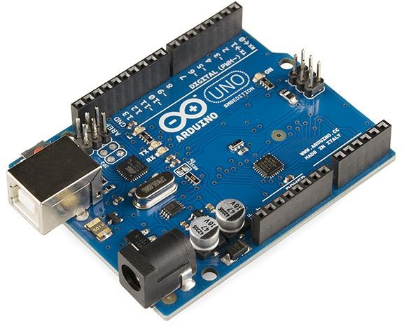

##### Figure 3.0: Arduino UNO

The Arduino Uno is a popular microcontroller board based on the ATmega328P microcontroller chip. It's widely used in the maker and hobbyist community for prototyping and creating interactive electronic projects due to its simplicity, versatility, and open-source nature. Here's a comprehensive description:

1. **Microcontroller:** The heart of the Arduino Uno is the ATmega328P microcontroller chip. It runs at 16 MHz and has 32 KB of flash memory for storing code, 2 KB of SRAM for data storage, and 1 KB of EEPROM for non-volatile storage.
2. **Digital I/O Pins:** The Arduino Uno has 14 digital input/output pins. These pins can be configured as either inputs or outputs, allowing the board to interact with digital sensors, actuators, LEDs, and other digital devices.
3. **Analog Input Pins:** There are 6 analog input pins on the Arduino Uno labeled A0 through A5. These pins can read analog voltage values from sensors and other analog devices.
4. **Power Pins:** The board can be powered via USB connection, an external power supply, or a battery. It has a built-in voltage regulator that allows it to be powered with voltages between 7V and 12V.
5. **USB Connection:** The Arduino Uno features a USB connection that allows it to be connected to a computer for programming and serial communication. It uses a USB to UART bridge chip (typically the Atmega16U2 or Atmega8U2) to facilitate communication between the computer and the microcontroller.
6. **Reset Button:** A reset button allows you to reset the microcontroller, restarting your program from the beginning.
7. **Clock Crystal**: The Arduino Uno uses an external 16 MHz crystal oscillator to provide precise timing for the microcontroller.
8. **Voltage Regulator:** The board includes a voltage regulator that regulates the voltage supplied to the microcontroller and other components, ensuring stable operation even when powered with varying input voltages.
9. **LEDs:** There are several LEDs on the board that serve various purposes:

* Power LED: Indicates that the board is receiving power.
* LED connected to digital pin 13: Often used for simple debugging or as a visual indicator in projects.

1. **ICSP Header:** The In-Circuit Serial Programming (ICSP) header allows you to program the microcontroller and bootloader using an external programmer.
2. **Operating Voltage:** The Arduino Uno operates at 5 volts, making it compatible with a wide range of sensors, actuators, and other electronic components.
3. **Open-Source Platform:** The Arduino Uno is based on open-source hardware and software, which means that the design files, schematics, and source code are freely available for anyone to use, modify, and distribute.

Overall, the Arduino Uno is a versatile and beginner-friendly platform for learning about electronics and programming, as well as for prototyping and building a wide range of projects.

**Pin Diagram of Arduino**

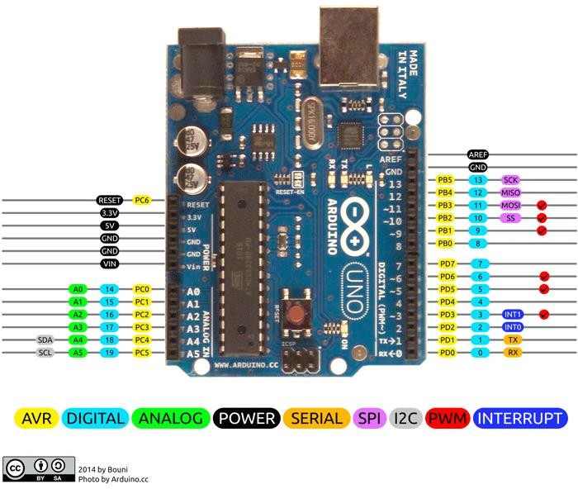

**Figure 3.1: Pin Diagram of Arduino**

### IR Sensor

An IR sensor, or infrared sensor, is a device that detects infrared radiation in its surrounding environment. Infrared radiation is electromagnetic radiation with wavelengths longer than those of visible light, typically in the range of 700 nanometers (nm) to 1 millimeter (mm).

IR sensors work by detecting changes in the intensity of infrared radiation reaching them. They consist of an IR emitter (usually an IR LED) and an IR detector (such as a photodiode or phototransistor) placed near each other. When the IR emitter emits infrared light, it travels through the air and can be reflected, absorbed, or transmitted by objects in its path. The IR detector then receives the infrared radiation and generates an electrical signal proportional to the intensity of the received IR radiation.

IR sensors have various applications, including:

1. Proximity sensing: Detecting the presence or absence of objects within a certain range.
2. Object detection: Identifying the presence and position of objects in the sensor's field of view.
3. Motion detection: Sensing movement by detecting changes in IR radiation caused by moving objects.
4. Remote control: Receiving signals from IR remote controls used for controlling devices such as TVs, DVD players, and air conditioners.
5. Line following: Following lines or tracks marked with IR-reflective or IR-absorbing materials,

commonly used in robotics and automated systems.

IR sensors are widely used due to their low cost, simplicity, and effectiveness in various applications where detection of infrared radiation is required.

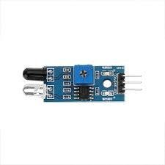

**Figure 3.2: IR Sensor**

### Jumper Wires

Jumpers are tiny metal connectors used to close or open a circuit part. They have two or more connection points, which regulate an electrical circuit board. Their function is to configure the settings for computer peripherals, like the motherboard. Suppose your motherboard supported intrusion detection. A jumper can be set to enable or disable it. [Jumper wires](https://www.wiltronics.com.au/product-category/jumper-wires/) are electrical wireswith connector pins at each end. They are used to connect two points in a circuit without [soldering.](https://www.wiltronics.com.au/wiltronics-knowledge-base/what-is-soldering/)

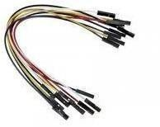

**Figure 3.3: Jumper Wires**

### Node MCU

The NodeMCU is a popular open-source development board based on the ESP8266 microcontroller chip. Here's a brief definition:

1. **Microcontroller:** The NodeMCU board is built around the ESP8266 microcontroller chip, which features a powerful 32-bit RISC CPU running at 80 MHz. It integrates Wi-Fi connectivity, making it suitable for IoT (Internet of Things) projects.
2. **Wi-Fi Connectivity:** One of the key features of the NodeMCU is its built-in Wi-Fi capability. This allows the board to connect to Wi-Fi networks and communicate with other devices over the internet.
3. **Lua Interpreter:** The NodeMCU firmware includes a Lua interpreter, which allows developers to write code directly in the Lua scripting language. This simplifies the development process, as it eliminates the need to compile code before uploading it to the board.
4. **Arduino IDE Support:** While the NodeMCU can be programmed using Lua, it is also compatible with the Arduino IDE (Integrated Development Environment). This allows developers to write code for the NodeMCU using familiar Arduino libraries and programming syntax.
5. **GPIO Pins:** The NodeMCU features a number of General-Purpose Input/Output (GPIO) pins, which can be used to interface with external sensors, actuators, and other electronic components.
6. **USB Connectivity:** The board includes a USB port for connecting to a computer, allowing developers to upload code and communicate with the NodeMCU using a serial interface.
7. **Power Supply:** The NodeMCU can be powered via USB or an external power source. It typically operates at 3.3 volts, although some versions of the board include onboard voltage regulators that allow it to be powered with higher voltages.

Overall, the NodeMCU is a versatile and cost-effective platform for prototyping IoT projects, home automation systems, and other wireless applications. Its built-in Wi-Fi connectivity and support for popular programming languages make it particularly well-suited for projects that require internet connectivity.

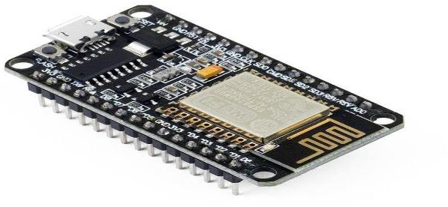

### Servo Motor

##### Figure 3.4: Node MCU

A servo motor is a type of rotary actuator that allows for precise control of angular position. It consists of a motor, a gearbox, and a control circuit. Servo motors are commonly used in various applications, including robotics, remote-controlled vehicles, industrial automation, and more.

Key features of servo motors include:

1. **Position Control:** Servo motors can rotate to a specific angle based on the electrical signal they receive. This precise control over position makes them ideal for applications where accuracy and repeatability are essential.
2. **Feedback Mechanism:** Most servo motors incorporate a feedback mechanism, such as a potentiometer or an encoder, which provides information about the motor's current position. This feedback allows the control system to adjust the motor's position as needed, ensuring accurate positioning.
3. **Closed-loop Control:** Servo motors typically operate in a closed-loop control system, where the feedback signal is continuously compared to the desired position. The control circuit adjusts the motor's speed and direction to minimize any error between the actual and desired positions.
4. **Torque**: Servo motors can provide a relatively high torque output compared to their size, making them suitable for applications that require both precision and power.
5. **Compact and Lightweight:** Servo motors are often compact and lightweight, making them suitable for use in space-constrained applications or systems where weight is a concern.

Overall, servo motors offer precise position control, high torque output, and compact size, making them well-suited for a wide range of applications in robotics, automation, and beyond.

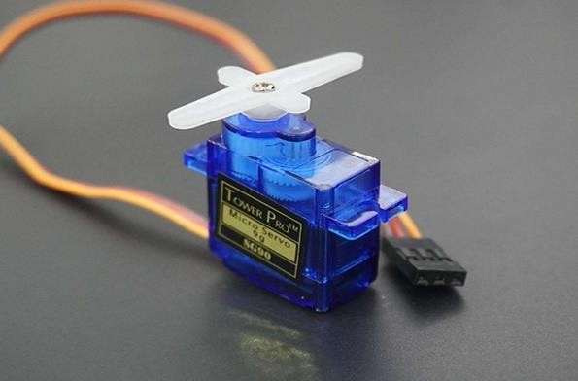

**Figure 3.5: Servo Motor**

##### LCD Display

An LCD (Liquid Crystal Display) is a flat-panel display technology that uses the light- modulating properties of liquid crystals to display images or text. Here's a brief definition:

**LCD Display:** An LCD display consists of a thin layer of liquid crystal material sandwiched between two transparent electrodes and two polarizing filters. When an electric current is applied to specific areas of the liquid crystal layer, it causes the crystals to align in a way that either allows light to pass through or blocks it, depending on the voltage applied.

LCD displays are commonly used in a wide range of electronic devices, including calculators, digital clocks, smartphones, computer monitors, and more. They offer several advantages, such as low power consumption, thin profile, light weight, and the ability to display information in a variety of lighting conditions.

In electronics projects, LCD displays are often interfaced with microcontrollers like Arduino to provide visual feedback or display sensor data. They come in various sizes and configurations, including character LCDs, graphical LCDs, and TFT (Thin-Film Transistor) LCDs, each suited for different applications and requirements..

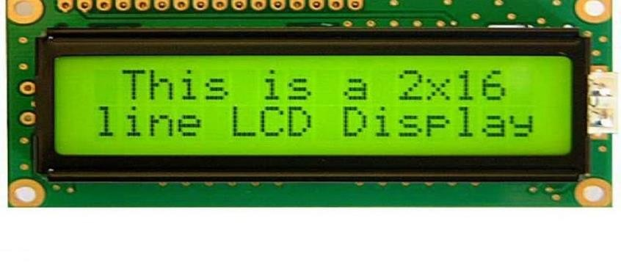

**Figure 3.6: LCD Display**

### 3.5.7 Bread Board

A breadboard is a fundamental tool used in electronics prototyping and experimentation. It consists of a rectangular plastic board with a grid of holes into which electronic components can be inserted and connected without the need for soldering. The holes on the breadboard are typically arranged in rows and columns, with each row connected internally but not connected to adjacent rows. This design allows for easy and temporary connections between components using jumper wires.

Breadboards are commonly used by hobbyists, students, and professionals to build and test electronic circuits quickly and without the need for specialized equipment. They are versatile, reusable, and allow for rapid iteration and modification of circuit designs. Additionally, breadboards often feature markings and labels to help users organize and understand the layout of their circuits.

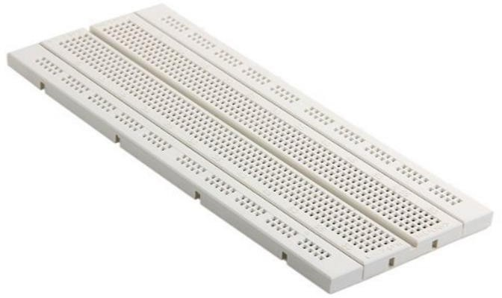

**Figure 3.7: Bread Board**

### Descriptions of software needed

* + 1. **Arduino IDE**

Arduino is an open-source electronics platform that has gained immense popularity for its versatility, simplicity, and accessibility. It comprises both hardware and software components, designed to facilitate the creation of interactive electronic projects for hobbyists, students, educators, and professionals alike.

Hardware: At the heart of the Arduino platform are microcontroller boards, such as the Arduino Uno, Nano, Mega, and others. These boards feature a microcontroller chip (commonly based on AVR or ARM architectures) along with input/output pins, analog input pins, power pins, and other components. The most basic Arduino boards, like the Uno, are equipped with digital and analog pins, USB connectivity, and power connectors, making them suitable for a wide range of projects.

Software: Arduino software, also known as the Integrated Development Environment (IDE), provides a user-friendly interface for writing, compiling, and uploading code to Arduino boards. The Arduino programming language is based on Wiring, a simplified version of C/C++, making it accessible even to beginners. The IDE includes a vast library of pre-written code (called sketches), which users can utilize and modify for their projects. Additionally, Arduino supports a wide range of sensors, actuators, displays, and communication modules through various libraries and shields, further expanding its capabilities.

Community and Ecosystem: One of Arduino's greatest strengths lies in its vibrant and supportive community. Arduino users share their projects, code, tutorials, and troubleshooting tips through forums, social media, and online platforms, fostering collaboration and innovation. Moreover, the Arduino ecosystem includes a vast array of third-party accessories, shields, and compatible hardware, providing users with endless possibilities for experimentation and project development.

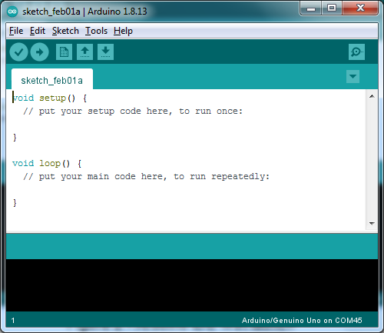

**Figure 3.8: Arduino IDE**

### 3.6.2. C/C++

C/C++ is a widely used programming language with a rich history and broad application across various domains, from system programming to application development and beyond. Here's an overview:

Origin and Evolution: C was developed by Dennis Ritchie at Bell Labs in the early 1970s as a successor to the B language. It quickly gained popularity due to its simplicity, efficiency, and portability, becoming the language of choice for system programming and operating systems development. In the 1980s, Bjarne Stroustrup introduced C++, an extension of C that added object-oriented programming (OOP) features, further expanding the language's capabilities and applicability.

Syntax and Features: C and C++ share many similarities in syntax and structure, with C++ extending and enhancing the features of C. Both languages are known for their low-level control over hardware, efficient memory management, and support for procedural and structured programming paradigms. C++ introduces OOP concepts such as classes, inheritance, polymorphism, and encapsulation, allowing developers to write modular, reusable code.

Applications: C and C++ find application in a wide range of domains, including system programming, embedded systems, game development, high-performance computing, and software development for operating systems and device drivers. C is commonly used for writing low-level system software, such as kernels, drivers, and firmware, where direct hardware

interaction and performance are critical. C++ is favored for larger-scale software projects and applications requiring OOP features, such as enterprise software, desktop applications, and video games.

### Advantages of C/C++

1. **Efficiency:** C/C++ are known for their efficiency in terms of both execution speed and memory usage. C/C++ compilers generate highly optimized machine code, resulting in fast execution of programs. Additionally, manual memory management in C allows developers to have fine-grained control over memory allocation and deallocation, minimizing overhead and reducing the risk of memory leaks.
2. **Portability:** Code written in C/C++ is highly portable across different platforms and architectures. C/C++ compilers are available for a wide range of operating systems, including Windows, Linux, macOS, and various embedded systems. This portability allows developers to write code once and run it on multiple platforms without significant modifications.
3. **Low-level Control:** C/C++ provide low-level control over hardware, making them suitable for system programming, device drivers, and embedded systems development. Developers can directly access hardware components and interact with memory addresses, enabling them to write code that is tightly optimized for specific hardware configurations.
4. **Broad Application:** C/C++ find application in a wide range of domains, including system programming, embedded systems, game development, high-performance computing, and operating systems development. They are well-suited for projects that require high performance, real-time processing, or direct hardware interaction.

### Disadvantages of C/C++

* 1. **Complexity**: C/C++ can be more complex and challenging to learn and use compared to higher-level languages like Python or Java. Memory management, pointer arithmetic, and manual memory allocation in C can be particularly daunting for beginners and prone to errors such as memory leaks and buffer overflows.
  2. **Lack of Built-in Safety Features:** Unlike modern languages with built-in safety features such as automatic memory management (garbage collection) and array bounds checking, C/C++ require developers to manually manage memory and ensure program correctness. This can lead to vulnerabilities such as buffer overflows, null pointer dereferences, and memory leaks, which are common sources of security vulnerabilities and bugs.
  3. **Limited Standard Library**: While C/C++ have standard libraries (C Standard Library for C and Standard Template Library for C++), they may lack the breadth and depth of libraries and frameworks available in higher-level languages. This can require developers to write more code from scratch or rely on third-party libraries, potentially increasing development time and complexity.
  4. **Platform Dependency**: While C/C++ code is generally portable across different platforms and architectures, there may still be platform-specific considerations and dependencies, particularly in system-level programming or embedded systems development. Writing platform-independent code in C/C++ can require additional effort and careful consideration of platform-specific features and APIs.

# CHAPTER 4 SYSTEM DESIGN

**Chapter 4**

**SYSTEM DESIGN**

### Architectural Design

Designing a smart parking system involves considering various architectural aspects to ensure efficiency, scalability, reliability, and security. Here's a brief overview of the architectural design for a smart parking system:

##### Client Interface:

* + Mobile Applications: Develop user-friendly mobile apps for drivers to find and reserve parking spaces, make payments, and receive notifications.
  + Web Interface: Create a web portal for users who prefer to access the system via a desktop browser.

##### Sensors and Hardware:

* + Parking Sensors: Install sensors (such as infrared) in parking spaces to detect vehicle presence and occupancy status.
  + Gate Control Systems: Deploy barriers or gates controlled electronically to manage entry and exit to parking lots.
  + Camera Systems: Optionally, integrate camera systems for license plate recognition and additional security.

##### Communication Infrastructure:

* + Internet Connectivity: Ensure reliable internet connectivity for real-time data transfer between sensors, servers, and client applications.
  + Wireless Protocols: Utilize protocols like Wi-Fi, Bluetooth, or LoRa for communication between

sensors, gate control systems, and the central server.

##### Server Infrastructure:

* Cloud-based Architecture: Host server components on cloud platforms for scalability, flexibility, and ease of maintenance.
* Centralized Database: Maintain a centralized database to store parking lot configurations, sensor data, user information, and transaction records.
* Backend Services: Develop backend services to handle user authentication, parking space management, payment processing, and notifications.
* Real-time Analytics: Implement analytics tools to monitor parking lot occupancy, predict demand, and optimize resource allocation.

##### Data Security and Privacy:

* Encryption: Implement encryption techniques to secure data transmission and storage, preventing unauthorized access.
* Access Control: Enforce strict access controls and authentication mechanisms to protect sensitive information and system functionalities.
* Compliance: Ensure compliance with data privacy regulations (e.g., GDPR) and industry standards to safeguard user privacy and rights.

##### User Experience Enhancement:

* + Smart Signage: Install digital signage or displays to provide real-time parking availability information and guidance to drivers.
  + Notification Systems: Send automated notifications to users regarding parking availability, reservation confirmations, and payment reminders.
  + Integration with Navigation Apps: Integrate with popular navigation apps to provide seamless navigation to available parking spaces.

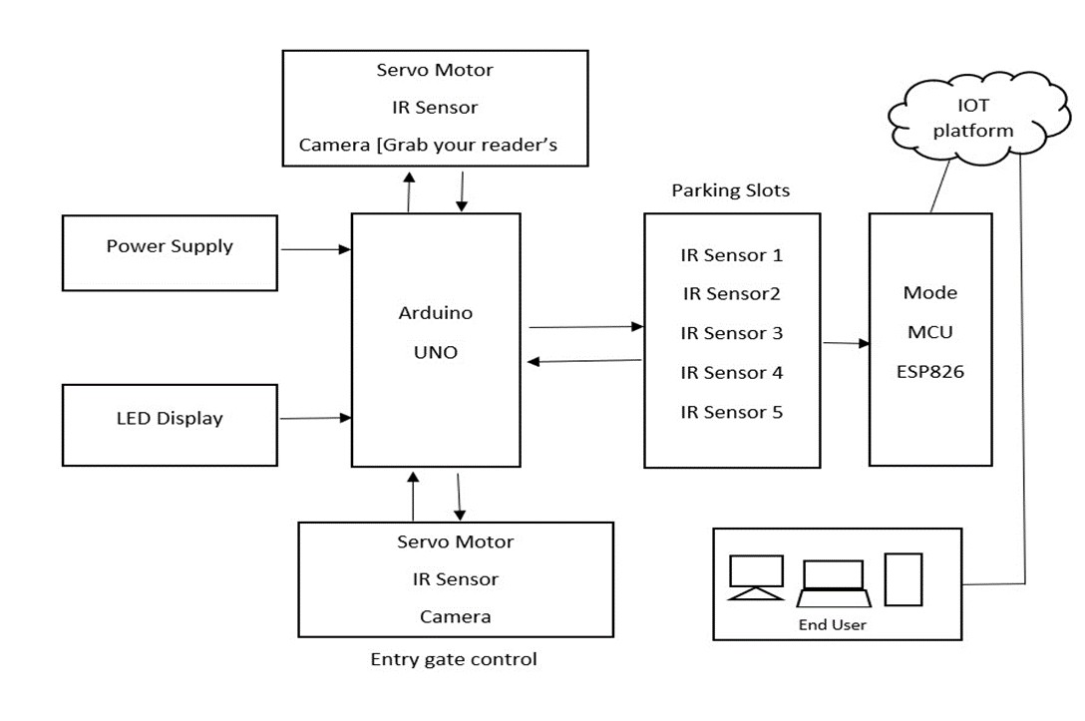

##### Scalability and Redundancy:

* + Load Balancing: Implement load balancing techniques to distribute incoming traffic evenly across multiple servers and ensure system responsiveness.
  + Redundancy: Design the system with redundancy measures to minimize downtime and ensure continuous operation, even in the event of hardware failures or network issues.

By addressing these architectural considerations, a smart parking system can deliver an efficient, user-friendly, and reliable parking experience while maximizing utilization and revenue for parking operators.

##### Figure 4.0: Architecture Design of the System

We are using Arduino uno as the main board to connect with the hardware which we are using in the smart parking system the entry gate has servo motor , Ir Sensor and Camera when the car enter the parking system the timer start calculating the time and when it exit the smart parking system the camera detects the same number plate the stop calculating the time by calculating the time and the amount will be imposed on the fasttag

### Modular Design Details

### Flowchart

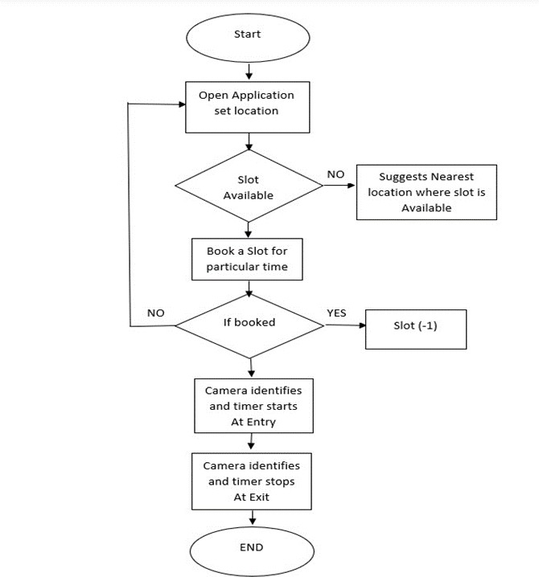

l

##### Figure 4.1: Flowchart of Parking System

1. **Start/End**: This is the beginning and end point of the flowchart, indicating the start and completion of the process.
2. **Vehicle Arrival**: This step involves detecting the arrival of a vehicle at the parking facility. This detection can be done through various means such as sensors, cameras, or license plate recognition systems.
3. **Available Parking Space:** Once a vehicle arrives, the system checks if there are any

available parking spaces. This step is crucial for determining whether the incoming vehicle can be accommodated immediately or if it needs to wait until a space becomes available.

1. **Space Allocation**: If there is an available parking space, it is allocated to the arriving vehicle. This step involves assigning a specific parking spot to the vehicle based on the system's algorithms, which consider factors such as proximity, size of the vehicle, and any special requirements.
2. **Vehicle Parked**: After the parking space is allocated, the vehicle parks in the designated spot. This step confirms that the vehicle has successfully parked in the assigned space.
3. **Vehicle Departure**: When the vehicle is ready to leave the parking facility, its departure is detected by the system. This detection can be done through sensors or other means.
4. **Free Up Parking Space**: Once the departure is detected, the parking space previously occupied by the vehicle is freed up. This step ensures that the parking spot becomes available for other vehicles to use.
5. **Update Parking Availability Status**: After a parking space is freed up, the system updates its records to reflect the change in availability. This ensures that the system always has up-to-date information about the status of each parking space.

The flowchart provides a structured visual representation of the steps involved in managing parking spaces in a smart parking system. It helps to illustrate the sequence of events and decision points in the process, making it easier to understand and implement the system effectively.

# CHAPTER 5 IMPLEMENTATION

**Chapter 5**

**IMPLEMENTATION**

### 5.1 Software Tools Used Blynk.Console

Blynk is a robust digital platform tailored for creating, deploying, and managing Internet of Things (IoT) projects. It bridges the gap between IoT hardware and end-user interfaces by providing a full suite of tools that facilitate building and managing IoT solutions. Blynk is highly favored by developers, hobbyists, and industrial practitioners due to its simplicity, versatility, and extensive support for various hardware platforms.

The core of Blynk revolves around three primary components: the Blynk App, Blynk Server, and Blynk Libraries. The Blynk App is available for both iOS and Android devices and features a customizable dashboard where users can drag and drop widgets such as buttons, sliders, and displays to create a tailored interface for their IoT project. This app acts as the control panel, providing users real-time control and monitoring capabilities over their connected devices.

Blynk Server handles the communication between the app and the IoT hardware. It can be hosted on Blynk's cloud, which offers an out-of-the-box solution for quick setup and accessibility or can be deployed locally on a user’s server for enhanced privacy and control. The server manages device authentication, data logging, and real-time command and status processing.

Blynk Libraries, written for popular development environments such as Arduino, ESP8266, and Raspberry Pi, allow seamless integration of hardware with the Blynk server. These libraries simplify the coding required to connect any supported hardware to the internet, making it accessible even to those with minimal programming expertise.

### Implementation details

**Step 1:**

### Hardware Setup

The first step is to gather all the necessary hardware components, ardunio uno, bread bord, node mcu, lcd display, ir sensors, wire and card board

After gathering all the components, we start assembling following the below steps :

##### Connect IR Sensors to Arduino Uno:

* + - * Connect the output pin of each IR sensor to a digital input pin on the Arduino Uno.
      * Connect the VCC and GND pins of the IR sensors to the 5V and GND on Arduino respectively.

##### Set Up the LCD Display:

* + - * Connect the RS, E, D4, D5, D6, and D7 pins of the LCD to digital pins on the Arduino (e.g., 7, 6, 5, 4, 3, and 2).
      * Connect the VSS and VDD to GND and 5V on the Arduino, respectively.
      * Connect the VO pin of the LCD to the middle pin of the potentiometer. Attach the other two pins of the potentiometer to 5V and GND for contrast control.
      * Connect a resistor (around 220 ohms) between the A (Anode) and 5V, and connect K (Cathode) to GND to power the backlight.

##### Interface Arduino with NodeMCU:

* Use Serial Communication (via RX/TX pins) or I2C (if available and preferred for complexity). For simplicity, use the Serial ports where Arduino Uno sends data to NodeMCU.
* Connect TX of Arduino to RX of NodeMCU and vice versa. Also connect GND of Arduino to GND of NodeMCU.

##### Powering the System:

* + - * Ensure that both Arduino and NodeMCU are powered. They can be powered via USB or an external 5V power supply if standalone operation is required.

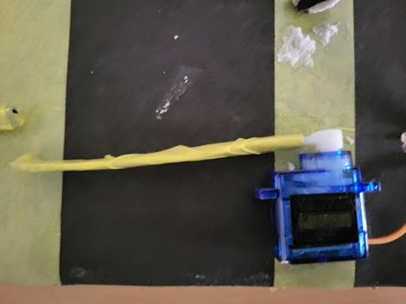

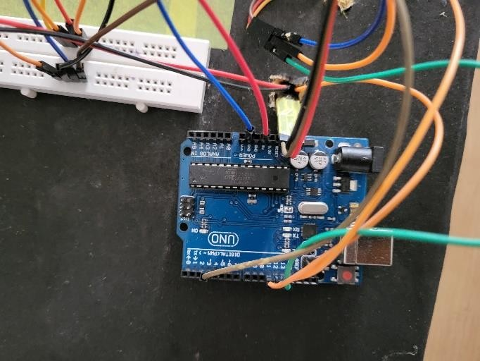

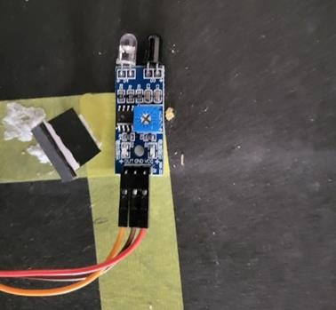

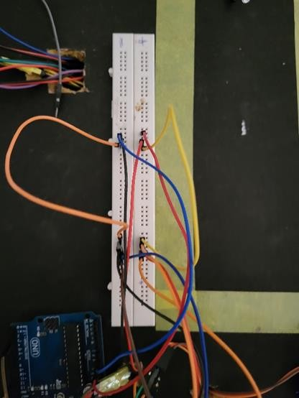

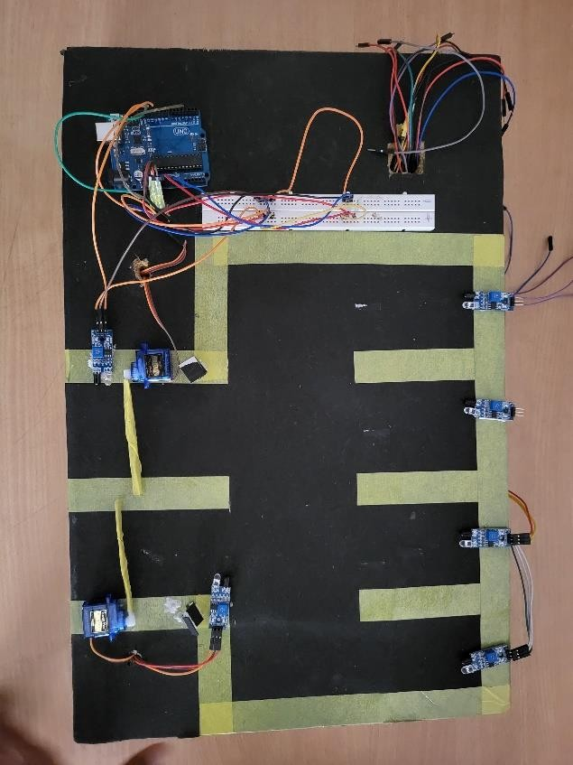

**Figure 5.0: Hardware Connections**

### Step 2:

**Software Setup**

Once the hardware is step up and assembling is done we perform following operations:

##### Download and Install:

* Ensure you have the latest version of Arduino IDE installed.
* Download and install the Blynk library in the Arduino IDE:
* Go to Sketch > Include Library > Manage Libraries in the Arduino IDE.
* Search for “Blynk”, find the Blynk library, and install it.

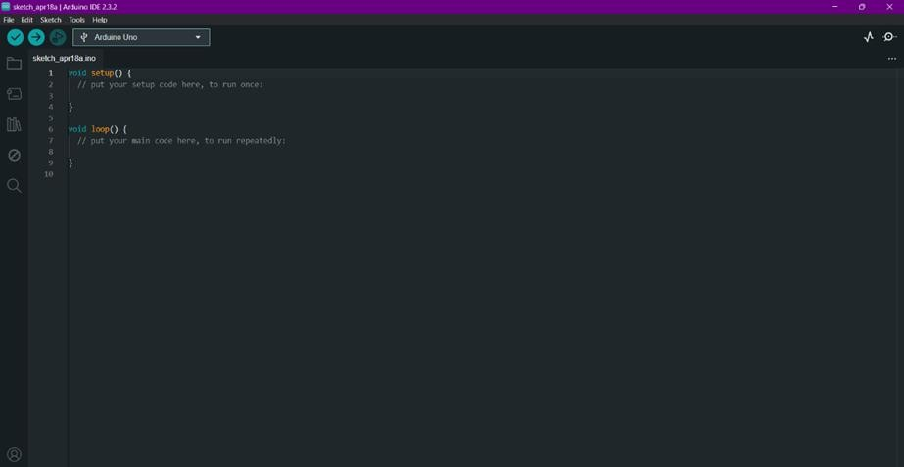

##### Figure 5.1: Arduino setup

* + 1. **Blynk App Setup:**
       - Download the Blynk app on your smartphone (available for iOS and Android).
       - Create a new Blynk account if you don't already have one.
       - Once logged in, create a new project in the app.
       - Select NodeMCU as the device and choose your connection type (WiFi).
       - The app will generate an Auth Token. Email this to yourself, as you will need to insert it into your NodeMCU code.

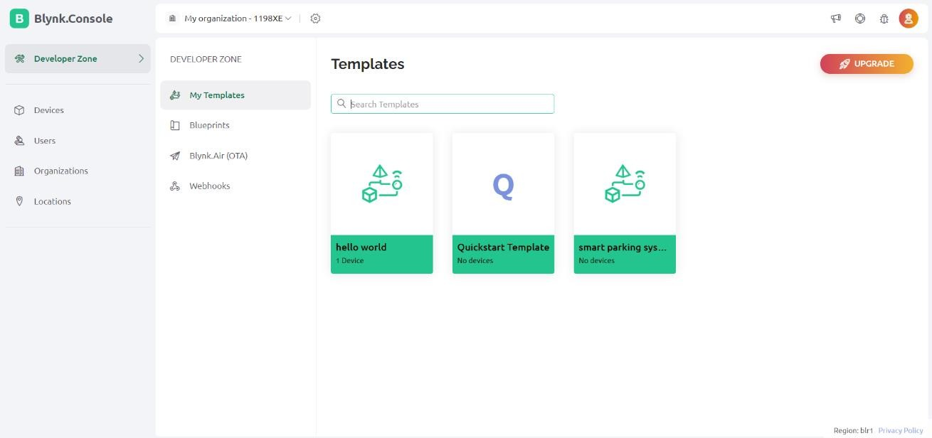

##### Programming NodeMCU with Blynk:

1. Basic Setup:

* Open Arduino IDE and create a new sketch for NodeMCU.
* Include the Blynk library and ESP8266 WiFi library.

```cpp

#include <ESP8266WiFi.h> #include <BlynkSimpleEsp8266.h>

// WiFi credentials

char ssid[] = "YourWiFiSSID"; char pass[] = "YourWiFiPassword";

// Blynk authorization token char auth[] = "YourAuthToken";

1. Connect to Blynk:

- In your setup function, start by initializing Blynk and connecting to your WiFi networ

cpp

void setup() { Serial.begin(9600); Blynk.begin(auth, ssid, pass);

}

void loop() { Blynk.run();

}

##### Programming Arduino Uno to Interact with Sensors:

1. Read Sensor Data:
   * Program the Arduino to read the IR sensor inputs for parking slot occupancy.
   * Send this data to NodeMCU using Serial communication. cpp

void setup() {

Serial.begin(9600); // Make sure this baud rate matches NodeMCU's

}

void loop() {

int sensorValue = digitalRead(sensorPin); // Replace 'sensorPin' with actual pin Serial.println(sensorValue);

delay(1000); // Delay to reduce data sending rate

}

##### Programming Arduino Uno to Interact with Sensors:

1. Read Sensor Data:

* Program the Arduino to read the IR sensor inputs for parking slot occupancy.
* Send this data to NodeMCU using Serial communication. void setup() {

Serial.begin(9600); // Make sure this baud rate matches NodeMCU's

void loop() {

int sensorValue = digitalRead(sensorPin); // Replace 'sensorPin' with actual pin Serial.println(sensorValue);

delay(1000); // Delay to reduce data sending rate

}

##### Integrating Arduino with NodeMCU:

1. Receive Data on NodeMCU:

* Read the data from Arduino on NodeMCU and send it to Blynk.
* Use Virtual Pins in Blynk to display this data cpp

BLYNK_WRITE(V1) { // Assuming you use V1 to display sensor data int parkingStatus = param.asInt(); // receiving data from Arduino

// You can add code here to handle the parking status display

}

void setup() { Serial.begin(9600); Blynk.begin(auth, ssid, pass);

}

void loop() { Blynk.run();

if (Serial.available()) {

int status = Serial.parseInt(); Blynk.virtualWrite(V1, status);

##### Step 3

**Power on the setup**

Setting up the power for your smart parking system using an Arduino Uno, NodeMCU, IR sensors, and a display requires careful consideration to ensure stable and safe operation. Below, I'll outline a comprehensive guide to powering your setup efficiently.

##### Step 4

**Importing Module**

Open terminal in raspberry pi and install the following modules: Arduino Libraries

When developing with Arduino and NodeMCU, you rely on libraries to interface with hardware components easily. Here’s how you can manage these imports:

##### Standard Libraries

These are part of the Arduino software (IDE), which help in basic functions such as interfacing with different sensors, communications, et

Copy code

#include <SPI.h> // For SPI communication, useful in many sensor interfaces #include <Wire.h> // For I2C communication

#include <EEPROM.h> // For reading and writing to the EEPROM of the Arduino

# CHAPTER 6 TESTING

## Chapter 6

**TESTING**

Testing is a crucial phase in software development, involving the deliberate execution of a program to identify any flaws that could cause it to fail. This process plays a vital role in quality assurance and ensuring the reliability of software systems. It serves as the final review of specifications, design, and coding, highlighting any discrepancies or errors that need to be addressed. Testing is an essential component of software quality assurance, providing assurance that the software meets the specified requirements and functions as intended. However, testing also presents an intriguing anomaly in software development, as it involves uncovering issues that may not have been apparent during earlier stages of development, thereby contributing to the continuous improvement of software products.

### Scope

The scope of testing for the project "Enhancing Autonomous Mobility: IoT, ML, Perceptual Progress in Driving" encompasses various aspects crucial for ensuring the functionality, performance, and reliability of the autonomous mobility system. Some key areas within the scope of testing include:

* + 1. **Functionality Testing:** This involves testing the system's core functionalities related to autonomous navigation, obstacle detection and avoidance, lane detection, stop sign recognition, and decision-making algorithms. Each functionality is tested thoroughly to ensure it performs as expected and meets the specified requirements.
    2. **Performance Testing:** Performance testing evaluates the system's responsiveness, stability, and scalability under different conditions. This includes assessing the system's response time, data transfer speed, computational efficiency, and resource utilization to ensure optimal performance under varying loads and scenarios.
    3. **Compatibility Testing:** Compatibility testing ensures that the autonomous mobility system is compatible with different hardware components, software platforms, communication protocols, and environmental conditions. It verifies that the system can seamlessly integrate with diverse devices, sensors, and networks without any compatibility issues.
    4. **Usability Testing:** Usability testing focuses on evaluating the user interface (UI) and user experience (UX) of the autonomous mobility system. It assesses the system's ease of use, intuitiveness, accessibility, and overall user satisfaction to ensure that it meets the needs and expectations of end-users.
    5. **Security Testing:** Security testing is essential to identify and mitigate potential vulnerabilities, threats, and risks associated with the autonomous mobility system. It involves assessing the system's authentication mechanisms, data encryption, access controls, and compliance with security standards to safeguard against cyber threats and unauthorized access.

### Unit Testing

Unit testing is an integral part of the software development process, focusing on testing individual units or components of the autonomous mobility system. For our project, unit testing will involve testing key components such as ML algorithms for object detection, edge detection algorithms for lane detection, and decision-making algorithms for navigation. By testing each unit in isolation, developers can ensure that they function as expected and meet their specified requirements. The benefits of unit testing include early defect detection, improved reliability, and simplified debugging, ultimately contributing to the overall quality and effectiveness of the autonomous mobility system.

The benefits of unit testing include:

* + Test individual components of the system, such as sensors, cameras, microcontrollers, and software modules, to ensure they perform as expected.
  + Verify that each component accurately detects vehicle presence, communicates with other system components, and responds appropriately to input

### Integration Testing

Integration testing is essential for verifying the interactions between different components or modules of the autonomous mobility system. This testing phase ensures that individual components work together seamlessly when integrated into the system. For our project, integration testing will focus on testing the integration of IoT devices, ML models, and perceptual progress algorithms. By identifying and addressing any issues that arise during integration, developers can ensure that the system functions as intended and meets the specified requirements. The benefits of integration testing include early defect detection, improved software quality, and reduced risks, ultimately leading to a more robust and reliable autonomous mobility system.

The benefits of integration testing include:

* + Test the integration of different system components to ensure they work together seamlessly.
  + Verify that data is transmitted correctly between components, and that the system as a whole behaves as intended.

### System Testing

System testing evaluates the overall functionality, performance, reliability, and compatibility of the autonomous mobility system as a whole. This testing phase validates that the system meets the specified requirements and objectives and functions correctly in its intended environment. For our project, system testing will involve testing the complete system in real- world driving scenarios, including various road conditions, traffic situations, and environmental factors. By conducting comprehensive system testing, developers can ensure that the autonomous mobility system performs reliably and effectively, enhancing safety, efficiency, and user satisfaction. The benefits of system testing include enhancing performance, improving reliability, and reducing maintenance costs, ultimately contributing to the success of the autonomous mobility project.

The benefits of system testing include:

##### Scope Definition:

* + - * Define the scope of system testing, including the functionalities, features, and interfaces that need to be tested.
      * Identify the test scenarios and test cases based on the system requirements and user expectations.

##### Test Environment Setup:

* + - * Set up the test environment to replicate the production environment as closely as possible.
      * Configure hardware, software, networks, databases, and other components required for testing.

##### Functional Testing:

* + - * Verify that the system functions correctly according to its specifications and requirements.
      * Test individual features and functionalities to ensure they work as expected and produce the desired outcomes**.**

##### Integration Testing:

* + - * Test the integration of different system components to ensure they work together seamlessly.
      * Verify that data flows correctly between modules, interfaces are properly implemented, and interactions between components are handled correctly.

##### Interface Testing:

* + - * Test the interfaces between the system and external systems, modules, or third- party components.
      * Verify that data exchange, communication protocols, and compatibility are functioning as intended.

##### Performance Testing:

* + - * Evaluate the performance of the system under various conditions, such as different loads, volumes of data, and concurrent users.
      * Measure response times, throughput, scalability, and resource usage to ensure the system meets performance requirements.

# CHAPTER 7 RESULTS AND ANALYSIS

**Chapter 7**

**RESULTS AND ANALYSIS**

### 7.1. Screenshots and Analysis

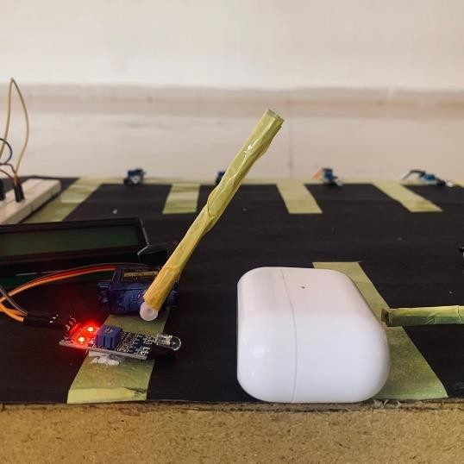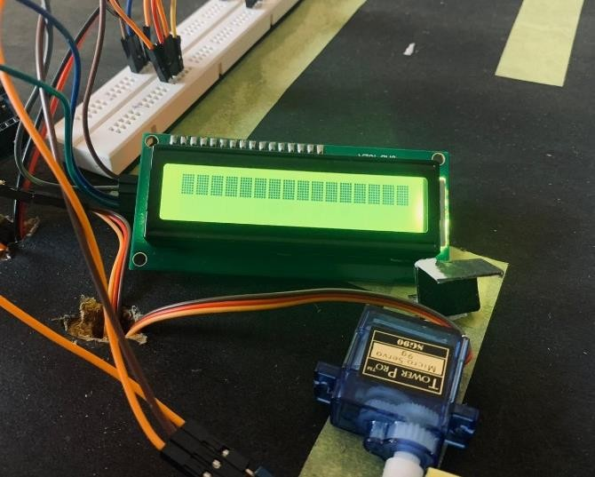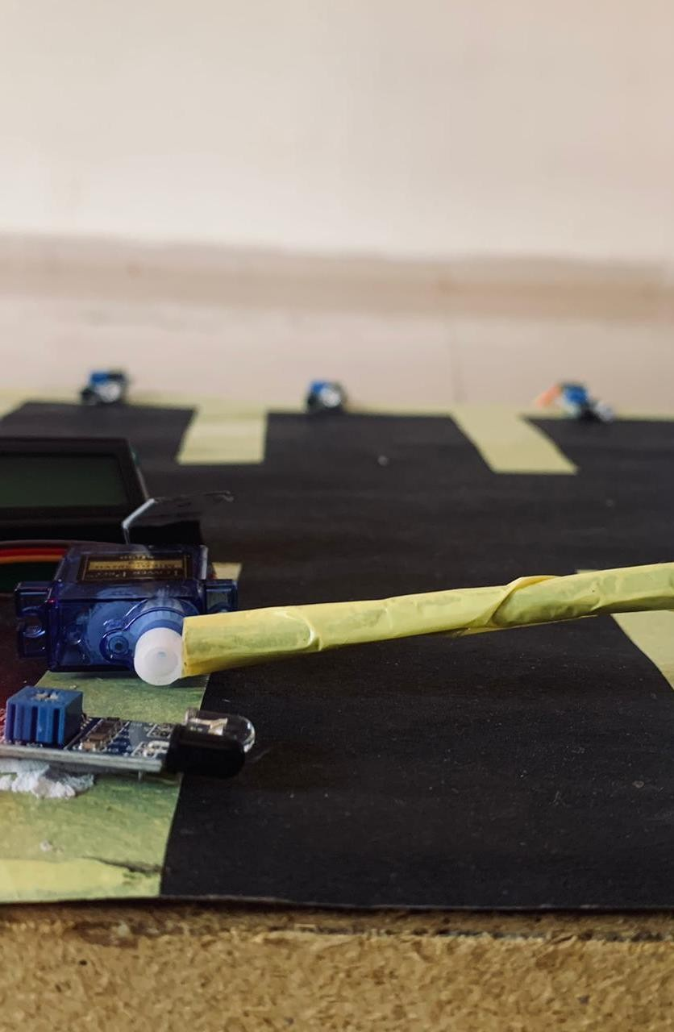

##### Figure 7.0: Entry Gate

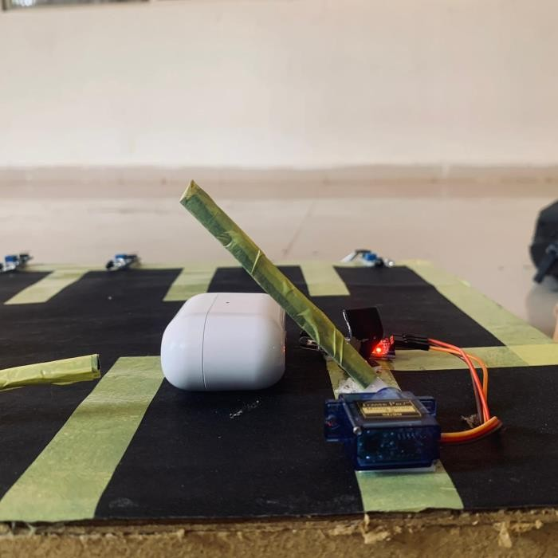

**Figure 7.1: Exit Gate**

The figure 7.1 illustrates the creation of the Region of Interest (ROI) through the definition of source and destination points. Additionally, it demonstrates the utilization of the calculated lane center relative to the frame center to determine the appropriate navigation action, such as moving left, right, or forward.

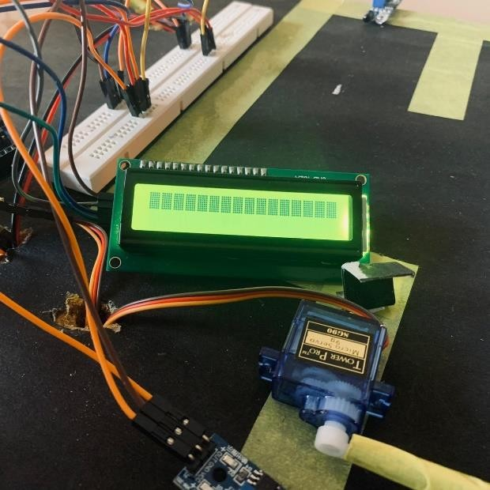

##### Figure 7.2: LCD Display Screen

The figure 7.2 shows the Remaining slots in the parking space and also shows how many cars have been parked in the space.

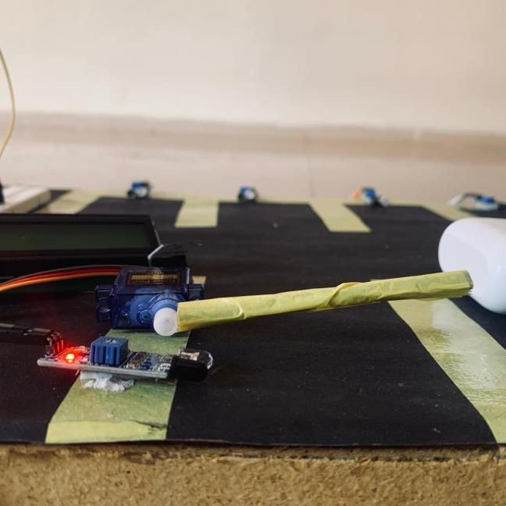

##### Figure 7.3: IR Sensors Detection for the Cars

The figure 7.3 shows when a car is entered to parking space it detects and opens the gate if there is a space available or else it doesn’t open the gate

# CHAPTER 8 CONCLUSION AND FUTURE WORK

**Chapter 8**

**CONCLUSION AND FUTURE WORK**

### Conclusion

In conclusion, the implementation of a smart parking system marks a pivotal advancement in urban infrastructure, offering tangible solutions to longstanding challenges in parking management. Through the seamless integration of IoT technologies, real-time data analytics, and user-centric interfaces, the system has demonstrated remarkable efficiency gains, significantly reducing search times for parking spaces and alleviating traffic congestion.

By optimizing space utilization and providing drivers with timely information, the system not only enhances convenience but also contributes to environmental sustainability by minimizing vehicle emissions associated with circling for parking. Despite these achievements, ongoing efforts are essential to address existing limitations, including scalability issues and user adoption barriers. Moving forward, future work should prioritize technological innovations to enhance system reliability and expand coverage to broader urban areas.

Moreover, attention to user experience refinement and strategic partnerships with city authorities will be crucial to ensuring the seamless integration of smart parking systems into the fabric of modern urban environments. Ultimately, by leveraging emerging technologies and fostering collaboration across stakeholders, smart parking systems hold immense potential to transform urban mobility and enhance the quality of life for residents and visitors alike.

### Future Work

Future work on smart parking systems should focus on several key areas to enhance their efficiency and user adoption. Firstly, integrating advanced technologies such as artificial intelligence and machine learning could predict parking patterns more accurately and provide dynamic recommendations to users, thereby optimizing space utilization. There is also a need to improve scalability and interoperability, allowing these systems to expand seamlessly across different geographic locations and ensuring they work compatibly with other smart city infrastructure. Enhancing user interfaces and experience is crucial; more intuitive and user-friendly mobile applications can significantly boost user satisfaction and system usage. Additionally, exploring the implementation of varied pricing strategies could help manage demand during peak times, making the system more efficient. Finally, attention should be given to the ethical use and protection of user data, ensuring privacy and security in line with regulatory requirements, thereby increasing public trust and system reliability. These improvements will not only streamline urban mobility but also contribute to broader goals such as reducing emissions and improving the quality of urban life.

Moving forward, future work on smart parking systems should prioritize several key areas to further enhance their functionality and impact. One critical avenue for advancement lies in the integration of cutting-edge technologies to optimize system performance and user experience. Research efforts could focus on leveraging artificial intelligence and machine learning algorithms to predict parking demand, dynamically adjust pricing based on real-time data, and provide personalized recommendations to drivers. Additionally, advancements in sensor technology and data analytics could lead to more accurate detection of available parking spaces and improved reliability in guiding drivers to vacant spots. Furthermore, scalability remains a significant consideration, necessitating exploration into scalable architectures and interoperability standards to facilitate the seamless integration of smart parking systems across diverse urban environments. Collaborative efforts with city authorities and urban planners will be essential to ensure alignment with broader smart city initiatives and regulatory frameworks. Ultimately, by embracing these challenges and opportunities for innovation, future iterations of smart parking systems have the potential to revolutionize urban mobility and contribute to more sustainable, efficient, and livable cities.

## REFERENCES

1. Anand Raj, Garv Agarwal, Pranjal Goyal, Yash Mittal, Sandeep Kumar Singh, "ParkSmart: Leveraging Neural Networks for Predictive Parking in Smart Cities", 2024 International Conference on Integrated Circuits and Communication Systems (ICICACS), pp.1-5, 2024.
2. T.C. Kalaiselvi, K. Sathyavardhan, S. Balambigai, S. Santhoshsiva, "Smart Car Parking System", 2024 Second International Conference on Emerging Trends in Information Technology and Engineering (ICETITE), pp.1-8, 2024.
3. Yuto Fujimaki, Toru Namerikawa, "Decentralized Optimal Parking Lot Allocation via Dynamic Parking Fee", 2023 28th Asia Pacific Conference on Communications (APCC), pp.261-266, 2023.
4. Sandeep Saharan, Neeraj Kumar, Seema Bawa, "DyPARK: A Dynamic Pricing and Allocation Scheme for Smart On-Street Parking System", IEEE Transactions on Intelligent Transportation Systems, vol.24, no.4, pp.4217-4234, 2023.
5. Elmer R. Magsino, Gerald P. Arada, Catherine Manuela L. Ramos, "An Evaluation of Temporal- and Spatial-Based Dynamic Parking Pricing for Commercial Establishments", IEEE Access, vol.10, pp.102724-102736, 2022.
6. T. Nakazato, Y. Fujimaki and T. Namerikawa: Parking Lot Allocation Using Rematching and Dynamic Parking Fee Design, IEEE Transactions on Control of Network Systems, 9-4, 1692/1703 (2022).
7. T. Sutjarittham, H.H. Gharakheili, S.S. Kanhere and V. Sivaraman: Monetizing Parking IoT Data via Demand Prediction and Optimal Space Sharing, IEEE Internet of Things Journal, 9-8, 5629/5644 (2022).
8. W. Wu, W. Liu and F. Zhang: A New Flexible Parking Reservation Scheme for the Morning Commute under Limited Parking Supplies, Networks and Spatial Economics 21, 513/545 (2021).
9. W. Wu, W. Liu and F. Zhang: A New Flexible Parking Reservation Scheme for the Morning Commute under Limited Parking Supplies, Networks and Spatial Economics 21, 513/545 (2021).
10. "Design of a Smart Parking System based on IoT Technology" by Minzhen Luo, Yonghong Tian, Qianwen Wu, and Huiwen Zhang. (2019 IEEE 6th International Conference on Industrial Engineering and Applications (ICIEA), April 2019).
11. "Internet of Things (IoT) Technologies for HealthCare: Third International Conference, HealthyIoT 2016, Västerås, Sweden, October 18-19, 2016, Revised Selected Papers" edited by Mobyen Uddin Ahmed, Shahina Begum, and Octavian Postolache.
12. <https://ieeexplore.ieee.org/abstract/document/7562735>
13. https://github.com/AyushDevil/Smart-Parking-System-using-IoT-Technologies