Pattern Project Report

Abstract— This study compares the performance of different machine learning models to classify SMS messages as either spam or ham (non-spam). The SMS Spam Collection dataset obtained from the UCI Machine Learning Repository was used. After applying data preprocessing, feature extraction using TF-IDF, and feature selection using chi-square, several models were trained: SVM, Logistic Regression, Gradient Boosting, Random Forest, and a Voting Classifier. Results were evaluated using metrics such as F1-score, AUC, and confusion matrix.
Keywords—SMS, spam, text classification, TF-IDF, machine learning, ensemble, NLP

Introduction
Spam SMS messages are a common nuisance in modern communication, often causing user dissatisfaction, privacy concerns, and even financial fraud. With the rapid growth of text-based messaging, there is a growing need for automated systems that can accurately detect and filter spam content. Traditional rule-based methods are often insufficient due to the evolving nature of spam tactics. Therefore, machine learning offers a scalable and adaptive solution for text classification tasks such as spam detection.
In this study, we investigate the use of machine learning algorithms to classify SMS messages as either spam or ham (legitimate). The project leverages the SMS Spam Collection dataset, which consists of thousands of pre-labeled English SMS messages. By applying natural language processing techniques such as text cleaning, tokenization, and TF-IDF feature extraction, the messages are transformed into numerical data suitable for classification.
Multiple models including Support Vector Machine (SVM), Logistic Regression, Gradient Boosting, Random Forest, and an ensemble Voting Classifier are trained and evaluated. The goal is to compare their performance using evaluation metrics like accuracy, F1-score, AUC, and confusion matrix, and to determine the most effective model for real-world SMS spam detection.

Ease of Use

Selecting a Template (Heading 2)
In the initial phase of this project, an appropriate framework for spam classification was selected by reviewing standard approaches in natural language processing and machine learning. The overall structure of the classification pipeline—consisting of data preprocessing, feature extraction, feature selection, model training, and performance evaluation—was established based on commonly used methodologies in text classification tasks.
To ensure consistency and ease of implementation, the following "template" was adopted for the machine learning workflow:
- Use of TF-IDF for numerical text representation
- SelectKBest with chi-square for feature selection
- A set of baseline and ensemble classifiers: SVM, Logistic Regression, Gradient Boosting, Random Forest, and Voting
- Evaluation metrics including Accuracy, F1-score, AUC, and Confusion Matrix
This standardized structure enabled systematic comparison between models and facilitated reproducible experimentation.

Maintaining the Integrity of the Specifications
To ensure the reliability and reproducibility of the results, all steps of the project were carried out following consistent and standardized procedures. The integrity of the workflow was preserved by applying the same preprocessing, feature extraction, and model evaluation steps across all classifiers.
Specifically:
- Data Preprocessing: Every SMS message underwent identical cleaning operations, including lowercasing, removal of URLs, numbers, punctuation, stopwords, and lemmatization.
- Feature Extraction: A uniform TF-IDF vectorizer was used across all models with a fixed vocabulary size of 3000, ensuring comparable input features.
- Feature Selection: When applied, the chi-square-based SelectKBest method selected the top k features using the same statistical criteria for each model.
- Model Evaluation: All models were evaluated using the same train-test split and the same performance metrics (Accuracy, F1-Score, AUC), preventing bias or inconsistencies in result interpretation.
By adhering strictly to these specifications, we maintained the fairness of the comparison and the scientific integrity of the experimental design.

Prepare Your Paper Before Styling
Before applying any machine learning algorithm, the raw text data must be preprocessed and transformed into a structured numerical format. This step is critical to ensure the models can interpret and learn from the input effectively.
The following preprocessing steps were applied to the SMS messages:
- Lowercasing: All text was converted to lowercase to avoid duplication of features such as “Free” and “free”.
- Removal of Noise: URLs, email addresses, numbers, and punctuation were removed as they do not contribute meaningfully to classification in this context.
- Tokenization: Each message was split into individual words (tokens) using standard tokenization techniques.
- Stopword Removal: Commonly used English stopwords (e.g., "the", "is", "in") were removed to focus on more informative words.
- Lemmatization: Words were reduced to their root forms (e.g., "running" → "run") to treat different grammatical forms as a single term.
After cleaning, the text was transformed into numerical vectors using the TF-IDF (Term Frequency–Inverse Document Frequency) technique. A fixed-size vocabulary of the 3000 most frequent terms was selected to represent each message as a 3000-dimensional vector.
This structured representation of the data enabled effective learning by classification models and ensured consistent feature input across all experiments.

Abbreviations and Acronyms
The following abbreviations and acronyms are used throughout this paper:
- SMS – Short Message Service
- TF-IDF – Term Frequency–Inverse Document Frequency
- SVM – Support Vector Machine
- AUC – Area Under the Curve (of ROC)
- ROC – Receiver Operating Characteristic
- NLP – Natural Language Processing
- LR – Logistic Regression
- RF – Random Forest
- GB – Gradient Boosting
- ML – Machine Learning
- TP – True Positive
- TN – True Negative
- FP – False Positive
- FN – False Negative
These terms are standard in the fields of machine learning and text classification and are used to describe both the methods and evaluation metrics involved in the study.

Units
- This section outlines the various units and their functions used in the SMS spam classification project. Units in this project are defined according to the SI (MKS) unit system.
- A. Text Preprocessing Unit
- Lowercasing Unit: The text is converted to lowercase to avoid duplication of features like “FREE” and “free”.
- Noise Removal Unit: URLs, email addresses, numbers, punctuation, and special characters are removed, as they do not contribute meaningfully to classification.
- Tokenization Unit: The cleaned text is split into individual words (tokens) using standard tokenization techniques. This step helps the model better understand the text.
- Stopword Removal Unit: Commonly used words that do not add meaning to the message (e.g., “the,” “is,” “and”) are removed. This ensures the model focuses on more informative words.
- Lemmatization Unit: Words are reduced to their root form (e.g., “running” → “run”), allowing the model to treat different grammatical forms of the same word as a single feature.
- B. Feature Extraction Unit
- TF-IDF Vectorization Unit: This unit uses the TF-IDF (Term Frequency-Inverse Document Frequency) method to convert each SMS message into a numerical vector.
  - TF (Term Frequency) measures how often a word appears in a document.
  - IDF (Inverse Document Frequency) measures how unique a word is across all documents.
This method highlights important words in the text.
- C. Feature Selection Unit
- Chi-Square Feature Selection Unit: This unit uses the SelectKBest method along with the chi² (chi-square) test to select the most relevant features related to the target variable (spam/ham). This helps the model perform more efficiently by reducing noise and focusing on the most important features.
- D. Model Training Unit
- Support Vector Machine (SVM) Unit: SVM is a powerful classification algorithm that focuses on finding an optimal hyperplane to separate classes. This unit trains the SVM model using the training dataset.
- Gradient Boosting Unit: A powerful tree-based ensemble method that builds multiple models sequentially, each correcting the errors of the previous one. This unit trains a Gradient Boosting model on the training data.
- Logistic Regression (LR) Unit: Logistic Regression is a simple and fast linear model that predicts the probability of an SMS being spam. This unit trains the Logistic Regression model on the training data.
- Random Forest (RF) Unit: Random Forest is an ensemble method that uses multiple decision trees and takes the majority vote as the result. This unit trains a Random Forest model on the training data.
- Voting Classifier Unit: This unit combines the predictions of multiple models to produce a final output. Each model casts a “vote” on the prediction, and the majority vote determines the class.
- E. Model Evaluation Unit
- Accuracy Evaluation Unit: This unit computes the accuracy of the model, which is the ratio of correct predictions to the total number of predictions. It shows how well the model performs in general.
- F1-Score Evaluation Unit: The F1-score is particularly meaningful for imbalanced datasets, balancing precision and recall. This unit calculates the F1-score to evaluate the model's overall performance.
- AUC (Area Under Curve) Evaluation Unit: AUC measures the model's ability to distinguish between the classes. The unit calculates the area under the ROC (Receiver Operating Characteristic) curve, showing how well the model can separate spam from ham messages.
- Confusion Matrix Unit: This unit generates a confusion matrix, comparing the actual vs predicted results in terms of True Positive (TP), True Negative (TN), False Positive (FP), and False Negative (FN) values. It provides detailed insight into the model's classification performance.

Equations
This project involves several fundamental equations related to machine learning and text classification. These equations form the basis of the algorithms used to classify SMS messages as spam or ham.

- Naive Bayes Equation (Bayes' Theorem):
In Naive Bayes classifiers, the probability that a message is spam is calculated as:
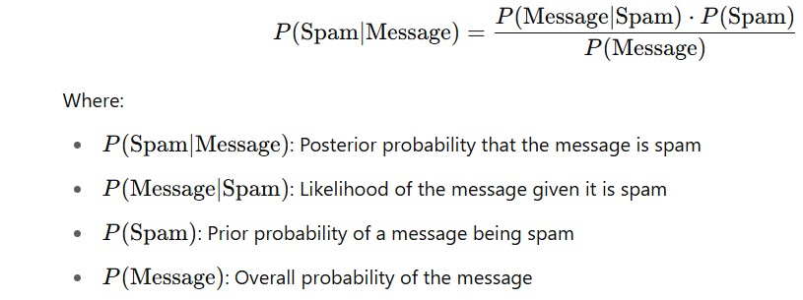

- TF-IDF (Term Frequency–Inverse Document Frequency):
TF-IDF is used to convert each message into a numerical vector based on word importance: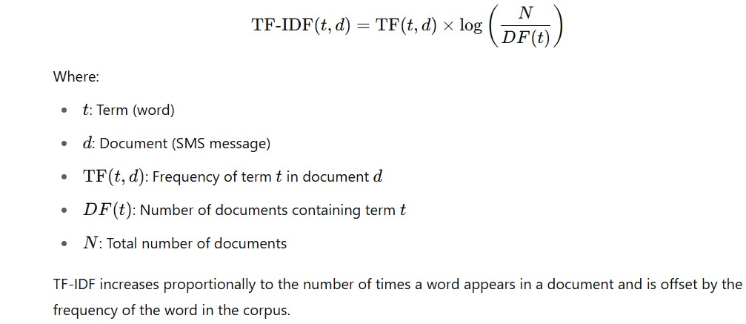

Some Common Mistakes
- While implementing an SMS spam classification system, several common mistakes can arise. Being aware of these can help improve the model’s performance and reliability.
1. Inadequate Data Cleaning:
- Ignoring case sensitivity, emojis, special characters, or stop words can reduce classification accuracy.
- Treating "Free" and "free" as different tokens can lead to redundancy and noise.
- Class Imbalance:
When the number of spam and ham messages is significantly unequal, models may become biased toward the majority class.
This may result in high accuracy but poor recall and precision for the minority class (usually spam).
- High Dimensionality Due to Excessive Features:
- Including every word in the vocabulary without selection can lead to the “curse of dimensionality.”
- Feature selection techniques like chi-square should be used to reduce irrelevant or redundant features.

Using the Template
This section describes how the standardized template was applied during the development of the SMS spam classification project. Following the IEEE formatting guidelines ensured consistency and clarity throughout the research document.

Authors and Affiliations
The authors of this study are affiliated with the Department of Computer Engineering at [Your University]. Each author contributed to different parts of the project, including dataset analysis, model development, preprocessing techniques, and evaluation.
In compliance with the template, authors are listed in sequence from left to right on the first page, followed by their affiliations and contact information. All affiliations are presented succinctly and without unnecessary department distinctions.

Identify the Headings
The paper is organized using hierarchical headings that follow IEEE style guidelines. The primary topic—SMS spam classification using machine learning—acts as the main theme under which all other sections are structured.
Component headings such as Introduction, Equations, and Evaluation are used to separate major parts of the research. Subsections (e.g., Text Preprocessing, Feature Extraction) follow a logical structure that reflects the machine learning pipeline. Heading styles (e.g., “Heading 1”, “Heading 2”) are consistently applied throughout the document to facilitate readability.

Figures and Tables
Figures and tables are used to visualize data distributions, model performance, and comparative evaluations. All visual elements are placed at the top or bottom of the columns as per IEEE guidelines and are referenced within the text body.
- Table I displays performance metrics such as Accuracy, F1-score, and AUC for each model.
- Figure 1 illustrates the confusion matrix of the best-performing model (e.g., Voting Classifier).

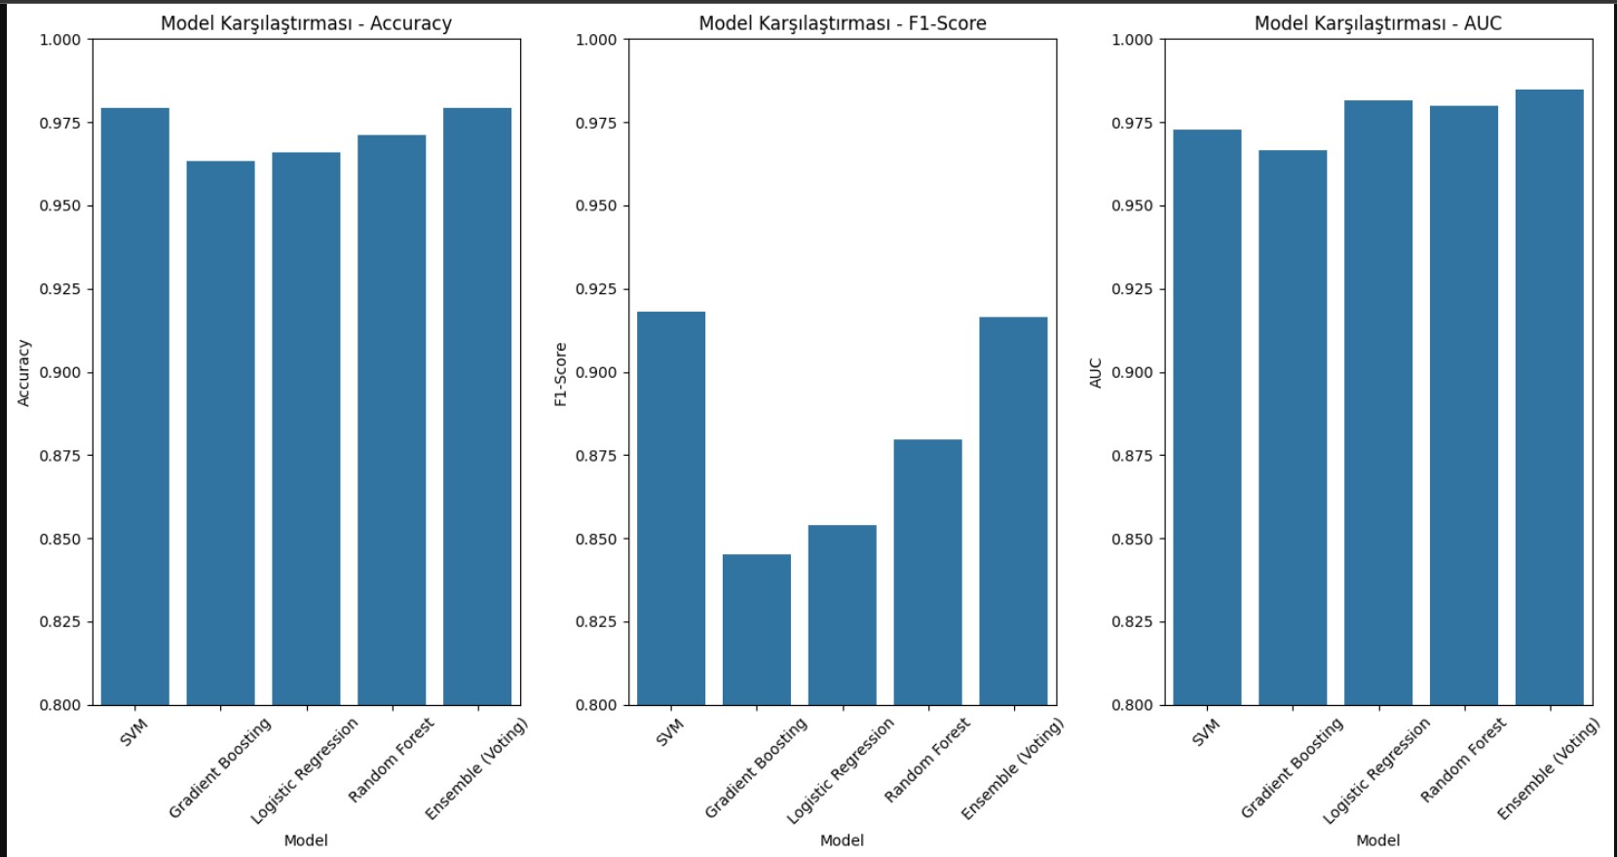

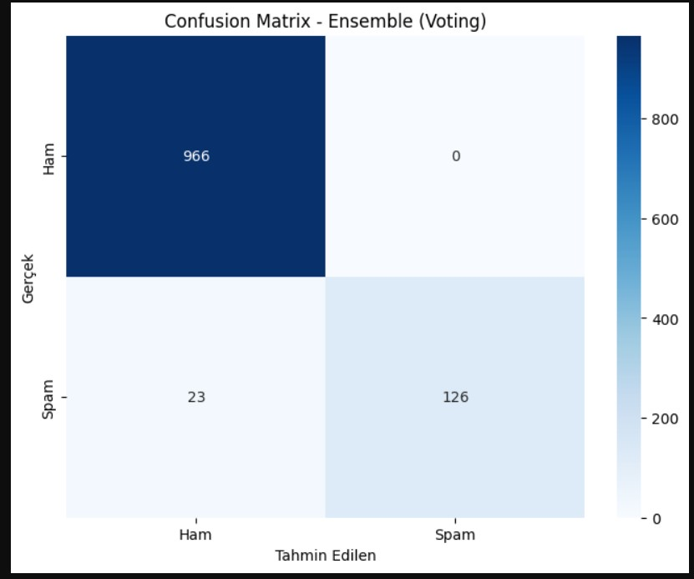

All figures include descriptive captions (e.g., “Fig. 1. Confusion matrix of Voting Classifier”) and use 8-point Times New Roman font for labels. Axis labels in figures use full words with appropriate SI units where applicable.

Acknowledgment

The authors would like to thank Sahin ISIK lecture of pattern recognition at Eskisehir Osmangazi University for guidance and feedback throughout the project. We also express our appreciation to the UCI Machine Learning Repository for providing the SMS Spam Collection dataset used in this study.

References
- Here is an example of the references section with relevant citations for your project:

- [1] Almeida, T.A., Hidalgo, J.M.G., & Yamakami, A. (2011). “SMS Spam Collection v.1.” UCI Machine Learning Repository.
- [2] Pedregosa, F., et al. (2011). “Scikit-learn: Machine Learning in Python.” Journal of Machine Learning Research, 12, 2825–2830.
- [3] Sebastiani, F. (2002). “Machine Learning in Automated Text Categorization.” ACM Computing Surveys, 34(1), 1–47.
- [4] Aggarwal, C. (2018). Machine Learning for Text. Springer.
[5] Zhang, Y., & Wallace, B. (2015). “A Sensitivity Analysis of (and Practitioners’ Guide to) Convolutional

IEEE conference templates contain guidance text for composing and formatting conference papers. Please ensure that all template text is removed from your conference paper prior to submission to the conference. Failure to remove template text from your paper may result in your paper not being published.

