Presenting outputs

## Q1: What is the win rate by Tier and Sub sector ID. Split the above in to FY19 and FY20.

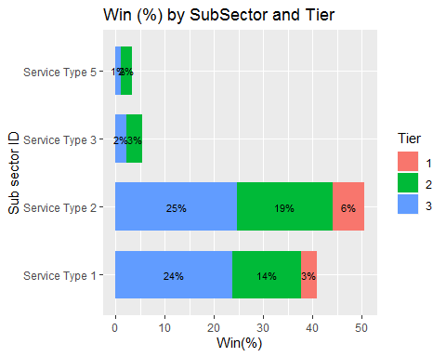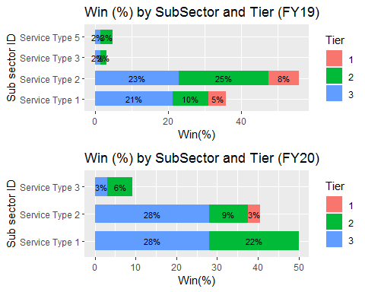

##Q2: How many opportunities are open (i.e. not closed lost or closed won) by stage and tier. (e.g. we have x number of opportunities open at stage y for Tier 1)

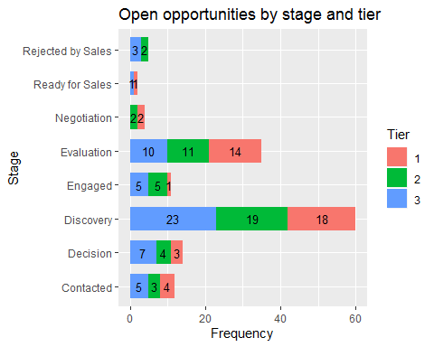

##Q3: What is the average order value (ABC) by Tier and Sub sector.

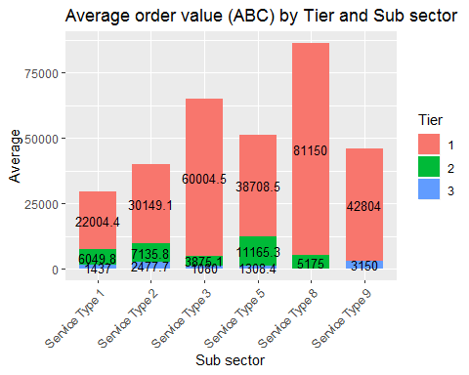

##Q4: What is average sales age by tier and sub sector.

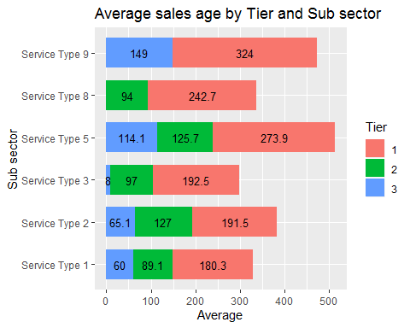

##Q5: For deals that have closed won what is the average sales age by tier and subsector.

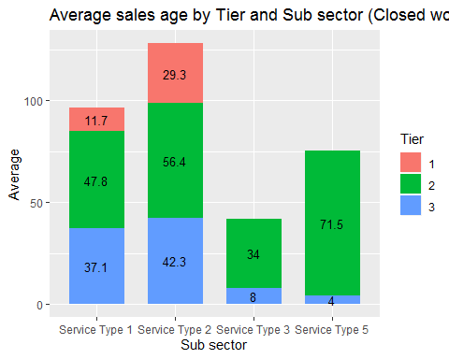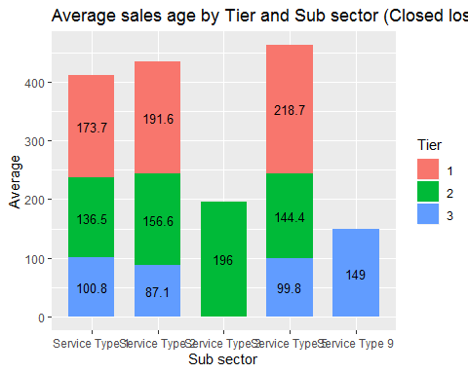

##Q6: Number of deals closed by tier by opportunity owner.

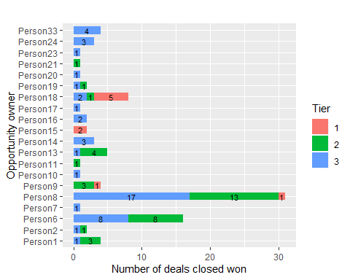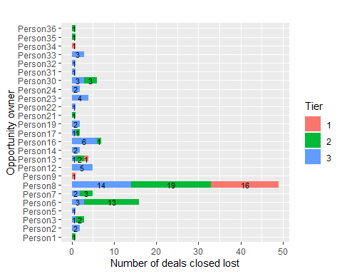

## Q7: What is our sweet spot - i.e. which subsector and tier are we winning most deals? Which sub sector and tier are we losing most deals?

## Q8: Is there a trend where deals are taking longer to close due to order value (ABC)?

The correlation between sales age and order value is positive and the correlation is very low (0.21). Which means, the sales age increase with order value. Although their relationship statitically significant (p-value is less than 0.05), but it’s a weak relation. The trend is not obvious.

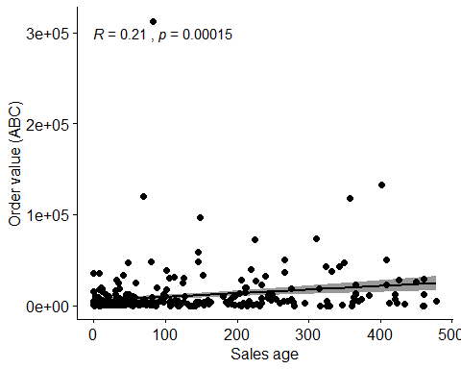

## Q9: Deals won by campaign, deals lost by campaign

