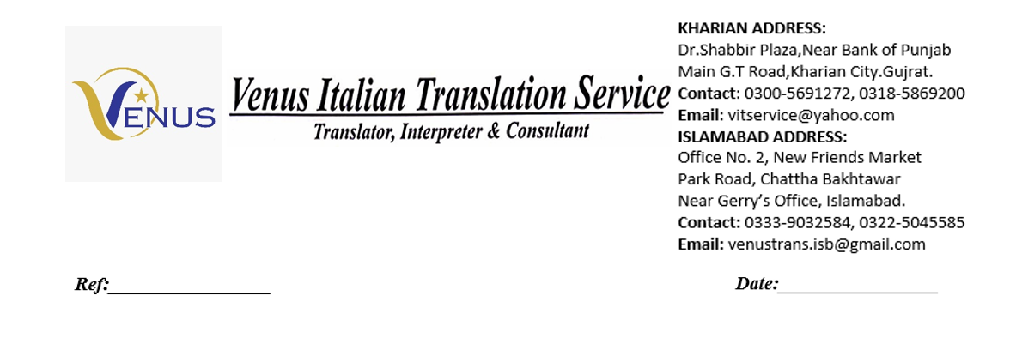

This is to certify that eman has successfully completed the internship at our organization from 2025-09-03 to 2025-09-17. During this period, they demonstrated dedication, learning, and professionalism.

Issued on: 16-09-2025

