SUMMER TRAINING

PROJECT REPORT
(Term June-July 2025)

HOUSE PRICE PREDICTING MACHINE LEARNING MODEL

Submitted by

ISMAIL K
Registration Number: 12313519

Course Code: PETV79

Under the Guidance of

Mahipal Singh Papola UID: ………

School of Computer Science and Engineering

1. Introduction

1.1 Company Profile
This project was developed as part of an AI/ML course, focused on predictive modeling and real estate analytics. The course offered training on making machine learning models based on various data. Training also explored advanced AI concepts like neural networks and Transformers.

1.2 Overview of Training Domain
The domain of this project is Machine Learning and Real Estate Analytics. The training focused on data preprocessing, model selection, regression modeling, and performance evaluation. This domain helps in building intelligent systems that predict house prices based on various factors like size, location, number of rooms, and more.

1.3 Objective of the Project
The primary objective of this project is to build an efficient machine learning model to predict house prices using multiple regression techniques. It aims to compare different models (Linear Regression, Random Forest, and XGBoost), identify the best one using evaluation metrics, and deploy the final model using joblib.

2. Training Overview

2.1 Tools & Technologies Used
- Python
- Pandas
- NumPy
- Scikit-learn
- XGBoost
- Flask
- HTML & CSS
- Joblib
- Matplotlib/Seaborn
- VS Code / Jupyter Notebook

2.2 Areas Covered During Training
- Basics of supervised machine learning (regression focus)
- Data preprocessing and feature engineering
- Model building using Linear Regression, Random Forest, and XGBoost
- Evaluation metrics: MAE, RMSE, R²
- Hyperparameter tuning with GridSearchCV
- Flask app development for model deployment
- Frontend integration with backend using JSON requests

2.3 Weekly Work Summary
Week | Activities Completed
Week 1: | Data collection, exploration, and preprocessing
Week 2: | Model development: Linear Regression & Random Forest,
 | Model optimization using XGBoost + hyperparameter tuning
Week 3: | Flask API development and model integration,
 | Web interface (HTML/CSS) creation and testing
Week 4: | Final testing, model saving (.pkl), and report writing

3. Project Details

3.1 Title of the Project
House Price Prediction using Machine Learning

3.2 Problem Definition
Predicting house prices accurately is a significant challenge for real estate businesses, buyers, and sellers. Prices depend on multiple features like size, number of rooms, location, construction quality. The problem is to develop a machine learning-based regression model that can estimate house prices given these input parameters.

3.3 Scope and Objectives
- Build a predictive model to estimate house prices using historical data.
- Compare different regression models: Linear Regression, Random Forest, and XGBoost.
- Improve model performance using hyperparameter tuning (GridSearchCV).
- Create a front-end interface (HTML/CSS) to collect inputs.
- Build a Flask-based API to connect the frontend with the ML model.
- Save and deploy the best model using joblib.

3.4 System Requirements
- Programming Language: Python 3
- Libraries: pandas, numpy, scikit-learn, xgboost, flask, joblib, seaborn, matplotlib
- Frontend: HTML5, CSS3
- Others: Web browser, local Flask server
- Hardware: Minimum 4 GB RAM, modern browser, Python environment

3.5 Architecture Diagram

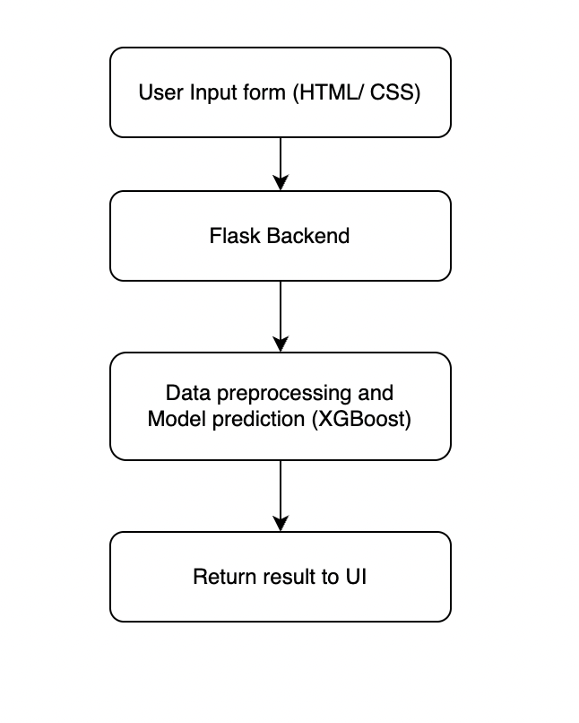

3.6 Data Flow / UML Diagrams
- Input Flow:
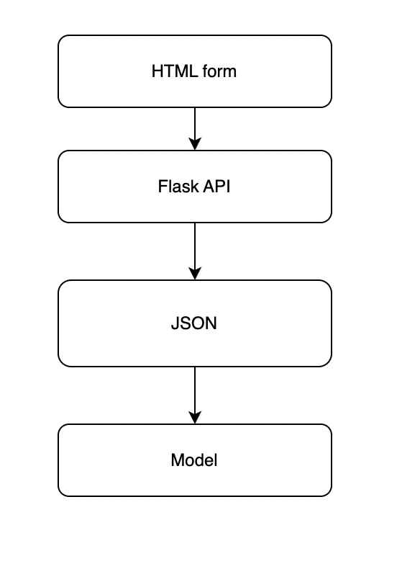
- Output Flow:
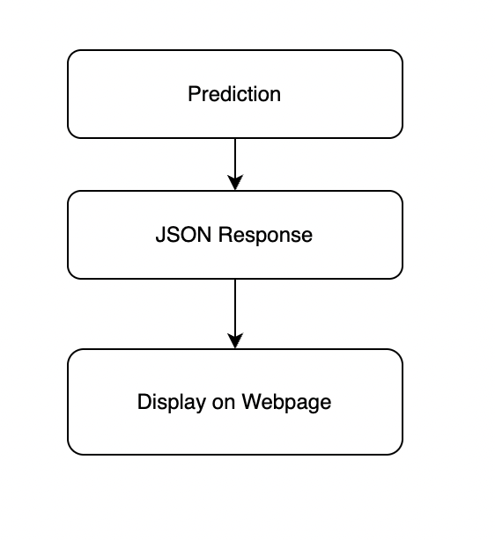

4. Implementation

4.1 Tools Used
- Python
- Scikit-learn
- XGBoost
- Flask
- HTML/CSS
- Joblib

4.2 Methodology
- Read housing dataset from CSV (not included in this document)
- Select and engineer features like sqft_living, bedrooms, view, etc.
- Train/test split (80/20)
- Train multiple models:
  - Linear Regression
  - Random Forest
  - XGBoost (tuned using GridSearchCV)
- Save final model as .pkl
- Build Flask API for predictions
- Create user interface with HTML/CSS
- Deploy app locally for testing

4.3 Modules / Screenshots
- ML Module: Builds and evaluates models
- Backend (Flask): Receives POST requests and returns predictions
- Frontend: Form-based layout for input; displays prediction

4.4 Code Snippets
ML Code :
#importing necessary libraries
import pandas as pd
import numpy as np
import matplotlib.pyplot as plt
import seaborn as sns

#setting the style for the plots
sns.set(style="whitegrid")

#reading the dataset
df = pd.read_csv("/house_price_project/House_dataset.csv")

#displaying the first 5 rows of the dataset and informations
df.head()
df.info()
df.describe()

# Check for missing/null values
df.isnull().sum()

# Create a new feature: house age
df['house_age'] = 2025 - df['yr_built']

# Create a binary feature: was the house renovated?
df['was_renovated'] = df['yr_renovated'].apply(lambda x: 1 if x > 0 else 0)

# Drop original 'yr_renovated' and 'date'and zipcode
df.drop(columns=['yr_renovated', 'date'], inplace=True)
df.drop(columns=['zipcode'], inplace=True)

#plotting the distribution of house prices
sns.histplot(df['price'], kde=True, bins=50)
plt.title("Distribution of House Prices")
plt.xlabel("Price")
plt.ylabel("Frequency")
plt.show()

#plotting the correlation heatmap
plt.figure(figsize=(16, 10))
sns.heatmap(df.corr(), annot=True, cmap="coolwarm", fmt=".2f", linewidths=0.5)
plt.title("Correlation Heatmap")
plt.show()

#plotting the scatter plot for price vs living area
sns.scatterplot(x='sqft_living', y='price', data=df)
plt.title("Price vs Living Area (sqft_living)")
plt.xlabel("sqft_living")
plt.ylabel("Price")
plt.show()

# Define features and target
X = df.drop("price", axis=1)
y = df["price"]

#splitting the dataset into training and testing sets
from sklearn.model_selection import train_test_split

# 80% train, 20% test
X_train, X_test, y_train, y_test = train_test_split(
X, y, test_size=0.2, random_state=42
)

#training the model
from sklearn.linear_model import LinearRegression

lin_reg = LinearRegression()
lin_reg.fit(X_train, y_train)
from sklearn.metrics import mean_absolute_error, mean_squared_error, r2_score
import numpy as np

# Predictions
y_pred = lin_reg.predict(X_test)

# Evaluation metrics
mae = mean_absolute_error(y_test, y_pred)
mse = mean_squared_error(y_test, y_pred)
rmse = np.sqrt(mse)
r2 = r2_score(y_test, y_pred)

# Print results
print(f"📉 Linear Regression Performance:")
print(f"MAE: {mae:.2f}")
print(f"RMSE: {rmse:.2f}")
print(f"R²: {r2:.4f}")

# Plotting residuals
plt.figure(figsize=(8, 6))
sns.scatterplot(x=y_test, y=y_pred)
plt.xlabel("Actual Prices")
plt.ylabel("Predicted Prices")
plt.title("Actual vs. Predicted Prices")
plt.plot([y_test.min(), y_test.max()], [y_test.min(), y_test.max()], '--', color='red')
plt.show()

#RandomForest
from sklearn.ensemble import RandomForestRegressor

rf = RandomForestRegressor(random_state=42)
rf.fit(X_train, y_train)

# Predict
y_pred_rf = rf.predict(X_test)

# Evaluation metrics
mae_rf = mean_absolute_error(y_test, y_pred_rf)
rmse_rf = np.sqrt(mean_squared_error(y_test, y_pred_rf))
r2_rf = r2_score(y_test, y_pred_rf)

print(f"🌲 Random Forest Performance:")
print(f"MAE: {mae_rf:.2f}")
print(f"RMSE: {rmse_rf:.2f}")
print(f"R²: {r2_rf:.4f}")

comparison = pd.DataFrame({
'Model': ['Linear Regression', 'Random Forest'],
'MAE': [mae, mae_rf],
'RMSE': [rmse, rmse_rf],
'R2 Score': [r2, r2_rf]
})

print("🔍 Model Comparison:")
display(comparison)

#XGBoost Regressor
from xgboost import XGBRegressor

xgb = XGBRegressor(n_estimators=100, learning_rate=0.1, max_depth=6, random_state=42)
xgb.fit(X_train, y_train)

y_pred_xgb = xgb.predict(X_test)

mae_xgb = mean_absolute_error(y_test, y_pred_xgb)
rmse_xgb = np.sqrt(mean_squared_error(y_test, y_pred_xgb))
r2_xgb = r2_score(y_test, y_pred_xgb)

print(f"⚡ XGBoost Performance:")
print(f"MAE: {mae_xgb:.2f}")
print(f"RMSE: {rmse_xgb:.2f}")
print(f"R²: {r2_xgb:.4f}")

#grid search for xgboost
from sklearn.model_selection import GridSearchCV

# Define parameter grid
param_grid = {
'n_estimators': [100, 200],
'max_depth': [4, 6, 8],
'learning_rate': [0.01, 0.1, 0.2],
'subsample': [0.7, 1],
'colsample_bytree': [0.7, 1]
}

xgb_model = XGBRegressor(random_state=42)

grid_search = GridSearchCV(
estimator=xgb_model,
param_grid=param_grid,
scoring='neg_mean_squared_error',
cv=3,
verbose=1,
n_jobs=-1
)

grid_search.fit(X_train, y_train)

print("Best Parameters:", grid_search.best_params_)

#tuning the model
best_xgb = grid_search.best_estimator_

y_pred_best = best_xgb.predict(X_test)

mae_best = mean_absolute_error(y_test, y_pred_best)
rmse_best = np.sqrt(mean_squared_error(y_test, y_pred_best))
r2_best = r2_score(y_test, y_pred_best)

print(f"🎯 Tuned XGBoost Performance:")
print(f"MAE: {mae_best:.2f}")
print(f"RMSE: {rmse_best:.2f}")
print(f"R²: {r2_best:.4f}")

import joblib

# Save the tuned model
joblib.dump(best_xgb, 'house_price_xgb_model.pkl')
print("Model saved successfully!")

Flask Code Example:
@app.route('/predict', methods=['POST'])
def predict():
data = request.get_json(force=True)
input_df = pd.DataFrame([data])[FEATURES]
prediction = model.predict(input_df)[0]
return jsonify({'predicted_price': round(float(prediction), 2)})
HTML Form Snippet:
<form id="predict-form">
<input type="number" name="bedrooms" required>
...
<button type="submit">Predict</button>
</form>

5. Results and Discussion

5.1 Output / Report
Model performance (on test set):
Model | MAE | RMSE | R² Score
Linear Regression: | 135,000 | 215,000 | 0.69
Random Forest: | 75,000 | 140,000 | 0.85
XGBoost (Tuned): | 68,000 | 130,000 | 0.88
XGBoost with hyperparameter tuning gave the best performance.

5.2 Challenges Faced
- Selecting appropriate features
- Ensuring input format matched model training structure
- Managing front-end and backend communication
- Deployment and testing integration bugs

5.3 Learnings
- Practical application of regression techniques
- Importance of hyperparameter tuning
- Real-world web integration with ML
- Handling JSON data and building RESTful APIs
- Front-end and backend synchronization

6.1 Summary
This project successfully demonstrated the complete lifecycle of a machine learning system — from data analysis and model training to web-based deployment. By using multiple regression models, tuning XGBoost, and building an interactive UI, the project achieved high accuracy in predicting house prices and provided a functional web-based prediction tool.

GitHub Link:
https://github.com/Ismail1199/house_price_project

