**Waste to wealth: A mechanism to achieve zero wastes in Villages**

Our country, India is facing a major problem of waste disposal containing solid as well as liquid wastes. Especially in Rural areas where people have no idea regarding proper waste management, we see solid wastes dumped in heaps around us. This causes a serious threat to human beings as well as animals. Rotten vegetables, fruits and other food wastes dumped along with polythene bags really lead to the death of animals when they are consumed by them as they are not separated properly. Recent research tells us that about 90-95% of the cattle contain 10-16 kg of plastic bags inside their body. Hence it is necessary for us to manage wastes and treat them effectively and efficiently. Wastes can be efficiently managed in rural areas by creating the awareness to the local community and make them involve collectively in the disposal methods. By implementing proper disposal methods which are supported with innovative and feasible ideas will help the local community to convert waste into wealth. For developing India as a sustainable society, involvement of the local community is crucial.

The proposed project highlights some of the key modifications in the waste management in order to improve efficiency. It also makes sure that the conversion of waste into wealth will benefit the local community.

**Solid Waste Generation**

**Segregation of wastes at homes**

**Biodegradable Non-Biodegradable**

**Collection of the wastes in different bags based on the type of waste**

**Transporting to nearby SLRMC (Solid Liquid Resource Management Center)**

**Storage in SLRMC**

**Methods to convert “Garbage to Gold”**

1. **Segregation of waste at home in different garbage bags**

Each and every individual must take responsibility to segregate waste into biodegradable (rotten vegetables, fruits, and other food wastes, etc.) and non-biodegradable wastes (glass and plastic bottles, polythene bags, scrap metals, etc.) before destruction and storage of the wastes. Non-biodegradable can further be split and collected separately on the assigned day of the week or month. **Awareness and educational programs must be created among the people in all rural areas by the NGOs. An hour is enough to change our people’s mentality.**

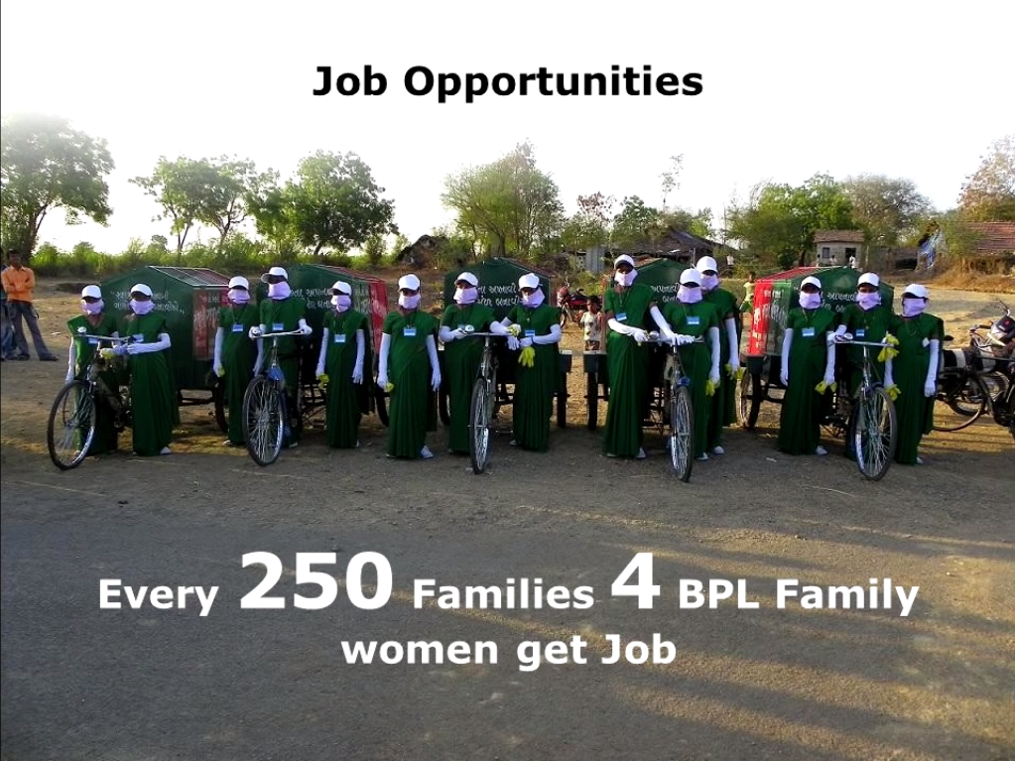

1. **Volunteers for collecting the wastes to transport them**

The local community of the village can create their own job force using unemployed youth, part time students, housewives, retired people etc. **Women, men and youngsters who are interested** can become volunteers to collect the wastes and send them to respective waste management centers. ~~They can be paid by the government and their job can be made permanent too~~. The income generated through waste management can be shared to the staff involved in the process. Through this way we can bring community together for a common purpose.

1. **A timetable to be followed on daily basis**

**A timetable can be followed on a daily basis** for collecting the wastes. For example:-

|  |  |  |
| --- | --- | --- |
| **Day** | **Waste to be collected** | |
| Monday | Food wastes | Plastic bottles |
| Tuesday | Food wastes |  |
| Wednesday | Food wastes | Scrap metals |
| Thursday | Food wastes |  |
| Friday | Food wastes | Glass bottles |
| Saturday | Food wastes |  |
| Sunday | Food wastes | Tins ,Cans |

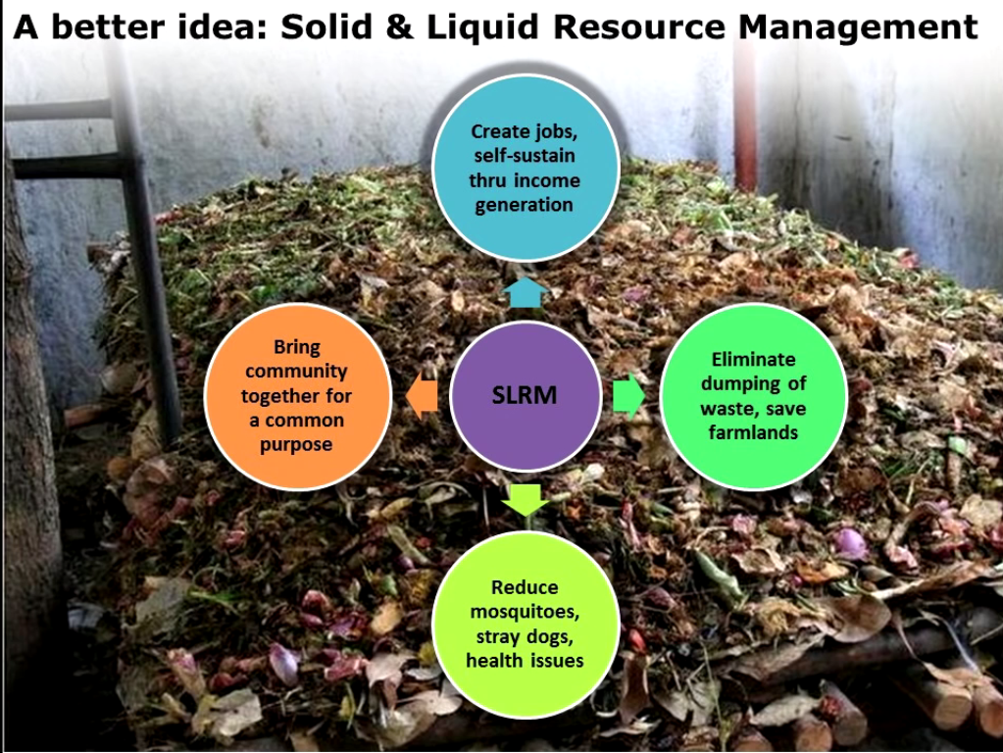

1. **Transportation to Solid Liquid Resource Management Center(SLRMC)**

**A small Solid Liquid Resource management Center should be established at least for 2-3 villages as this can serve as a common point for final waste collection.** Hence these collected wastes have to be transported to the SLRMC.

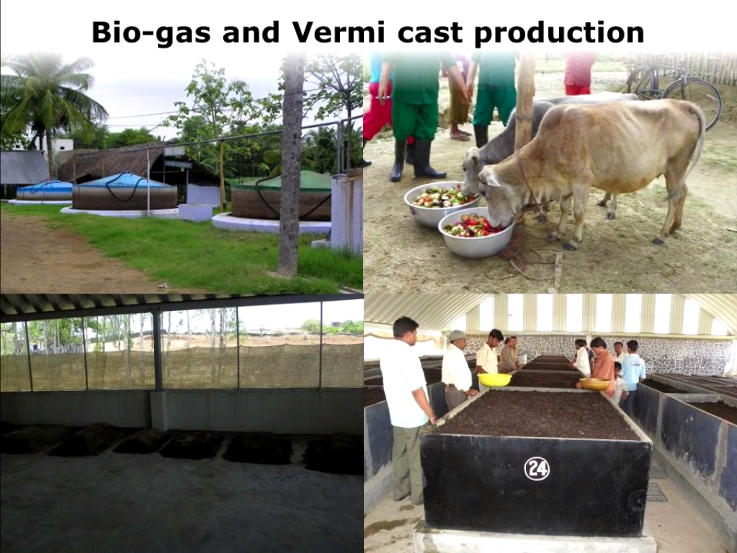

1. **Food stuffs collected within 12 hours is not a waste**

**Leftover food collected from restaurants, homes within a duration of 12 hours is not a waste at all.** These leftovers can be given to cattle as food**. For Every 25 kg of leftover food, a cattle of cows which are dry can be appointed.** With the **help of these cows these leftover food can be converted to cow dung in** less than another **12 hours.**

**USE OF ARTIFIICIAL INTELLIGENCE**

1. **Establishing a bio gas plant**

**Bio degradable wastes which are separated have to be fed into a digester containing slurry (food wastes + cow dung + water).** These wastes are kept in the digester and undergo anaerobic fermentation and release bio gas. When sufficient amount of Biogas is collected in the dome large pressure is exerted on the slurry which in turn forces the spent slurry to overflow through the outlet chamber. Once more biogas is generated they can be used to illuminate street lights in villages.

1. **Pyrolysis treatment of plastic wastes**

This project focuses on controlling the treatment of plastic waste using Artificial Intelligence.In this method there are 3 processes which are being followed at first , a continuous monitoring the plastic wastage system and passing smoke takes place, followed by pyrolysis treatment system and **a wireless GPRS** data information transmission system. The dry distillation gasification treatment process is mainly realized by the following sub systems, namely a charging system, a combustion system, a combustion-supporting system, a cooling system, a tail gas purification system, a water circulation system and a chimney. The monitored data information is transmitted remotely to higher environmental protection departments through the wireless GPRS and a modem. The method has the characteristics of advance, reliability, intelligence and informatization.

The Pyrolysis treatment can be done to treat plastics by heating them at high temperature about 350-450 C in the absence of oxygen to generate oil used as an industrial fuel. Aspirational applications of pyrolysis would convert biomass into **syngas and bio char.** These treatment plants can be constructed along with **SLRMC in semi urban areas thereby reducing cost.**

**Efficient use of plastic and glass wastes**

**Plastics and Glass wastes can be recycled efficiently** by combining with tar to **pave roads**. This helps increase the strength of the road, reducing road fatigue. These roads have **better resistance** towards **rainwater and cold weather.**

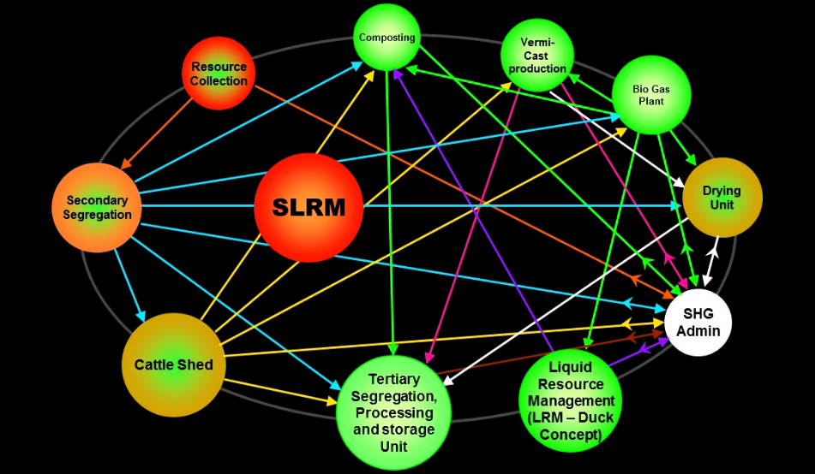

**Conclusion**

The following options may be suggested to overcome the problems related to production, processing, preservation and utilization of organic waste.

1. Motivation of the people is essential.
2. Proper methods of processing (composting) and preservation for efficient management is essential.
3. Government intervention is needed to overcome the problems.
4. Making/amending and implementing of the legislation regarding waste disposal and management system is needed.