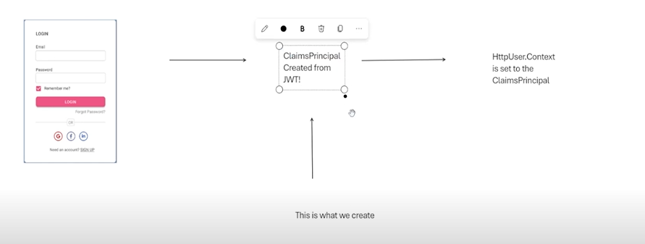

So the user will enter his credentials, he will send his jwt generated to the server, once they are authenticated , the claims principle is going to be created and within this claims we will get access to all these values  
  
Concept of claims: its like a wallet that stores these values, emails ,pass.. and we can use this object all through the app as long as the user is logged in  
  
