Cairo University  
Faculty of Computers and Information



**CS251**

**Software Engineering I**

PN: edugame

Software Design

**TN: Gamers++**

December 2016

Contents

Team 3

Document Purpose and Audience 3

System Models 3

I. Class diagrams 3

Important Algorithm 5

II. Sequence diagrams 6

Class - Sequence Usage Table 8

Ownership Report 8

# Team

|  |  |  |  |
| --- | --- | --- | --- |
| ID | Name | Email | Mobile |
| 20140066 | Alaa Atef Badr | [alaa.badr.25@gmail.com](mailto:alaa.badr.25@gmail.com) | 01140911255 |
| 20140062 | Ismail Ahmed Mahmoud | [ismail.ahmed2014@stud.fci-cu.edu.eg](mailto:ismail.ahmed2014@stud.fci-cu.edu.eg) | 01005887976 |
| 20140206 | Karim Ehab Ahmed | [karimehabahmed@stud.fci-cu.edu.eg](mailto:karimehabahmed@stud.fci-cu.edu.eg) | 01062064070 |
| 20140274 | Mostafa Mohamed ElMenshawy | [mustafa1elmenshawy@gmail.com](mailto:mustafa1elmenshawy@gmail.com) | 01148504856 |

# Document Purpose and Audience

A fully detailed SRS document for a game-based educational website, targeting teenagers & teachers.

Expecting our professor and TAs to read this document for feedback. Also it will act as a reference for us during our working period. Our final version will be introduced to Computek for submission.

# System Models

## I. Class diagrams

### Class Description

| **Class ID** | **Class Name** | **Description & Responsibility** |
| --- | --- | --- |
|  | **User** |  |
|  | **Student** |  |
|  | **Teacher** |  |
|  | **Category** |  |
|  | **Game** |  |
|  | **Level** |  |
|  | **MCQ** |  |
|  | **TorF** |  |
|  | **Achievements** |  |
|  | **Welcome Page** |  |
|  | **Home Page** |  |
|  | **Teacher Home Page** |  |
|  | **Game Page** |  |
|  | **Authentication Control** |  |
|  | **Home Control** |  |
|  | **Game Control** |  |

## II. Sequence diagrams

### Register Sequence Diagram

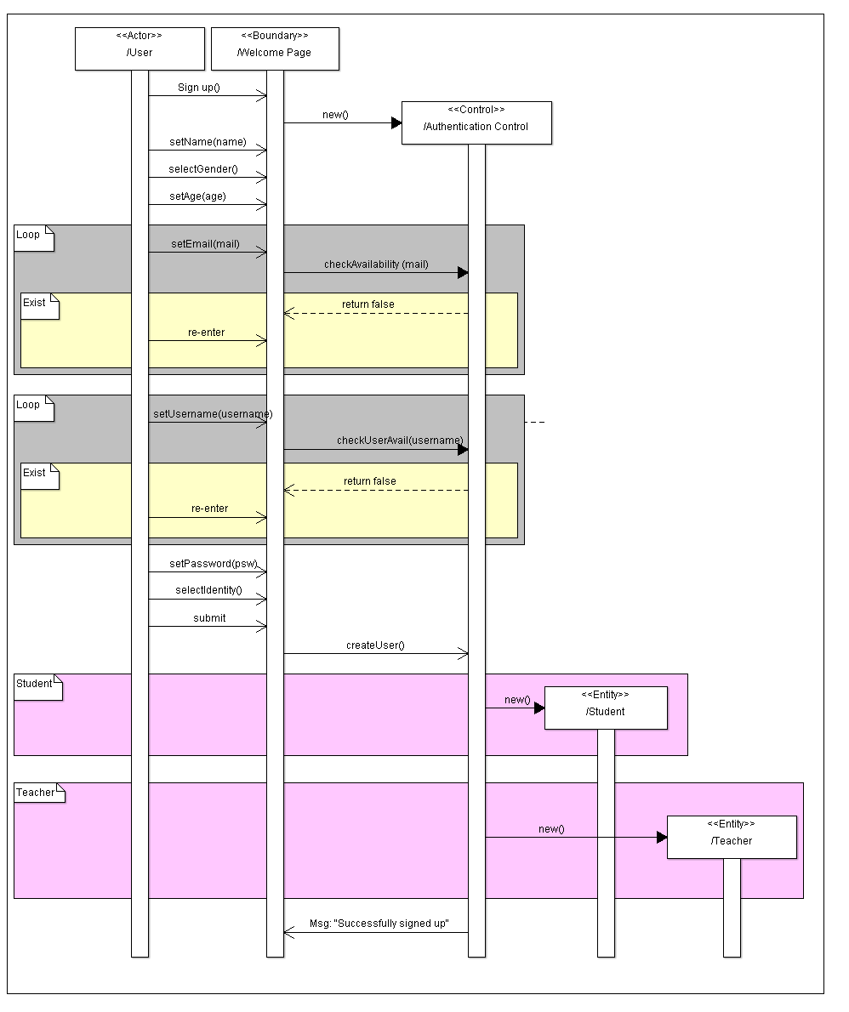

### Play game Sequence Diagram

#### Login Pre-condition

#### Choose Category Pre-condition

#### Choose Game Pre-Condition

#### Play

### Add game Sequence Diagram

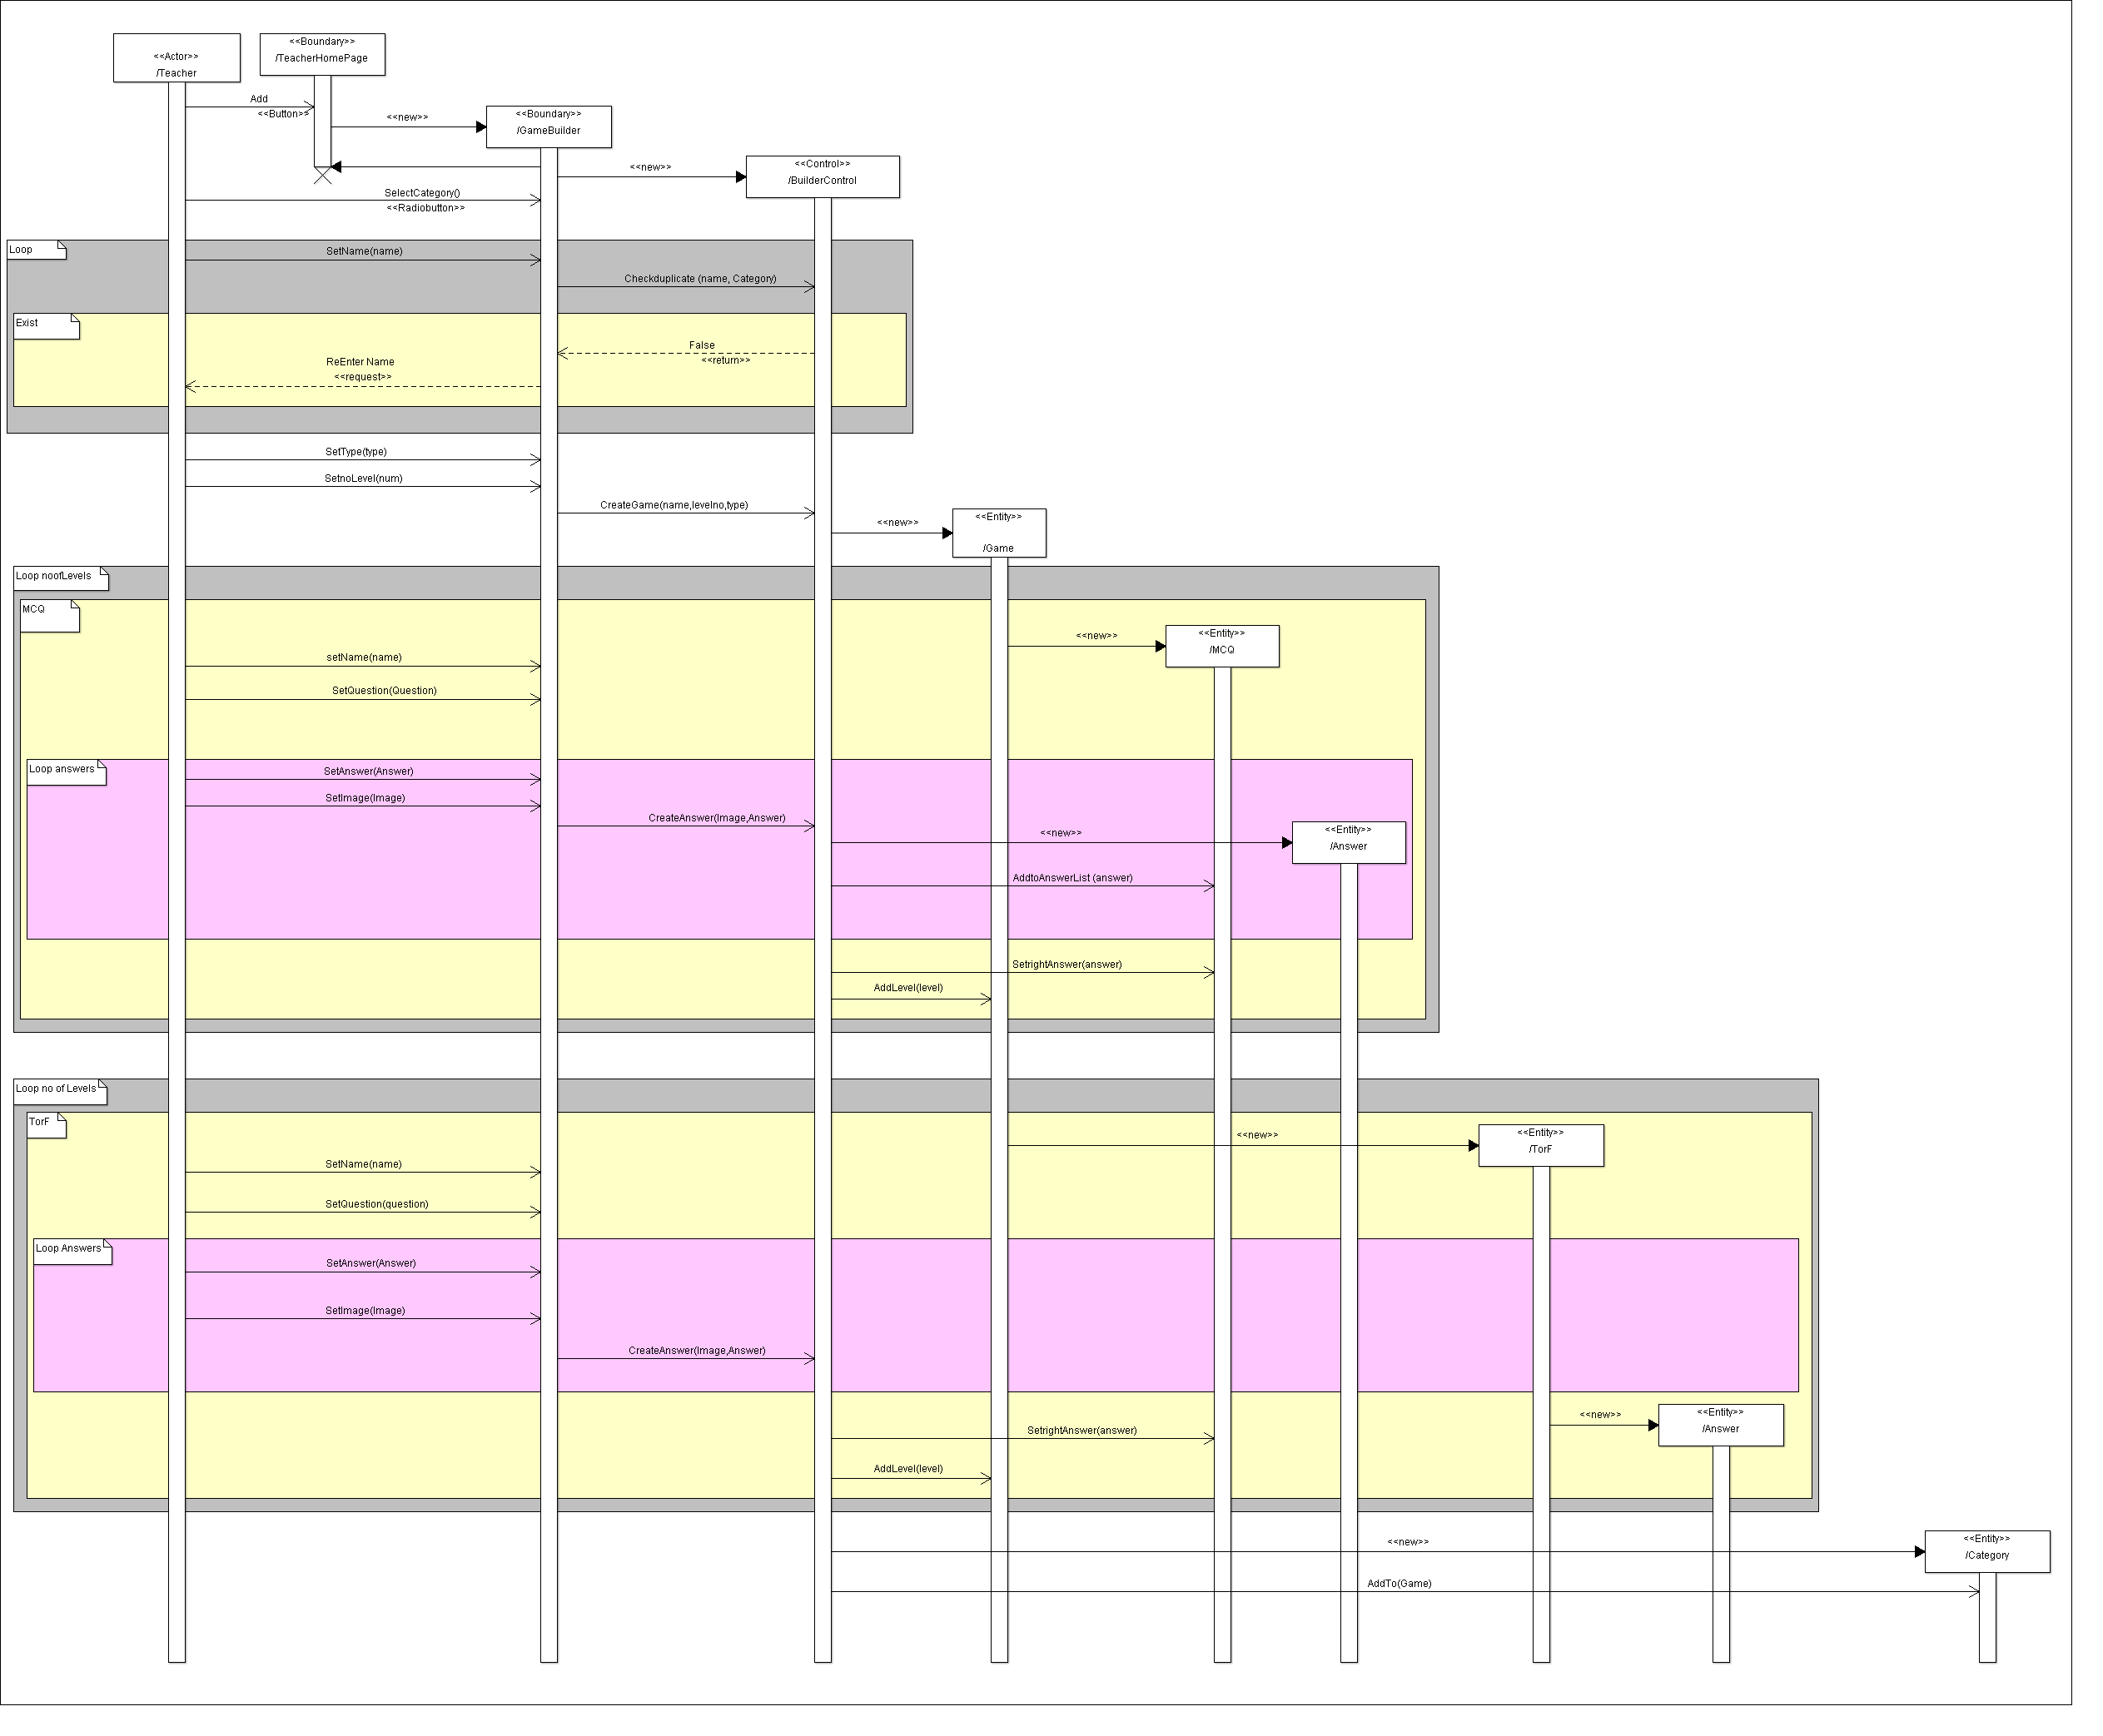

### Class - Sequence Usage Table

| **Class Name** | **Sequence Diagrams** | **Overall used methods** |
| --- | --- | --- |
| E.g. Employee | 1, 3, 5 (means Seq Ids 1, 3, 5 used Employee class) | Save, GetData |
|  |  |  |

# Ownership Report

|  |  |
| --- | --- |
| Item | Owners |
|  |  |
|  |  |
|  |  |