1. For a 4-Queen problem find a solution by applying simple attack detection techniques. **10**
2. Represent the following facts (parent, male, and female) using Predicate Logic and write logical statement to find the listed relations given below. **5**

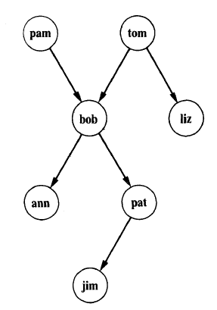

Female: pam, liz, pat, ann

Male: tom, bob, jim

1. Find all X and Y such that X is a ***grandparent*** of Y.
2. Find all X and Y such that Y is an ***offspring*** (child) of X.
3. For all X and Y such that X is a ***mother*** of Y.
4. For all X, if X has a child who has a ***sister*** then X has two children.(*Introduce new relation* ***sister &has two children****).*
5. Define the relation **aunt (X, Y)** in terms of the relations **parent** and **sister**.
6. Consider the Wumpus World domain displayed in the diagram below **5**

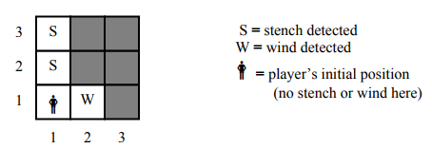

The light squares have been explored by the player, the dark squares have not. Given that a stench indicates the presence of a Wumpus in an adjacent square (diagonal squares included) and a wind indicates the presence of a pit in an adjacent square, use first-order logic to conclude the position of Wumpus in the Wumpus World.

Email to: [dr.saifuddin.aiub@gmail.com](mailto:dr.saifuddin.aiub@gmail.com) by 26th August, 2017