**PSQL TP4 (CSV files)**

**Subject:** PostgreSQL

**Students:** BOURBAI Ismail

**Create DB and Tables:**

**Question 01:**

The following figure shows us the verification of the creations of tables and the database:

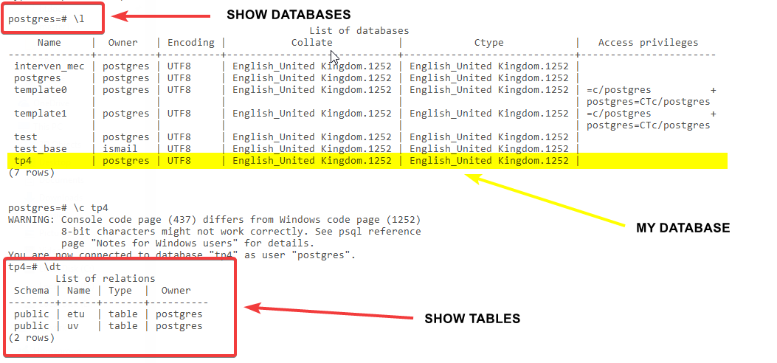

Figure - Question 01

**Question 02:**

The following figure shows us the content of our tables:

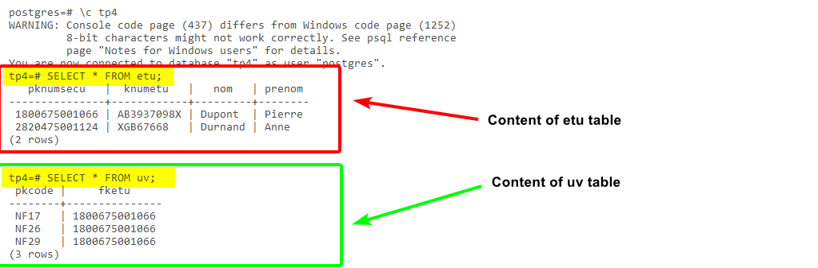

Figure - Question 02

**Import data from CSV files:**

**Question 01:**

To clear tables of etu and uv we execute the following script:

*DELETE FROM uv;*

*DELETE FROM etu;*

**Question 02:**

We call them CSV because it’s stands for **C**omma-**S**eparated **V**alues, and that mean is a delimited text file that uses a comma to separate values.

**Question 03:**

Complete the instructions to insert data from CSV files:

*\copy etu (pknumsecu, knumetu, nom, prenom) FROM 'etus.csv' WITH CSV DELIMITER ';'*

*\copy uv (fketu, pkcode) FROM 'uvs.csv' WITH CSV DELIMITER ';'*

And the Result is:

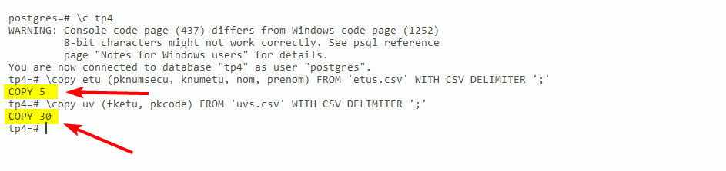

Figure - Question 03