**Report**

**Subject:** Plan of Execution of Queries.

**Students:** CHARFAOUI Younes, BOURBAI Ismail.

**Github Repository:** [**https://github.com/IsmailBourbie/master-one-practical-work/tree/master/db_dm/TP4**](https://github.com/IsmailBourbie/master-one-practical-work/tree/master/db_dm/TP4)

**Step One:**

We’ve installed *MySQL* in our computers, and we’ve used Command line and Text editorfor manipulating and queries the DBMS

**Step Two:**

In this step we create a sample table without partitions using the following SQL Script

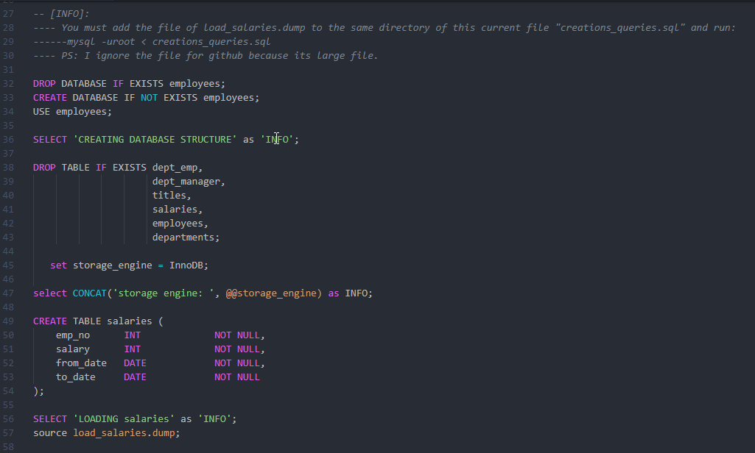

Figure 1 Example of Creation table

**Step Three:**

In This Step we have used script to load our prepared data into the table and count all rows inserted, the following screenshot explain that:

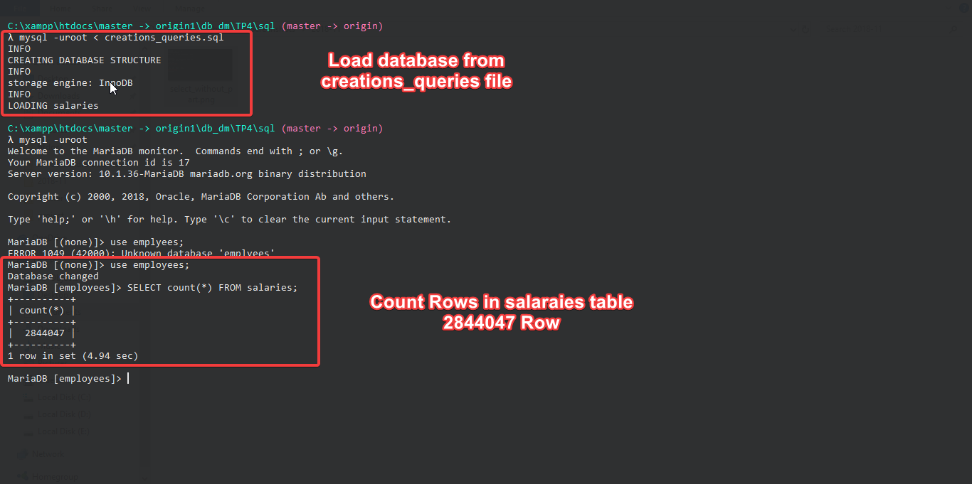

Figure 2 SQL Loader Script

*PS: we didn’t add The Loader file in the repo of GitHub because it is a large file.*

**Step Four:**

The following screenshots show the execution time of select operation on our table without using partitions:

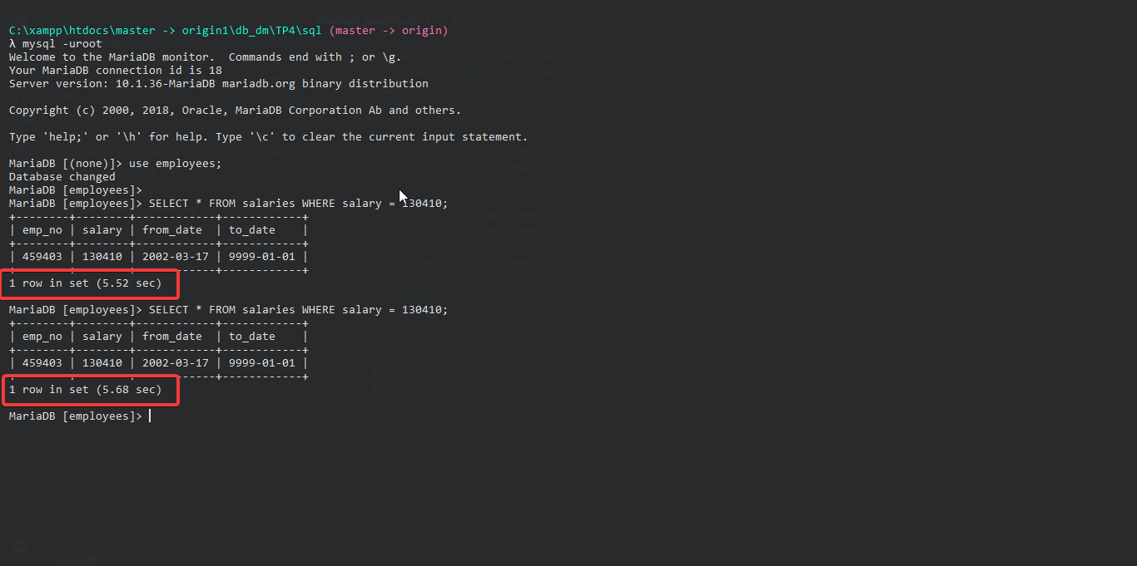

Figure - Execution time without partitions.

**Comment:**

Its take 5.5sec;

**Step Five:**

The execution of the last script (*Figure 4*) take a long time, So we can add Fragmentation to our table (Partitions), and use partitioning BY RANGE.

We can do that by creating partitioned table or just ADD partition on our existing table using the following script:

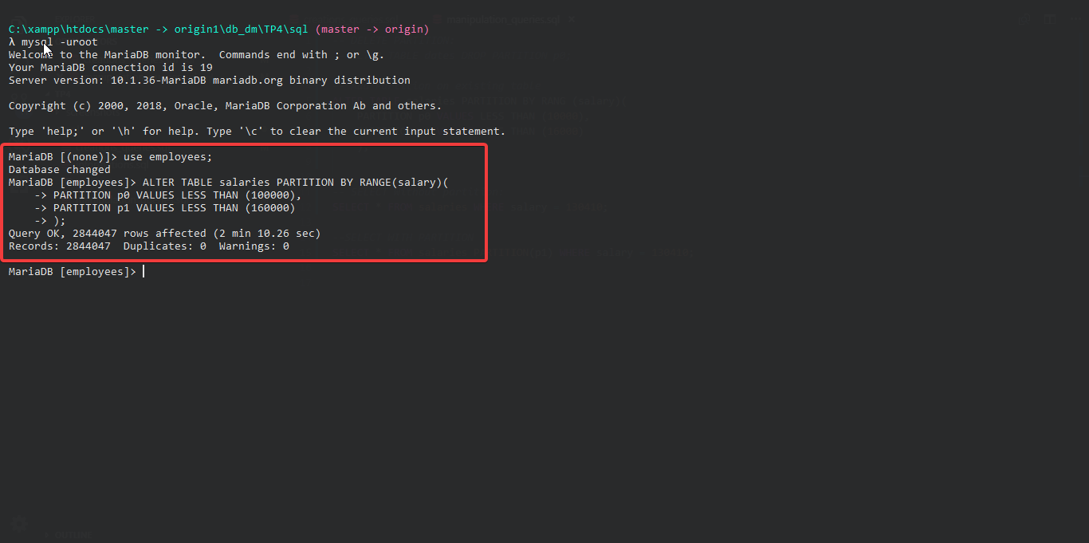

Figure - PARTITION on exesting table

**Step Six:**

We execute the same query of selection operation but this time using partition,

The following script show the query and the result:

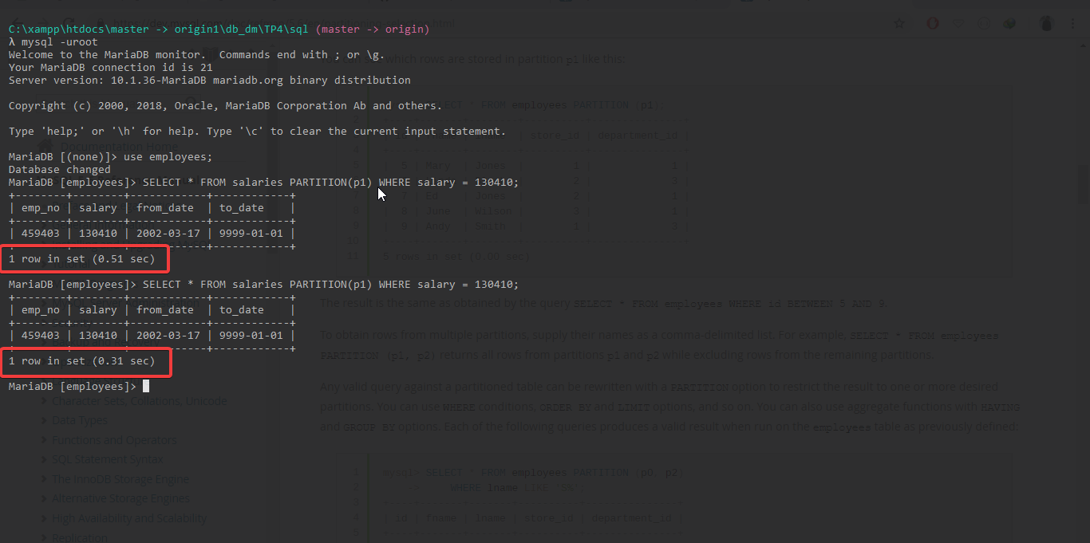

Figure Select using partition

**Comment:**

Its take just 0.3-0.5sec!

**Conclusion:**

In This Practical word we saw that Fragmentation is very useful, it optimize the execution time of queries.