Comparative Shortest-Path Algorithm Analysis
Final Project Report
CSE202 — Algorithms II | Acibadem University

1. Problem Description
The shortest-path problem asks: given a weighted directed graph G = (V, E) and a source vertex s, what is the minimum-weight path from s to every other vertex? This is one of the most widely studied problems in graph theory, with practical applications in navigation systems, network routing, and logistics planning.

This report focuses on a specific formulation: answering shortest-path queries on weighted graphs with non-negative edge weights. Rather than simply solving the problem, the goal is to design, implement, and rigorously compare three distinct algorithmic approaches, each making different trade-offs between preprocessing cost, query speed, memory usage, and graph representation.

The central question driving this comparison is:

- How does the choice of data structure (adjacency matrix vs. adjacency list) affect the performance of the same algorithm?
- When does investing in heavy preprocessing become worthwhile to answer future queries faster?
- How does graph density and size interact with algorithm efficiency?

All experiments use randomly generated directed graphs with positive integer weights. The source vertex is always node 0. Correctness is verified by comparing the output of all three approaches on the same graph, and all three agree on every test.

2. Algorithmic Approaches
Three approaches were designed and implemented. They differ in graph representation, algorithmic strategy, and design philosophy, covering three distinct points in the trade-off space.

2.1 Approach 1 — Dijkstra with Adjacency Matrix
The adjacency matrix stores edge weights in a V×V two-dimensional array, where entry [u][v] holds the weight of the edge from u to v (∞ if no edge exists). This representation gives O(1) edge-weight lookup at the cost of O(V²) memory regardless of how many edges are actually present.

The algorithm iterates V times. In each iteration it performs a linear scan over all V distance entries to find the unvisited vertex with the smallest tentative distance (the “find min” step), then relaxes all V entries in that vertex’s matrix row. Both inner operations are O(V), giving a total time complexity of O(V²).

Design philosophy: on-demand, dense-graph optimised.
No preprocessing is performed. Every query runs the full algorithm. The O(V) inner loops match the matrix’s O(V) neighbour-scan cost perfectly, and the predictable memory access pattern is cache-friendly on dense graphs where most matrix entries are real edges.

2.2 Approach 2 — Dijkstra with Adjacency List + Min-Heap
The adjacency list stores, for each vertex u, only the list of (v, w) pairs for edges that actually exist. Memory usage is O(V + E), which is significantly lower than O(V²) on sparse graphs.

Python’s heapq module provides the min-heap priority queue. Instead of scanning all V distances to find the next minimum (O(V)), the heap yields it in O(log V). Edge relaxation visits only real neighbours (O(degree(u))), not all V vertices. The total complexity is O((V + E) log V).

Design philosophy: on-demand, sparse-graph optimised.
Like Approach 1, no preprocessing is performed. However, by combining the efficient adjacency list with the heap, this approach avoids redundant work on sparse graphs where E ≪ V². It is the standard production-quality implementation of Dijkstra’s algorithm.

2.3 Approach 3 — Floyd-Warshall (All-Pairs, Preprocessing)
Floyd-Warshall computes shortest paths between every pair of vertices in a single O(V³) preprocessing pass. It is based on the following dynamic programming recurrence: the shortest path from i to j using only vertices {0…k} as intermediaries is either the path not using k (dist[i][j][k−1]) or the path through k (dist[i][k][k−1] + dist[k][j][k−1]). Collapsing to an in-place 2-D table, the triple loop iterates over all intermediate vertices k:

for k in range(V):
for i in range(V):
for j in range(V):
dist[i][j] = min(dist[i][j], dist[i][k] + dist[k][j])
After preprocessing, any query (source → target) is answered in O(1) by reading a single cell from the distance table.

Design philosophy: heavy preprocessing, instant queries.
This approach makes sense when the same graph will be queried many times. The O(V³) upfront cost is amortised across Q queries. As Q grows, the per-query cost of Floyd-Warshall approaches zero, while repeated Dijkstra continues to cost O((V+E) log V) per query indefinitely.

3. Complexity Analysis
The table below summarises the theoretical complexities of all three approaches. V denotes the number of vertices and E the number of edges. For a sparse graph with density d, E ≈ d × V².

Approach | Representation | Time Complexity | Space Complexity | Query Time
Dijkstra (Matrix) | Adjacency Matrix | O(V²) | O(V) | O(V²)
Dijkstra (Heap) | Adjacency List | O((V+E) log V) | O(V + E) | O((V+E) log V)
Floyd-Warshall | Adjacency Matrix | O(V³) preprocess | O(V²) | O(1) after prep

Table 1. Time and space complexity summary for the three approaches.

3.1 Impact of Graph Density
Density d is the fraction of the V² possible directed edges that exist. Its effect on the three approaches differs substantially:

- Dijkstra Matrix: complexity is O(V²) regardless of density. The inner loops always scan all V slots. Dense graphs actually favour this approach because the constant factor of O(V²) is small relative to Dijkstra Heap’s O(V² log V) when E ≈ V².
- Dijkstra Heap: complexity is O((V + E) log V) = O((V + d×V²) log V). At low density, E is small and the heap operates near O(V log V). At high density, E ≈ V² and the heap must process many more entries, eroding its advantage over the matrix variant.
- Floyd-Warshall: the O(V³) preprocessing is entirely independent of E. The adjacency matrix is scanned exhaustively. Density affects initialisation time but not the triple loop.

3.2 Impact of Graph Size (Scalability)
As V grows, O(V²) and O(V³) diverge rapidly from O((V+E) log V) on sparse graphs. Specifically:

- Doubling V multiplies Dijkstra Matrix time by ≈4× (quadratic).
- Doubling V multiplies Floyd-Warshall preprocessing by ≈8× (cubic).
- Doubling V multiplies Dijkstra Heap time by ≈4× on sparse graphs, but the log V factor makes the constant smaller than Dijkstra Matrix in practice.

This is confirmed empirically in Section 4.3, where Floyd-Warshall at n=500 takes nearly 8 seconds while Dijkstra Heap completes in under 2 ms on the same graph.

4. Experimental Results
All experiments were run on the same randomly generated graphs (seed=42 for reproducibility). Timing uses Python’s time.perf_counter, averaged over 7 runs per measurement to reduce scheduling noise.

4.1 Fair Comparison — Single Query
The same sparse graph (density=0.10) is given to all three approaches, which each answer a single query from vertex 0. Floyd-Warshall’s reported time includes preprocessing plus one query_all_from call, since the preprocessing is unavoidable.

Size | Edges | Dijkstra Matrix | Dijkstra Heap | Floyd-Warshall
n=50 | 253 | 0.32 ms | 0.09 ms | 6.93 ms
n=100 | 1010 | 0.77 ms | 0.13 ms | 52.5 ms
n=200 | 4051 | 2.99 ms | 0.35 ms | 410.6 ms

Table 2. Single-query runtime on a sparse graph (density=0.10) at three graph sizes.
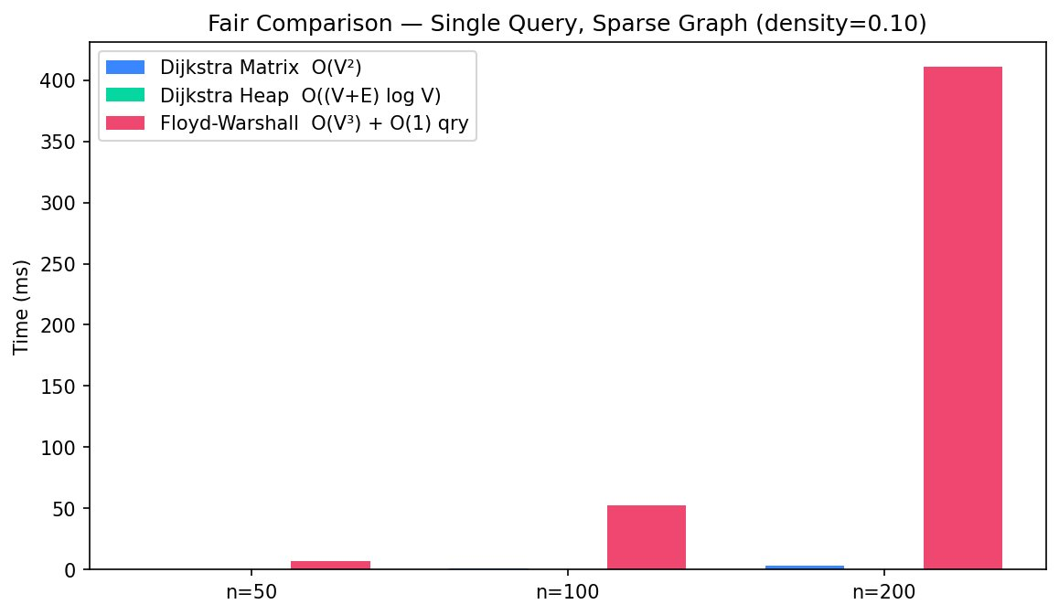
Figure 1. Fair comparison bar chart. Dijkstra Heap is fastest on a single query. Floyd-Warshall’s bar is dominated by preprocessing cost.

On a single query, Dijkstra Heap is by far the fastest because it only processes vertices reachable from the source and pays no preprocessing cost. Floyd-Warshall is the slowest here, as its entire O(V³) preprocessing must be paid even for one answer.

4.2 Density Comparison
Both Dijkstra variants are tested on the same n=100 graph at densities ranging from 0.05 to 1.0 (4.75 to 990 edges per 100 vertices).

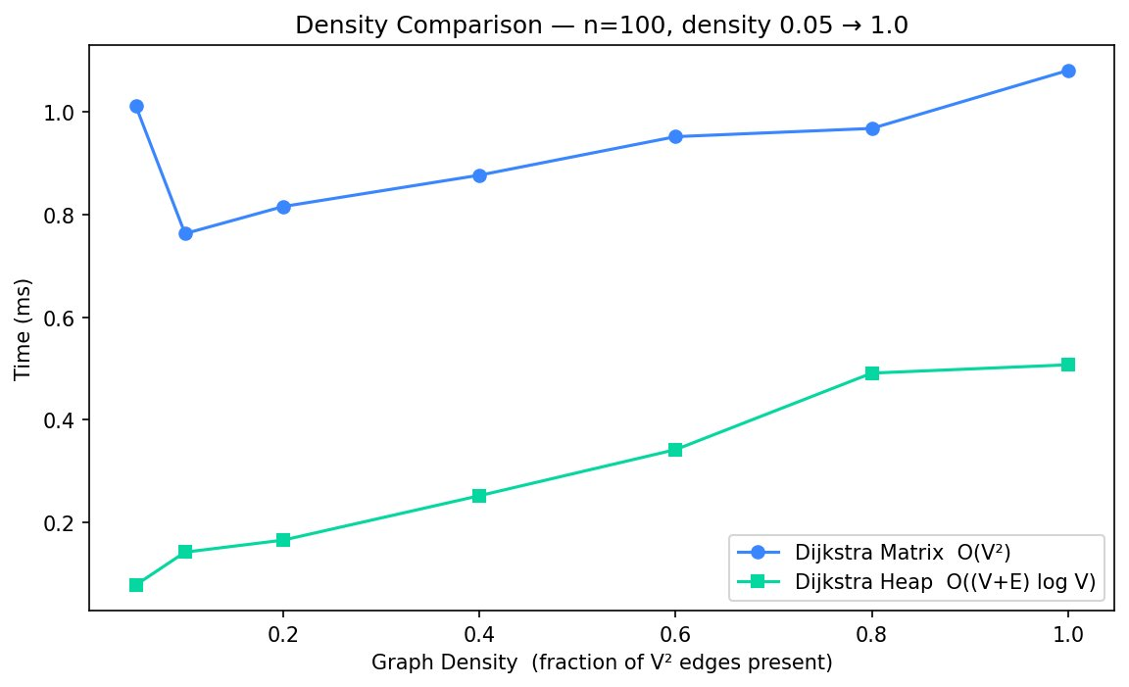
Figure 2. Dijkstra Matrix vs Dijkstra Heap as graph density increases (n=100).

Two observations stand out. First, Dijkstra Matrix’s runtime is nearly flat across all densities, confirming that its O(V²) complexity is driven by V alone, not E. Second, Dijkstra Heap’s runtime rises with density as more edges are pushed onto and popped from the heap. Contrary to the O(V² log V) worst-case theory, Dijkstra Heap remains faster than Dijkstra Matrix at all tested densities for n=100, which reflects the practical efficiency of Python’s heapq versus the interpreted inner loop of the matrix scan.

4.3 Scalability
All three approaches are tested on sparse graphs (density=0.10) with n growing from 10 to 500.

n | Edges | Dijkstra Matrix | Dijkstra Heap | FW Preprocess
10 | 9 | 0.012 ms | 0.003 ms | 0.029 ms
50 | 253 | 0.237 ms | 0.051 ms | 5.82 ms
100 | 1010 | 0.851 ms | 0.121 ms | 51.1 ms
200 | 4051 | 3.19 ms | 0.358 ms | 452.5 ms
500 | 25150 | 21.3 ms | 1.76 ms | 7899.9 ms

Table 3. Scalability results. FW preprocess time is shown separately because its query cost is negligible (O(1)).
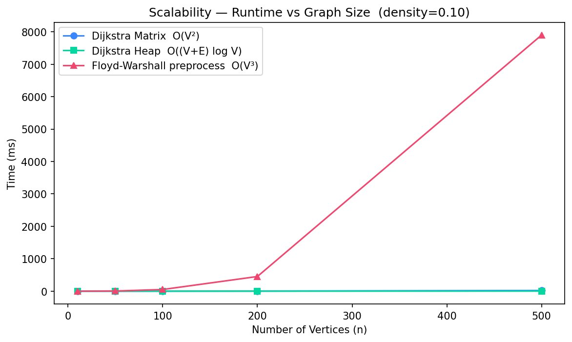
Figure 3. Scalability chart. Floyd-Warshall’s O(V³) curve diverges sharply from the two Dijkstra variants.

Floyd-Warshall’s O(V³) growth is visually dramatic. At n=200 it is roughly 126× slower than Dijkstra Matrix and 1264× slower than Dijkstra Heap. At n=500 the preprocessing takes nearly 8 seconds while Dijkstra Heap answers the same query in 1.76 ms. This confirms that Floyd-Warshall is inappropriate for large graphs when only a small number of queries will be answered.

4.4 Query-Volume Trade-off
This experiment directly measures the break-even point where Floyd-Warshall’s preprocessing cost is recovered through faster queries. The graph is fixed at n=100 (density=0.10). Floyd-Warshall preprocesses once (≈51 ms), then answers each query in O(1). Dijkstra Heap runs from scratch for every query.

Queries (Q) | Dijkstra Heap total | Floyd-Warshall total | FW cheaper?
1 | 0.19 ms | 51.3 ms | No
10 | 1.04 ms | 51.3 ms | No
50 | 5.26 ms | 51.3 ms | No
100 | 10.2 ms | 51.3 ms | No
200 | 20.2 ms | 51.4 ms | No
500 | 50.6 ms | 51.4 ms | No
1000 | 101.8 ms | 51.5 ms | YES ✓

Table 4. Total cumulative time as query count Q increases from 1 to 1000.
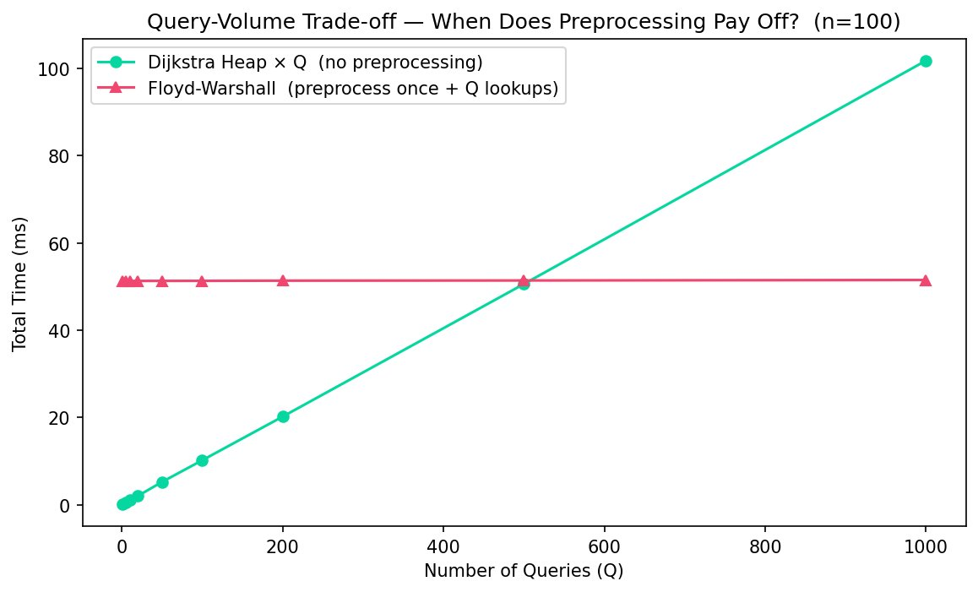
Figure 4. The crossover point: Floyd-Warshall becomes cheaper at approximately Q=1000 for n=100.

The Floyd-Warshall total cost line is essentially flat — it barely moves from Q=1 to Q=1000 because the O(1) lookup time is negligibly small. Dijkstra Heap’s total cost grows linearly with Q. The empirical crossover on this machine occurs between Q=500 and Q=1000. The theoretical crossover can be estimated as:

Q* ≈ T_preprocess / T_dijkstra = 51.3 ms / 0.19 ms ≈ 270 queries

The empirically observed crossover is higher because Floyd-Warshall’s O(1) lookup time is not exactly zero (dictionary overhead, function call cost). The exact crossover will shift depending on graph size: a larger graph increases T_preprocess cubically while T_dijkstra grows quadratically, so the crossover point Q* rises for larger graphs.

5. Comparative Discussion

5.1 When is each approach preferable?
- Dijkstra Heap is the best general-purpose choice. It is the fastest on single queries, scales well on sparse graphs, and has the lowest memory usage. It should be used whenever queries arrive on-demand on large or sparse graphs.
- Dijkstra Matrix is preferable on very dense graphs (E ≈ V²) and when simplicity of implementation matters. Its flat O(V²) behaviour is predictable and cache-friendly. For dense graphs at moderate V, the constant factor advantage of the matrix scan can overtake the heap.
- Floyd-Warshall is preferable when the same graph will be queried many hundreds or thousands of times, especially when queries can involve arbitrary (source, target) pairs rather than a fixed source. The preprocessing cost is amortised rapidly in high-query-volume scenarios such as database-backed route planners or traffic simulation systems.

5.2 Trade-offs
Three fundamental trade-offs emerge from this comparison:

- Preprocessing time vs. query time: Floyd-Warshall inverts the cost model. All on-demand approaches pay per query; Floyd-Warshall pays once. This is the most important trade-off from a systems-design perspective.
- Memory vs. runtime: adjacency lists use O(V+E) space but require heap bookkeeping; adjacency matrices use O(V²) space but enable O(1) edge lookup. Floyd-Warshall’s distance table adds another O(V²) on top of the input.
- Algorithmic generality: Floyd-Warshall handles any graph (including negative weights without negative cycles) in one pass. Dijkstra requires non-negative weights. The data structure choice (matrix vs. list) does not affect correctness, only performance.

5.3 Theoretical vs. Empirical Observations
The density experiment (Section 4.2) produced one result that differs from naive theoretical expectation: Dijkstra Heap outperforms Dijkstra Matrix at all densities tested, including density=1.0. Theory predicts that at full density (E = V² = 9900 edges for n=100), the heap approach should run in O(V² log V) ≈ O(V² × 7) steps, which should be worse than the matrix’s O(V²). In practice, Python’s heapq is implemented in C and is faster per operation than the interpreted Python loops of the matrix algorithm. This illustrates an important principle: Big-O complexity predicts asymptotic growth but does not determine absolute runtime. Constant factors and implementation quality matter at moderate problem sizes.

6. Conclusions
This project demonstrated that the same shortest-path problem admits radically different algorithmic solutions, each suited to a different operating context. The key conclusions are:

- Data structure choice alone changes the complexity of the same algorithm: switching from adjacency list + heap to adjacency matrix + linear scan changes Dijkstra’s complexity from O((V+E) log V) to O(V²). For sparse graphs this is a significant degradation; for dense graphs it converges.
- The preprocessing vs. query-time trade-off is measurable and quantifiable. For the n=100 test graph, Floyd-Warshall becomes cheaper than repeated Dijkstra Heap at approximately Q=1000 queries. This crossover is predictable from theory and confirmed empirically.
- Scalability is the most critical practical concern. Floyd-Warshall’s O(V³) growth makes it unusable for large graphs with low query volume. Dijkstra Heap’s O((V+E) log V) growth is the most scalable of the three.
- Empirical performance and theoretical complexity can diverge at moderate problem sizes due to implementation-level constants (e.g., C-level heapq vs. interpreted matrix scans). Both dimensions must be considered when selecting an algorithm for a real system.

In summary, algorithm selection is not a matter of finding the “best” algorithm in the abstract, but of matching the algorithm’s cost structure to the constraints of the deployment context — graph size, density, expected query volume, and available memory.

