
Egypt University of Informatics
Computer and Information Systems
Data Analysis Course

The Relationship Between GPA and Sports Involvement

Submitted by:
Yassin Saeed / 24-101295
Lojyn Islam / 24-101200
Mariam Mostafa / 24-101251
Aly Mashhour / 24-101204

Introduction
The relationship between sports involvement and academic performance is a common topic among university students. Some students believe that regular training helps discipline, stress management, and consistency, while others think that spending more time on sports may reduce the time available for studying. This report investigates whether sports participation is actually related to cumulative GPA.
The analysis is based on survey data collected from university students. In addition to GPA, the survey asked about the number of days students play sports each week, how many sports or physical activities they are involved in, how many days off they have, and how many credit hours they are currently taking. The goal is to examine patterns in the data and test whether sports involvement shows a statistically significant relationship with GPA.

Research Question
Is there a significant relationship between sports involvement and GPA among university students?

Hypothesis
H₀ (Null Hypothesis): There is no significant relationship between the number of days a student plays sports per week and cumulative GPA.
H₁ (Alternative Hypothesis): There is a significant relationship between the number of days a student plays sports per week and cumulative GPA.

Population of Interest
University students in different fields of study.

Sampling Method
A convenience sampling method was used. The survey was distributed through university WhatsApp groups, student chats, and social media, which made it possible to collect responses quickly within the project deadline. This method was practical for this study, but it also means the sample may not fully represent the wider student population.

Bias Identification
This survey may be affected by several forms of bias. First, the data is self-reported, so some students may not report their GPA or sports habits with full accuracy. Second, convenience sampling means the responses came from students who were easier to reach, which can make the sample less representative. Third, recall bias may affect answers to questions such as weekly sports days or credit hours. Finally, one GPA entry appears to have been submitted using a different grading scale, which shows that response formatting can also affect the quality of the data.
To reduce these issues, the survey used clear wording and direct questions. During data cleaning, inconsistent values were checked and invalid entries were excluded from the final analysis.

Survey Questions
• Name
• Age
• How many days per week do you play sports?
• How many sports or physical activities are you involved in?
• How many days per week do you have off?
• What is your cumulative GPA?
• How many credit hours are you currently taking?

Online Survey Link
https://docs.google.com/forms/d/e/1FAIpQLSej1FYLSieZwqkL0-dJdD_cSCewz49uCfw6GBrHcqi4hG37Og/viewform?usp=publish-editor

Number of Samples Collected
A total of 50 responses were collected. After data cleaning, 49 valid responses were used in the final analysis. One GPA entry was excluded because it did not match the 4.0 GPA scale used in the rest of the dataset.

Analysis
All figures in this report were generated directly in Python using pandas, seaborn, matplotlib, and scipy. The analysis began with descriptive statistics, followed by visual comparisons and Pearson correlation tests. Extreme credit-hour values above 50 were treated as invalid and excluded from calculations involving credit hours.
Mean : Sum of all GPA values / total number of GPA
(2.5 * 8) + ( 3 * 5) + 2 + ( 2.7 * 5) + ( 2.6 * 3 ) + 0.7 + 1.9 + 2.2 + 2.25 + 2.4 +2.47 +2.72+(2.8*3) + 2.89 + (2.9 *2) + (3.1*2) + 3.3+ 3.4+ (3.5*2) +3.6 + (3.7*2) +3.75+ (3.8*2) + 3.95 +4 = 140.23
140.23 / 50 = 2.8046 the average GPA
Median : 2.8
Mode : 2.5

Visualizations and Interpretation
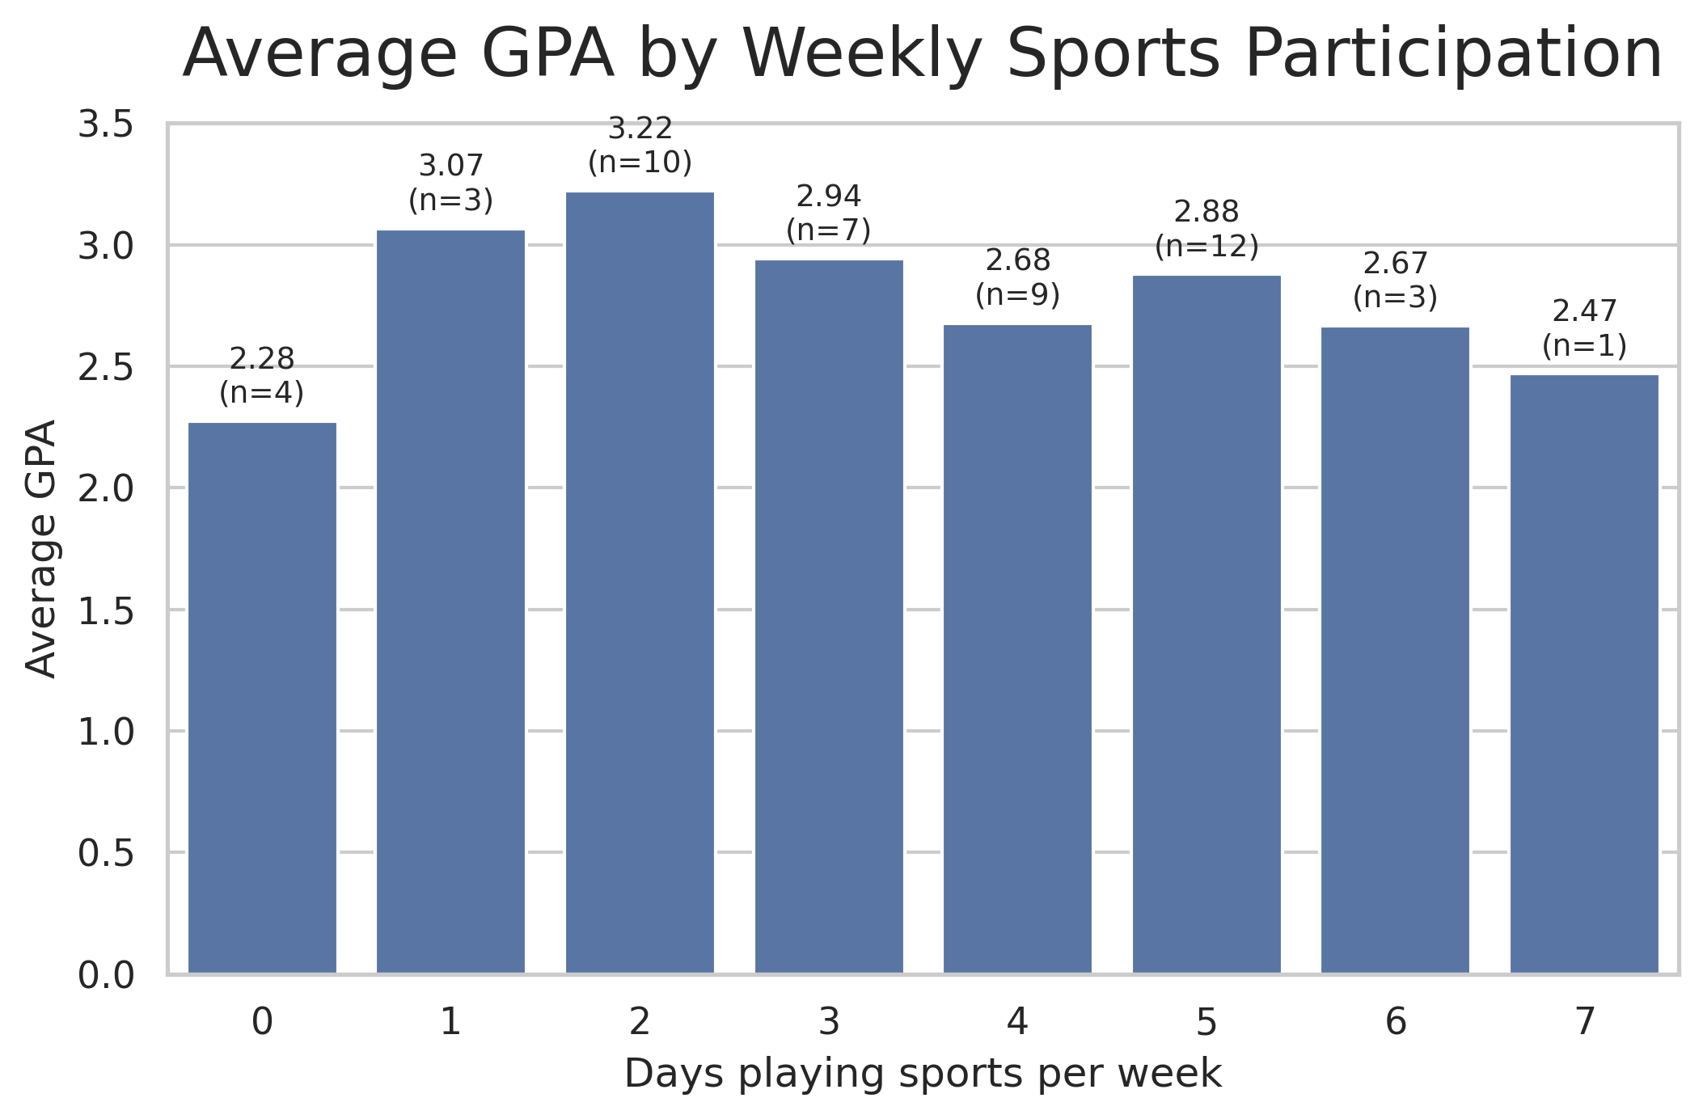
Figure 1. Average GPA by number of days playing sports per week.
The highest average GPA appears among students who reported playing sports 2 days per week (3.22). Students who reported 1 day per week also had a relatively high average GPA (3.07). However, the averages do not follow one steady upward or downward trend as sports days increase. This suggests that the relationship is not linear or strong. It is also important to note that some groups are small, especially the 6-day and 7-day groups, so these averages should be interpreted carefully.
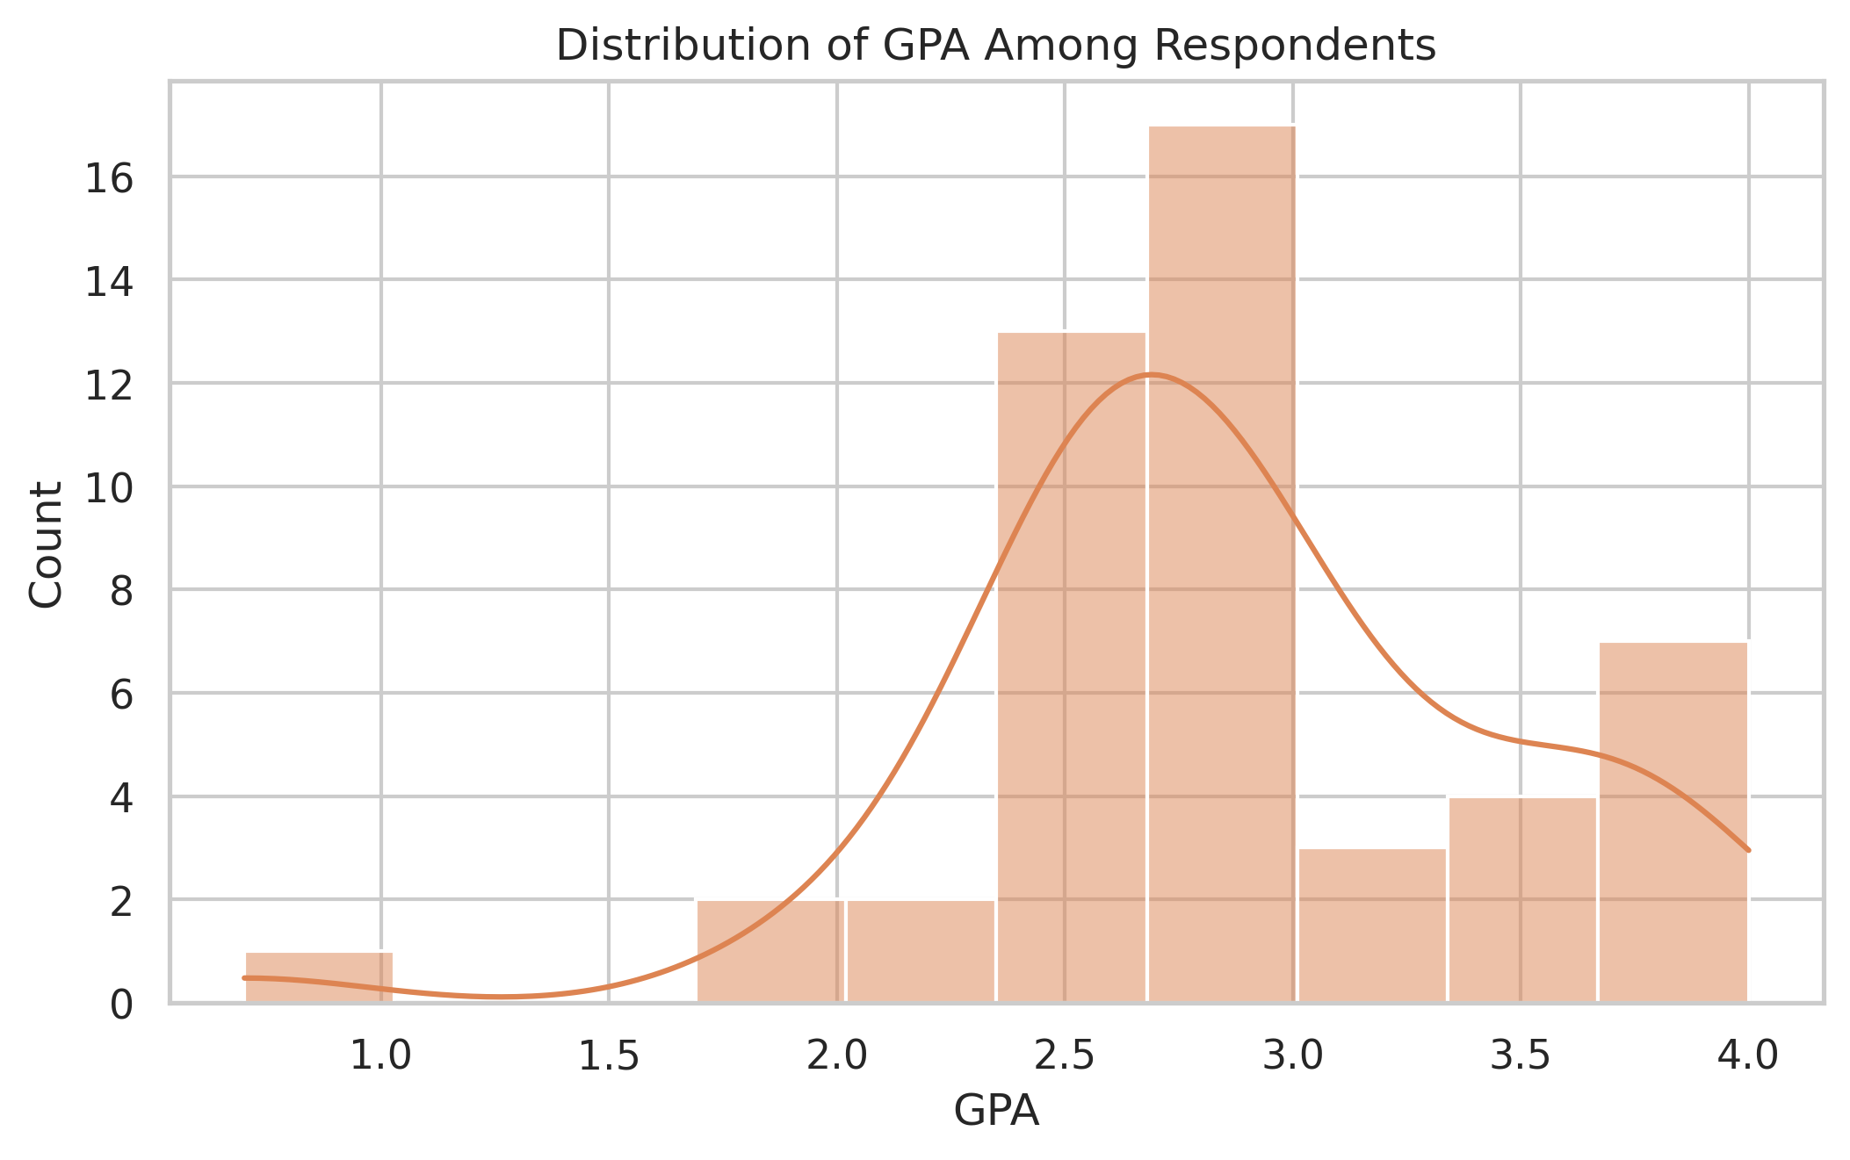
Figure 2. Distribution of GPA among respondents.
The GPA distribution is centered mostly between 2.5 and 3.1, with a sample mean of 2.86 and a median of 2.80. There is one very low GPA value around 0.7, but most observations are concentrated in the middle range. Overall, the distribution shows some spread, but not enough to suggest any unusual clustering tied directly to sports participation.
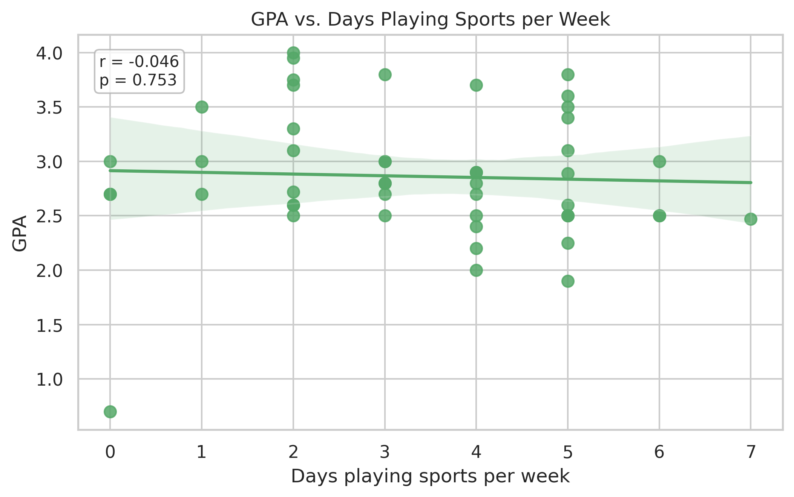
Figure 3. Scatter plot of GPA versus weekly sports participation with regression line.
This graph provides the clearest view of the relationship between sports days and GPA. The fitted line is almost flat, and the Pearson correlation is very weak (r = -0.046). The p-value is 0.753, which is far above the 0.05 significance level. This means the data does not provide evidence of a statistically significant linear relationship between the two variables.
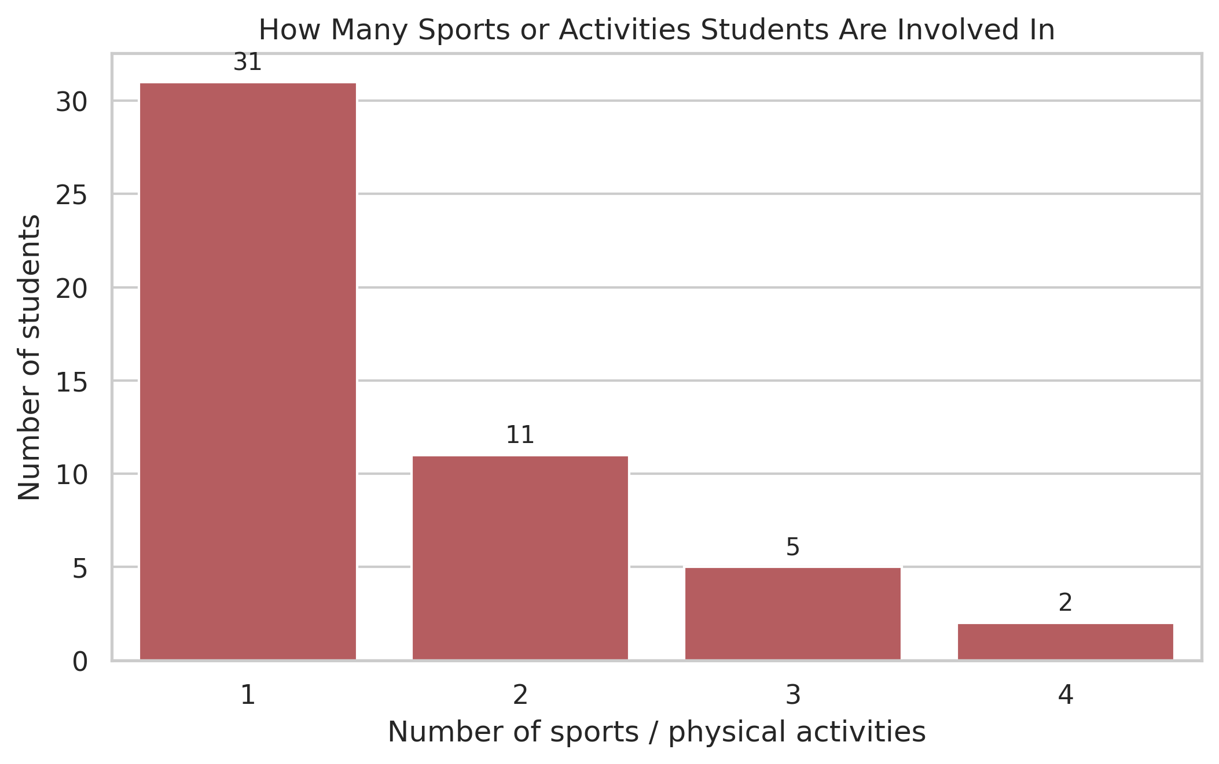
Figure 4. Number of sports or physical activities students are involved in.
Most students in the sample are involved in only one sport or physical activity (31 students, about 63.3% of the sample). The number drops to 11 students for two activities, 5 students for three activities, and 2 students for four activities. This means the dataset is heavily weighted toward students with limited sports variety.
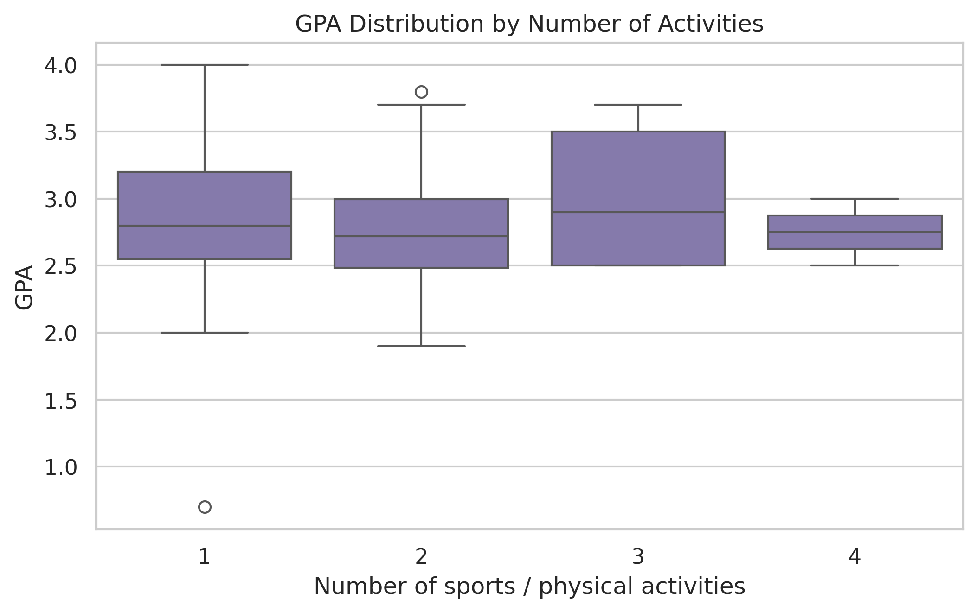
Figure 5. GPA distribution by number of sports or physical activities.
The box plot shows strong overlap between the GPA distributions of the activity groups. The medians are close, and no group shows a clear or consistent advantage. This supports the idea that simply being involved in more sports or activities does not automatically correspond to a higher or lower GPA in this sample.

Conclusion

Based on the analysis, sports involvement does not appear to be a strong predictor of GPA in this sample. The statistical test showed no significant relationship between the number of days students play sports and their GPA, as the Pearson correlation was very weak and the p-value was greater than 0.05. This means the null hypothesis is not rejected, and the data does not provide enough evidence of a meaningful linear relationship between sports participation frequency and academic performance.

Additional checks were also carried out to compare GPA with the number of physical activities and with credit hours, and these results were also not statistically significant. This further suggests that GPA was not strongly associated with sports involvement.

Overall, students who participated in sports more frequently did not consistently have either higher or lower GPAs. Within this dataset, academic performance seems to be influenced more by other factors such as study habits, time management, course difficulty, motivation, sleep, and personal circumstances. Therefore, while sports may still play an important role in students’ lives, sport’s effect on GPA was not strong enough in this sample to be detected as statistically significant.

Any Potential Issues
• The data is self-reported, which means some responses may contain inaccurate GPA or sports information.
• One GPA entry appears to have been submitted using a different grading scale, which required exclusion during cleaning.
• Some comparison groups are very small, especially students who reported 6 or 7 sports days and those involved in 4 activities.
• The survey did not measure other important variables such as study hours, sleep quality, course difficulty, or stress level.

