Python Operators

Operators are used to perform operations on variables and values.

In the example below, we use the + operator to add together two values:

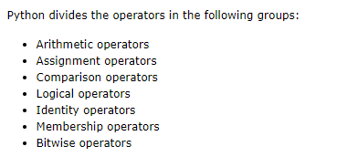

## Python Arithmetic Operators They are used with numeric values to perform common math operations:

## Python Assignment Operators

# Assignment operators are used to assign values to variables:

# 

## 

## 

## 

## 

## Python Comparison Operators

# Comparison operators are used to compare two values:

# 

# 



 

