Week 1 Notes:

Research must be:
Reliable:
Repeatable: make sure work can be taken and repeated
Valid:

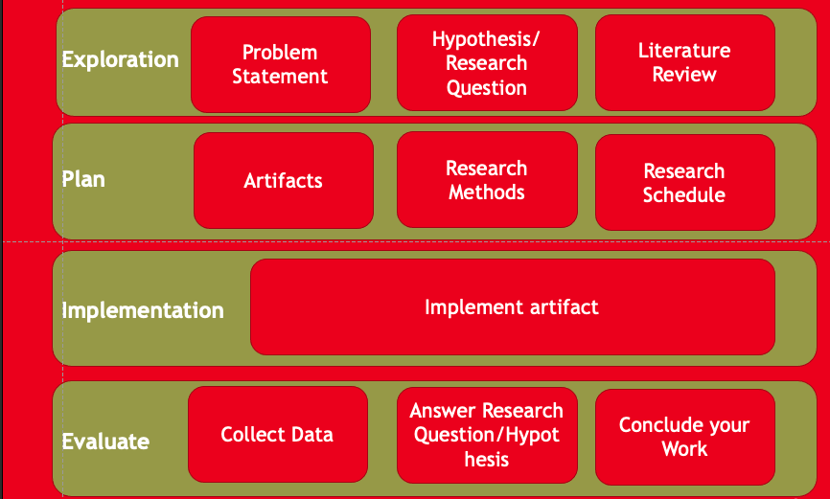

Qualitative:
Quantitative: Measuring absolutes (can be generalised)

