**COM526 Introduction to AI**

**AE1 Portfolio Report**

Contents

**WEEK 1 ACTIVITIES** 3

1) Define in your own words the following terms in relation to AI and intelligent agents: 4

2) General AI vs Narrow AI 5

References: 5

**WEEK 2 ACTIVITIES** 6

1) Machine Learning, a sub-field of AI, can be achieved using different approaches. Describe the concept of 6

2) Types of Problems Solved Using Artificial Intelligence 7

3) Classify the problems below as classification or regression. 7

4) Steps for building a model 8

5) Explain in your own words what is Robotic Process Automation. What are the major differences between RPA and Macros? 9

References: 9

**WEEK 3 ACTIVITIES** 10

1) What are search algorithms and why are they important in the field of AI? Provide some examples where they could be beneficial. 10

2) Watch the video A* Search Algorithm on YouTube: 10

References: 11

**WEEK 4 ACTIVITIES** 12

1) Explain the difference in a short paragraph between 12

2) For each of the following search strategies, work out the path returned by the search algorithm on the graph shown below. 13

References: 13

**WEEK 5 ACTIVITIES** 14

1) Describe redundant paths in TREE-SEARCH and explain how we can avoid them? 14

2) One strategy to solve Constraint Satisfaction Problems is the backtracking approach. Describe its main steps in a few lines. 14

3) Consider the following scenario: you are in charge of scheduling for computer science classes that meet Mondays, Wednesdays and Fridays. There are 4 classes that meet on these days and 3 professors who will be teaching these classes. You are constrained by the fact that each professor can only teach one class at a time. 14

4) Read on “Responsible AI” practices and write a short paragraph to explain why developing a framework is important. 15

**Introduction**

COM456 Introduction to AI Portfolio Assignment is a collection of all activities completed from week one of the module through to week 5, the portfolio will highlight the theory learnt, AI concepts, design of algorithms, and completing simple problems using AI techniques.

# **WEEK 1 ACTIVITIES**

## 1) Define in your own words the following terms in relation to AI and intelligent agents:

a) Turing test: A test developed by Alan Turning to define intelligence. The test involves three parties on computer, a human, and the interrogator, to pass the computer must fool the interrogator in thinking that it is a human. The Turing test on a basic level would essentially tests if the computer is able to perform these four “skills” as stated in “**Artificial intelligence: a modern approach**” by **Stuart Russell and Peter Norvig**

Natural Language Processing

Knowledge Representation

Automated Reasoning

Machine Learning

Artificial Intelligence: A Modern Approach

b) Rational act: For an Agent, acting rationally is the process of using given knowledge and facts to move forward reaching either the best outcome or best expected outcome based on one’s goals.

**Artificial Intelligence: A Modern Approach**

c) Agent: An agent is something that is able to produce an effect through actions, computer agents execute actions to achieve results such as operate autonomously, perceive their environment, persist over a prolonged time period, adapt, and pursue defined goals.

**Artificial Intelligence: A Modern Approach**

d) Agent function: The function of an agent is to act for the user or other program to complete a pre-defined goal.

**Artificial Intelligence: A Modern Approach**

e) Environment: The environment for an agent would be anything that the agent is able to perceive through sensors. Environment is the task provided before a given agent, environments come in all types, some are more difficult for agents than others.

This is best shown in a figure taken from “**Artificial Intelligence: A Modern Approach**”

f) Percept: The inputs received by the agent through sensors from ones surrounding environment.

**Artificial Intelligence: A Modern Approach**

g) Action: after a solution is found the execution phase will commence in which the agent will make use of its solution to help guide its actions. An agent’s actions are generally not just one single action if the environment is known but instead a map.

**Artificial Intelligence: A Modern Approach**

## 2) General AI vs Narrow AI

Some computer algorithms are capable of mimicking human intelligence, to reason and solve problems on their own, and to apply previously acquired knowledge on completely new types of problems.

Which category or domain do these algorithms fall into? Choose A or B below and explain your choice in a paragraph.

A. Artificial Narrow Intelligence (Narrow AI)

B. Artificial General Intelligence (General AI)

**Option B (General AI)**: I have chosen option B (General AI), as general AI has the ability to solve multiple types of problems (even ones it has never seen before) whether it’s with previously acquired knowledge or newly provided information. Narrow AI on the other hand is specific to its field, as stated in the question if a narrow AI agent were to be given a new type of problem to what it is used to it would not be able to solve it.

## References:

Russell, S, & Norvig, P 2016, Artificial Intelligence: a Modern Approach, EBook, Global Edition : A Modern Approach, Pearson Education, Limited, Harlow. Available from: ProQuest Ebook Central. [15 September 2021].

MONETT, D., LEWIS, C.W.P., THÓRISSON, K.,R., BACH, J., BALDASSARRE, G., GRANATO, G., BERKELEY, I.S.N., CHOLLET, F., CROSBY, M., SHEVLIN, H., FOX, J., LAIRD, J.E., LEGG, S., LINDES, P., MIKOLOV, T., RAPAPORT, W.J., ROJAS, R., ROSA, M., STONE, P., SUTTON, R.S., YAMPOLSKIY, R.V., WANG, P., SCHANK, R., SLOMAN, A. and WINFIELD, A., 2020. Special Issue “On Defining Artificial Intelligence”—Commentaries and Author’s Response. Journal of Artificial General Intelligence, 11(2), pp. 1-100.

WANG, P., 2019. On Defining Artificial Intelligence. Journal of Artificial General Intelligence, 10(2), pp. 1-37.

(Total Number of words: 400)

# **WEEK 2 ACTIVITIES**

## Machine Learning, a sub-field of AI, can be achieved using different approaches. Describe the concept of

Base Example: A Child (toddler) comes into contact with a kitten for the first time. The child doesn’t know what it is called and there are three different ways the child could learn the name of this animal. This example I read from “ Artificial intelligence for marketing: practical applications ”

1. **Unsupervised learning and provide one example**: Unsupervised learning is when a machine is given a cluster of data that has not been classified or labelled in anyway by humans to analyse and find patterns or data groupings without any human intervention. Applications of these could be exploiting data, cross selling strategies, image recognition. If we make use of the base example we can use Unsupervised learning for the child to learn the name of the animal. With Unsupervised learning the child will have to be alone to figure things out by itself, it may not get the correct answers but it will learn more and more about the thing it is trying to figure out (such as cats will meow and dogs will bark).
2. **Supervised learning and provide one example:** Supervised learning is a (machine learning) task in which the machine is given training data which has been labelled for a specific output and the algorithm will have to analyse and learn the patterns that lead the input data to the desired output so that it will be able to yield similar/same results when given a data set it has never seen before. If we make use of the base example we can use Supervised learning to teach the child the name of the kitten. Simply point to it repeating a few dozen times the word “kitty”. Supervised learning would be you Pointing at the kitten and calling it a “kitty” (given the child a labelled example).
3. **Reinforcement learning and provide one example:** Reinforcement Learning is essentially a system to allow the machine to self learn, it works by giving “rewards” for doing correct things and “punishments” for doing the incorrect things which trains the robot or machine to know what to do as it wants to achieve “rewards”. If we make use of the base example we can use Reinforcement learning to teach the child the name of the kitten. Simply correct the child when they mistaken the kitten for something other than what it is and praise the child when they get the name correct.

Russell, S, & Norvig, P 2016, Artificial Intelligence: a Modern Approach, EBook, Global Edition : A Modern Approach, Pearson Education, Limited, Harlow. Available from: ProQuest Ebook Central. [26 October 2021].

## Types of Problems Solved Using Artificial Intelligence

Different Artificial Intelligence algorithms can be used to solve a category of problems. Differentiate between classification, regression and clustering problems and name some algorithms that can be used to solve each type of problem.

**Classification**: Predictive problem in which it would predict the class label for any given example data

**Regression**: Predictive model in which it would predict a relationship between two variables

**Clustering**: Predictive model which divides the data into groups (clusters), It will split data in a specific way that the points within single clusters will become very similar and points in different clusters will be very different (groups unlabelled data)

Classification is a predictive model which attempts to apply class labels on given example data for example an email (in Gmail) can be labelled as one of three “Primary”, “Promotions”, “Updates”. Regression on the other hand is a predictive model which will generate a continuous quantity, it will predict a discrete value in an integer while classification predictive model is a probability for a class label.

Clustering is similar to Classification in a way that it groups the given example data, but it differs here as it groups them into unlabelled clusters (groups) and ensures that each point/item in the cluster are very similar and the points in other clusters are different. Clustering uses unsupervised learning to function.

## Classify the problems below as classification or regression.

**Regression**

**Classification**

**Classification**

**Regression**

**Classification**

**Classification**

## Steps for building a model

Machine learning is integrated in many of the technologies we use every day. For example, have you noticed that platforms will have personalised recommendations, whether it's another funny video on YouTube or a book by your favourite author on Amazon? These are "recommender systems" and they typically consist of a machine learning model trained on a user's browsing history.

Imagine the recommender system of your favourite online clothing store. They have data on all the clothes you've viewed and the clothes you ended up buying. This is enough to make a model to output personalised clothing recommendation for you. Below are tasks to create this model, however, they are incorrectly ordered.

**Correctly order the tasks.**

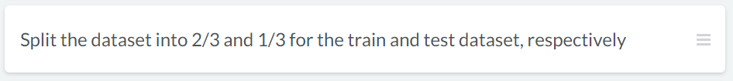

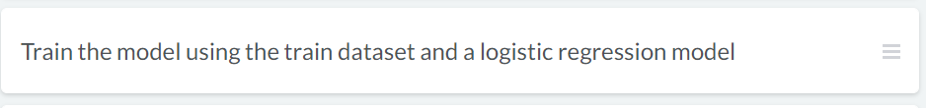

## Explain in your own words what is Robotic Process Automation. What are the major differences between RPA and Macros?

**RPA (Robotic Process Automation):** This is a software process in which you get an automated specialised computer program using rule-based software to perform tasks that are extremely repetitive, this is used to improve the quality of business.

**Differences between RPA and Macros:**

Macros compared to RPA have a limited range on what they can automate as it is difficult to connect them with other products that what they are built with (outside Microsoft Office).

Macros require a certain level of programming knowledge to create in contrast to RPA requiring almost nothing to use.

RPA are able to obtain knowledge over time from their procedures while Macros are unable to as they only perform quick simple tasks (programmed by you likely).

## References:

Newman, D, & Blanchard, O 2019, Human/Machine : The Future of Our Partnership with Machines, Kogan Page, Limited, London. Available from: ProQuest Ebook Central. [26 October 2021].

Russell, S, & Norvig, P 2016, Artificial Intelligence: a Modern Approach, EBook, Global Edition : A Modern Approach, Pearson Education, Limited, Harlow. Available from: ProQuest Ebook Central. [26 October 2021].

(Total Number of words: 713)

# **WEEK 3 ACTIVITIES**

## What are search algorithms and why are they important in the field of AI? Provide some examples where they could be beneficial.

Search algorithms are a sequence of instructions given to the program to help it efficiently find whatever it is the programmer/user wants. Search algorithms in AI is the method of going from the starting state to the goal state and creating a solution after its done.

When agents are built to act rationally, they are more than likely making use of a kind of search algorithm in the background to create a solution for their problem. Search algorithms are so crucial to allow AI to make decisions especially when there are many outcomes such as in games.

Russell, S, & Norvig, P 2016, Artificial Intelligence: a Modern Approach, EBook, Global Edition : A Modern Approach, Pearson Education, Limited, Harlow. Available from: ProQuest Ebook Central. [26 October 2021].

## Watch the video A* Search Algorithm on YouTube:

**(Screenshot of video)**

This video is only 3 minutes long, but feel free to pause and watch couple of times until you understand the concept of A* Search algorithm. Have a pen and paper ready as it will be easier to draw any diagrams.

1. **In a short paragraph, describe what A* (star) search means (try to use terms such as nodes, goal, cost (least distance, shortest time) and heuristics).**

A* algorithm is a path finding algorithm which consists of Nodes, Edges (weighted and unweighted), and a (open) set. It follows the algorithm F(n) (addition of G and H) = G(n) (being the current shortest distance) + H(n) (being the estimate of distance to end) and “n” is the previous node, with this formula the algorithm takes into consideration all the variables (including cost) to find the best path from the starting node and work its way to the end node.

1. **Find the best path for the following problem.**

You need to find the shortest path between S and G by performing the A* Algorithm on the following figure. You should follow the same approach as in the video or lecture notes and show your calculations/diagrams. Explicitly write down the queue at each step.

S: Start

G: Goal

**Best path: ACG**

**Total cost: 4**

## References:

Russell, S, & Norvig, P 2016, Artificial Intelligence: a Modern Approach, EBook, Global Edition : A Modern Approach, Pearson Education, Limited, Harlow. Available from: ProQuest Ebook Central. [26 October 2021].

(Total Number of words: 180)

# **WEEK 4 ACTIVITIES**

## Explain the difference in a short paragraph between

1. **Uninformed and Informed search algorithms (provide some examples)**
   1. Uninformed Search Algorithms are algorithms which have not been provided with any pre-defined information of any sort about the problem (apart from its definition), these algorithms can generally solve any solvable problem but may struggle and be much less efficient. Informed Search Algorithms are able to do very well and efficient as they are given some guidance helping them reach the solutions.
   2. Uninformed Search Algorithms: Depth First Search, Breadth First Search
   3. Informed Search Algorithms: Greedy Search, A* Search, Graph Search

Russell, S, & Norvig, P 2016, Artificial Intelligence: a Modern Approach, EBook, Global Edition : A Modern Approach, Pearson Education, Limited, Harlow. Available from: ProQuest Ebook Central. [26 October 2021].

1. **TREE-SEARCH and GRAPH-SEARCH**

## For each of the following search strategies, work out the path returned by the search algorithm on the graph shown below.

1. Depth-first search algorithm.
2. Breadth-first search algorithm.
3. Uniform cost search algorithm.

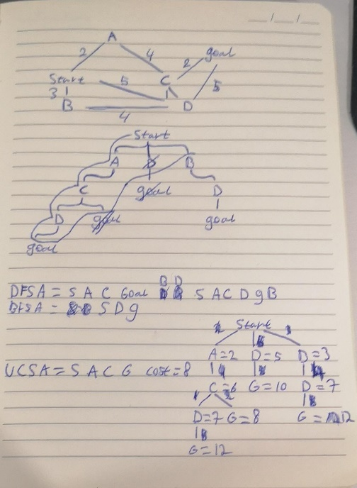

Answers (Solution returned):

1. Depth-first search> Solution is ___Start, A, C, D, Goal, B_
2. Breadth-first search> Solution is ___Start, D, Goal_
3. Uniform cost search> Solution is ___Start, A, C, Goal - Cost = 8_

## References:

Russell, S, & Norvig, P 2016, Artificial Intelligence: a Modern Approach, EBook, Global Edition : A Modern Approach, Pearson Education, Limited, Harlow. Available from: ProQuest Ebook Central. [26 October 2021].

(Total Number of words: 83)

# **WEEK 5 ACTIVITIES**

## Describe redundant paths in TREE-SEARCH and explain how we can avoid them?

## One strategy to solve Constraint Satisfaction Problems is the backtracking approach. Describe its main steps in a few lines.

Backtracking search is an uninformed algorithm utilised to solve CSPs. Backtracking picks one variable at a time and assigns it and then continues down the tree considering only values which do not conflict with the previously assigned variables. If the search reaches a dead end or a conflict it will backtrack up until it finds a variable that can have its value changed. If it goes all the way up to the start (root) this means No solution.

## Consider the following scenario: you are in charge of scheduling for computer science classes that meet Mondays, Wednesdays and Fridays. There are 4 classes that meet on these days and 3 professors who will be teaching these classes. You are constrained by the fact that each professor can only teach one class at a time.

**The classes are:**

1. Class 1 - Programming: meets from 8:00-9:00am

2. Class 2 - Artificial Intelligence: meets from 8:30-9:30am

3. Class 3 – Machine Learning: meets from 9:00-10:00am

4. Class 4 - Computer Vision: meets from 9:00-10:00am

**The professors are:**

1. Professor A, who is qualified to teach Classes 1 and 2.

2. Professor B, who is qualified to teach Classes 3 and 4.

3. Professor C, who is qualified to teach Classes 1, 3, and 4.

Formulate this problem as a constraint-satisfaction problem (CSP) in which there is one variable per class, stating the domains and constraints. Constraints should be specified formally and precisely by filling up the table below.

|  |  |  |
| --- | --- | --- |
| Variables | Domains | Binary Constraints |
| C1 | {A, C} | C1 ≠C2 |
| C2 |  |  |
| C3 |  |  |
| C4 |  |  |

## Read on “Responsible AI” practices and write a short paragraph to explain why developing a framework is important.

(Total Number of words: ____)