P(bachelors degree) = 0.45
P(working in nursing) = 0.85
P(in nursing and bachelors) = 0.4

Probability that the graduate is currently working in nursing, given that they have a bachelors degree.

0.4
------ = 0.89
0.45

----------------------------------------------------------------------------------
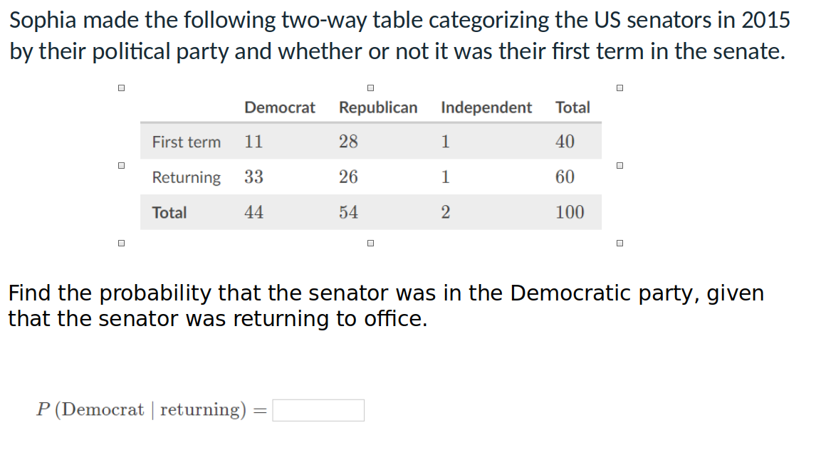

Democrat = 60
Returning = 33

(60 / 100)
------------- = 0.55
(33 / 100)

----------------------------------------------------------------------------------------

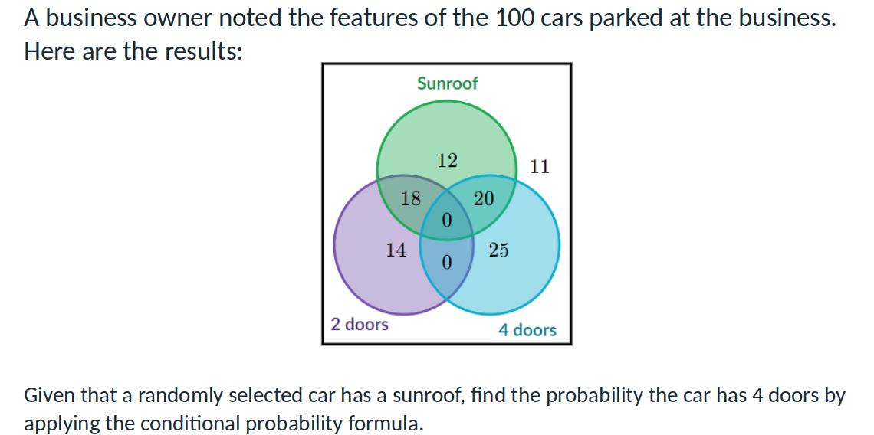

Sunroof = 12 + 18 + 20 = 50
doors = 20

(20/100)
----------- = 0.4
(50/100)

-----------------------------------------------------------------------------------------------------
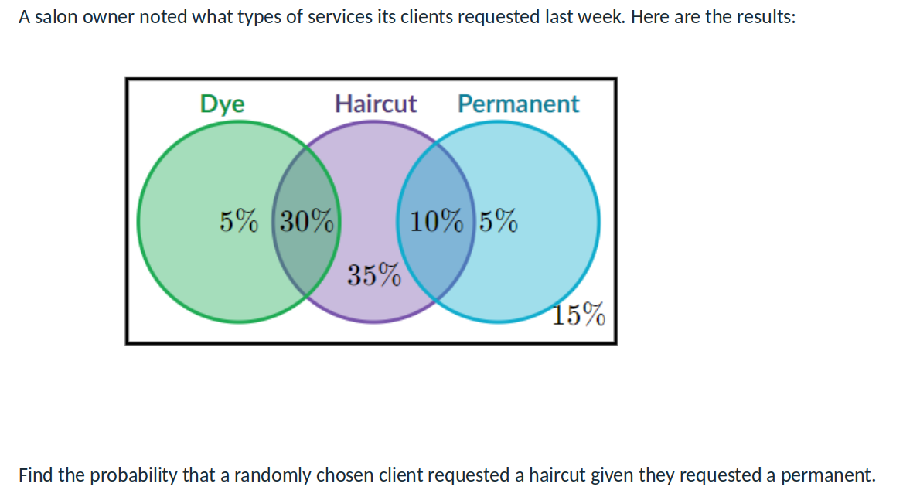

Permanent: 15%
Haircut: 10%

10%
------ = 0.67
15%

